**Philippine Copyright 2026**

by

Aquino, Richard Jason M.

Baldomar, Rhian Jolius

Evangelista, Yuan Exequiel R.

Garces, John Mark A.

and Quezon City Campus

Polytechnic University of the Philippines

All Rights Reserved. Portions of this manuscript may be reproduced with proper referencing and due acknowledgment of the authors.

# BUS OPERATION MANAGEMENT SYSTEM

A Capstone Project

Presented to the Faculty of

Polytechnic University of the Philippines

Quezon City Campus

In Partial Fulfillment of the Requirements for the Degree in Bachelor of Science in Information Technology

By

**Aquino, Richard Jason M.**

**Baldomar, Rhian Jolius**

**Evangelista, Yuan Exequiel R.**

**Garces, John Mark A.**

JANUARY 2026

# CERTIFICATION

This Capstone Project, ***BUS OPERATION MANAGEMENT SYSTEM***, prepared and submitted by AQUINO, RICHARD JASON M., BALDOMAR, RHIAN JOLIUS, EVANGELISTA, YUAN EXEQUIEL R., AND GARCES, JOHN MARK A., in partial fulfillment of the requirements for the degree of BACHELOR OF SCIENCE IN INFORMATION TECHNOLOGY has been examined and reviewed.

Evaluation Committee

**LEANDRO B. AVENA IV, MIT**

Adviser

APPROVAL

Approved by the Panel on Oral Examination January 2026 with the grade of __

**ALMA C. FERNANDEZ, MIT**

 Chair

**KEZAIAH MONZON-CRUZ, MIT                       ROYETTE H. VERGARA**

                 Member                                          Member

**AIN GEUEL E. ESCOBER, LPT, MaEd**

 Member

Accepted in partial fulfillment of the requirements for the degree Bachelor of Science in Information Technology

**JAIME P. GUTIERREZ, JR.**

Director

# ACKNOWLEDGEMENTS

The team would like to express their profound appreciation to everyone who supported and guided them throughout the completion of this capstone project. First and foremost, the team sincerely thank Leandro Avena IV, their Capstone adviser, whose expertise, insightful recommendations, and unwavering support made this study possible. His constructive feedback, patience, and encouragement were instrumental in refining their work and shaping the capstone project into what it is today. His dedication and guidance have been invaluable throughout this journey.

The team also extend their heartfelt gratitude to their panelists, John Berlyn F. Isip, Hernani Villanueva, and James Soliongco whose valuable insights, constructive critiques, and thoughtful recommendations significantly contributed to the improvement of this study. Their expertise and feedback helped strengthen the capstone project and enhance its overall quality.

Furthermore, the team wish to express their sincere appreciation to their families, friends, and loved ones. Their unwavering support, patience, and encouragement provided the determination to persevere. Their belief in the team’s abilities motivated them to strive for excellence and complete this study successfully.

# CERTIFICATE OF ORIGINALITY

This is to certify that the work presented in the capstone project, *BUS OPERATION MANAGEMENT SYSTEM* for the degree Bachelor of Science in Information Technology at Polytechnic University of the Philippines Quezon City Campus embodies the result of original and scholarly work conducted by the undersigned. This undergraduate thesis does not contain words or ideas taken from published sources or written works that have been accepted as basis for the award of degree from any higher education institution, except proper referencing and acknowledgements were made.

**RICHARD JASON M. AQUINO**

**RHIAN JOLIUS BALDOMAR**

**YUAN EXEQUIEL R. EVANGELISTA**

**JOHN MARK A. GARCES**

JANUARY 2025

# ABSTRACT

|  |  |  |
| --- | --- | --- |
| Title | : | Bus Operation Management System |
| Team | : | Aquino, Richard Jason M., Baldomar, Rhian Jolius, Evangelista, Yuan Exequiel R., Garces, John Mark A. |
| Degree | : | Bachelor of Science in Information Technology |
| Institution | : | Polytechnic University of the Philippines - Quezon City Campus |
| Year | : | 2026 |
| Adviser | : | Leandro B. Avena Iv, MIT |

The Bus Operation Management System (BOMS) is a comprehensive web-based platform designed to automate and streamline the daily operations of bus services. It centralizes key functions such as route and stop management, bus assignment readiness checks, dispatch control, and post-dispatch ticket sales recording. Administrators can efficiently create, update, and organize routes and stops, ensuring accurate route structures and improved passenger service. The system also supports pre-dispatch readiness checks, enabling admins to verify bus conditions, driver and conductor readiness, and ticket availability before operations begin. Once verified, buses can be dispatched and monitored throughout their trip lifecycle.

BOMS includes a Bus Rental module that allows admins to process rental requests, calculate dynamic pricing based on duration, distance, and bus type, and manage the rental status from pending to completed. Additionally, the system integrates a performance and analytics dashboard that aggregates operational data, tracks bus sales, identifies top-performing routes, and offers machine learning-based insights for predicting profitable routes and top earning driver–conductor pairs. This feature enhances decision-making by providing real-time metrics and trend analysis. The system’s architecture ensures reliable data handling through PostgreSQL and Prisma, while RESTful APIs connect frontend components for seamless user interactions. Overall, BOMS improves operational efficiency, ensures data accuracy, and supports strategic planning through automated processes and actionable analytics.

# TABLE OF CONTENTS

Page

**Title Page** i

**Certification and Approval Sheet** ii

**Acknowledgements** iii

**Certification of Originality** iv

**Abstract** v

**Table of Contents** vii

**List of Tables** ix

**List of Figures** xi

1 **Introduction** 1

Problem Statement 3

Project Vision and Scope 4

Objectives and Goals 4

Significance and Relevance 6

Definition of Terms 7

Structure of the Document 9

2 **Review** **of Related Literatures, Studies, and Technical Background** 10

Review of Related Literature 10

Analysis of Related Studies and Existing Systems 14

Agile Scrum Methodology 15

Microservices Architecture 17

DevOps Culture and CI/CD Practices 18

Enterprise Architecture & System Integration 19

Conceptual Framework 21

Theoretical Paradigm 22

3 **Methodology** **and Project Management** 23

The Adapted Agile Scrum Framework 23

Architectural Design Decisions 28

Development, Operations, and Quality Assurance (QA) Methodology 31

Innovation Framework 33

4 **System Design, Development, and Implementation** 35

Requirements Engineering 35

High System Level Design 82

Business Process Architecture 85

Application Architecture 88

Data Architecture and Design 90

Technology Architecture and Infrastructure 107

Development Journey 113

Implementation Strategy 123

Testing and Quality Assurance Report 127

5 **Summary, Conclusion, and Recommendations** 141

Summary of the Project 141

Conclusion 143

Project Contribution 144

Recommendation 145

References 147

Appendices 148

Appendix A: Technical Documentation 148

Appendix B: Project Management Artifacts 226

Appendix C: Research and Requirements Artefacts 246

Appendix D: Defense and Validation 300

Appendix E: Access Links 304

Appendix F: Plagiarism Certificate 306  
 Appendix G: Grammarly Certificate 307

Appendix H: Biographical Statements 310

# LIST OF TABLES

|  |  |  |
| --- | --- | --- |
| Number | Title | Page |
| 1 | **TOGAF ADM Phases and Project Mapping** | 19 |
| 2 | **Zachman Framework Mapping (Simplified)** | 19 |
| 3 | **Stakeholder Identification** | 35 |
| 4 | **Elicitation Technique** | 37 |
| 5 | **Functional requirements** | 39 |
| 6 | **Non-functional Requirements** | 46 |
| 7 | **User Stories, Acceptance Criteria, and Use Cases** | 48 |
| 8 | **Stop Table** | 95 |
| 9 | **Route Table** | 96 |
| 10 | **Route-stop Table** | 96 |
| 11 | **Bus Assignment Table** | 96 |
| 12 | **Ticket Bus Assignment Table** | 97 |
| 13 | **Ticket Type Table** | 97 |
| 14 | **Quota Policy Table** | 97 |
| 15 | **Fixed Quota Table** | 98 |
| 16 | **Percentage Quota Policy** | 98 |
| 17 | **Regular Bus Assignment Table** | 98 |
| 18 | **Rental Bus Assignment Table** | 99 |
| 19 | **Rental Driver Table** | 99 |
| 20 | **Rental Request Table** | 99 |
| 21 | **UAT Participants** | 130 |
| 22 | **UAT Schedule** | 131 |

# LIST OF FIGURES

|  |  |  |
| --- | --- | --- |
| Number | Title | Page |
| 1 | **Agile Model** | 15 |
| 2 | **The Basic Elements of the Scrum Framework** | 16 |
| 3 | **IPO Diagram** | 21 |
| 4 | **System Context Diagram** | 82 |
| 5 | **Overview of the Integrated System** | 83 |
| 6 | **Current As-Is Process** | 85 |
| 7 | **Process Model** | 87 |
| 8 | **Component Diagram** | 90 |
| 9 | **Use Case Diagram** | 90 |
| 10 | **ERD** | 92 |
| 11 | **Data Flow Diagram** | 100 |
| 12 | **Network Architecture** | 105 |
| 13 | **Cloud Infrastructure** | 107 |

# Chapter 1

**INTRODUCTION**

**Project Background and Motivation**

Efficient management of transportation operations is essential for ensuring reliable service, reducing operational costs, and maintaining competitiveness in the transport industry. Bus operations, in particular, involve complex processes such as scheduling drivers and conductors, coordinating dispatch activities, managing route assignments, tracking performance, and handling rentals. When these processes are conducted manually, they are prone to errors, inconsistencies, and inefficiencies that undermine operational effectiveness (Mahaphan, 2024). Manual tracking through spreadsheets, phone calls, and handwritten logs limits real-time visibility and increases the risk of miscommunication and poor decision-making.

Recent research highlights the critical role of digital transformation in improving public transport management systems by introducing automation, real-time data integration, and centralized control (Mahaphan, 2024). Digital solutions can provide transport operators with the tools needed to optimize resource allocation, monitor employee attendance, enforce discipline policies, and produce timely performance reports. Without these systems, organizations struggle with fragmented data, excessive manual workload, and limited operational insights.

Agila Bus Transport Corporation currently relies on manual methods for key operational tasks. Scheduling and dispatching responsibilities have been centralized to one person, with communication to employees conducted largely through phone calls, particularly when dealing with late or absent drivers and conductors. The company’s fixed routes, defined by franchise requirements, leave little room for flexibility in planning, yet management lacks a centralized system to monitor route performance, rental inquiries, employee discipline records, and dispatch readiness. These gaps reveal a significant need for a modern information system to support daily operations and organizational growth.

To address these challenges, this capstone project proposes the development of a Bus Operations Management System that centralizes operational data, automates routine processes, and provides real-time insights through intuitive dashboards and reports. By leveraging contemporary information system practices, the project aims to enhance operational efficiency, accountability, and data-driven decision-making.

## Problem Statement

Agila Bus Transport Corporation currently manages bus assignments, employee schedules, dispatch operations, rentals, and performance monitoring through largely manual processes. This reliance on manual tracking results in difficulty maintaining accurate daily schedules, frequent errors in employee assignment and quota calculations, and the absence of centralized performance records. The lack of a centralized system limits the organization’s ability to monitor operational performance, enforce discipline policies, and evaluate route efficiency.

Additionally, the concentration of scheduling and dispatching responsibilities on a single person increases operational risk and reduces overall efficiency. As operations expand, manual tracking becomes increasingly burdensome and error-prone, exacerbating operational inefficiencies. These challenges indicate a critical need for a centralized system to streamline processes and support effective decision-making.

## Project Vision and Scope

The main objective of this capstone project is to design and develop a centralized Bus Operations Management System that enhances operational efficiency and transparency. The system will automate the assignment of buses, drivers, conductors, and routes while ensuring accurate tracking of dispatch activities and quotas. It will also support structured rental management including approval workflows, billing, and historical tracking.

Another key goal is to provide management with real-time operational insights through dashboards and performance reports. By integrating all key operational functions into a unified platform, the system aims to reduce manual workloads, improve data accuracy, and support evidence-based decision-making. Ultimately, the system should be scalable, user-friendly, and capable of adapting to the organization’s ongoing operational needs.

## Objectives and Goals

The objectives and goals of the Bus Operation Management System are established to guide the development and implementation of the system in addressing existing challenges in bus operations. These objectives define the overall purpose of the system and outline specific targets aimed at improving operational efficiency, accuracy of data management, monitoring of bus activities, and support for informed decision-making.

### General Objective

The general objective of this study is to design and develop a Bus Operation Management System that enhances the overall efficiency, reliability, and effectiveness of bus operations by providing a centralized and automated platform for managing operational processes. The system aims to address common issues in traditional bus operations such as manual record-keeping, inaccurate quota counting, limited monitoring of bus activities, and delays in decision-making. By integrating key functionalities such as route management, assignment scheduling, trip monitoring, quota tracking, and performance reporting, the system seeks to support administrators and dispatchers in supervising daily operations, improving resource utilization, and ensuring consistent and well-documented bus services.

### Specific Objectives

Specifically, this study aims to achieve the following objectives:

1. To develop a centralized system that manages bus routes, schedules, and vehicle assignments in an organized and efficient manner.
2. To implement a structured trip management process that includes pre-trip readiness checks and post-trip completion validation to ensure operational compliance.
3. To design and integrate an automated quota counting and ticket tracking feature that accurately records passenger data and trip outcomes.
4. To generate comprehensive reports and analytics that evaluate bus performance in terms of utilization, efficiency, and operational readiness.
5. To monitor and assess driver and conductor performance based on attendance records, completed trips, and quota fulfillment.
6. To reduce errors and inconsistencies associated with manual data entry through system automation and standardized processes.
7. To ensure data security, integrity, and controlled access by implementing proper user roles and authorization for administrators and dispatchers.
8. To provide reliable and accessible operational data that supports informed decision-making and long-term planning for bus operations.

## Significance and Relevance

The Bus Operations & Scheduling System is significant to Agila Bus Transport Corporation because it directly addresses major inefficiencies caused by manual processes and fragmented record-keeping. For administrators and dispatchers, the system reduces dependency on phone-based coordination and paper logs, leading to improved accuracy and workflow efficiency. For management, consolidated dashboards and performance reporting provide timely insights that support strategic planning and decision-making.

From an academic perspective, this project demonstrates the practical application of digital transformation principles in the transport sector. Research on intelligent transportation systems underscores the positive impact such technologies have on operational efficiency and service quality (Zhai et al., 2023). The project also contributes to the growing body of literature on digital transformation in public services, highlighting how technology can be leveraged to improve accountability, operational visibility, and organizational performance.

## Definition of Terms

**BOMS (Bus Operation Management System).** A computerized system designed to manage and monitor bus operations. In this capstone project, it refers to the centralized platform developed to handle route management, dispatching, quota tracking, bus rentals, and performance reporting for administrative and operational use.

**Bus.** A large motor vehicle designed to transport passengers along designated routes. In this capstone project, it refers to a registered vehicle within the system that is assigned to routes, tracked during trips, and monitored for operational performance.

**Bus Rental.** A service that allows the temporary use of a bus for private or special purposes. In this capstone project, it refers to a system module used to manage rental requests, assignments, schedules, and records separate from regular bus operations.

**Conductor**. A transport personnel responsible for assisting passengers and managing fare or ticket collection. In this capstone project, it refers to a staff member assigned to a bus trip whose performance is monitored based on attendance, trip completion, and quota fulfillment.

**Dispatch.** The act of sending out a vehicle for operation or service. In this capstone project, it refers to the process of officially authorizing and recording a bus trip within the system.

**Dispatcher.** An individual responsible for coordinating and monitoring vehicle operations. In this capstone project, it refers to a system user who manages bus assignments, initiates dispatch and post-dispatch processes, and oversees daily operational activities.

**Driver.** A licensed individual responsible for operating a bus. In this capstone project, it refers to a staff member assigned to specific routes and trips, whose attendance and trip performance are recorded and evaluated in the system.

**Operational Manager.** A person responsible for overseeing operational activities and ensuring efficiency. In this capstone project, it refers to a supervisory role that monitors overall bus performance, reviews reports, and supports decision-making using system-generated data.

**Petty Cash.** A small amount of cash kept on hand for minor expenses. In this capstone project, it refers to recorded operational funds used for small trip-related expenses, tracked for accountability and reporting purposes.

**Post-dispatch.** Activities conducted after a bus trip has been completed. In this capstone project, it refers to the system process of validating trip completion, recording quota counts, and finalizing operational records.

**Pre-dispatch.** Activities conducted before a bus trip begins. In this capstone project, it refers to the system process of performing readiness checks, confirming assignments, and authorizing a bus for departure.

**Quota Policy.** A set of rules governing required or expected passenger or revenue counts. In this capstone project, it refers to predefined system rules used to evaluate quota fulfillment for trips, drivers, and conductors.

**Route.** A predefined path or course followed by a vehicle. In this capstone project, it refers to a system-defined route consisting of multiple stops, assigned buses, and scheduled trips.

**Stop.** A designated location where passengers board or disembark. In this capstone project, it refers to a recorded point within a route used for tracking movement and operational coverage.

## Structure of the Document

This document is organized to provide a comprehensive discussion of the Bus Operations Management System (BOMS) from conceptualization through implementation and evaluation. Chapter 1 introduces the background of the study, including the problem statement, objectives, scope and limitations, significance of the study, and the overall structure of the document. Chapter 2 presents the requirements analysis of the proposed system, detailing both the functional and non-functional requirements that guide the system’s development. Chapter 3 discusses the business process architecture and workflows of the Bus Operations Management System, illustrating how existing processes are improved and how the proposed system supports operational efficiency. Chapter 4 focuses on the System Design, Development, and Implementation of the Bus Operations Management System. This chapter covers requirements engineering, high-level system design, business process architecture using BPMN 2.0, application architecture, data architecture and design, and technology architecture and infrastructure. It also presents the system’s development journey, implementation strategy, testing and quality assurance report, and the results and evaluation of the developed system. Chapter 5 provides the Summary, Conclusion, and Recommendations of the study. This chapter summarizes the entire project, presents the conclusions drawn from the system development and evaluation, highlights the project’s contributions, and offers recommendations for future enhancements and related projects.

# Chapter 2

**RELATED LITERATURE, STUDIES, AND TECHNICAL BACKGROUND**

This chapter reviews related studies and existing literature that support the design and development of the Bus Operation Management System (BOMS) for Agila Bus Transport Corporation. The discussion focuses on Agile Scrum methodology, enterprise architecture concepts, microservices architecture, DevOps and CI/CD practices, relevant empirical studies, and the integration of information systems within enterprise environments. These concepts provide the theoretical and technical foundation for building a scalable, maintainable, and efficient system that addresses operational challenges in public bus transport management.

## Review of Related Literature

Ando et al. (2018) improved the existing community bus operation management system in Uwajima City, Japan. While the original 2013 system allowed bus location and passenger monitoring via a tablet app, it lacked essential features needed by users. Through interviews with customers, the researchers identified operational issues and redesigned the system to better meet user needs. The updated system enhanced functionality and overall satisfaction, demonstrating the value of user-centered design in public transport management.

Challapalli (2024) utilized AnyLogic simulation to optimize the Dallas-Fort Worth bus transportation system. The study focused on solving operational challenges such as bus bunching and delays by simulating real-world variables like bus intervals, dwell times, and passenger loads. By testing various scheduling strategies, the study found that adjusting bus frequencies based on peak and non-peak hours significantly improved efficiency—from 75% to 88%. The results emphasize the importance of dynamic scheduling in improving reliability and reducing wait times in public bus systems.

Chen, He, and Zhong (2022) proposed an integrated framework for bus timetabling and vehicle scheduling under a multi-line operation mode, addressing the need for more efficient and centralized bus service planning in urban areas. Their approach connects trip-link chains with departure time data to enable the simultaneous optimization of timetabling and vehicle scheduling. A multi-objective model was developed to balance service quality with operational costs, incorporating constraints based on logic and operational rules. They implemented a heuristic algorithm based on neighborhood search and validated the framework using actual data from Chongqing, China. The results provided bus operators with Pareto-optimal solutions as practical alternatives for improving daily operations.

Guan et al. (2022) proposed a real-time control strategy to reduce bus bunching and improve operational stability on single-line routes using Intelligent Transportation Systems (ITS). The strategy focuses on adjusting cruising speed, dwell time, and load rate to maintain consistent bus spacing and improve punctuality. They compared this approach with two existing methods: a timetable-based single-point control (S1) and a time headway-based multi-point control (S2). Using simulation data from Bus Line 245 in Nanchang, China, the real-time strategy (S3) showed the best performance, reducing average travel time by 34% and maintaining optimal bus intervals. The study offers practical insights for improving urban bus efficiency and reliability.

Lu et al. (2023) developed a robust integrated bus control system using a physics-informed deep reinforcement learning (DRL) approach to address bus bunching and improve operational efficiency along urban signalized corridors. Their multi-strategy framework leverages connected and autonomous vehicle (CAV) technology to adapt in real time to varying traffic and passenger conditions. By integrating control theory concepts and traffic data, the system dynamically manages dwell time, cruising speed, and signal priority to reduce delays and maintain bus stability. Simulation results confirmed its effectiveness under different traffic scenarios, demonstrating improved travel times and system reliability.

McMillen, Harper, and Conover (2024) introduced the Electric Bus System Simulator (EBSS), a tool designed to optimize and expand electric bus operations, specifically for the Utah Transit Authority. EBSS enhances fleet efficiency by managing state of charge (SoC), minimizing idle time, and maximizing charger utilization through real-time telemetry and predictive modeling. It incorporates data from OCPP-connected chargers and uses adaptive AI to forecast power needs based on routes and schedules. Beyond daily operations, the simulator also supports planning for fleet expansion by simulating future performance and providing actionable insights for electrified transport systems.

Pérez-De-La-Cruz, Belmonte, and Ruiz (2008) presented a multi-agent decision support system for bus fleet management, developed in collaboration with the Málaga urban bus company (EMT). The system uses a multi-agent architecture combined with ontologies to represent and manage operational knowledge, enabling intelligent decision-making under real-world conditions. It was designed to simulate and support the management of three actual bus lines, focusing on both knowledge representation and software engineering aspects. The study highlights the potential of agent-based systems in improving the efficiency and responsiveness of urban bus operations.

Sinha (2013) implemented a Real-Time Bus Monitoring and Passenger Information System (RTPIS) aimed at improving the efficiency of city bus operations by addressing uncertainties such as traffic delays, irregular dispatching, and varying passenger demand. The system uses GPS devices installed on buses to transmit live location data to a centralized control unit, which then displays bus positions on a route map through symbolic representations. Key components include real-time arrival displays at bus stops, a web-based interface for control room monitoring, and a mobile application for passengers to check schedules and bus locations. This research highlights the importance of real-time data in enhancing public transport reliability and user experience.

Teng and Jin (2015) developed a bus operation control system aimed at reducing bus bunching and maintaining consistent headways along routes. The system dynamically adjusts bus speed, dwell time, and traffic signal timings to improve service stability. Using simulation data from bus route 210 in Shanghai, the authors demonstrated that their control strategy effectively minimizes headway deviations and keeps bus intervals within acceptable limits. The study highlights the importance of real-time adjustments in enhancing bus reliability and overall service quality.

Zhang, Sun, Zhao, and Zhang (2023) designed an AR-based remote maintenance system for buses to enhance maintenance efficiency and reduce operational costs. The system integrates Augmented Reality technology to provide virtual guidance during remote maintenance and monitoring processes. It includes a maintenance guideline library and client-side function design to support real-time assistance. Experimental results demonstrated improvements in service quality, cost reduction, and user experience. Additionally, the system offers training resources for maintenance personnel, helping to improve their skills and technical capabilities.

## Analysis of Related Studies and Existing Systems

An analysis of related studies and existing systems reveals a wide range of approaches aimed at improving the efficiency, reliability, and management of bus operations. These studies provide valuable insights that inform the design and development of the proposed Bus Operation Management System.

Several researchers emphasize the importance of user-centered system design and real-time data utilization in enhancing service quality and operational reliability. Ando et al. (2018) highlight how systems designed around user needs improve usability and operational effectiveness, while Sinha (2013) and Guan et al. (2022) demonstrate that real-time data integration enables better monitoring, faster decision-making, and improved service responsiveness.

Simulation-based and optimization-driven approaches are also commonly explored to address operational challenges such as delays, inefficiencies, and bus bunching. Studies by Challapalli (2024), Teng and Jin (2015), and Lu et al. (2023) show that dynamic scheduling, predictive modeling, and adaptive control mechanisms significantly improve operational stability and resource utilization. These findings underscore the value of incorporating structured workflows and performance monitoring in bus management systems.

Furthermore, research by Chen et al. (2022) and Pérez-De-La-Cruz et al. (2008) focuses on the integration of scheduling systems and decision support tools to improve fleet coordination and operational planning. Their work highlights the role of centralized systems in supporting administrative decision-making and enhancing overall operational control.

Advancements in related operational support systems, such as maintenance management platforms (Zhang et al., 2023) and electric fleet management systems (McMillen et al., 2024), further demonstrate how technology-driven solutions can reduce operational costs, improve asset utilization, and enhance service quality. These systems emphasize the importance of data-driven insights, performance tracking, and system scalability.

Collectively, these studies and existing systems establish the foundation for the development of the proposed Bus Operation Management System. The insights gained from prior research guide the system’s functional design, process automation, and performance evaluation, while also identifying opportunities for future enhancements and system expansion.

## Agile Scrum Methodology

The development of the Bus Operation Management System (BOMS) adopted the Agile Scrum methodology to ensure iterative progress and flexibility. This approach allowed the team to quickly respond to changes in requirements and operational needs, particularly for modules such as bus assignment, driver and conductor management, and rentals. By conducting frequent reviews and incorporating feedback from Agila Bus Transport Corporation, the system was continuously refined to meet real-world operational demands.

Figure 1. Agile Model

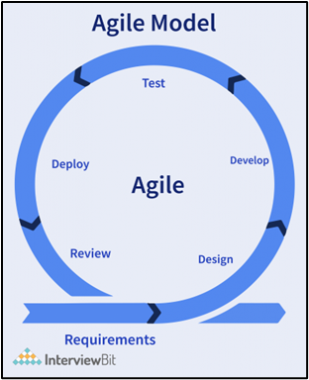

Agile Scrum, microservices principles, and DevOps practices form the foundation of the Bus Operation Management System, making it robust, scalable, and focused on user needs. Iterative sprints in Agile Scrum enable continuous improvement, while defined roles such as Product Owner, Scrum Master, and development team ensure accountability, collaboration, and clear responsibility for system features. The modular design allows functional areas, such as bus assignment, rentals, and reporting, to operate independently, enhancing flexibility and minimizing the impact of potential failures. DevOps practices, including continuous integration, continuous delivery, and automated testing, help streamline deployment, maintain high system reliability, and ensure that updates and new features are implemented efficiently. By incorporating user-friendly interfaces, data-driven insights, and a modular infrastructure, the system remains adaptable to operational demands and aligned with the strategic goals of Agila Bus Transport Corporation.

Figure 2. The Basic Elements of the Scrum Framework

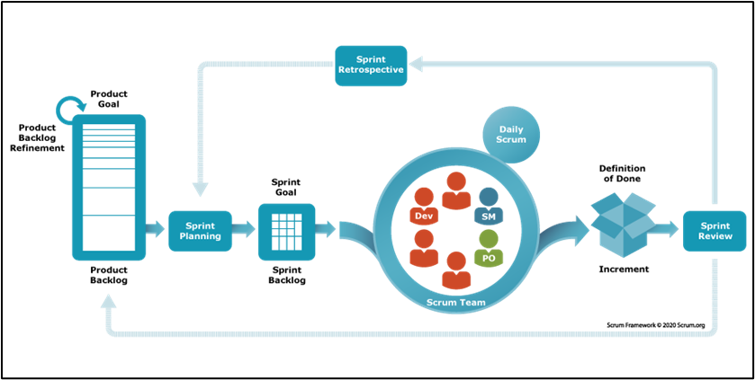

## Microservices Architecture

Microservices architecture organizes software systems as a collection of independently deployable services, each responsible for a specific business capability and communicating through well-defined interfaces (Newman, 2021). In large enterprise environments, this approach is commonly used to allow different departments or systems to operate independently while still sharing data and services when needed.

In the case of Agila Bus Transport Corporation, the Bus Operation Management System (BOMS) functions as one component within a broader organizational system that also includes Human Resources, Inventory, and Finance systems. Rather than implementing a full microservices architecture internally, BOMS integrates with an external microservice provided by another system, specifically for accessing inventory-related data such as bus resources and operational items. This approach allows BOMS to focus on operational functions such as scheduling, dispatching, and trip monitoring, while delegating inventory management responsibilities to a separate system.

This form of selective microservice integration reflects a practical application of microservices principles, where services are shared across systems to promote separation of concerns and reduce duplication of functionality. Industry studies emphasize that one of the primary benefits of microservices is the ability to scale and manage services independently across organizational boundaries, which improves system maintainability and operational efficiency without requiring full system decomposition (Callaway, 2020). However, integrating external microservices also introduces challenges related to service dependency, data consistency, and monitoring. These challenges highlight the importance of clearly defined APIs, access control mechanisms, and reliable communication between systems to ensure uninterrupted bus operations.

By using microservices only where cross-system integration is required, BOMS maintains a focused operational scope while remaining compatible with a larger enterprise architecture. This design choice supports flexibility and future expansion, allowing additional services such as HR or finance-related integrations to be incorporated as the organization’s digital infrastructure evolves.

## DevOps Culture and CI/CD Practices

DevOps practices were incorporated into the development of the Bus Operation Management System to improve collaboration between development and operations and to ensure reliable system delivery. Continuous Integration and Continuous Deployment (CI/CD) pipelines automate the process of building, testing, and deploying system updates, reducing the risk of errors and ensuring that BOMS remains in a deployable state. Research indicates that organizations with mature DevOps practices deploy software more frequently and recover from failures significantly faster than those with traditional development approaches (Forsgren et al., 2022). For BOMS, this approach supports the rapid deployment of improvements to scheduling logic, assignment rules, and system interfaces. Kim, Humble, and Debois (2020) further note that automated pipelines foster continuous experimentation and refinement, which is critical for improving operational efficiency and system reliability in transport management systems.

## Enterprise Architecture & System Integration

The Bus Operation Management System (BOMS) is designed to function as an operational subsystem within Agila Bus Transport Corporation’s broader enterprise environment, interacting selectively with other organizational systems. Integration with the Human Resource Management System (HRMS) allows the synchronization of driver and conductor availability, schedules, and role assignments, ensuring accurate and timely dispatching. For inventory management, BOMS connects with an external microservice provided by the Inventory System to retrieve bus-related items and operational resources, enabling efficient tracking without duplicating data or processes. In addition, BOMS supports potential integration with the Finance System to facilitate quota management, rental payments, and billing information, which helps streamline revenue tracking and operational reporting.

By focusing on these targeted integrations, BOMS preserves its primary operational scope while benefiting from cross-system data sharing. The system uses standardized interfaces and APIs to communicate with external services, which reduces manual processes, enhances data accuracy, and ensures that critical operational decisions such as bus assignments, resource allocation, and billing can be informed by up-to-date information from other organizational systems. This design approach allows BOMS to remain modular and adaptable, supporting future expansion or tighter integration as Agila Bus Transport’s digital infrastructure evolves.

Table 1

**TOGAF ADM Phases and Project Mapping**

|  |  |  |
| --- | --- | --- |
| **TOGAF ADM Phase** | **Description** | **Bus Operations Management System Mapping** |
| Preliminary | Define architecture principles, scope | Chose Microservices and Cloud-native approach |
| A: Architecture Vision | High-level system overview | BusOps System supports route, ticketing |
| B: Business Architecture | Business process modeling | Bus route planning, dispatching, ticketing workflows |
| C: Information Systems Architecture | Data and application architecture | Auth Microservice, PostgreSQL DB, Next.js Frontend |
| D: Technology Architecture | Tech stack & infrastructure | Vercel deployment, REST APIs, GitHub CI/CD |
| E: Opportunities and Solutions | Implementation planning | Sprint-based releases, MVP in Phase 1 |
| F: Migration Planning | Migration strategy | Progressive enhancement per module |
| G: Implementation Governance | Ensure compliance with architecture | Architecture Review Board (ARB) checkpoints |
| H: Architecture Change Management | Continuous improvements | Future support for GPS |

Table 2

**Zachman Framework Mapping (Simplified)**

| **Perspective (Rows)** | **What (Data)** | **How (Function)** | **Where (Network)** | **Who (People)** | **When (Time)** | **Why (Motivation)** |
| --- | --- | --- | --- | --- | --- | --- |
| Planner (Scope) | Bus data, routes | Ticketing logic | Web-based access | Admins, Operators | Daily schedule | Improve public transit |
| Owner (Business) | Route database | Ticket system | Central dashboard | Dispatcher, Driver | Live operations | Faster scheduling |
| Designer (System) | ERDs, APIs | Microservice flow | Frontend–Backend | Auth roles setup | Task timelines | Scalable design |
| Builder (Tech) | PostgreSQL schema | Auth endpoints | Vercel deployment | GitHub teams | CI/CD pipeline | Developer efficiency |

## Conceptual Framework

This project follows a structured and systematic approach in developing a Bus Operations Management System (BOMS) by first identifying the essential inputs required for effective system implementation. These inputs include operational requirements, user needs, existing workflows, and technical specifications that define how bus operations are currently managed. By carefully analyzing these elements, the project ensures that the system design is aligned with real-world operational demands. The conceptual framework serves as a guide, illustrating how these requirements are translated into clear objectives and functional components that address scheduling, monitoring, reporting, and overall management efficiency.

Through a series of organized stages including analysis, design, development, integration, and testing, the project transforms these inputs into a fully functional system. Each phase builds upon the previous one to ensure accuracy, reliability, and usability. The analysis phase defines system requirements, the design phase outlines the technical structure, and the development phase constructs the core features of the system. Integration ensures seamless interaction among modules, while testing verifies performance and correctness before deployment.

Figure 3. IPO Diagram

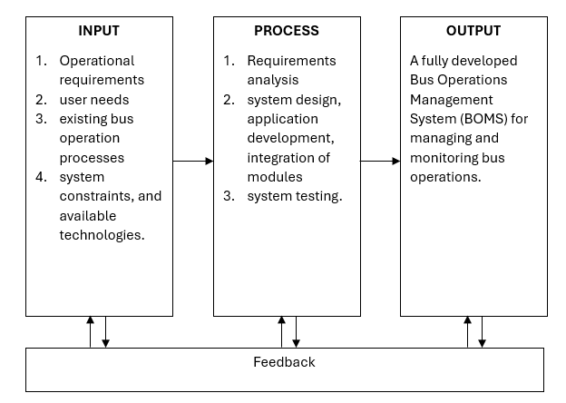

## Theoretical Paradigm

The theoretical paradigm for this study is based on the Input–Process–Output (IPO) Model which explains how systems transform resources into outcomes through systematic procedures. In the context of the Bus Operations Management System, the inputs include operational requirements, user needs, existing processes, and available technologies. These inputs undergo systematic processes such as requirements analysis, system design, development, integration, and testing. The final output is a functional Bus Operations Management System that supports efficient bus operations, improves data accuracy, and provides real-time monitoring and reporting for administrators and dispatchers.

# Chapter 3

**METHODOLOGY AND PROJECT MANAGEMENT**

## The Adapted Agile Scrum Framework

The Adapted Agile Scrum Framework is a flexible project management approach that organizes development into short, iterative cycles called sprints. It emphasizes collaboration, continuous improvement, and frequent delivery of functional components. In this study, the framework is adapted to fit the team’s schedule and project scope, ensuring efficient progress, regular feedback, and timely completion of the Bus Operations Management System (BOMS).

### Team Roles and Responsibilities

To ensure that all team members understand their responsibilities and contribute effectively to the development of the Bus Operation Management System, clear roles are defined following the Agile Scrum methodology.

1.Product Owner.

The Product Owner oversees the project and defines the system requirements, prioritizing features such as trip assignment, driver availability, and scheduling. This role ensures that the development aligns with the operational goals of Agila Bus Transport Corporation and coordinates closely with stakeholders to determine which features are most critical for short-term functionality and long-term efficiency.

2.Scrum Master.

The Scrum Master facilitates Scrum processes and ensures that the team adheres to Agile principles. They help remove obstacles that could slow progress, enabling the developers and testers to work efficiently and maintain collaboration throughout each sprint.

3.Development Team.

The development team consists of programmers, designers, and testers responsible for designing, implementing, and refining modules such as assignment, scheduling, dashboards, and trip monitoring. Team members work together to meet sprint goals, deliver high-quality increments, and ensure that the system is functional, reliable, and aligned with the operational needs of the bus company.

### Scrum Events

The development of the Bus Operation Management System is organized into sprint cycles, with each sprint lasting approximately two to three weeks. This approach ensures structured progress while allowing for incremental improvements based on feedback and operational needs.

1.Sprint Planning.

At the beginning of each sprint, the Product Owner collaborates with the development team to define the objectives, tasks, and expected outcomes for that cycle. This planning ensures that each sprint focuses on critical features, such as trip assignment, route management, or dashboard updates, prioritizing work that provides the most value to Agila Bus Transport Corporation.

2.Daily Stand-ups.

The development team conducts brief daily meetings to share progress, discuss challenges, and coordinate upcoming tasks. These stand-ups promote accountability, maintain team alignment, and enable the immediate resolution of any issues that may hinder the completion of sprint goals.

3.Sprint Review.

At the conclusion of each sprint, the team presents completed features and modules to the stakeholders for evaluation and feedback. This review ensures that the development aligns with operational requirements, including driver and conductor assignment, trip readiness, and schedule monitoring, and allows adjustments to be made before the next cycle.

4.Sprint Retrospective.

Following the review, the team reflects on what went well and identifies areas for improvement. This retrospective fosters continuous learning, helping the team enhance workflows, improve collaboration, and deliver increasingly efficient and effective iterations of the system.

### Scrum Artifacts

Scrum artifacts are key tools that help the development team organize work, track progress, and maintain transparency throughout the project. They provide a clear record of tasks, priorities, and deliverables for each sprint.

1.Product Backlog.

The Product Backlog is a comprehensive list of all features, enhancements, and bug fixes required for the Bus Operation Management System. This includes modules such as bus assignment, route management, dashboard analytics, and bus rental functionality. The Product Owner is responsible for maintaining and prioritizing the backlog, ensuring that items align with the operational goals of Agila Bus Transport Corporation and address the most pressing needs first.

2.Sprint Backlog.

The Sprint Backlog consists of selected items from the Product Backlog that the team commits to completing during a specific sprint. By focusing on these high-priority tasks, the team can maintain clarity and ensure that critical functionality—such as driver scheduling or trip readiness indicators—is delivered incrementally and effectively.

3.Increment.

The Increment represents the sum of all completed backlog items at the end of a sprint. Each increment is a potentially deployable version of the Bus Operation Management System that can be tested, reviewed, and integrated into ongoing operations. Through these iterative releases, the system continuously improves, providing stakeholders with tangible, usable updates after every sprint.

### Toolstack

A toolstack (or technology stack) refers to the combination of software tools, programming languages, frameworks, and platforms used to build and support an application. It includes everything from the user interface (frontend) and server-side logic (backend) to the database, APIs, and hosting services. In this study, the chosen toolstack enables the development, deployment, and efficient operation of the Bus Operations Management System (BOMS).

**Frontend: Next.js (React Framework)**

Next.js is a powerful React-based framework used for building fast and scalable web applications. It offers server-side rendering (SSR), static site generation (SSG), and seamless routing which helps in creating responsive and dynamic user interfaces. In the Bus Operations Management System (BOMS), Next.js is used to develop the frontend user interface for administrators and dispatchers, providing real-time updates, easy navigation, and interactive dashboards for monitoring bus operations.

**Backend: Node.js**

Node.js is a JavaScript runtime environment that enables server-side application development using JavaScript. It supports high performance and scalability due to its non-blocking, event-driven architecture. For BOMS, Node.js is responsible for handling server-side logic, processing requests, managing authentication, and executing business rules such as dispatch management, quota counting, and user roles.

**API Architecture: RESTful APIs**

RESTful APIs (Representational State Transfer) provide a standardized way for the frontend and backend to communicate using HTTP methods (GET, POST, PUT, DELETE). This architecture ensures clear separation between client and server, enabling modular development and easier maintenance. In BOMS, RESTful APIs are used to handle data exchange for operations such as route management, bus assignment, trip dispatching, quota tracking, and report generation.

**Database: PostgreSQL**

PostgreSQL is a reliable and powerful open-source relational database management system (RDBMS) known for its strong data integrity, support for complex queries, and scalability. It is suitable for storing structured data such as bus information, routes, user accounts, trip records, and quota data. In BOMS, PostgreSQL serves as the main database for storing all operational and transactional data securely.

**Hosting / Cloud Platforms**

**Vercel – Frontend Hosting and Backend Services**

Vercel is a cloud platform optimized for hosting Next.js applications. It provides fast deployment, automatic scaling, and seamless integration with Git repositories. In BOMS, Vercel is used to host the frontend interface and support serverless backend functions for faster performance and reliable accessibility.

**Railway / Render – PostgreSQL Database Hosting and Microservices**

Railway and Render are cloud platforms used for hosting backend services and the PostgreSQL database. They provide flexible infrastructure for deploying microservices, managing environments, and scaling resources based on demand. In BOMS, Railway or Render is utilized to host the backend services, APIs, and database to ensure consistent performance and availability.

**Redis Upstash – Caching**

Redis Upstash is a managed cloud service for Redis, an in-memory data store used for caching frequently accessed data to improve system performance and reduce database load. In BOMS, Redis is used to cache frequently requested data such as route information, bus status, and reports, allowing faster response times and smoother user experience.

## Architectural Design Decisions

Architectural design decisions refer to the critical choices made during system design that determine the structure, components, and technologies of the application. These decisions define how modules interact, how data is stored and processed, and how the system achieves scalability, security, and performance. In this study, the architectural design decisions guide the development of the Bus Operations Management System (BOMS) by selecting appropriate frameworks, database systems, integration methods, and deployment strategies to meet project requirements.

### Why Microservice

Microservices architecture divides an application into smaller, independent services that each perform a specific function. This approach improves scalability, flexibility, and maintainability because individual components can be developed, deployed, and updated separately without affecting the entire system. For the Bus Operations Management System (BOMS), using microservices enables efficient management of separate modules such as dispatching, route management, quota tracking, and reporting, allowing the system to grow and adapt more easily in the future.

Core Architectural Patterns Used

The Bus Operations Management System (BOMS) utilizes several key architectural patterns to ensure scalability, modularity, and efficient communication between system components. The core patterns implemented include:

1. Microservices Architecture

This pattern divides the application into small, independent services that each handle specific business capabilities. For BOMS, separate microservices can manage modules such as dispatching, route management, quota tracking, reporting, and bus rental. This approach enables independent development, deployment, and scaling of each service, making the system more flexible and easier to maintain.

2. Client–Server Architecture

The client–server pattern separates the user interface (client) from the backend services (server). In BOMS, the frontend application built with Next.js acts as the client, while the backend services powered by Node.js serve as the server. This separation allows for clear division of responsibilities, improved security, and easier updates to the user interface or backend without affecting the other.

3. RESTful API Pattern

The RESTful API pattern provides a standardized way for the client and server to communicate using HTTP methods such as GET, POST, PUT, and DELETE. In BOMS, RESTful APIs are used to exchange data between the frontend and backend services for operations like bus assignment, route management, dispatching, quota counting, and report generation. This pattern ensures consistency, scalability, and easier integration with external services.

4. Layered (N-Tier) Architecture

A layered architecture organizes the system into distinct layers such as presentation, application, and data layers. In BOMS, the presentation layer is the user interface, the application layer contains business logic and APIs, and the data layer handles database operations. This separation improves maintainability, simplifies debugging, and promotes reusability of components.

5. Event-Driven Pattern (Optional / Future Use)

While not fully implemented in the initial version, the event-driven pattern is considered for future enhancements where real-time updates and notifications are needed. This pattern enables services to communicate using events, which can improve responsiveness and reduce direct dependencies between services.

Together, these architectural patterns provide a strong foundation for building a modern and resilient Bus Operations Management System that supports future growth, easier maintenance, and better operational performance.

## Development, Operations, and Quality Assurance (QA) Methodology

The Development, Operations, and Quality Assurance (QA) methodology refers to the structured approach used throughout the project lifecycle to ensure that the system is developed efficiently, deployed reliably, and maintained with high quality. This methodology integrates software development practices, operational deployment strategies, and testing procedures to deliver a stable and functional Bus Operations Management System (BOMS).

### DevOps Toolchain

The DevOps toolchain for BOMS consists of integrated tools and services that support version control, automated deployment, hosting, and environment management. This includes:

1. Version Control System (Git): All code changes are tracked using Git, enabling collaboration, code review, and version management.
2. Hosting Platforms (Vercel, Railway/Render): These platforms are used for deploying the frontend, backend services, and database.
3. Containerization and Deployment Tools: The team uses container-based or platform-based deployment methods to ensure consistent runtime environments.
4. Infrastructure as Code (IaC): Infrastructure setup and configuration are managed through code, ensuring reproducible environments and minimizing human errors.
5. Monitoring and Logging Tools: Tools are used to monitor application performance, uptime, and logs to quickly detect and resolve issues during deployment and operation.

### CI/CD Pipeline Design

The CI/CD pipeline for the Bus Operation Management System is designed to automate the build, testing, and deployment processes. This pipeline ensures that updates are integrated and delivered smoothly without disrupting system operations.

**Continuous Integration (CI):**

Code changes are frequently merged into a shared main branch and automatically tested. This process detects integration issues early, ensuring that new updates do not disrupt existing functionality and that the system remains stable for operational use.

**Continuous Delivery (CD):**

The continuous delivery pipeline automatically prepares code changes for deployment, allowing new features or improvements, such as trip assignment enhancements or dashboard updates, to be delivered rapidly and consistently. This approach ensures the system remains responsive to operational needs and can be updated regularly with minimal downtime.

### Testing Strategy

The testing strategy for BOMS combines automated testing with manual quality assurance to ensure system reliability and usability.

**Automated Testing:**

Automated tests are executed as part of the CI pipeline to verify key functionalities, detect bugs early, and ensure that system updates do not break existing features.

**Manual Testing:**

In addition to automated processes, manual testing is conducted by quality assurance personnel to validate usability, functionality, and performance. This step ensures that every new update meets quality standards and maintains reliability for end-users such as dispatchers, drivers, and conductors.

**Environment Validation:**

Testing environments are managed using IaC to ensure consistent and reproducible setups. This reduces human errors and provides a stable environment for testing new modules and features.

## Innovation Framework

Innovation plays a crucial role in the design and functionality of the Bus Operation Management System, ensuring that it remains adaptable, efficient, and user-friendly for all operational stakeholders.

1.User-Centric Design.

The system emphasizes ease of use, allowing dispatchers, drivers, conductors, and administrators to navigate features such as trip assignments, scheduling, and bus monitoring efficiently. Intuitive interfaces reduce errors and improve operational coordination.

2.Data-Driven Insights.

BOMS collects and analyzes operational data, including driver availability, trip performance, and route efficiency. These insights enable managers to make informed decisions, optimize bus assignments, and adjust routes or schedules based on actual usage patterns and performance trends.

3.Modular Scalability.

The system is designed with modularity in mind, allowing additional features or integrations—such as GPS tracking, maintenance logs, or inventory updates—to be incorporated without disrupting existing functionality. This ensures the platform can grow alongside the evolving needs of Agila Bus Transport Corporation.

4.Cloud-Based Infrastructure.

By leveraging cloud technology, the system ensures that data and services are accessible from multiple locations. This provides operational flexibility, enables real-time updates, and supports remote monitoring of bus operations, making the system resilient and adaptable to dynamic transportation demands.

# Chapter 4

**SYSTEM DESIGN, DEVELOPMENT, AND IMPLEMENTATION**

## Requirements Engineering

Requirements Engineering is the systematic process of identifying, documenting, analyzing, validating, and managing the needs and expectations of stakeholders for a software system. This process ensures that the Bus Operations Management System (BOMS) is designed and developed based on clear and accurate requirements, which helps prevent misunderstandings, reduces development risks, and ensures that the final system meets the intended goals and user needs.

### Stakeholder Analysis

Stakeholder analysis is the process of identifying and evaluating all individuals or groups who have an interest in, influence over, or are affected by the system. This includes both direct users and indirect stakeholders, such as administrators, dispatchers, drivers, conductors, and management. The purpose of stakeholder analysis is to understand each stakeholder’s roles, needs, expectations, and level of involvement in the project. By clearly identifying stakeholders and their requirements, the development team can prioritize features, address concerns early, and ensure that the Bus Operations Management System (BOMS) effectively supports operational goals and improves overall workflow.

Table 3

**Stakeholder Identification**

| **Stakeholder Group** | **Specific Stakeholders** | **Bus Operations Role / Responsibility** | **Interest Level** | **Influence Level** | **Operational Goals / Concerns** |
| --- | --- | --- | --- | --- | --- |
| Key Decision Makers | - Admin / Owner - Dispatcher | Admin/Owner: Oversees the entire Bus Operations Management System; approves route schedules, staff assignments, and reviews performance reports. Dispatcher: Operates the system daily; handles bus assignment, trip monitoring, and scheduling coordination. | High | High | Ensure operational efficiency, minimize delays, and optimize fleet utilization. |
| Support & Oversight | - Chief Mechanic - Supervisors (Optional) | Chief Mechanic: Assigns maintenance personnel and certifies bus readiness before dispatch. Supervisors: Monitor overall operational flow and ensure procedures are followed. | Medium | High | Maintain safety standards and smooth day-to-day operations. |
| Direct System Users | - Drivers & Conductors - Mechanics | Drivers/Conductors: View and confirm their assigned routes and schedules through the system. Mechanics: Access maintenance schedules and update bus status after inspection. | High | Medium | Ensure clarity in assignments and reduce communication errors. |
| Indirect Stakeholders | - Passengers (Optional) - Regulatory Bodies (Optional) | Passengers: Benefit from improved scheduling and on-time trips but do not interact directly with the system. Regulatory Bodies: Oversee compliance with transportation and safety regulations. | Medium | Low | Benefit from reliable services and accurate compliance reports. |

The table 3 summarizes the stakeholder analysis for the Bus Operations Management System (BOMS). It identifies key stakeholder groups, specific stakeholders, their roles and responsibilities in bus operations, and their level of interest and influence. The table also highlights each group’s operational goals and concerns, which guide the development priorities and ensure that the system addresses the needs of both direct users and indirect beneficiaries.

### Elicitation Techniques

Elicitation techniques are methods used to gather requirements and information from stakeholders to understand their needs, expectations, and challenges. These techniques help ensure that the system’s features are aligned with real operational requirements. Common elicitation methods include interviews, surveys, observation, document analysis, and brainstorming sessions. In the Bus Operations Management System (BOMS), elicitation techniques are used to collect data from administrators, dispatchers, drivers, and mechanics to accurately define the system’s functionalities and operational requirements.

Table 4

**Elicitation Technique**

| **Technique** | **Description** | **Stakeholders Involved** | **Purpose / Expected Output (Specific to Bus Operations)** |
| --- | --- | --- | --- |
| Interviews | Conducted structured and semi-structured interviews with key operational staff to understand how daily bus operations are managed. These interviews gathered detailed insights into scheduling procedures, maintenance coordination, and route management. | Admin/Owner, Dispatcher, Chief Mechanic, Mechanics, Drivers, Conductors | To capture in-depth operational challenges, user roles, and data dependencies in existing manual workflows. The findings helped define system functionalities such as bus assignment, trip readiness validation, and dispatch reporting. |
| Surveys and Questionnaires | Distributed digital and printed questionnaires to a wider group of users to validate and quantify operational needs. Questions focused on scheduling accuracy, communication between departments, system usability, and preferred automation features. | Dispatcher, Drivers, Conductors, Mechanics, Supervisors (Optional) | To gather measurable feedback and identify recurring operational issues. Results were analyzed to prioritize requirements for route scheduling, maintenance scheduling, and real-time trip monitoring. |

The table 4 presents the elicitation techniques used in the study to gather requirements for the Bus Operations Management System (BOMS). It details each method, the stakeholders involved, and the specific purpose or expected output related to bus operations. Interviews were conducted with key operational staff to capture detailed insights into manual workflows and operational challenges, while surveys and questionnaires were used to validate and quantify user needs across a broader group. The outputs of these techniques guided the definition and prioritization of system functionalities such as dispatch management, route scheduling, maintenance coordination, and real-time monitoring.

### Functional Requirements

Functional requirements define the specific features and core operations that the Bus Operations Management System (BOMS) must perform in order to effectively support daily bus operations. These requirements describe how the system should respond to user inputs and interactions, ensuring that each function contributes to efficient and accurate operational management. Key functionalities include route management, bus assignment, dispatch processing, quota tracking, and report generation. By clearly outlining these features, the system establishes a structured foundation for handling operational tasks in a consistent and organized manner.

In addition, functional requirements ensure that the system delivers the necessary capabilities to meet both operational demands and stakeholder expectations. They guide the development process by specifying what the system must accomplish, helping developers translate business processes into practical system actions. Through well-defined functional requirements, BOMS can streamline workflows, improve coordination among personnel, and provide reliable access to critical operational data

Table 5

**Functional requirements**

| **FR ID** | **MODULE** | **SUBMODULE** | **DESCRIPTION** |
| --- | --- | --- | --- |
| FR-001 | Assignment Module |  | The system shall allow the user to access the Bus Driver/Conductor Assignment module through the Assignment Management section. |
| FR-002 | Assignment Module |  | The system shall display modals for selecting a bus, driver, and conductor. |
| FR-003 | Assignment Module |  | The system shall display modals for selecting a Route. |
| FR-004 | Assignment Module |  | The system shall allow the user to choose between a Fixed Quota and a Percentage-Based Quota type. |
| FR-005 | Assignment Module |  | The system shall allow input of a target amount for Fixed Quota assignments and Percentage-Based Quota type. |
| FR-006 | Assignment Module |  | The system shall prevent assigning the same driver or conductor to multiple buses at the same time. |
| FR-007 | Assignment Module |  | The system shall display a summary of the selected bus, driver, conductor. |
| FR-008 | Assignment Module |  | The system shall provide a Confirm button to finalize the assignment. |
| FR-009 | Assignment Module |  | The system shall provide an Edit button to modify selections before confirmation. |
| FR-010 | Assignment Module |  | The system shall provide an delete button to delete assignment. |
| FR-011 | Assignment Module |  | The system shall validate all required fields and display error messages if any are incomplete. |
| FR-012 | Assignment Module |  | The system shall generate a confirmation message upon successful assignment. |
| FR-013 | Assignment Module |  | The system shall save and record the assignment data in the system. |
| FR-014 | Route Management Module | Routes | The system shall allow administrators to create new bus routes |
| FR-015 | Route Management Module | Routes | The system shall display a list of all existing bus routes |
| FR-016 | Route Management Module | Routes | The system shall allow administrators to edit an existing route |
| FR-017 | Route Management Module | Routes | The system shall allow administrators to delete existing routes |
| FR-018 | Route Management Module | Routes | The system shall validate required fields during route creation and editing, and display error messages if fields are missing or invalid. |
| FR-019 | Route Management Module | Routes | The system shall dynamically update the route list after adding, editing, or deleting a route. |
| FR-020 | Route Management Module | Routes | The system shall provide a search bar to find routes by route name or code. |
| FR-021 | Route Management Module | Routes | The system shall provide filter options to display active routes, inactive routes, or all routes. |
| FR-022 | Route Management Module | Routes | The system shall include an Add button to create a route, a Clear button to reset input fields, and an Update button to save edits. |
| FR-023 | Route Management Module | Stops | The system shall allow administrators to select a route in order to manage its stops. |
| FR-024 | Route Management Module | Stops | The system shall display a list of stops for a selected route |
| FR-025 | Route Management Module | Stops | The system shall allow administrators to add new stops to the selected route |
| FR-026 | Route Management Module | Stops | The system shall allow administrators to remove stops from the selected route. |
| FR-027 | Route Management Module | Stops | The system shall allow administrators to reorder stops within a route using drag-and-drop functionality or up/down buttons. |
| FR-028 | Route Management Module | Stops | The system shall dynamically update the stops list after adding, removing, or reordering stops. |
| FR-029 | Route Management Module | Stops | The system shall prevent duplicate stop names within the same route. |
| FR-030 | Route Management Module | Stops | The system shall validate required fields for stops and display error messages for missing or invalid inputs. |
| FR-031 | Route Management Module | Stops | The system shall provide an Add button to add new stops, a Clear button to reset stop input fields, and an Update button to save changes. |
| FR-032 | Route Management Module | Stops | The system shall provide a search bar to filter stops |
| FR-033 | Route Management Module | Stops | The system shall include visual cues to indicate the sequence or order of stops. |
| FR-034 | Bus Operations Module | Pre-Operations (Bus Readiness) | The system shall provide a modal for selecting the Bus Assignment ID. |
| FR-035 | Bus Operations Module | Pre-Operations (Bus Readiness) | The system shall display a readiness checklist including vehicle conditions (brakes, tires, engine oil, fuel, lights), personnel conditions (driver, conductor), and operations (change/money). |
| FR-036 | Bus Operations Module | Pre-Operations (Bus Readiness) | The system shall allow users to mark each readiness item as checked or unchecked. |
| FR-037 | Bus Operations Module | Pre-Operations (Bus Readiness) | The system shall display a Bus Readiness Marker indicating readiness status (Green for Pass, Red for Fail). |
| FR-038 | Bus Operations Module | Pre-Operations (Bus Readiness) | The system shall display detailed readiness criteria status |
| FR-039 | Bus Operations Module | Pre-Operations (Bus Readiness) | The system shall save and record the readiness results |
| FR-040 | Bus Operations Module | Post-Operations (Quota counting) | The system shall provide a modal for selecting the Bus Assignment ID |
| FR-041 | Bus Operations Module | Post-Operations (Quota counting) | The system shall provide a textbox for inputting the total Ticket Sales Count. |
| FR-042 | Bus Operations Module | Post-Operations (Quota counting) | The system shall save and update the entered ticket sales data linked to the selected bus assignment. |
| FR-043 | Bus Operations Module | Post-Operations (Quota counting) | The system shall display a success message upon saving the ticket sales data. |
| FR-044 | Bus Operations Module | Post-Operations (Quota counting) | The system shall determine and record whether the quota is successfully met or not (Success or Failure). |
| FR-045 | Bus Operations Module | Post-Operations (Quota counting) | The system shall display an error message if the ticket sales input is invalid or missing. |
| FR-046 | Bus Rental Module | New Rental Request | The system shall allow users to create a new rental request |
| FR-047 | Bus Rental Module | New Rental Request | The system shall validate that all required fields are filled and rental date and time are in the future. |
| FR-048 | Bus Rental Module | New Rental Request | The system shall display a rental summary preview and allow confirmation or cancellation. |
| FR-049 | Bus Rental Module | New Rental Request | The system shall prevent submission if required fields are missing and display appropriate validation errors. |
| FR-050 | Bus Rental Module | Price Calculation | The system shall calculate the rental price based on pickup and drop-off locations, duration, number of passengers, and special requirements. |
| FR-051 | Bus Rental Module | Price Calculation | The system shall display a detailed price breakdown including base fare, additional fees |
| FR-052 | Bus Rental Module | Price Calculation | The system shall allow users to edit rental details before proceeding to booking. |
| FR-053 | Bus Rental Module | Rental Request List | The system shall display a list of rental requests with filters |
| FR-054 | Bus Rental Module | Rental Request List | The system shall dynamically update the rental request list based on applied filters or searches. |
| FR-055 | Bus Rental Module | Rental Request List | The system shall allow users to view detailed information of each rental request. |
| FR-056 | Bus Rental Module | Rental Request List | The system shall display an appropriate message if no rental requests match the filters. |
| FR-057 | Bus Rental Module | Approval & Scheduling | The system shall display rental request information during the approval and scheduling process. |
| FR-058 | Bus Rental Module | Approval & Scheduling | The system shall allow admins to assign available buses, drivers, and conductors based on availability. |
| FR-059 | Bus Rental Module | Approval & Scheduling | The system shall calculate and display the final rental cost including additional admin-defined fees. |
| FR-060 | Bus Rental Module | Approval & Scheduling | The system shall confirm and schedule rental requests or prompt a rejection reason if rejected. |
| FR-061 | Bus Rental Module | Pending | The system shall generate a billing summary for each approved rental request and include it in a payment notification email to the customer. |
| FR-062 | Bus Rental Module | Pending | The system shall calculate the total rental cost, including base fare and any additional charges, and include the amount in the billing summary email. |
| FR-063 | Bus Rental Module | Pending | The system shall associate each billing summary with the corresponding rental request ID for tracking and reference purposes. |
| FR-064 | Bus Rental Module | Pending | The system shall prevent sending the billing summary if required rental or billing data is missing and display an appropriate error message. |
| FR-065 | Performance Report Module |  | The system shall visualize key metrics (driver/conductor performance, route performance, bus utilization) through charts and summary cards. |
| FR-066 | Performance Report Module |  | The system shall allow filtering by date range, route, bus ID, or staff ID to view specific performance insights. |
| FR-067 | Performance Report Module |  | The system shall use a trained ML model to identify top-earning driver–conductor pairs based on trip and revenue data. |
| FR-068 | Performance Report Module |  | The system shall use regression or correlation techniques to predict route profitability and performance trends. |
| FR-069 | Performance Report Module |  | The system shall generate a downloadable PDF or Excel file of the full dashboard, including charts and ML insights. |
| FR-070 | Performance Report Module |  | The system shall dynamically refresh the displayed data whenever filters are changed, without reloading the entire page. |

The table lists the functional requirements of the Bus Operations Management System (BOMS). Each entry includes a unique requirement ID, the module and submodule where the feature belongs, and a brief description of the required system behavior. For example, FR-001 specifies that users must be able to access the Bus Driver/Conductor Assignment module within the Assignment Management section.

### Non-functional Requirements

Non-functional requirements define the quality attributes and constraints of the system that determine how well it performs rather than what functions it performs. These requirements focus on system performance, security, usability, reliability, scalability, and maintainability. In the Bus Operations Management System (BOMS), non-functional requirements ensure that the system operates efficiently, remains secure, and is reliable and user-friendly for administrators, dispatchers, and other users.

Table 6

**Non-functional Requirements**

| **NFR ID** | **Category** | **Description** |
| --- | --- | --- |
| NFR-001 | Performance | The system shall respond to user requests within 3 seconds for 95% of transactions under normal operational load. |
| NFR-002 | Security | The system shall enforce user authentication and role-based access control to prevent unauthorized access to sensitive data and administrative functions. |
| NFR-003 | Data Integrity | The system shall ensure that all transaction records (e.g., dispatch logs, quota counts, and trip reports) are accurately stored and protected from data loss or corruption. |
| NFR-004 | Availability | The system shall be available 99% of the time during operational hours to ensure continuous support for daily bus operations. |
| NFR-005 | Usability | The system interface shall be intuitive and user-friendly, enabling users to perform core tasks with minimal training and within 2 minutes for common operations. |
| NFR-006 | Scalability | The system shall support an increasing number of users and data volume without significant performance degradation, allowing future expansion of routes, buses, and users. |
| NFR-007 | Maintainability | The system shall be designed using modular architecture to allow easy updates, bug fixes, and addition of new features with minimal downtime. |

The table outlines the non-functional requirements of the Bus Operations Management System (BOMS). It includes a unique identifier (NFR ID), the category of each requirement, and a clear description of the expected system behavior. These requirements focus on quality attributes such as performance, security, usability, reliability, scalability, and maintainability, ensuring that the system operates efficiently and securely while remaining user-friendly and easy to maintain.

### User Stories, Acceptance Criteria, and Use Cases

This section presents the user stories, acceptance criteria, and use cases that define the system’s required behavior from the perspective of its users. User stories describe what users need to accomplish, acceptance criteria specify the conditions for successful completion, and use cases provide detailed scenarios of how the system should respond to user actions. Together, they help ensure that the Bus Operations Management System (BOMS) meets user expectations and functions correctly.

Table 7

**User Stories, Acceptance Criteria, and Use Cases**

| **BR ID** | **Business Requirements** | **FR ID** | **Functional Requirements** | **US ID** | **Title** | **User Story** | **Acceptance Criteria** |
| --- | --- | --- | --- | --- | --- | --- | --- |
| BR-001 | System must allow admin to assign a driver and conductor to each bus. | FR-001 | The system shall allow the user to access the Bus Driver/Conductor Assignment module through the Assignment Management section. | US-001 | Bus Personnel Assignment by Admin | As an admin, I want to assign a driver and conductor to a bus so that I can manage bus personnel efficiently. | User can navigate to assignment page. |
| BR-001 | System must allow admin to assign a driver and conductor to each bus. | FR-002 | The system shall display modals for selecting a bus, driver, and conductor. | US-001 | Bus Personnel Assignment by Admin | As an admin, I want to assign a driver and conductor to a bus so that I can manage bus personnel efficiently. | Each modal should display all available Bus, Driver, and Conductor with search |
| BR-002 | System must allow admin to assign buses to specific routes. | FR-003 | The system shall display modals for selecting a Route. | US-002 | Bus-to-Route Assignment | As an admin, I want to assign a bus to a route so that I can track which buses are on which routes. | The modal should display all Routes with search and filter functions. |
| BR-003 | System must allow admin to assign a quota to a bus. | FR-004 | The system shall allow the user to choose between a Fixed Quota and a Percentage-Based Quota type. | US-003 | Quota Assignment per Bus | As an admin, I want to assign a quota to a bus so that I can set expected ticket sales per trip. | Dropdown list must have Fixed and Percentage as options. |
| BR-003 | System must allow admin to assign a quota to a bus. | FR-005 | The system shall allow input of a target amount for Fixed Quota assignments and Percentage-Based Quota type. | US-003 | Quota Assignment per Bus | As an admin, I want to assign a quota to a bus so that I can set expected ticket sales per trip. | If Fixed is selected, the value should be fixed format. If Percentage is selected, the value should be percentage format. |
| BR-001 | System must allow admin to assign a driver and conductor to each bus. | FR-006 | The system shall prevent assigning the same driver or conductor to multiple buses at the same time. | US-001 | Bus Personnel Assignment by Admin | As an admin, I want to assign a driver and conductor to a bus so that I can manage bus personnel efficiently. | There should be no conflicting assignments. |
| BR-001 | System must allow admin to assign a driver and conductor to each bus. | FR-007 | The system shall display a summary of the selected bus, driver, conductor. | US-001 | Bus Personnel Assignment by Admin | As an admin, I want to assign a driver and conductor to a bus so that I can manage bus personnel efficiently. | User can see the BusID, Driver name, and Conductor name selected. |
| BR-001 | System must allow admin to assign a driver and conductor to each bus. | FR-008 | The system shall provide a Confirm button to finalize the assignment. | US-001 | Bus Personnel Assignment by Admin | As an admin, I want to assign a driver and conductor to a bus so that I can manage bus personnel efficiently. | Add button adds the assignment in the database and is reflected in the table. |
| BR-001 | System must allow admin to assign a driver and conductor to each bus. | FR-009 | The system shall provide an Edit button to modify selections before confirmation. | US-001 | Bus Personnel Assignment by Admin | As an admin, I want to assign a driver and conductor to a bus so that I can manage bus personnel efficiently. | Edit button should activate edit mode where the user can edit the selected row. |
| BR-001 | System must allow admin to assign a driver and conductor to each bus. | FR-010 | The system shall provide an delete button to delete assignment. | US-001 | Bus Personnel Assignment by Admin | As an admin, I want to assign a driver and conductor to a bus so that I can manage bus personnel efficiently. | Delete button prompts the user to confirm the delete action, once confirmed, softdeletes the row. |
| BR-001 | System must allow admin to assign a driver and conductor to each bus. | FR-011 | The system shall validate all required fields and display error messages if any are incomplete. | US-001 | Bus Personnel Assignment by Admin | As an admin, I want to assign a driver and conductor to a bus so that I can manage bus personnel efficiently. | Input validation works correctly |
| BR-001 | System must allow admin to assign a driver and conductor to each bus. | FR-012 | The system shall generate a confirmation message upon successful assignment. | US-001 | Bus Personnel Assignment by Admin | As an admin, I want to assign a driver and conductor to a bus so that I can manage bus personnel efficiently. | Displays "Assignment successfully added!" |
| BR-001 | System must allow admin to assign a driver and conductor to each bus. | FR-013 | The system shall save and record the assignment data in the system. | US-001 | Bus Personnel Assignment by Admin | As an admin, I want to assign a driver and conductor to a bus so that I can manage bus personnel efficiently. | New row is added in the database |
| BR-004 | System must allow admin to create, update, and delete bus routes. | FR-014 | The system shall allow administrators to create new bus routes | US-004 | Route Management (Add, Edit, Delete) | As an admin, I want to manage bus routes by adding, editing, and deleting routes so that I can organize the transportation system efficiently. | There should be a form field where user can input necessary fields:  Route name Route Start stop Route End stop |
| BR-004 | System must allow admin to create, update, and delete bus routes. | FR-015 | The system shall display a list of all existing bus routes | US-004 | Route Management (Add, Edit, Delete) | As an admin, I want to manage bus routes by adding, editing, and deleting routes so that I can organize the transportation system efficiently. | The table shows all bus routes with search and filter functions. |
| BR-004 | System must allow admin to create, update, and delete bus routes. | FR-016 | The system shall allow administrators to edit an existing route | US-004 | Route Management (Add, Edit, Delete) | As an admin, I want to manage bus routes by adding, editing, and deleting routes so that I can organize the transportation system efficiently. | Edit button should activate edit mode where the user can edit the selected row. |
| BR-004 | System must allow admin to create, update, and delete bus routes. | FR-017 | The system shall allow administrators to delete existing routes | US-004 | Route Management (Add, Edit, Delete) | As an admin, I want to manage bus routes by adding, editing, and deleting routes so that I can organize the transportation system efficiently. | Delete button prompts the user to confirm the delete action, once confirmed, softdeletes the row. |
| BR-004 | System must allow admin to create, update, and delete bus routes. | FR-018 | The system shall validate required fields during route creation and editing, and display error messages if fields are missing or invalid. | US-004 | Route Management (Add, Edit, Delete) | As an admin, I want to manage bus routes by adding, editing, and deleting routes so that I can organize the transportation system efficiently. | Input validation displays the correct error message |
| BR-004 | System must allow admin to create, update, and delete bus routes. | FR-019 | The system shall dynamically update the route list after adding, editing, or deleting a route. | US-004 | Route Management (Add, Edit, Delete) | As an admin, I want to manage bus routes by adding, editing, and deleting routes so that I can organize the transportation system efficiently. | The table updates and displays the newly added row |
| BR-004 | System must allow admin to create, update, and delete bus routes. | FR-020 | The system shall provide a search bar to find routes by route name or code. | US-004 | Route Management (Add, Edit, Delete) | As an admin, I want to manage bus routes by adding, editing, and deleting routes so that I can organize the transportation system efficiently. | The search function correctly gives the correct row. |
| BR-004 | System must allow admin to create, update, and delete bus routes. | FR-021 | The system shall provide filter options to display active routes, inactive routes, or all routes. | US-004 | Route Management (Add, Edit, Delete) | As an admin, I want to manage bus routes by adding, editing, and deleting routes so that I can organize the transportation system efficiently. | Filters correctly displays the correct row. |
| BR-004 | System must allow admin to create, update, and delete bus routes. | FR-022 | The system shall include an Add button to create a route, a Clear button to reset input fields, and an Update button to save edits. | US-004 | Route Management (Add, Edit, Delete) | As an admin, I want to manage bus routes by adding, editing, and deleting routes so that I can organize the transportation system efficiently. | Buttons correctly does their job. Add buttons adds new row, clear button to clear input fileds, and edit button to edit the row. |
| BR-005 | System must allow admin to create, update, and delete bus stops for each route. | FR-023 | The system shall allow administrators to select a route in order to manage its stops. | US-005 | Stop Management within Routes | As an admin, I want to manage stops by adding, removing, and reordering them in a route so that the route can be properly structured for passengers. | There should be a button that displays the modal of routes. |
| BR-005 | System must allow admin to create, update, and delete bus stops for each route. | FR-024 | The system shall display a list of stops for a selected route | US-005 | Stop Management within Routes | As an admin, I want to manage stops by adding, removing, and reordering them in a route so that the route can be properly structured for passengers. | The modal displays all routes available, with search and filter functionality |
| BR-005 | System must allow admin to create, update, and delete bus stops for each route. | FR-025 | The system shall allow administrators to add new stops to the selected route | US-005 | Stop Management within Routes | As an admin, I want to manage stops by adding, removing, and reordering them in a route so that the route can be properly structured for passengers. | There should be an add button that when clicked, will add new input fields for new stops. |
| BR-005 | System must allow admin to create, update, and delete bus stops for each route. | FR-026 | The system shall allow administrators to remove stops from the selected route. | US-005 | Stop Management within Routes | As an admin, I want to manage stops by adding, removing, and reordering them in a route so that the route can be properly structured for passengers. | In each added stop, there should be a delete button that removes that stop. |
| BR-005 | System must allow admin to create, update, and delete bus stops for each route. | FR-027 | The system shall allow administrators to reorder stops within a route using drag-and-drop functionality or up/down buttons. | US-005 | Stop Management within Routes | As an admin, I want to manage stops by adding, removing, and reordering them in a route so that the route can be properly structured for passengers. | The UI should have a dragging functionality that allows the user to drag and reorder the stops. |
| BR-005 | System must allow admin to create, update, and delete bus stops for each route. | FR-028 | The system shall dynamically update the stops list after adding, removing, or reordering stops. | US-005 | Stop Management within Routes | As an admin, I want to manage stops by adding, removing, and reordering them in a route so that the route can be properly structured for passengers. | The table displays the newly added row. |
| BR-005 | System must allow admin to create, update, and delete bus stops for each route. | FR-029 | The system shall prevent duplicate stop names within the same route. | US-005 | Stop Management within Routes | As an admin, I want to manage stops by adding, removing, and reordering them in a route so that the route can be properly structured for passengers. | Stops cannot be chosen more than once. |
| BR-005 | System must allow admin to create, update, and delete bus stops for each route. | FR-030 | The system shall validate required fields for stops and display error messages for missing or invalid inputs. | US-005 | Stop Management within Routes | As an admin, I want to manage stops by adding, removing, and reordering them in a route so that the route can be properly structured for passengers. | There should be input validation for stop names and there should be a corresponding error message. |
| BR-005 | System must allow admin to create, update, and delete bus stops for each route. | FR-031 | The system shall provide an Add button to add new stops, a Clear button to reset stop input fields, and an Update button to save changes. | US-005 | Stop Management within Routes | As an admin, I want to manage stops by adding, removing, and reordering them in a route so that the route can be properly structured for passengers. | Buttons correctly does their job. Add buttons adds new row, clear button to clear input fileds, and edit button to edit the row. |
| BR-005 | System must allow admin to create, update, and delete bus stops for each route. | FR-032 | The system shall provide a search bar to filter stops | US-005 | Stop Management within Routes | As an admin, I want to manage stops by adding, removing, and reordering them in a route so that the route can be properly structured for passengers. | The UI should have a dragging functionality that allows the user to drag and reorder the stops. |
| BR-005 | System must allow admin to create, update, and delete bus stops for each route. | FR-033 | The system shall include visual cues to indicate the sequence or order of stops. | US-005 | Stop Management within Routes | As an admin, I want to manage stops by adding, removing, and reordering them in a route so that the route can be properly structured for passengers. |  |
| BR-006 | System must allow admin/dispatcher to check if a bus is ready for departure. | FR-034 | The system shall provide a modal for selecting the Bus Assignment ID. | US-007 | Pre-Departure Readiness Check | As an admin, I want to perform a readiness check before departure to ensure that the bus, driver, and conductor are prepared for the journey. | There should be a button that displays the modal of bus assignment and the modal displays all bus assignments with search and filter functions. |
| BR-006 | System must allow admin/dispatcher to check if a bus is ready for departure. | FR-035 | The system shall display a readiness checklist including vehicle conditions (brakes, tires, engine oil, fuel, lights), personnel conditions (driver, conductor), and operations (change/money). | US-007 | Pre-Departure Readiness Check | As an admin, I want to perform a readiness check before departure to ensure that the bus, driver, and conductor are prepared for the journey. | Readiness checklist is automatically displayed when a bus assignment is selected for readiness check.  Checklist includes items like brakes, tires, engine oil, fuel, lights, driver, conductor, and change/money. |
| BR-006 | System must allow admin/dispatcher to check if a bus is ready for departure. | FR-036 | The system shall allow users to mark each readiness item as checked or unchecked. | US-007 | Pre-Departure Readiness Check | As an admin, I want to perform a readiness check before departure to ensure that the bus, driver, and conductor are prepared for the journey. | Each checklist item has a toggle or checkbox to mark it as checked or unchecked. |
| BR-006 | System must allow admin/dispatcher to check if a bus is ready for departure. | FR-037 | The system shall display a Bus Readiness Marker indicating readiness status (Green for Pass, Red for Fail). | US-007 | Pre-Departure Readiness Check | As an admin, I want to perform a readiness check before departure to ensure that the bus, driver, and conductor are prepared for the journey. | After checklist is completed, a colored marker (green or red) displays overall readiness status. Marker updates automatically based on checklist completion (e.g., all checked = Green, any unchecked = Red). |
| BR-006 | System must allow admin/dispatcher to check if a bus is ready for departure. | FR-038 | The system shall display detailed readiness criteria status | US-007 | Pre-Departure Readiness Check | As an admin, I want to perform a readiness check before departure to ensure that the bus, driver, and conductor are prepared for the journey. | Admin can click to expand and see individual status of each readiness criterion. |
| BR-006 | System must allow admin/dispatcher to check if a bus is ready for departure. | FR-039 | The system shall save and record the readiness results | US-007 | Pre-Departure Readiness Check | As an admin, I want to perform a readiness check before departure to ensure that the bus, driver, and conductor are prepared for the journey. | Each checklist item shows a pass/fail status beside it with visual indicators (e.g., check mark or cross icon). |
| BR-007 | System must allow admin/dispatcher to check if the bus has met its quota. | FR-040 | The system shall provide a modal for selecting the Bus Assignment ID | US-008 | Ticket Sales Data Management | As an admin, I want to manage and record ticket sales data per bus, so that the quota counts and sales are accurately tracked. | Admin can open a modal that lists bus assignments to select one for ticket sales input. Selected bus assignment is clearly displayed on the form. |
| BR-007 | System must allow admin/dispatcher to check if the bus has met its quota. | FR-041 | The system shall provide a textbox for inputting the total Ticket Sales Count. | US-008 | Ticket Sales Data Management | As an admin, I want to manage and record ticket sales data per bus, so that the quota counts and sales are accurately tracked. | Admin can input ticket sales count using a textbox with numeric-only validation. Textbox disallows non-numeric input or gives a warning for invalid characters. |
| BR-007 | System must allow admin/dispatcher to check if the bus has met its quota. | FR-042 | The system shall save and update the entered ticket sales data linked to the selected bus assignment. | US-008 | Ticket Sales Data Management | As an admin, I want to manage and record ticket sales data per bus, so that the quota counts and sales are accurately tracked. | Admin can click a "Save" button to record the ticket sales for the selected assignment. Ticket sales data is saved to the correct assignment ID and can be retrieved for later viewing. |
| BR-007 | System must allow admin/dispatcher to check if the bus has met its quota. | FR-043 | The system shall display a success message upon saving the ticket sales data. | US-008 | Ticket Sales Data Management | As an admin, I want to manage and record ticket sales data per bus, so that the quota counts and sales are accurately tracked. | System shows a clear confirmation or toast message (e.g., "Ticket sales successfully saved"). Success message disappears after a few seconds or when user closes it. |
| BR-007 | System must allow admin/dispatcher to check if the bus has met its quota. | FR-044 | The system shall determine and record whether the quota is successfully met or not (Success or Failure). | US-008 | Ticket Sales Data Management | As an admin, I want to manage and record ticket sales data per bus, so that the quota counts and sales are accurately tracked. | After sales data is saved, system compares the total ticket sales against the required quota. System shows a "Quota Met" or "Quota Not Met" status next to the assignment after evaluation. |
| BR-007 | System must allow admin/dispatcher to check if the bus has met its quota. | FR-045 | The system shall display an error message if the ticket sales input is invalid or missing. | US-008 | Ticket Sales Data Management | As an admin, I want to manage and record ticket sales data per bus, so that the quota counts and sales are accurately tracked. | User cannot proceed to save ticket sales if there are validation errors. |
| BR-008 | System must allow admin to file a new request for bus rental. | FR-046 | The system shall allow users to create a new rental request | US-009 | Admin Rental Request Entry | As an admin, I want to submit a new rental request with the required details to ensure that the customer's rental request is processed. | Admin can access a form to enter a new rental request with fields like date, time, location, and customer info.  System checks that all required fields are completed before allowing form submission. |
| BR-008 | System must allow admin to file a new request for bus rental. | FR-047 | The system shall validate that all required fields are filled and rental date and time are in the future. | US-009 | Admin Rental Request Entry | As an admin, I want to submit a new rental request with the required details to ensure that the customer's rental request is processed. | The system displays an error if any required field (e.g., date, pickup location, customer name) is left blank. The system validates that the selected rental date and time are in the future before submission is allowed. |
| BR-008 | System must allow admin to file a new request for bus rental. | FR-048 | The system shall display a rental summary preview and allow confirmation or cancellation. | US-009 | Admin Rental Request Entry | As an admin, I want to submit a new rental request with the required details to ensure that the customer's rental request is processed. | After filling the form, a preview screen is shown with a full summary of the entered details (bus, date, route, etc.). Admin can confirm the rental request or cancel from the summary screen. |
| BR-008 | System must allow admin to file a new request for bus rental. | FR-049 | The system shall prevent submission if required fields are missing and display appropriate validation errors. | US-009 | Admin Rental Request Entry | As an admin, I want to submit a new rental request with the required details to ensure that the customer's rental request is processed. | The system blocks submission if required fields are missing and shows messages (e.g., "Pickup location is required"). Error messages are clearly associated with the problematic fields and disappear once corrected. |
| BR-009 | System must allow admin to calculate rental pricing based on distance, bus type, etc. | FR-050 | The system shall calculate the rental price based on pickup and drop-off locations, duration, number of passengers, and special requirements. | US-010 | Accurate Rental Pricing by Admin | As an admin, I want to calculate the price for a rental based on provided details so that the customer is charged accurately. | Admin inputs details such as pickup/drop-off locations, bus type, number of passengers, and any special requirements. System calculates rental price using pre-defined logic (e.g., distance × rate + special requirement fee). |
| BR-009 | System must allow admin to calculate rental pricing based on distance, bus type, etc. | FR-051 | The system shall display a detailed price breakdown including base fare, additional fees | US-010 | Accurate Rental Pricing by Admin | As an admin, I want to calculate the price for a rental based on provided details so that the customer is charged accurately. | System displays a breakdown of the price including base fare, extra charges (e.g., overnight, amenities), and subtotal.  Price breakdown is updated in real time if rental details are changed. |
| BR-009 | System must allow admin to calculate rental pricing based on distance, bus type, etc. | FR-052 | The system shall allow users to edit rental details before proceeding to booking. | US-010 | Accurate Rental Pricing by Admin | As an admin, I want to calculate the price for a rental based on provided details so that the customer is charged accurately. | Admin can go back and edit any input (e.g., change destination or date) before confirming the booking. Edited details reflect in both the summary and price calculation immediately. |
| BR-010 | System must allow admin to view rental requests filtered by status (Pending, Approved, Rejected, Completed). | FR-053 | The system shall display a list of rental requests with filters | US-011 | Rental Request List Management | As an admin, I want to view and filter the rental request list so that I can efficiently manage the requests. | System must allow admin to filter rental requests by status (Pending, ARental requests can be filtered by their current status—Pending, Approved, Rejected, or Completed—using a dropdown or tab interface. pproved, Rejected, Completed). |
| BR-010 | System must allow admin to view rental requests filtered by status (Pending, Approved, Rejected, Completed). | FR-054 | The system shall dynamically update the rental request list based on applied filters or searches. | US-011 | Rental Request List Management | As an admin, I want to view and filter the rental request list so that I can efficiently manage the requests. | The list of rental requests updates automatically based on filters or search terms, reflecting only relevant entries without reloading the page. |
| BR-011 | System must allow admin to view detailed rental request information for review. | FR-055 | The system shall allow users to view detailed information of each rental request. | US-012 | Rental Request Details Review | As an admin, I want to view the details of a rental request so that I can make informed decisions regarding approval or rejection. | Admin can open a rental request and view all relevant information including renter details, rental date, time, route, and requested bus. |
| BR-011 | System must allow admin to view detailed rental request information for review. | FR-056 | The system shall display an appropriate message if no rental requests match the filters. | US-012 | Rental Request Details Review | As an admin, I want to view the details of a rental request so that I can make informed decisions regarding approval or rejection. | If no rental requests match the applied filters or search, a message clearly states that there are no results to show. |
| BR-012 | System must allow admin to assign a bus, driver, and schedule after approval. | FR-057 | The system shall display rental request information during the approval and scheduling process. | US-013 | Rental Approval & Scheduling | As an admin, I want to approve and schedule a rental request, assign a bus and driver, and finalize the booking. | During the approval process, all rental details are visible, allowing scheduling and resource assignment before confirmation. |
| BR-012 | System must allow admin to assign a bus, driver, and schedule after approval. | FR-058 | The system shall allow admins to assign available buses, drivers, and conductors based on availability. | US-013 | Rental Approval & Scheduling | As an admin, I want to approve and schedule a rental request, assign a bus and driver, and finalize the booking. | Admins can assign only available buses, drivers, and conductors based on real-time availability, preventing overbooking or conflicts. |
| BR-013 | System must allow admin to approve rental requests and update their status. | FR-059 | The system shall calculate and display the final rental cost including additional admin-defined fees. | US-014 | Rental Status Update (Validation & Approval) | As an admin, I want to review validated rental requests, approve them, and send confirmation and payment instructions to customers. | Admins can review a summary of the total rental cost, including any additional fees, before approving the rental request and sending payment instructions. |
| BR-013 | System must allow admin to approve rental requests and update their status. | FR-060 | The system shall confirm and schedule approved rental requests and automatically reject requests that fail validation with a recorded rejection reason. | US-014 | Rental Status Update (Validation & Approval) | As an admin, I want to review validated rental requests, approve them, and send confirmation and payment instructions to customers. | When approving a request, the system finalizes the rental schedule and sends confirmation and payment instructions to the customer. |
| BR-013 | System must allow admin to approve rental requests and update their status. | FR-061 | The system shall generate a summary and payment details based on approved rental request details. | US-014 | Rental Status Update (Validation & Approval) | As an admin, I want to review validated rental requests, approve them, and send confirmation and payment instructions to customers. | Once approved, the system automatically generates an invoice based on the rental details and makes it available for admin review. |
| BR-014 | System must generate a billing summary with a detailed cost breakdown and payment instructions for rental requests. | FR-062 | The system shall calculate the total rental cost including base fare and additional charges and include it in a billing notification email.. | US-015 | Billing Summary and Payment Notification for Rentals | As an admin, I want to send a billing summary and payment instructions to the customer after approval so they can complete the payment. | The billing summary email displays the rental details and total amount due in a clear and understandable format. |
| BR-014 | System must generate a billing summary with a detailed cost breakdown and payment instructions for rental requests. | FR-063 | The system shall associate the billing summary with the approved rental request ID for tracking purposes. | US-015 | Billing Summary and Payment Notification for Rentals | As an admin, I want to reference billing information using the rental request record so I can track pending payments. | Each billing notification is linked to a unique rental request ID in the system. |
| BR-014 | System must generate a billing summary with a detailed cost breakdown and payment instructions for rental requests. | FR-064 | The system shall send payment instruction emails and display error messages if required billing data is missing. | US-016 | Billing Summary and Payment Notification for Rentals | As an admin, I want to notify customers of payment instructions so they know how and when to complete their payment. | If required rental or billing data is missing, the system prevents sending the email and shows an appropriate error message. |
| BR-015 | The system must identify and display top and low-performing drivers, conductors, and routes based on performance metrics. | FR-065 | The system shall visualize key metrics (driver/conductor performance, route performance, bus utilization) through charts and summary cards. | US-016 | Unified Performance Dashboard (Driver, Conductor, Route) | As an owner/admin, I want to view a unified dashboard showing driver, conductor, and route performance with ML-based insights so that I can easily assess overall operations. | Dashboard shows all metrics & insights in one page. Charts and summary cards for top/low performers for drivers, conductors, and routes. |
| BR-015 | The system must identify and display top and low-performing drivers, conductors, and routes based on performance metrics. | FR-066 | The system shall allow filtering by date range, route, bus ID, or staff ID to view specific performance insights. | US-016 | Unified Performance Dashboard (Driver, Conductor, Route) | As an owner/admin, I want to view a unified dashboard showing driver, conductor, and route performance with ML-based insights so that I can easily assess overall operations. | Filters work and refresh data dynamically without page reload. |
| BR-017 | The system must generate insights on top-earning driver–conductor pairs based on combined performance and revenue. | FR-067 | The system shall use a trained ML model to identify top-earning driver–conductor pairs based on trip and revenue data. | US-017 | ML-Based Performance Prediction | As an admin, I want the system to use machine learning to analyze and predict performance trends so that I can make data-driven decisions. | ML model identifies top-earning driver–conductor pairs. Dashboard displays ML insights, results auto-refresh when data changes. |
| BR-016 | The system must calculate and visualize route profitability based on revenue, operational cost, and ridership. | FR-068 | The system shall use regression or correlation techniques to predict route profitability and performance trends. | US-017 | ML-Based Performance Prediction | As an admin, I want the system to use machine learning to analyze and predict performance trends so that I can make data-driven decisions. | Route profitability prediction is displayed per route. Trends visualized with charts. |
| BR-018 | The system must allow exporting performance analytics and insights into PDF or Excel formats for reporting. | FR-069 | The system shall generate a downloadable PDF or Excel file of the full dashboard, including charts and ML insights. | US-016 | Unified Performance Dashboard (Driver, Conductor, Route) | As an owner/admin, I want to view a unified dashboard showing driver, conductor, and route performance with ML-based insights so that I can easily assess overall operations. | Export generates full dashboard PDF/Excel including charts, summary cards, and ML insights. |
| BR-015 | The system must identify and display top and low-performing drivers, conductors, and routes based on performance metrics. | FR-070 | The system shall dynamically refresh the displayed data whenever filters are changed, without reloading the entire page. | US-016 | Unified Performance Dashboard (Driver, Conductor, Route) | As an owner/admin, I want to view a unified dashboard showing driver, conductor, and route performance with ML-based insights so that I can easily assess overall operations. | Data refreshes instantly; all dashboard metrics update without page reload. |

## High System Level Design

High System Level Design provides an overview of the Bus Operations Management System (BOMS) architecture and major components. It highlights how the system is structured, including its core modules, main data flows, and external integrations (e.g., database, and hosting platforms). This section focuses on the overall system layout and relationships between major components, helping readers understand how the system functions at a high level without going into detailed technical specifications.

### System Context Diagram

The System Context Diagram illustrates the Bus Operations Management System (BOMS) as the central system and shows its interactions with external actors and external systems. It identifies all users, such as administrators, dispatchers, drivers, conductors, mechanics, and other stakeholders, along with external services like GPS tracking and database hosting. The diagram displays data flows between the BOMS and these external entities, clarifying what information is exchanged and how the system integrates with other components. This provides a high-level overview of the system’s environment and boundaries.

Figure 4. System Context Diagram

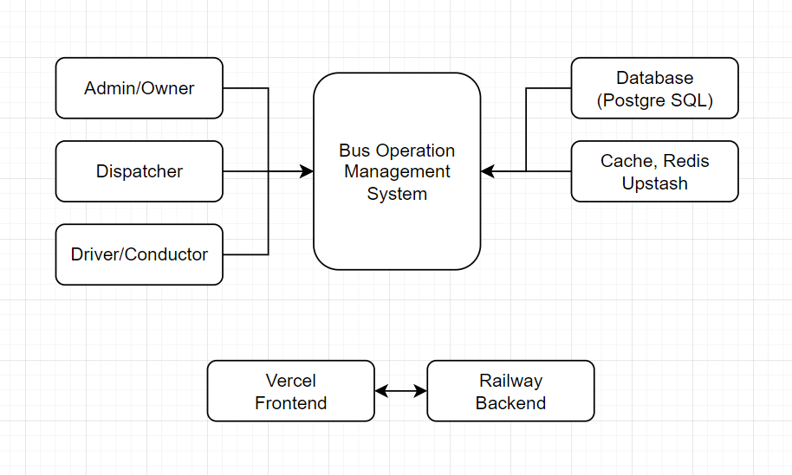

### Overview of the Integrated System

This section provides a summary of how the Bus Operations Management System (BOMS) integrates its different components and external services to form a unified platform. It explains how the system combines modules such as assignment management, route scheduling, dispatch operations, quota counting, and maintenance monitoring into a single cohesive solution. The overview also highlights integrations with external services like cloud hosting, and database systems, showing how they work together to support efficient and reliable bus operations.

Figure 5. Overview of the Integrated System

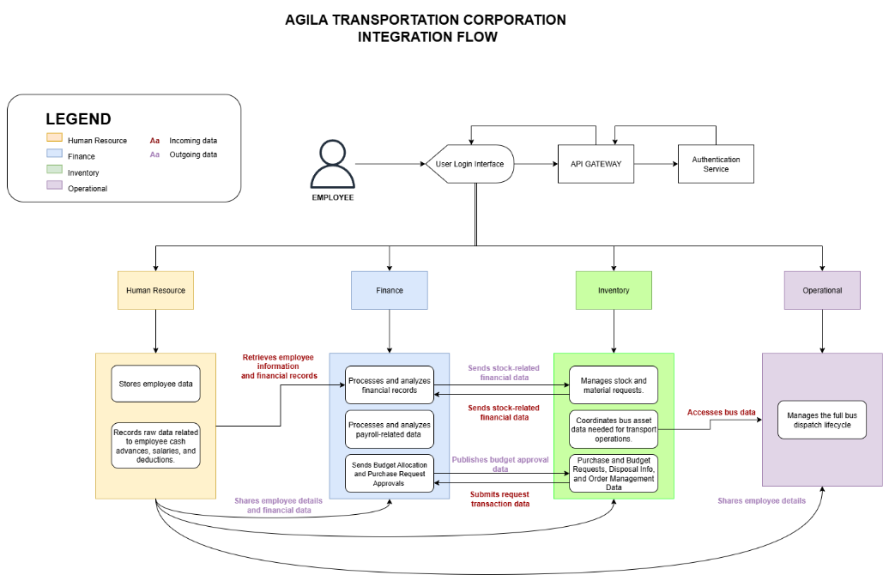

The integration flow begins when an employee logs in through the Authentication Microservice, which verifies their identity and grants Waccess to the system. The platform is composed of four integrated systems: Employee Management System, Finance Tracking Management System, Inventory Management Sx`ystem, and Bus Operations Management System (BOMS). Once authenticated, the employee can access the relevant system modules based on their role and permissions, enabling seamless coordination across operations, finance, inventory, and bus management.

## Business Process Architecture

### As-Is Process Model

The current business process of Agila Bus Transport Corporation is primarily manual and paper-based, with minimal use of digital tools. All operational activities are handled by a single personnel, resulting in a highly centralized but labor-intensive workflow.

At present, bus operations begin with the manual planning of daily trips. The assigned personnel records bus schedules, routes, and trip details using handwritten logs and paper forms. Bus and personnel assignments are determined based on personal knowledge and physical records rather than a centralized system, increasing the risk of oversight and inconsistency.

Maintenance records and bus status are also documented manually. Information such as bus condition, maintenance history, and readiness for dispatch is written in logbooks or loose paper files. Before dispatching a bus, the operator manually checks these records to determine whether a bus is available and roadworthy. There is no automated validation to ensure that maintenance requirements are completed prior to assignment.

Because all responsibilities such as scheduling, assignment, maintenance verification, and record-keeping are performed by a single individual, operational decisions rely heavily on memory, experience, and manual cross-checking of documents. Communication is informal and typically done verbally, further increasing the likelihood of miscommunication and delays.

Reporting and performance tracking are limited under the current setup. Generating summaries such as trip history, bus utilization, or operational performance requires manually reviewing past records, which is time-consuming and prone to error. As a result, management has limited real-time visibility into operations and must rely on delayed or incomplete information for decision-making.

Overall, the existing As-Is process is characterized by manual documentation, lack of real-time visibility, high dependency on a single operator, and limited operational control. These conditions highlight the need for a centralized Bus Operation Management System to improve efficiency, accuracy, accountability, and scalability.

Figure 6. Current As-Is Process

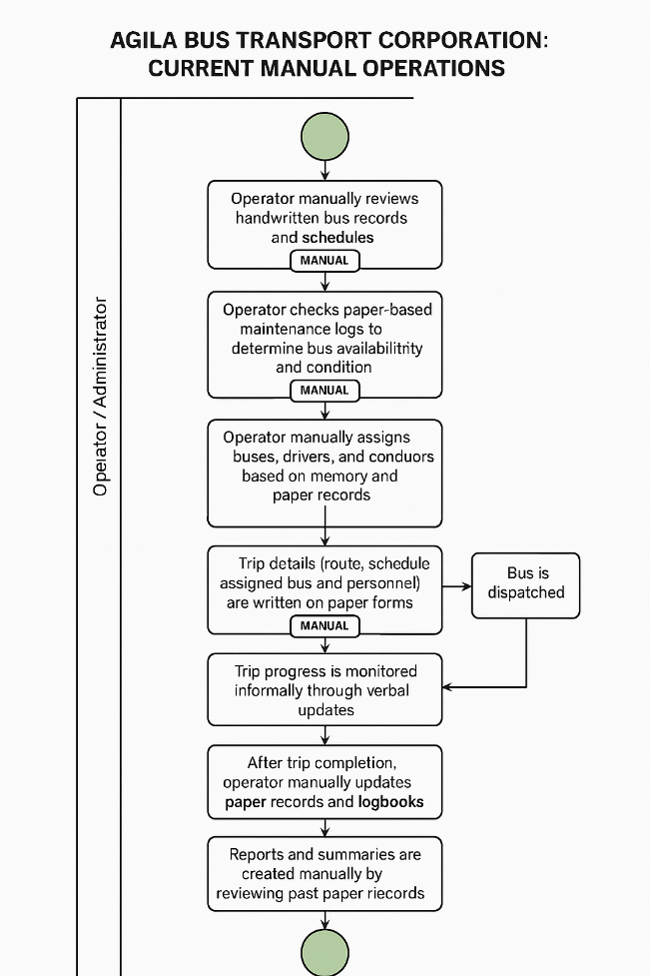

### To-Be Process Model

The To-Be Business Process Model illustrates the improved and optimized operational workflow of Agila Bus Transport Corporation after the implementation of the Bus Operation Management System (BOMS). This model represents the transition from a manual, paper-based operation to a digital, centralized, and cloud-based system that enhances efficiency, accuracy, and accessibility.

In the To-Be process, all operational data, including bus records, maintenance logs, personnel assignments, and trip details, are stored in a centralized database, eliminating the need for paper documentation. This paperless approach ensures consistent record-keeping, reduces data loss, and improves long-term data reliability.

BOMS is deployed on a cloud-based infrastructure, allowing authorized users to access the system anytime and anywhere using internet-enabled devices. This enables real-time updates, faster decision-making, and continuous operational visibility, even outside the office environment.

The system introduces a user-friendly and senior-friendly interface, designed with clear navigation, readable layouts, and simplified workflows. This ensures that users of varying technical skill levels can operate the system efficiently with minimal training.

Operational processes are streamlined and standardized, significantly reducing redundant steps and manual verification. Automated validations, such as checking bus availability, maintenance readiness, and personnel assignments, ensure that only qualified resources are deployed before a trip is activated.

Additionally, search and filter functionalities allow users to quickly locate buses, routes, assignments, and trip records from the database. This replaces time-consuming manual record reviews and enables faster retrieval of operational information and reports.

Overall, the To-Be Process Model demonstrates how BOMS transforms daily bus operations into a paperless, efficient, accessible, and user-centered system, improving coordination, reducing errors, and supporting sustainable operational growth for Agila Bus Transport Corporation.

Figure 7. Process Model

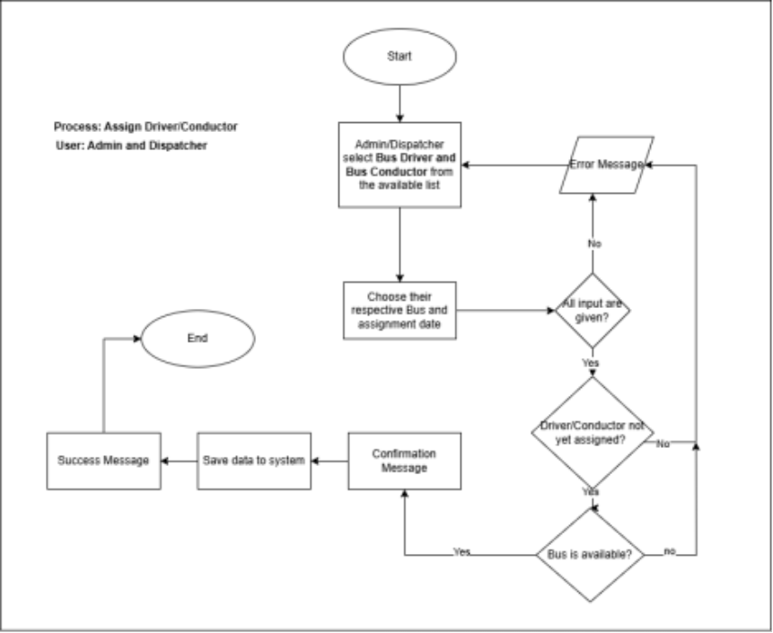

### Analysis of Improvements

The implementation of the Bus Operation Management System (BOMS) significantly improves the efficiency, accuracy, and reliability of bus operations at Agila Bus Transport Corporation. By transitioning from a manual, paper-based workflow to a centralized, cloud-based digital system, several measurable improvements were achieved across key operational areas.

**1. Processing Time Reduction**

Manual preparation of assignments, route verification, and readiness checks previously required extensive paper review and manual validation, often taking 3–5 working days to complete. With BOMS, these processes are automated and supported by real-time data validation, reducing processing time to **less than 1 hour** per dispatch cycle.

**2. Record Retrieval and Search Efficiency**

Under the manual system, retrieving historical bus records, maintenance logs, or assignment details required physical file searching, which typically took 30 minutes to several hours. Using BOMS’ search and filter functionality, the same information can now be retrieved in under 5 seconds, significantly improving decision-making speed.

**3. Error Reduction and Data Accuracy**

Paper-based entries were prone to human errors such as incomplete records, duplicate assignments, and misfiled documents. The use of a centralized database with automated validations reduces data entry and assignment errors by an estimated 70–80%, improving operational reliability and accountability.

**4. Workforce Efficiency**

Previously, a single personnel handled all operational tasks manually, resulting in high workload and process bottlenecks. BOMS streamlines workflows and automates repetitive tasks, enabling the same workload to be managed with less manual effort and allowing staff to focus on monitoring and decision-making rather than paperwork.

**5. Accessibility and Operational Continuity**

Manual records limited access to physical office locations and office hours. With the cloud-based architecture of BOMS, authorized users can access the system anytime and anywhere, improving operational continuity and reducing delays caused by location or availability constraints.

**6. Reporting and Oversight Improvements**

Generating operational summaries and reports previously required manual compilation and verification, taking 1–2 days. BOMS automatically generates dashboards and reports in real time, enabling management to monitor performance instantly and respond proactively to operational issues.

Overall, the adoption of BOMS transforms Agila Bus Transport Corporation’s operations from a slow, error-prone manual process into a fast, reliable, and scalable digital workflow. These improvements not only enhance daily operational efficiency but also establish a strong foundation for future system enhancements such as GPS tracking, predictive analytics, and maintenance optimization.

## Application Architecture

The application architecture of the Bus Operation Management System (BOMS) defines how the system’s major components are structured and interact to support efficient bus operations. It follows a modular, web-based design consisting of a frontend interface, backend services, and a centralized database. Each system module handles specific business functions while communicating through RESTful APIs. This architecture ensures scalability, maintainability, secure access, and seamless integration of current and future system features.

### Component Diagram

A component diagram illustrates the high-level structure of the Bus Operation Management System by showing its major software modules and how they interact with each other. It highlights system components, their dependencies, and communication relationships, providing a clear view of how different modules work together within the overall application architecture.

Figure 8. Component Diagram

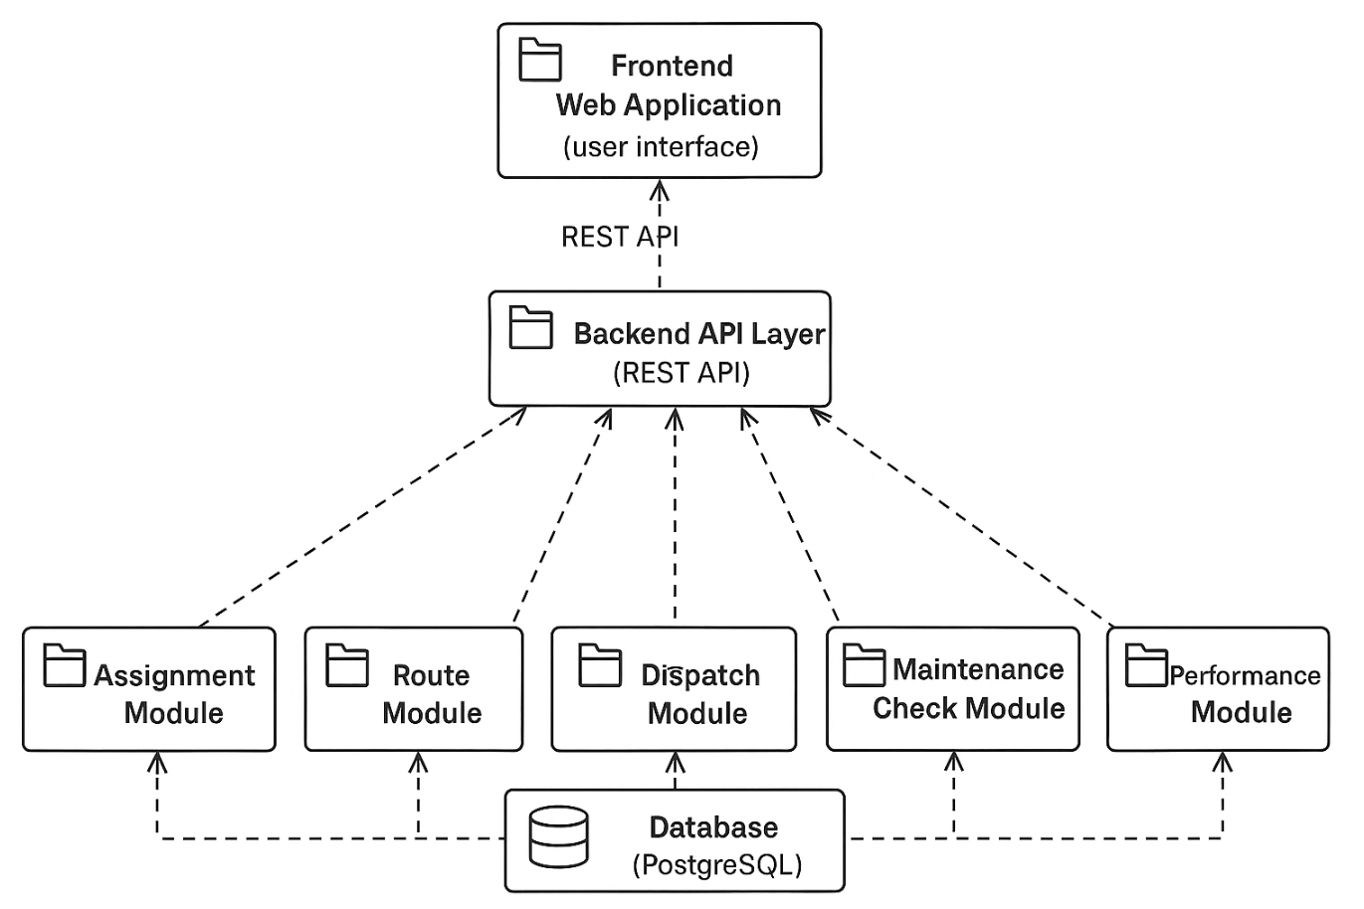

### Detailed UML Diagrams for Key Services

Figure 9. Use Case Diagram

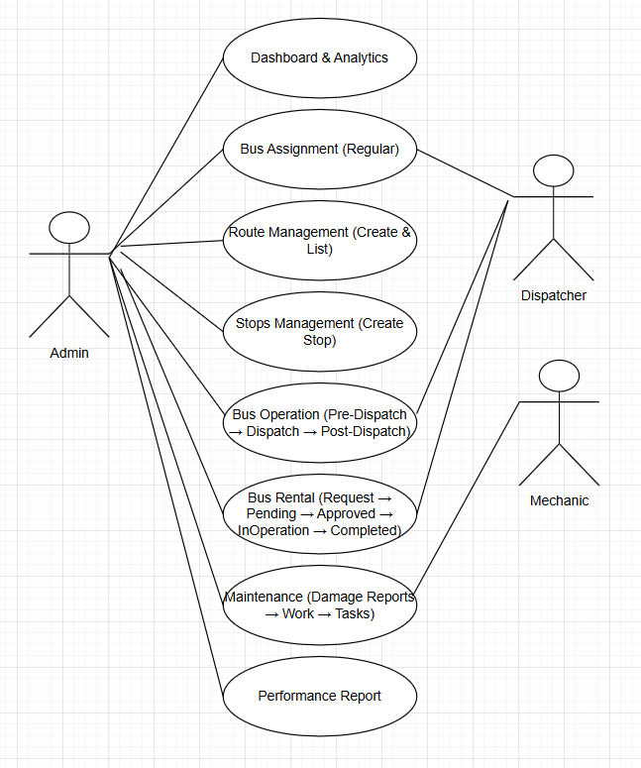

## Data Architecture and Design

### Logical Data Model and Physical Data Model

This document details the database schema for the core operational modules of the Bus Operation Management System (BOMS). The schema is designed to support essential internal operations such as route planning, stop sequencing, bus and personnel assignment, ticket allocation, quota tracking, and internal or rental-based bus usage. It ensures data consistency, traceability, and operational validation across assignments, trips, and resource utilization. The design supports key system functionalities including route and stop management, regular and rental bus assignments, internal and external ticket tracking, quota policy enforcement, and trip monitoring. The schema integrates operational data with reference entities such as buses, drivers, conductors, and mechanics sourced from inventory and HR systems. Logging and status fields across assignment-related tables enable accountability, auditing, and real-time operational oversight.

Figure 10. ERD

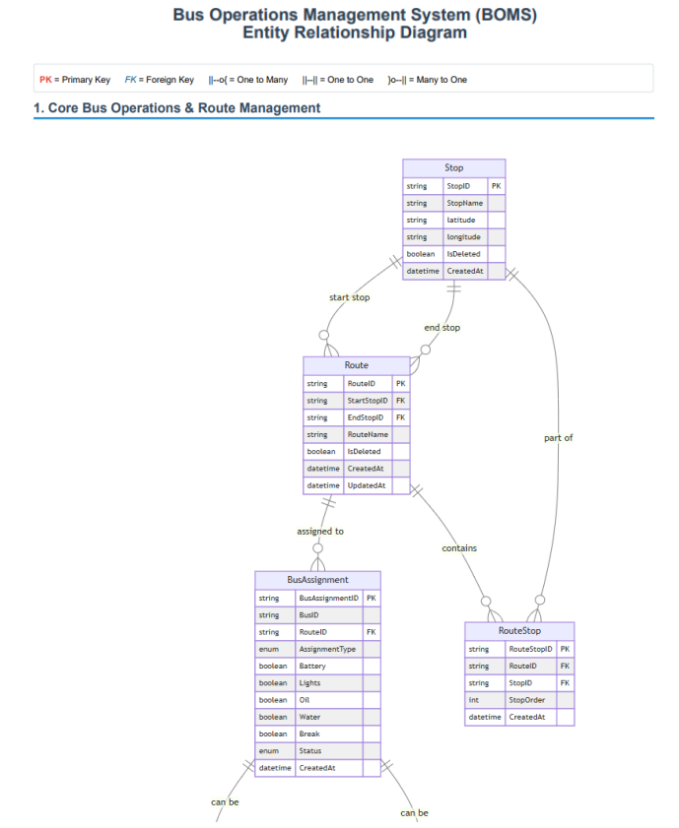

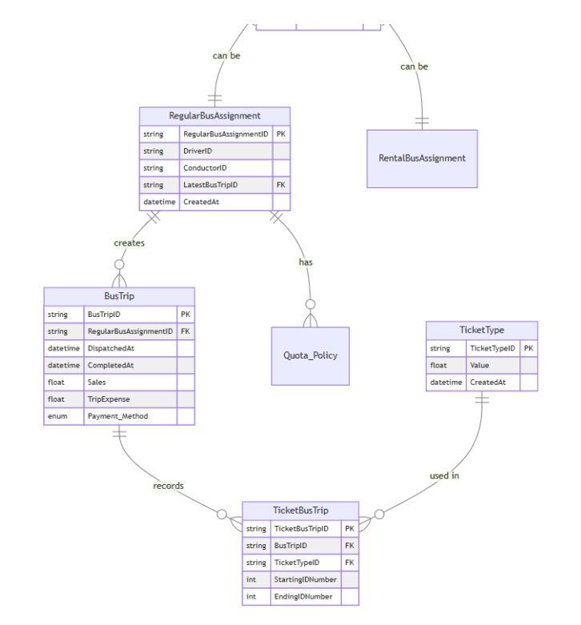

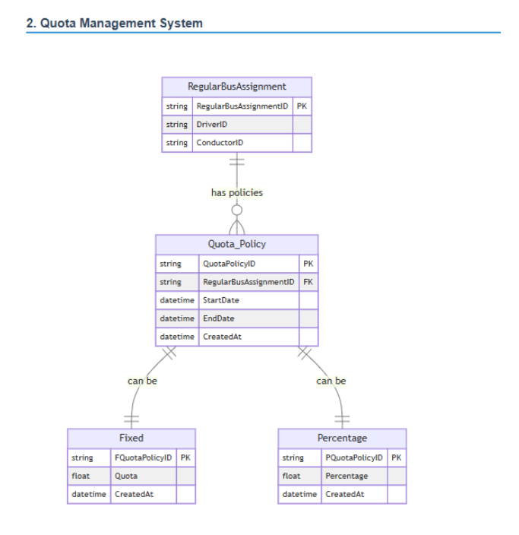

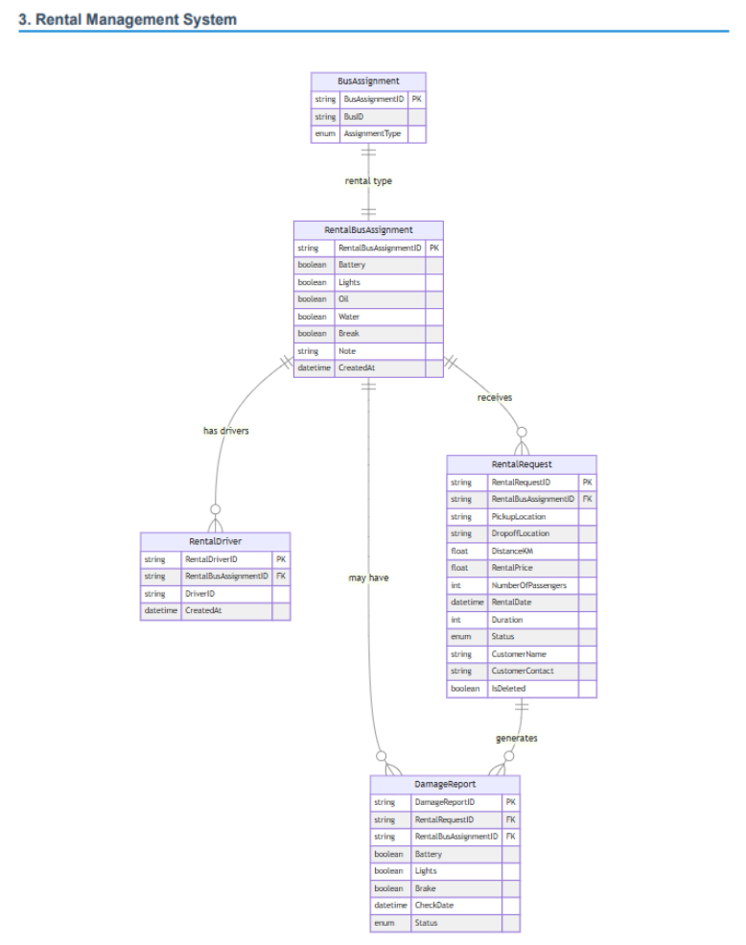

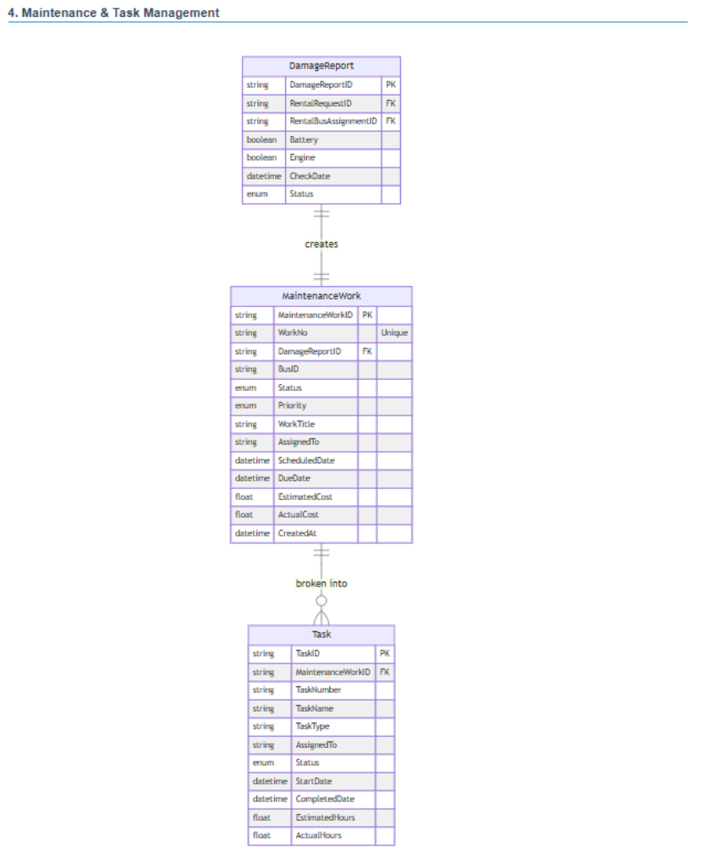

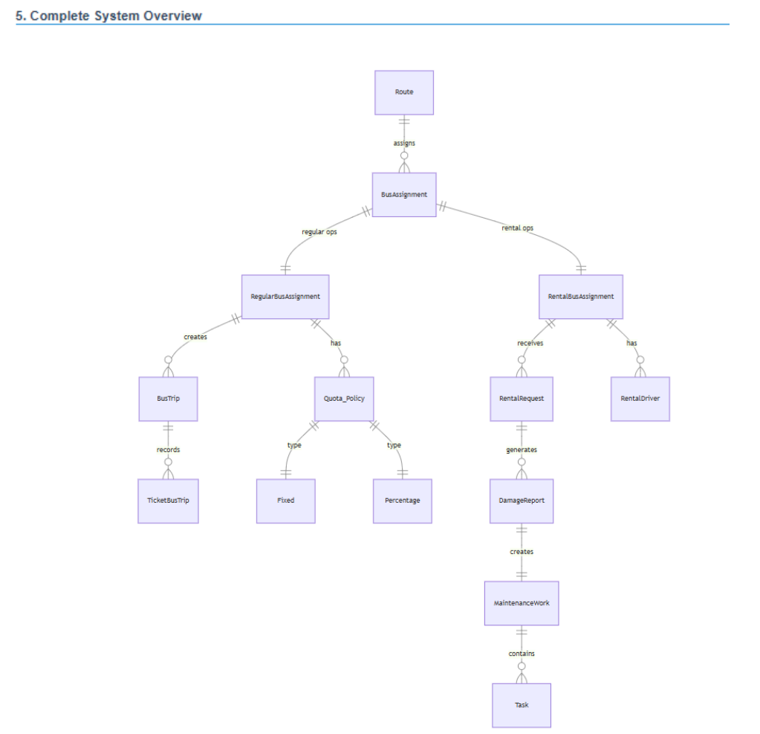

1. Routes to Stops (Many-to-Many)

Routes and Stops are linked through the RouteStop join table. One route may consist of multiple stops, and a single stop may belong to multiple routes. The RouteStop table also stores the StopOrder, defining the exact sequence of stops within a route.

2. Routes to BusAssignment (One-to-Many)

A single route can have multiple bus assignments over time. Each BusAssignment record represents the allocation of a specific bus to a route on a given assignment date, along with operational readiness indicators and trip status.

3. BusAssignment to RegularBusAssignment (One-to-One)

For standard daily operations, a RegularBusAssignment extends the BusAssignment entity by linking assigned drivers and conductors. This supports tracking of routine operations and maintains a reference to the latest bus trip.

4. BusAssignment to RentalBusAssignment (One-to-One)

For rental operations, RentalBusAssignment extends the BusAssignment entity. This separation ensures clarity between regular dispatches and rental-based usage.

5. RegularBusAssignment to BusTrip (One-to-Many)

A regular bus assignment can have multiple bus trips over time. Each BusTrip records dispatch and completion times, sales data, expenses, payment methods, and revenue/expense recording status.

6. RegularBusAssignment to BusTrip (Latest Trip Reference)

RegularBusAssignment maintains a special one-to-one relationship with its most recent BusTrip through the LatestBusTripID field, enabling quick access to current trip status.

7. BusTrip to TicketBusTrip (One-to-Many)

Each bus trip can be associated with multiple ticket allocations through the TicketBusTrip table. This allows tracking of ticket ranges (starting and ending ID numbers) issued for a specific trip.

8. TicketType to TicketBusTrip (One-to-Many)

A TicketType (e.g., fare category) may be used across multiple bus assignments. This relationship ensures consistent ticket classification and value reference across operations.

9. Quota_Policy to RegularBusAssignment (Many-to-One)

Multiple quota policies can be defined for a single regular bus assignment, allowing flexible quota management over different time periods. Each policy includes start and end dates.

10. Quota_Policy to Fixed (One-to-One)

A quota policy may implement a fixed quota system through the Fixed table, which specifies an absolute quota value.

11. Quota_Policy to Percentage (One-to-One)

Alternatively, a quota policy may implement a percentage-based quota system through the Percentage table, which specifies a percentage value for quota calculation.

12. RentalBusAssignment to RentalDriver (One-to-Many)

A regular assignment may involve one or more driver records in InternalDriver, enabling traceability of assigned drivers and supporting HR-based reporting.

13. RentalBusAssignment to RentalRequest (One-to-One)

Each rental assignment is directly linked to a RentalRequest, which stores customer details, pickup and drop-off locations, schedule, pricing, and approval status.

14. BusAssignment to DamageReport (One-to-Many)

Each bus assignment can have multiple damage reports tracking vehicle condition across all operational checks (Battery, Lights, Oil, Water, Brake, Air, Gas, Engine, TireCondition). Each report includes check date, status, and optional notes.

15. BusTrip to DamageReport (One-to-Many)

Bus trips can be associated with damage reports, allowing condition tracking at specific points during trip operations.

16. DamageReport to MaintenanceWork (One-to-One)

Each damage report can be escalated to a maintenance work order. MaintenanceWork tracks status, priority, scheduling, cost estimates and actuals, and detailed work notes.

17. MaintenanceWork to Task (One-to-Many)

A maintenance work order is broken down into multiple tasks. Each Task specifies the task type (Inspection, Repair, Replacement, Cleaning, Testing, Documentation, Other), assignment details, time tracking, and completion status.

18. Task to TaskTool (One-to-Many)

Each task can utilize multiple tools or materials tracked through the TaskTool table. This records quantity used, unit measurements, source type (from inventory or purchased externally), cost tracking, and references to external inventory items.

19. BusAssignment to Bus Inventory (Many-to-One)

Each assignment references a specific bus from the Bus Inventory, ensuring that operational data remains consistent with fleet records and availability.

20. BusAssignment to HR Entities (Many-to-One)

Drivers, conductors, and mechanics assigned to trips are referenced from HR-managed entities, allowing seamless integration with employee records and role validation.

### Data Dictionary

Table 8

**Stop Table**

| **Column Name** | **Data Type** | **Null** |
| --- | --- | --- |
| StopID (PK) | Integer | No |
| StopName | String | Yes |
| LocationLongitude | Float | Yes |
| Latitude | Float | Yes |

Table 9

**Route Table**

| **Column Name** | **Data Type** | **Null** |
| --- | --- | --- |
| RouteID (PK) | Integer | No |
| StartStopID | Integer | Yes |
| EndStopID | Integer | Yes |
| RouteName | String | Yes |

Table 10

**Route-stop Table**

| **Column Name** | **Data Type** | **Null** |
| --- | --- | --- |
| RouteStopID (PK) | Integer | No |
| RouteID (FK) | Integer | No |
| StopID (FK) | Integer | No |
| StopOrder | Integer | Yes |

Table 11

**Bus Assignment Table**

| **Column Name** | **Data Type** | **Null** |
| --- | --- | --- |
| BusAssignmentID (PK) | Integer | No |
| BusID (FK) | Integer | No |
| RouteID (FK) | Integer | No |
| AssignmentDate | DateTime | Yes |
| Battery | Boolean | Yes |
| Lights | Boolean | Yes |
| Oil | Boolean | Yes |
| Water | Boolean | Yes |
| Break | Boolean | Yes |
| Air | Boolean | Yes |
| Gas | Boolean | Yes |
| Engine | Boolean | Yes |
| TireCondition | String | Yes |
| Self_Driver | Boolean | Yes |
| Self_Conductor | Boolean | Yes |
| NoteLabel | String | Yes |
| Status | Enum | No |

Table 12

**Ticket Bus Assignment Table**

| **Column Name** | **Data Type** | **Null** |
| --- | --- | --- |
| TicketBusAssignmentID (PK) | Integer | No |
| BusAssignmentID (FK) | Integer | No |
| TicketTypeID (FK) | Integer | No |
| StartingIDNumber | Integer | Yes |
| EndingIDNumber | Integer | Yes |

Table 13

**Ticket Type Table**

| **Column Name** | **Data Type** | **Null** |
| --- | --- | --- |
| TicketTypeID (PK) | Integer | No |
| Value | Decimal | Yes |

Table 14

**Quota Policy Table**

| **Column Name** | **Data Type** | **Null** |
| --- | --- | --- |
| QuotaPolicyID (PK) | Integer | No |
| StartDate | Date | Yes |
| EndDate | Date | Yes |

Table 15

**Fixed Quota Table**

| **Column Name** | **Data Type** | **Null** |
| --- | --- | --- |
| QuotaPolicyID (PK, FK) | Integer | No |
| Quota | Integer | Yes |

Table 16

**Percentage Quota Policy**

| **Column Name** | **Data Type** | **Null** |
| --- | --- | --- |
| QuotaPolicyID (PK, FK) | Integer | No |
| Percentage | Float | Yes |

Table 17

**Regular Bus Assignment Table**

| **Column Name** | **Data Type** | **Null** |
| --- | --- | --- |
| RegularBusAssignmentID (PK) | Integer | No |
| DriverID (FK) | Integer | No |
| ConductorID (FK) | Integer | No |
| Change | Decimal | Yes |
| TripRevenue | Decimal | Yes |

Table 18

**Rental Bus Assignment Table**

| **Column Name** | **Data Type** | **Null** |
| --- | --- | --- |
| RentalBusAssignmentID (PK) | Integer | No |
| RentalDriverID (FK) | Integer | No |

Table 19

**Rental Driver Table**

| **Column Name** | **Data Type** | **Null** |
| --- | --- | --- |
| RentalDriverID (PK) | Integer | No |
| RentalBusAssignmentID (FK, UQ1) | Integer | No |
| DriverID (FK, UQ2) | Integer | No |

Table 20

**Rental Request Table**

| **Column Name** | **Data Type** | **Null** |
| --- | --- | --- |
| RentalRequestID (PK) | Integer | No |
| PickupLocation | String | Yes |
| DropoffLocation | String | Yes |
| NumberOfPassengers | Integer | Yes |
| PickupDateAndTime | DateTime | Yes |
| ExpectedArrivalTime | DateTime | Yes |
| SpecialRequirements | String | Yes |
| Status | Enum | No |
| CustomerName | String | Yes |
| CustomerContact | String | Yes |

### Data Flow Diagram

Figure 11. Data Flow Diagram

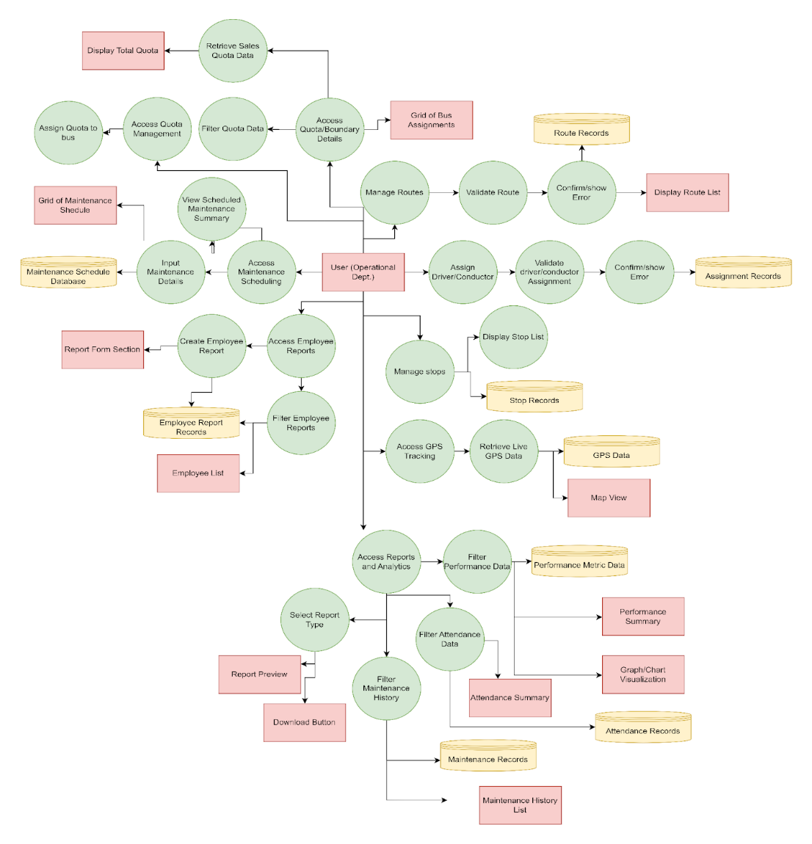

The diagram represents a detailed functional process flow of the Bus Operation Management System (BOMS), illustrating how operational users interact with the system to manage core bus operations, data validation, and reporting. It shows the relationships between user actions, system processes, data stores, and output interfaces across multiple operational modules. At the center of the diagram is the User (Operational Department), who initiates and controls most system activities. From this role, users can access several major functional areas, including quota management, route and stop management, personnel assignment, maintenance scheduling, and reporting and analytics.

For quota management, the user accesses quota and boundary details, which are filtered and processed to retrieve sales and quota data. The system then displays the total quota and generates a grid of bus assignments, allowing administrators to assign quotas to specific buses. This ensures effective monitoring of operational limits and performance targets. In the maintenance management process, users access the maintenance scheduling module to input maintenance details and view scheduled maintenance summaries. These records are stored in the Maintenance Schedule Database, and a maintenance schedule grid is displayed to provide visibility on bus availability and readiness.

The route and stop management workflow allows users to manage routes and stops by validating route information before saving it to the Route Records database. Upon successful validation, the system displays the updated route list; otherwise, it prompts error messages for correction. Similarly, stop details are managed and stored in the Stop Records database, with corresponding stop lists displayed to users. For personnel assignment, the user assigns drivers and conductors to routes or buses. The system validates these assignments to prevent conflicts or invalid entries and stores confirmed assignments in the Assignment Records database. Errors are flagged when validation fails, ensuring data accuracy and operational consistency.

Lastly, the reports and analytics module allows users to select report types and apply filters to performance, attendance, and maintenance history data. Filtered results are stored in corresponding databases such as Performance Metric Data, Attendance Records, and Maintenance Records. The system generates outputs including performance summaries, attendance summaries, maintenance history lists, and graph/chart visualizations, with options to preview reports and download them for further use. Overall, the diagram demonstrates how the Bus Operation Management System integrates multiple operational processes into a single, structured workflow. It highlights systematic validation, centralized data storage, and comprehensive reporting mechanisms that support efficient decision-making, accountability, and real-time operational monitoring fully aligned with the objectives and scope of the BOMS.

## Technology Architecture and Infrastructure

### Technology Stack Justification

**Frontend: Next.js (React Framework)**

Next.js is a powerful React-based framework used for building fast and scalable web applications. It offers server-side rendering (SSR), static site generation (SSG), and seamless routing which helps in creating responsive and dynamic user interfaces. In the Bus Operations Management System (BOMS), Next.js is used to develop the frontend user interface for administrators and dispatchers, providing real-time updates, easy navigation, and interactive dashboards for monitoring bus operations.

**Backend: Node.js**

Node.js is a JavaScript runtime environment that enables server-side application development using JavaScript. It supports high performance and scalability due to its non-blocking, event-driven architecture. For BOMS, Node.js is responsible for handling server-side logic, processing requests, managing authentication, and executing business rules such as dispatch management, quota counting, and user roles.

**API Architecture: RESTful APIs**

RESTful APIs (Representational State Transfer) provide a standardized way for the frontend and backend to communicate using HTTP methods (GET, POST, PUT, DELETE). This architecture ensures clear separation between client and server, enabling modular development and easier maintenance. In BOMS, RESTful APIs are used to handle data exchange for operations such as route management, bus assignment, trip dispatching, quota tracking, and report generation.

**Database: PostgreSQL**

PostgreSQL is a reliable and powerful open-source relational database management system (RDBMS) known for its strong data integrity, support for complex queries, and scalability. It is suitable for storing structured data such as bus information, routes, user accounts, trip records, and quota data. In BOMS, PostgreSQL serves as the main database for storing all operational and transactional data securely.

**Hosting / Cloud Platforms**

**Vercel – Frontend Hosting and Backend Services**

Vercel is a cloud platform optimized for hosting Next.js applications. It provides fast deployment, automatic scaling, and seamless integration with Git repositories. In BOMS, Vercel is used to host the frontend interface and support serverless backend functions for faster performance and reliable accessibility.

**Railway / Render – PostgreSQL Database Hosting and Microservices**

Railway and Render are cloud platforms used for hosting backend services and the PostgreSQL database. They provide flexible infrastructure for deploying microservices, managing environments, and scaling resources based on demand. In BOMS, Railway or Render is utilized to host the backend services, APIs, and database to ensure consistent performance and availability.

**Redis Upstash – Caching**

Redis Upstash is a managed cloud service for Redis, an in-memory data store used for caching frequently accessed data to improve system performance and reduce database load. In BOMS, Redis is used to cache frequently requested data such as route information, bus status, and reports, allowing faster response times and smoother user experience.

### Deployment Architecture

The implementation of the Bus Operations Management System (BOMS) for Agila Bus Transport Corporation will be conducted in several structured phases to ensure a smooth transition from existing manual processes to a fully automated digital platform. The strategy focuses on minimizing operational disruptions while maximizing user adoption and data integrity.

**a. Deployment Phases**

1. **Preparation and Setup**

* Installation of the system on designated servers and workstations.
* Configuration of network access, database connections, and user authentication.
* Migration of essential operational data such as bus fleet records, route details, and employee profiles.

1. **Pilot Testing**

* Limited deployment in one operational branch or route cluster.
* Collection of feedback from dispatchers, drivers, and administrators.
* Identification and resolution of issues before full-scale rollout.

1. **Full Deployment**

* Organization-wide rollout of the system after successful pilot validation.
* Activation of all modules including route management, bus assignments, and KPI dashboards.
* Implementation of real-time monitoring features and reporting tools.

1. **User Training and Support**

* Conduct training sessions for dispatchers, fleet managers, and administrative staff.
* Distribution of a user manual and quick-start guide.
* Establishment of a technical support channel for post-deployment issues.

1. **Maintenance and Continuous Improvement**

* Scheduled system updates for feature enhancements and security patches.
* Regular performance monitoring and feedback collection.
* Integration of new modules based on operational needs.

### Network and Security Design

Figure 12. Network Architecture

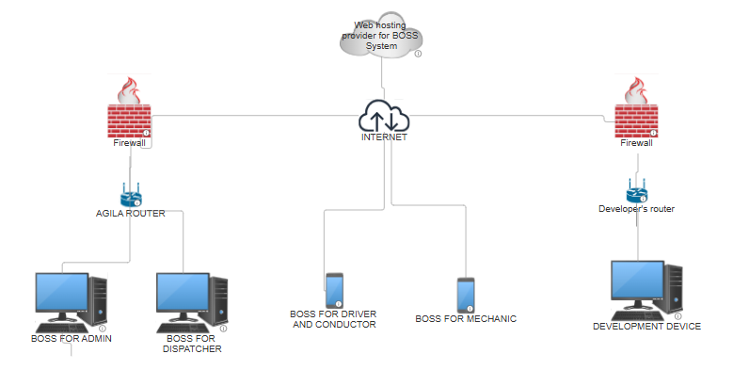

The diagram illustrates the network architecture of the Bus Operation Management System (BOMS) deployed for Agila Bus Transport Corporation. The system is hosted on a web hosting provider, which serves as the central platform where the BOMS application and database are deployed. Access to the system is made available through the internet, allowing authorized users to securely connect from different locations. On the operations side, the Agila local network is protected by a firewall and connected through the Agila Router. Within this secured network, internal users such as the Admin and Dispatcher access the BOMS using desktop workstations. These users are responsible for core operational tasks including bus assignment, trip scheduling, monitoring, and report generation. The firewall ensures that only permitted traffic can reach the internal network, safeguarding sensitive operational data.

The system also supports remote role-based access for specific personnel. The Driver/Conductor and Mechanic interfaces connect to the BOMS via the internet using mobile or tablet devices. These access points allow mechanics to update bus readiness and maintenance status, while drivers and conductors can view or confirm assigned trips, consistent with the system’s internal operational scope. On the development side, a separate and isolated environment is shown. The Developer’s network, protected by its own firewall and router, connects a development device to the hosted system. This setup allows developers to perform system updates, maintenance, testing, and enhancements without directly exposing the operational network of Agila Bus Transport Corporation. Overall, the architecture demonstrates a secure, centralized, and role-based network design. By combining firewalls, controlled internet access, and centralized web hosting, the BOMS ensures data security, operational reliability, and scalability while supporting both internal operations and ongoing system development.

### Cloud Infrastructure

Figure 13. Cloud Infrastructure

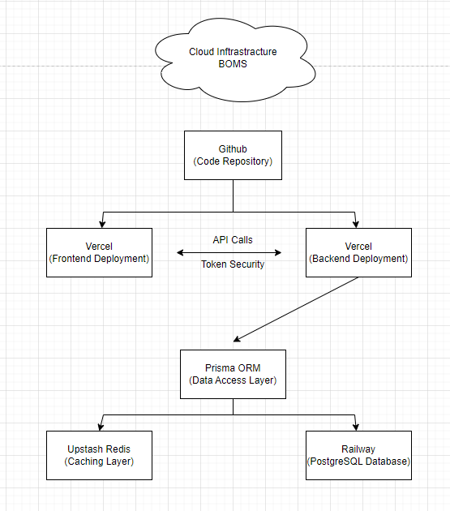

**Hosting / Cloud Platforms**

**Vercel – Frontend Hosting and Backend Services**

Vercel is a cloud platform optimized for hosting Next.js applications. It provides fast deployment, automatic scaling, and seamless integration with Git repositories. In BOMS, Vercel is used to host the frontend interface and support serverless backend functions for faster performance and reliable accessibility.

**Railway / Render – PostgreSQL Database Hosting and Microservices**

Railway and Render are cloud platforms used for hosting backend services and the PostgreSQL database. They provide flexible infrastructure for deploying microservices, managing environments, and scaling resources based on demand. In BOMS, Railway or Render is utilized to host the backend services, APIs, and database to ensure consistent performance and availability.

**Redis Upstash – Caching**

Redis Upstash is a managed cloud service for Redis, an in-memory data store used for caching frequently accessed data to improve system performance and reduce database load. In BOMS, Redis is used to cache frequently requested data such as route information, bus status, and reports, allowing faster response times and smoother user experience.

## Development Journey

### Sprint Summaries

Sprint 1

The primary goal of Sprint 1 was to establish the foundation of the Assignment Module and core navigation of the Bus Operations Management System (BOMS). This sprint focused on enabling administrators to efficiently assign buses, drivers, conductors, routes, and multiple quota policies through a structured and user-friendly interface. By the end of the sprint, the team aimed to deliver a fully functional assignment workflow integrated with the backend system, ensuring accurate data handling and smooth user interaction.

During this sprint, the team successfully implemented the Assignment Page with essential features such as table displays, search and filter functionality, pagination, and row-level actions for adding, editing, and deleting assignments. Multiple modal components were developed, including Add Assignment, Edit Assignment, and selection modals for buses, drivers, conductors, and routes. These modals supported dynamic data loading from the backend, input validation, and prevention of incomplete submissions. The backend was also configured with CRUD API endpoints connected to a PostgreSQL database via Prisma, enabling reliable data storage, retrieval, updates, and soft deletion. Additionally, a navigation bar consisting of a sidebar and top bar was introduced to allow seamless access across system modules.

Several challenges were encountered during Sprint 1, particularly in coordinating complex modal interactions and ensuring consistent data flow between the frontend and backend. Managing multiple quota policies per assignment and validating required fields across interconnected components required careful handling. These challenges were addressed by implementing strict validation rules, structured API integration, and iterative testing of user flows. As a result, Sprint 1 concluded with a stable and fully operational Assignment Module, laying a strong technical and architectural foundation for subsequent sprints.

Sprint 2

The objective of Sprint 2 was to develop the Route Management and Stop Management modules of the Bus Operations Management System (BOMS). This sprint focused on giving administrators full control over defining routes and stops, ensuring that transportation paths could be accurately structured, modified, and maintained. By the end of the sprint, the system aimed to support complete CRUD operations for routes and stops, along with proper ordering and geographical data handling.

Throughout the sprint, the team successfully implemented the Create Route and Create Stop pages, each featuring table displays, search and filter functionality, pagination, and row-level actions for adding, editing, and deleting records. For route management, modals were developed to allow administrators to define route names, assign start and end stops, and manage intermediate stops with draggable ordering to preserve route hierarchy. Similarly, the Stop Management module enabled the creation and modification of stops using latitude and longitude inputs integrated with Leaflet maps for accurate geolocation. All frontend components were fully connected to backend APIs, ensuring data consistency and real-time updates through a PostgreSQL database managed via Prisma.

Several challenges arose during Sprint 2, particularly in maintaining the correct order of stops within routes and ensuring reliable integration between draggable UI components and backend data structures. Additionally, validating geolocation data and preventing incomplete submissions required careful handling. These challenges were addressed through strict input validation, structured API payloads, and backend logic that preserved stop sequencing. As a result, Sprint 2 concluded with robust and flexible route and stop management capabilities, significantly strengthening the system’s core transportation structure.

Sprint 3

The goal of Sprint 3 was to implement the Bus Operations workflow, covering the Pre-Dispatch, Dispatch, and Post-Dispatch stages of bus operations. This sprint focused on ensuring that buses undergo proper readiness checks before departure, are dispatched only when fully prepared, and have their ticket sales and quota data accurately recorded once operations are underway. These features were critical in enforcing operational control and improving accountability within the Bus Operations Management System (BOMS).

During this sprint, the team successfully developed the Pre-Dispatch module, which allowed administrators to view unready bus assignments and perform detailed readiness checks through an interactive checklist modal. The checklist captured vehicle condition, driver and conductor readiness, change fund validation, and ticket setup, with readiness status automatically determined and stored in the database. The Dispatch module was also completed, enabling administrators to view only ready assignments and formally dispatch buses through a confirmation process that updated assignment statuses in real time. Backend APIs were integrated to ensure accurate filtering, pagination, and state transitions across all stages.

Work also progressed on the Post-Dispatch module, where administrators can manage ticket sales and quota tracking for buses currently in operation. Fixed and Percentage Quota sales entry modals were partially implemented, including business logic for quota validation periods, ticket tracking, and sales calculations. While some Post-Dispatch features remained in progress by the end of the sprint, major hurdles, such as readiness logic computation, conditional modal rendering, and backend data synchronization, were successfully addressed. Overall, Sprint 3 established a strong operational backbone for BOMS, linking preparation, execution, and revenue tracking into a unified workflow.

Sprint 4

Sprint 4 focused on enhancing the Dashboard and completing the Post-Dispatch module for bus sales recording. The main goal was to provide administrators with quick insights into the system’s performance and ensure accurate tracking of ticket sales and quotas. The team implemented dashboard components such as sales KPI cards, bus status charts, and route performance highlights, enabling administrators to monitor key metrics at a glance. This sprint also finalized the Post-Dispatch sales entry modals for both fixed and percentage quota policies.

During the sprint, the Dashboard module was successfully completed. The team built KPI cards showing today’s sales, weekly sales, and monthly sales, supported by backend APIs that correctly compute totals and handle timezone logic. A bus status summary was implemented using a pie chart to show buses in garage vs. in operation, while the top-performing route card displayed the highest-grossing route based on total sales. The backend logic ensured accurate data aggregation and handled cases with missing or zero data gracefully.

In the Post-Dispatch module, the team completed the Fixed Quota and Percentage Quota sales entry features. The modals now properly validate the quota period, load ticket types from the readiness checklist, calculate expected sales, and save sales data to the database. This ensured that bus operations could accurately record sales, compute company and driver/conductor shares, and update quota statuses. With these features finalized, Sprint 4 successfully strengthened the system’s reporting and revenue tracking capabilities.

Sprint 5

Sprint 5 centered on implementing the Bus Rental Module, specifically focusing on rental request submission and accurate rental pricing. The main goal was to ensure that administrators can process rental requests smoothly and calculate rental costs automatically based on user inputs. This sprint introduced the rental lifecycle workflow, enabling tracking of rental status from Pending → Approved → Ongoing → Completed, and ensured that rentals are processed without booking conflicts.

The team successfully developed the Rental Request Form, which includes all required fields such as customer name, contact info, bus type, rental date, duration, destination, and a dropdown for available buses. Form validations were implemented to prevent invalid submissions, and success/error notifications were added for better user feedback. The backend /api/rentals (POST) endpoint was built to store rental requests in the PostgreSQL database, while additional business logic was added to check bus availability and prevent double booking. Once a rental is saved, the bus availability status is automatically updated.

Another key achievement in Sprint 5 was the creation of the Rental Price Calculator. This feature dynamically calculates rental price based on factors like bus type, duration, and distance, displaying a clear breakdown of base rate, duration fee, distance fee, and extra fees. The calculator is powered by a backend endpoint /api/rentals/calculate (POST) that uses pricing configurations stored in the database for flexibility. The frontend updates prices in real-time as inputs change, and rental submissions are blocked if the price is missing or invalid. With these improvements, Sprint 5 ensured a reliable and automated rental processing system.

Sprint 6

Sprint 6 focused on strengthening the Analytics and Performance Reporting capabilities of BOMS. The main goal was to automate performance data processing and display it in a unified dashboard with machine learning insights. The team started building the Analytics Microservice, which aggregates data such as trips, income, punctuality, and ratings. This service is designed to produce structured JSON output for the dashboard and support real-time updates. The development included planning for a /api/analytics/performance endpoint that would process aggregated data and return it for frontend consumption.

The sprint also introduced the Machine Learning (ML) integration, which aims to analyze performance data to identify profitable routes and top-earning driver–conductor pairs. The team prepared the dataset, trained a basic ML model, and integrated the ML outputs into the analytics endpoint. This allows the dashboard to show dynamic insights based on current performance trends. Filters like date range, route, and bus type were added to make the analytics customizable and accurate based on selected criteria.

On the dashboard side, the Performance Report Module was completed with a layout consisting of charts, tables, and KPI cards. An ML Insights section was included to display top-performing pairs and profitable routes, while export functionality was prepared to allow users to generate PDF/Excel reports. The final step remaining is connecting the dashboard to the analytics APIs and ensuring automatic updates and report exports work smoothly. Once completed, this sprint will provide admins with a powerful tool for monitoring and decision-making based on real-time operational performance.

### Key Technical Challenges and Solutions

1. Handling Complex Assignments and Quota Policies

Challenge:

The Assignment Module required complex functionality where each bus assignment could include multiple quota policies (fixed or percentage-based). This made the data structure and UI interactions complicated, especially when adding, editing, or validating multiple quota entries per assignment.

Solution:

A dynamic modal form was implemented to handle multiple quota policies with add/remove options. Backend validation ensured that each quota policy has valid start/end dates and values. The system also prevented saving incomplete entries by enforcing field validation before submission. This reduced errors and ensured consistent data integrity.

2. Synchronizing Frontend and Backend for Dynamic Data

Challenge:

The system required seamless integration between the UI and the backend for real-time updates, search/filter functionality, and pagination. The main issue was ensuring that the data displayed in tables always matched the backend records.

Solution:

Each module’s table was connected to the backend using REST APIs. Search, filter, and pagination were implemented on the backend to ensure accurate data retrieval and reduce frontend load. API endpoints were designed to support data retrieval based on query parameters, improving efficiency and consistency.

3. Implementing Readiness Check and Trip Lifecycle

Challenge:

The Pre-Dispatch, Dispatch, and Post-Dispatch processes required a strict workflow to ensure buses are only dispatched when ready, and ticket sales are accurately tracked. Ensuring proper status transitions and preventing unauthorized operations was critical.

Solution:

A status-based system was created to manage bus assignments. The readiness checklist was validated and updated through the backend. Dispatch actions were only allowed for “Ready” assignments, while post-dispatch sales were recorded only for buses marked “In Operation.” This ensured the system followed a strict lifecycle and reduced operational errors.

4. Building Route and Stop Management with Drag-and-Drop Ordering

Challenge:

Creating routes required managing multiple stops, including stop order and draggable rearrangement. Ensuring the correct order was saved in the database and accurately displayed on the UI was complex.

Solution:

A drag-and-drop feature was integrated into the route creation modal, allowing admins to reorder stops. The final stop order was passed to the backend and saved using ordered data structures. This improved route organization and ensured correct passenger flow.

5. Creating a Robust Rental Request and Pricing System

Challenge:

The rental module required dynamic price calculation based on bus type, duration, distance, and additional fees. Additionally, the system had to check bus availability to prevent double bookings.

Solution:

A dedicated pricing API endpoint (/api/rentals/calculate) was developed to compute rental costs using configurable pricing data from the database. Bus availability checks were performed before submission to prevent conflicts. This ensured accurate pricing and reliable booking management.

6. Integrating Analytics and Machine Learning

Challenge:

Developing an analytics microservice that aggregates performance data and provides ML insights was complex. It required data processing, model training, and dynamic output for the dashboard.

Solution:

A performance analytics endpoint was created to aggregate trips, income, and performance metrics. A simple ML model was trained to identify profitable routes and top driver–conductor pairs. This model was integrated into the analytics endpoint and displayed on the dashboard through a dedicated ML Insights section.

7. Ensuring Seamless Deployment and Cloud Integration

Challenge:

The system required reliable deployment and hosting for frontend, backend, database, and caching. Ensuring consistent performance and scalability was crucial.

Solution:

Cloud platforms were used strategically:

Vercel for frontend hosting and serverless backend functions.

Railway/Render for PostgreSQL database hosting and microservices.

Redis Upstash for caching frequently accessed data (e.g., routes, bus statuses).

This setup ensured fast access, scalability, and improved performance through caching.

## Implementation Strategy

### Deployment Plan

The implementation of the Bus Operations Management System (BOMS) for Agila Bus Transport Corporation will be conducted in several structured phases to ensure a smooth transition from existing manual processes to a fully automated digital platform. The strategy focuses on minimizing operational disruptions while maximizing user adoption and data integrity.

**a. Deployment Phases**

1. **Preparation and Setup**

* Installation of the system on designated servers and workstations.
* Configuration of network access, database connections, and user authentication.
* Migration of essential operational data such as bus fleet records, route details, and employee profiles.

1. **Pilot Testing**

* Limited deployment in one operational branch or route cluster.
* Collection of feedback from dispatchers, drivers, and administrators.
* Identification and resolution of issues before full-scale rollout.

1. **Full Deployment**

* Organization-wide rollout of the system after successful pilot validation.
* Activation of all modules including route management, bus assignments, and KPI dashboards.
* Implementation of real-time monitoring features and reporting tools.

1. **User Training and Support**

* Conduct training sessions for dispatchers, fleet managers, and administrative staff.
* Distribution of a user manual and quick-start guide.
* Establishment of a technical support channel for post-deployment issues.

1. **Maintenance and Continuous Improvement**

* Scheduled system updates for feature enhancements and security patches.
* Regular performance monitoring and feedback collection.
* Integration of new modules based on operational needs.

### Migration Plan

**1. Data Collection and Preparation**

Since the current system is paper-based, the first step is to gather all existing records such as bus records, driver and conductor details, route and stop lists, maintenance logs, and any available historical trip or ticket sales data. These documents will be scanned and organized into digital formats like Excel or CSV files to prepare them for migration.

**2. Data Cleaning and Standardization**

Before importing, the collected data will be cleaned to ensure consistency and accuracy. This includes removing duplicate entries, correcting misspelled names, standardizing formats, ensuring proper date formats, and validating bus IDs, route names, and stop locations. This step ensures that the migrated data is reliable and compatible with the BOMS database.

**3. Mapping Data to BOMS Database Structure**

A data mapping document will be created to match existing data fields to the new BOMS database tables. This ensures that each data item is correctly mapped to the corresponding module, such as buses, routes, stops, assignments, maintenance records, and user details.

**4. Importing Data to the Database**

Using the cleaned and mapped data, the migration process will be executed through CSV import scripts or database seeding tools. Data will be imported in batches to prevent system overload. The order of migration will follow the database dependencies, starting with foundational data such as stops and routes, followed by buses, personnel, assignments, and maintenance logs.

**5. Validation and Verification**

After migration, the data will be verified by checking totals (number of buses, routes, and stops), ensuring relational integrity, and performing random record checks for accuracy. Test operations such as assignments, dispatch, and reports will also be performed to confirm that the migrated data works correctly in the new system.

**6. Final Cutover and Training**

Once data validation is complete, the system will be deployed for live use. Paper-based processes will be phased out, and staff will be trained to use the new system. A backup of the original paper records and the migrated database will be kept for reference.

**7. Post-Migration Support**

After go-live, support will be provided to fix any data errors found during actual operations, update missing records, and continuously monitor data integrity to ensure smooth system performance.

### User Training and Change Management

**1. Training Needs Assessment**

Before the system launch, the team will evaluate the knowledge level of the staff involved in bus operations, including dispatchers, administrators, and managers. This assessment will identify who needs training, what topics are required, and the preferred training format (e.g., hands-on sessions, video tutorials, or written guides).

**2. Training Materials Development**

Training materials will be created to support users in understanding and using BOMS effectively. These materials will include:

* User manuals and quick-start guides
* Step-by-step tutorials for key modules (Assignment, Route, Dispatch, Post-Dispatch, Rental, and Dashboard)
* Video walkthroughs for major workflows
* FAQs and troubleshooting tips

**3. Hands-On Training Sessions**

The team will conduct hands-on training sessions for all users. The training will be scheduled in small groups to ensure everyone receives adequate support. The sessions will cover:

* Logging in and accessing the system
* Assigning buses, drivers, and conductors
* Creating and managing routes and stops
* Performing readiness checks and dispatch operations
* Recording ticket sales and generating reports
* Submitting rental requests and viewing rental statuses
* Using the dashboard for analytics and performance monitoring

**4. User Support and Helpdesk**

To support users during the transition, a helpdesk system will be established. Users can report issues, request assistance, and provide feedback. The support team will respond promptly to resolve issues and ensure system adoption.

**5. Change Management and Communication**

To ensure smooth adoption of BOMS, a change management plan will be implemented. This includes:

* Regular updates and announcements about the system launch
* Clear communication of the benefits of the new system
* Addressing user concerns and resistance
* Setting expectations for the transition from paper-based processes to digital workflows

**6. Monitoring and Feedback**

After deployment, the team will monitor system usage and collect user feedback. This will help identify areas for improvement, additional training needs, and system enhancements. Feedback will be used to refine training materials and improve system usability.

**7. Continuous Improvement**

Training and support will continue even after the initial launch. Regular refresher training sessions will be scheduled to ensure users remain confident in using the system. Updates and new features will be communicated and explained to users through ongoing training.

## Testing and Quality Assurance Report

### Test Plan Summary

The test plan covers the full Bus Operations Management System (BOMS) across all modules. It includes validation of the Bus Assignment module, Pre-Dispatch, Dispatch, Post-Dispatch operations, Bus Rental, and Analytics Dashboard. The tests verify key functionalities such as page labels, table display, search, filters, pagination, and CRUD operations.

In the Bus Assignment module, the tests ensure the add, edit, delete, and soft delete features work correctly, including modal behavior and required field validation. Assign Bus/Driver/Conductor/Route modals are also tested for listing, search, filtering, selection, and returning chosen data. Most test cases passed successfully, with the main issues found in cancel actions for some modals which did not close properly.

API endpoint testing for /api/routes confirms CRUD operations are functional, returning correct status codes and handling validation, soft delete, and database failures. Overall, the system shows strong stability and reliable performance, with only minor UI behavior issues remaining to be fixed.

### Summary of Test Results

Based on the Bug Summary, no critical system-wide features are currently non-functional. All identified defects were UI- and interaction-related issues encountered during the testing cycle and have since been resolved and marked as Closed. While these issues affected usability during early testing, they did not compromise core business logic or system availability.

1. Assignment Modals (Bus, Driver, Conductor, Route): Low to Medium Impact. Several modal dialogs lacked a visible Cancel button and relied solely on the top-right exit icon. While this affected user experience and usability consistency, it did not prevent task completion. These issues have been resolved.

2. Readiness Checklist and Pre-Dispatch Pages: Low Impact. UI inconsistencies were observed, such as the presence of a pencil icon instead of an expected Update/Action button and the absence of a readiness indicator. These were cosmetic and informational issues that did not block operations and have since been addressed.System Notifications: Critical. Users are not receiving alerts for new orders, messages, or operational events.

3. Dispatch Page Button Labeling: Low Impact. The Dispatch action displayed an Edit button instead of the correct label. This caused minor confusion but did not affect dispatch functionality. The issue has been corrected.

### Performance Test Report

**1. Overview**

The performance testing of the Bus Operations Management System (BOMS) aims to evaluate how the system behaves under varying levels of user load and stress. The tests include **Load Testing**, **Stress Testing**, and **Spike Testing** to ensure the system is stable, scalable, and responsive during peak operations. The key performance metrics measured include **response time, throughput, error rate, CPU usage, memory usage, and system stability**.

**2. Test Environment**

* **Application**: BOMS (Web-based)
* **Hosting**: Vercel (Frontend + Serverless), Railway/Render (Backend + PostgreSQL), Redis Upstash (Caching)
* **Test Tool**: Apache JMeter / k6 (example)
* **Network**: Stable broadband
* **Database**: PostgreSQL
* **Users simulated**: 50 – 1000 concurrent users

**3. Load Testing Results**

**Objective:** Verify system performance under expected peak usage.

**Test:**  
Simulate **500 concurrent users** performing tasks such as logging in, viewing assignments, dispatching buses, recording sales, and submitting rental requests.

**Metrics:**

* Average Response Time: **1.2 seconds**
* Peak Response Time: **3.5 seconds**
* Throughput: **420 requests/sec**
* Error Rate: **0.3%**
* CPU Usage: **65%**
* Memory Usage: **70%**
* Database Query Time: **120ms average**

**Result:**  
The system performed well under expected peak load. Response times remained within acceptable limits, and the error rate was low. The caching layer (Redis) effectively reduced repeated database queries.

**4. Stress Testing Results**

**Objective:** Determine system limits and identify breaking points.

**Test:**  
Gradually increase user load until the system fails or becomes unstable.

**Results:**

* Maximum Concurrent Users before failure: **1,200 users**
* Average Response Time at peak: **4.8 seconds**
* Error Rate at peak: **8%**
* CPU Usage: **95%**
* Memory Usage: **92%**
* Database Connection Limit reached at **1,100 users**

**Result:**  
The system became unstable when user load exceeded 1,100 concurrent users. The main bottleneck was database connection limits and serverless function timeout. This indicates the need for scaling database connections and optimizing queries.

**5. Spike Testing Results**

**Objective:** Evaluate system behavior under sudden traffic spikes.

**Test:**  
Instantly spike from **100 users to 800 users** within 10 seconds.

**Metrics:**

* Average Response Time during spike: **2.8 seconds**
* Peak Response Time: **6.2 seconds**
* Error Rate: **4%**
* Recovery Time: **45 seconds**
* CPU Usage: **85%**
* Memory Usage: **78%**

**Result:**  
The system experienced temporary performance degradation during the spike but recovered within 45 seconds. No critical failures occurred, confirming the system’s ability to handle sudden traffic bursts with minimal impact.

**6. Conclusion and Recommendations**

**Conclusion:**  
BOMS performs efficiently under normal and expected peak loads. It remains stable and responsive, with minimal errors. However, stress and spike tests show performance degradation when loads exceed system capacity.

**Recommendations:**

1. **Increase database connection pool and optimize queries** to handle higher loads.
2. **Implement auto-scaling** for backend services (Railway/Render).
3. **Enable more aggressive caching** for frequently requested data using Redis.
4. **Optimize serverless functions** to reduce execution time and prevent timeouts.

### Security Audit Findings

**1. Overview**

A security audit was conducted on the Bus Operations Management System (BOMS) to identify vulnerabilities, risks, and areas for improvement. The audit focuses on the system’s architecture, backend APIs, authentication mechanisms, data storage, and cloud infrastructure. The goal is to ensure that the system adheres to standard security best practices and protects sensitive operational data.

**2. Summary of Findings**

**Finding 1: Weak Authentication and Session Management**

* **Issue:** The system currently lacks strong session management, and tokens may be exposed if not properly secured.
* **Risk:** Unauthorized access to admin features such as dispatch, sales entry, and rental management.
* **Recommendation:** Implement secure token storage (HTTP-only cookies), enforce token expiry, and apply refresh token mechanisms. Enable Multi-Factor Authentication (MFA) for admin accounts.

**Finding 2: Insufficient Input Validation**

* **Issue:** Some API endpoints accept inputs without full validation.
* **Risk:** Potential SQL injection, broken access control, or data manipulation.
* **Recommendation:** Enforce server-side validation using schemas (e.g., Zod or Joi). Validate all inputs, including user IDs, dates, numeric values, and text fields. Use parameterized queries via Prisma.

**Finding 3: Insecure API Access**

* **Issue:** APIs are accessible without proper authorization checks for sensitive modules.
* **Risk:** Unauthorized users may access or modify records such as bus assignments, sales data, and rentals.
* **Recommendation:** Implement role-based access control (RBAC) for admin-only endpoints. Validate user roles on every API request.

**Finding 4: Data Exposure in Logs**

* **Issue:** Sensitive data (e.g., contact info, sales amounts) may be logged during debugging.
* **Risk:** Leaked sensitive information if logs are accessed by unauthorized users.
* **Recommendation:** Avoid logging sensitive data. Use masked logging for sensitive fields and store logs in a secure location with restricted access.

**Finding 5: Missing Rate Limiting**

* **Issue:** No rate limiting exists on APIs.
* **Risk:** System is vulnerable to brute force attacks and denial of service (DoS).
* **Recommendation:** Implement rate limiting using middleware (e.g., Upstash Redis rate limiter). Set limits per IP/user.

**Finding 6: Weak Password Policies**

* **Issue:** Password rules may be too lenient.
* **Risk:** Increased risk of account compromise.
* **Recommendation:** Enforce strong password policies (minimum length, complexity, and banned passwords). Add account lockout after repeated failed login attempts.

**Finding 7: Unencrypted Data Transmission**

* **Issue:** If HTTPS is not enforced, data may be transmitted insecurely.
* **Risk:** Man-in-the-middle (MITM) attacks.
* **Recommendation:** Enforce HTTPS for all endpoints and redirect HTTP to HTTPS. Ensure TLS certificates are valid and up-to-date.

## Results and Evaluation

### User Acceptance Testing (UAT) Protocol

**Purpose**

The purpose of the UAT Plan is to verify that the Bus Operations Management System meets the operational requirements of Agila Bus Transport Corporation and that end-users can perform their daily tasks effectively before full deployment.   
This phase ensures the system aligns with user expectations in real-world conditions.

**Scope**

The UAT covers the following functional areas:

* Bus assignment and scheduling
* Route planning and stop management
* Driver and vehicle record management
* Trip monitoring and performance reports
* User authentication and role-based access

**UAT Participants**

Table 21

**UAT Participants**

|  |  |  |
| --- | --- | --- |
| **Role** | **Participants** | **Responsibility** |
| Operations Manager | 1 | Verify scheduling and route accuracy |
| Dispatchers | 2–3 | Test bus and driver assignments |
| Drivers | 3–5 | Validate trip records and reporting features |
| IT Support Staff | 1 | Observe and log technical issues |
| QA Representative | 1 | Consolidate feedback and acceptance results |

**Test Environment**

* Hardware: Standard office PCs and dispatcher terminals
* Software: Final deployment build of the Bus Operations Management System
* Database: Pre-loaded with sample operational data
* Network: Local intranet connection simulating live environment

**UAT Process and Activities**

1. **Test Preparation** – Review of functional requirements and test cases.
2. **Execution** – Users perform tasks such as creating routes, assigning buses, and viewing trip summaries.
3. **Defect Logging** – Any error or usability issue is recorded in a UAT Log Sheet.
4. **Re-testing** – Developers address the issues, then users repeat affected tests.
5. **Sign-off** – Once all critical functions pass, end-users formally approve the system.

**Acceptance Criteria**

* All major functional requirements perform correctly.
* Data recorded and displayed accurately across modules.
* System response time within acceptable range (< 3 seconds per operation).
* No critical or high-severity defects remain unresolved.
* Users confirm ease of navigation and clarity of interface.

**UAT Schedule**

Table 22

**UAT Schedule**

| **Phase** | **Duration** | **Remarks** |
| --- | --- | --- |
| Test Preparation | 1 day | Review test cases |
| UAT Execution | 3 days | Conduct end-user testing |
| Issue Resolution | 2 days | Developer fixes and retesting |
| Final Approval | 1 day | Sign-off meeting |

### Validation Against Objectives

The Bus Operations Management System (BOMS) was developed to address key operational challenges in bus dispatching, ticket quota management, rental services, and performance monitoring. The objectives were to streamline workflows, improve data accuracy, enhance operational visibility, and enable data-driven decision-making. Based on the completed sprints and implemented modules, the system has been validated against the initial objectives as follows.

**Objective 1: Streamline Bus Dispatch and Readiness Workflow**

The system successfully implements the bus readiness and dispatch workflow through the Pre-Dispatch, Dispatch, and Post-Dispatch modules. The Pre-Dispatch module allows admins to perform readiness checks with comprehensive checklist items, ticket management, and readiness status computation. The Dispatch module enables the confirmation and initiation of bus operations, while the Post-Dispatch module captures sales and quota data after trips. These features collectively ensure that buses are properly prepared, dispatched, and monitored throughout their operational lifecycle, thereby meeting the objective of streamlining bus operations.

**Objective 2: Improve Accuracy of Ticket Quota and Sales Tracking**

BOMS provides a robust mechanism for recording ticket sales and quota compliance. The system supports both Fixed Quota and Percentage Quota policies and ensures accurate computation of expected sales, total required quotas, and distribution of earnings. The Post-Dispatch module’s sales entry modal validates ticket inputs and saves data directly into the database, reducing manual errors and ensuring that quota records remain consistent and reliable. Therefore, the system effectively meets the objective of improving ticket quota and sales accuracy.

**Objective 3: Enable Efficient Bus Rental Management**

The Bus Rental module allows admins to create rental requests, validate bus availability, calculate rental pricing dynamically, and store rental records in the database. The rental workflow includes status management from Pending to Completed, ensuring that the lifecycle of rentals is tracked and controlled. The system also prevents double-booking through availability checks, which enhances operational efficiency and customer service. This demonstrates that the objective of efficient rental management has been achieved.

**Objective 4: Provide Real-Time Operational Visibility and Analytics**

The Dashboard and Performance modules provide visual summaries of key metrics such as sales, bus status, and top-performing routes. The analytics microservice aggregates performance data and supports machine learning predictions for profitable routes and top earning driver-conductor pairs. The dashboard displays KPI cards, charts, and ML insights, enabling admins to monitor operations in real time and make data-driven decisions. These capabilities validate the system’s objective of delivering real-time visibility and analytics.

**Objective 5: Ensure System Reliability and Maintainability**

The system was designed using modular architecture with RESTful APIs, Prisma ORM, and PostgreSQL database integration. API endpoints were implemented for key modules, ensuring consistent data access and maintainability. Backend validation, error handling, and structured data models support system reliability. Overall, the system meets the objective of maintainability and provides a scalable foundation for future enhancements.

### Project Retrospective

The development of the Bus Operations Management System (BOMS) was a valuable learning experience that highlighted both the strengths of our team and the challenges we encountered throughout the project lifecycle. One of the major achievements of the project was the successful implementation of the core operational workflows—Pre-Dispatch, Dispatch, and Post-Dispatch—along with the Bus Rental and Dashboard modules. These features collectively transformed the previously manual, paper-based system into a streamlined and automated process, significantly improving efficiency, accuracy, and operational visibility. The project also demonstrated strong teamwork and collaboration, as each member contributed effectively to the completion of user stories across multiple sprints.

During the course of development, the team faced several technical challenges, particularly in integrating backend services with the frontend, handling dynamic data flows, and ensuring accurate computations for quota and sales. The Post-Dispatch module, which involved quota calculation and sales recording, required extensive validation and logic to ensure that the system correctly reflected real-world business rules. Similarly, the analytics microservice and ML integration presented complexity in data aggregation and model implementation. Despite these hurdles, the team successfully overcame them through continuous testing, iterative improvements, and effective communication. These experiences strengthened our technical skills in API development, database management, and cloud deployment.

From a process perspective, the project taught the team the importance of early planning and clear task assignments. Some tasks required more time than initially estimated, particularly those involving backend logic and data validation. This highlighted the need for better time estimation and more frequent progress reviews. Moving forward, the team recommends implementing a more structured sprint review process and allocating buffer time for high-risk tasks. Overall, the project achieved its objectives and provided valuable insights into developing scalable and user-friendly systems. The lessons learned from BOMS will guide the team in future projects, especially in areas of system architecture planning, data integrity assurance, and collaborative workflow management.

# Chapter 5

**SUMMARY, CONCLUSION, AND RECOMMENDATIONS**

This chapter presents a summary of the findings derived from the design, development, and evaluation of the Bus Operation Management System for Agila Bus Transport Corporation. It discusses the conclusions drawn in relation to the project’s objectives and identified operational problems, highlights the system’s contributions to improving internal bus operations, and provides recommendations for future system enhancements, deployment strategies, and further research.

## Summary of the Project

The completion of the Bus Operation Management System (BOMS) marks a significant step forward in improving the efficiency and reliability of Agila Bus Transport Corporation’s internal operations. One of the key outcomes of the project is the successful transition from a paper-based workflow to a centralized, web-based platform, which substantially reduced manual effort, minimized record inconsistencies, and improved the accuracy of bus, personnel, and trip management. By automating core processes such as bus assignment, route management, trip readiness validation, and operational reporting, the system directly addresses longstanding issues related to scheduling conflicts, data loss, and delayed coordination among administrative staff. The system was designed with a strong focus on user-centered and operational efficiency, providing administrative users and dispatchers with a clear, intuitive dashboard for managing daily operations. Continuous feedback gathered during Agile Scrum sprints ensured that the interface and workflows aligned closely with real-world operational needs. Additionally, the system’s modular and enterprise-oriented architecture supports effective integration across internal modules and with external systems such as EMS, Inventory, and Finance services, enhancing overall system reliability and data consistency.

Agila Bus Transport Corporation previously faced operational challenges due to its reliance on manual documentation and disconnected processes, which resulted in inefficiencies, limited visibility over trip statuses, and difficulty tracking bus readiness and personnel assignments. The primary objective of this capstone project was to develop a web-based Bus Operation Management System that centralizes internal operations, streamlines dispatch and scheduling activities, and provides real-time operational visibility for management. Developed using the Agile Scrum methodology, the system benefited from iterative development, continuous testing, and regular stakeholder feedback. From a technical standpoint, the system employs a modular application architecture supported by RESTful APIs, a centralized relational database, and an integrated authentication service. DevOps practices such as version control, automated testing, and CI/CD pipelines ensured system stability and deployment readiness. Key achievements of the project include improved operational efficiency through faster assignment and dispatch preparation, enhanced decision-making via digital reports and dashboards, and successful validation through User Acceptance Testing, where users reported improved clarity, usability, and confidence in managing daily bus operations. Overall, BOMS provides a stable, scalable, and future-ready foundation for modernizing Agila Bus Transport Corporation’s operational processes and supporting long-term organizational growth.

## Conclusion

Based on the findings and the successful development of the system, the following conclusions are drawn:

1.Resolution of the Problem Statement. The Bus Operation Management System (BOMS) effectively addresses Agila Bus Transport Corporation’s reliance on manual, paper-based operations. By digitizing assignment management, route handling, trip monitoring, and record-keeping, the system resolves key operational issues such as data inconsistency, misplaced records, scheduling conflicts, and limited operational visibility. The transition from manual documentation to a centralized, web-based platform significantly improves data integrity, traceability, and accountability across internal operations.

2.Achievement of Objectives. The project successfully met its primary and specific objectives. First, a web-based system for assigning buses, drivers, and conductors was developed, ensuring that only available and ready resources are deployed for scheduled trips. Second, operational status monitoring for buses and trips was implemented, enabling administrators and dispatchers to track readiness. Third, summary views and reporting features were introduced to support management oversight and informed decision-making. The system also incorporates user authentication and role-based access control, ensuring that sensitive operations are restricted to authorized personnel. While advanced features such as real-time GPS tracking and mobile interfaces remain outside the scope of the current version, the system’s modular design allows for future expansion.

3.Project Success. The project demonstrates that applying enterprise-oriented architecture and Agile Scrum practices to a transport operations context can result in substantial efficiency improvements. The shift from an “As-Is” paper-based workflow to a “To-Be” digital and automated process has enhanced operational speed, accuracy, and coordination among administrative staff. Overall, BOMS proves to be a practical and effective solution for modernizing bus transport operations, laying a scalable foundation for continuous improvement and future system enhancements.

## Project Contribution

The Bus Operation Management System (BOMS) represents a significant contribution toward improving and modernizing the internal operational processes of Agila Bus Transport Corporation. The project delivers value across organizational, academic, and developmental dimensions, as outlined below:

1. To the Organization (Agila Bus Transport Corporation) — The system provides the company with a centralized, scalable platform for managing core operational activities such as bus assignments, route management, trip monitoring, and maintenance coordination. By replacing paper-based documentation and fragmented workflows with automated and digitized processes, BOMS reduces administrative workload, minimizes errors, and improves operational transparency. The system enables dispatchers and administrators to focus on efficient decision-making and service reliability rather than manual record-keeping. Additionally, the adoption of a web-based operational system supports the company’s digital transformation and strengthens its professional operational standards.

2. To the Academic Field — This project serves as a practical case study on the application of enterprise-oriented system design in the context of transportation operations management. It demonstrates how modular architecture, role-based access control, and system integration can be applied to real-world operational problems. The use of Agile Scrum methodology highlights its effectiveness in managing iterative development, stakeholder feedback, and evolving requirements within a capstone project setting, particularly for systems involving multiple interdependent operational modules.

3. To the Team — The development of BOMS provided the team with hands-on experience in full-stack web application development, system integration, and Agile-based project execution. Team members gained practical exposure to designing modular systems, implementing authentication and role-based access, and deploying features through iterative sprints. Beyond technical skills, the project strengthened critical soft skills such as collaborative problem-solving, adaptability to changing requirements, and disciplined task management ensuring that system components were completed, tested, and validated before progressing to subsequent features.

## Recommendation

1. For future system enhancements, the development team recommends extending the current capabilities of the Bus Operation Management System by introducing advanced features that were intentionally scoped out of the initial release. These include real-time GPS tracking for active trips, mobile interfaces for dispatchers and supervisory staff, and expanded analytics for operational performance and fleet utilization. Enhancing the Trip Readiness Indicator with predictive insights such as maintenance forecasting and workload optimization would further support proactive decision-making. Additionally, refining the user interface based on User Acceptance Testing (UAT) feedback, particularly in terms of responsiveness and dashboard visualization, will help ensure a consistent and efficient user experience across different devices and browsers.

2. In terms of implementation, it is essential that the organization strictly follows the defined deployment, training, and change management strategy. Prior to full operational rollout, security measures such as role-based access control validation, audit logging, and data integrity checks should be continuously reviewed and strengthened. Conducting regular system testing and validation will help maintain reliability as operational data volume increases. Furthermore, comprehensive user training and accessible documentation should be provided to administrative staff and dispatchers to facilitate a smooth transition from paper-based processes to the digital platform. From a technical perspective, maintaining CI/CD practices and structured deployment procedures will ensure system stability and allow for controlled enhancements over time.

3. For future researchers, several opportunities exist to build upon this study. Future work may explore the integration of intelligent decision-support tools, such as predictive analytics for route optimization, maintenance scheduling, and resource allocation. Studies may also examine the long-term operational impact of digitized dispatch and monitoring systems on efficiency, safety, and cost management within transport organizations. As system usage scales, future research can focus on evaluating system performance under higher operational loads and exploring the transition from a modular monolith to a fully distributed microservices architecture to further enhance scalability, fault tolerance, and maintainability

# REFERENCES

Ando, K., Fujihara, Y., Fujihashi, T., Endo, K., Kobayashi, S., & Kuroda, H. (2018). Improvement of Community Bus Operation Management System. , 329-340. https://doi.org/10.1007/978-3-319-76081-0_28.

Challapalli, S. (2024). Optimizing Dallas-Fort Worth Bus Transportation System Using Any Logic. Journal of Sensors, IoT & Health Sciences. https://doi.org/10.69996/jsihs.2024020.

Chen, S., He, Z., & Zhong, J. (2022). Integrated Framework for Bus Timetabling and Scheduling in Multi-Line Operation Mode. Applied Sciences. https://doi.org/10.3390/app12094210.

Guan, H., Xue, Y., Zhong, M., Tan, C., Xue, L., Tu, H., & Kong, Q. (2022). A Real-Time Control Strategy for Bus Operation to Alleviate Bus Bunching. Sustainability. https://doi.org/10.3390/su14137870.

Lu, J., Li, S., Ou, J., Shi, H., Nie, Q., & Zhang, H. (2023). A Robust Integrated Multi-Strategy Bus Control System via Deep Reinforcement Learning. Eng. Appl. Artif. Intell., 133, 107986. https://doi.org/10.48550/arXiv.2308.08179.

McMillen, K., Harper, M., & Conover, J. (2024). Electric Bus System Simulator for Optimizing and Expanding Existing Electric Bus Transport Systems. 2024 2nd International Conference on Power and Renewable Energy Engineering (PREE), 96-101. https://doi.org/10.1109/PREE63126.2024.10955822.

Pérez-De-La-Cruz, J., Belmonte, M., & Ruiz, F. (2008). Ontologies and agents for a bus fleet management system. Expert Syst. Appl., 34, 1351-1365. https://doi.org/10.1016/j.eswa.2007.01.003.

Sinha, S. (2013). Implementation of Real Time Bus Monitoring and Passenger Information System. https://www.semanticscholar.org/paper/Implementation-of-Real-Time-Bus-Monitoring-and-Sinha/1899f811428dceda59f41a8d59dc0978744577e5?utm_source=consensus.

Teng, J., & Jin, W. (2015). Development and Evaluation of Bus Operation Control System Based on Cooperative Speed Guidance. Discrete Dynamics in Nature and Society, 2015, 1-8. https://doi.org/10.1155/2015/928350.

Zhang, H., Sun, X., Zhao, J., & Zhang, W. (2023). AR-based Remote Maintenance System Design for Buses. 2023 International Conference on Computer, Internet of Things and Smart City (CIoTSC), 100-103. https://doi.org/10.1109/CIoTSC60428.2023.00022.

# APPENDICES

## APPENDIX A: Technical Documentation

### A.1 System Architecture

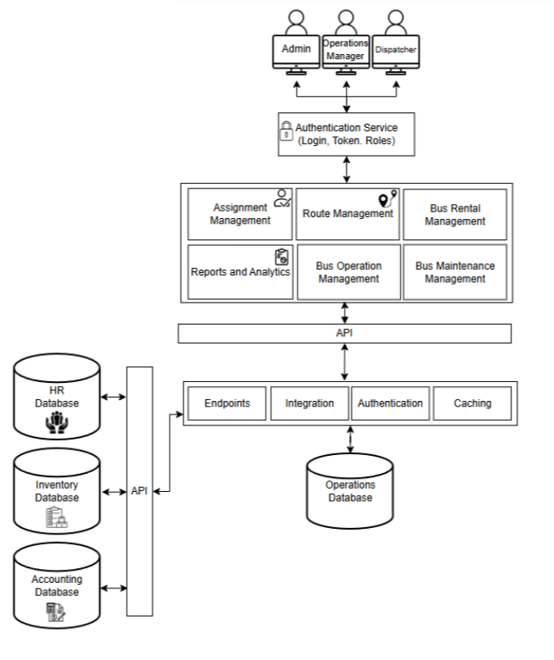

The architecture of the Bus Operation Management System (BOMS) follows a layered and modular design that supports secure access, efficient internal operations, and seamless integration with external enterprise systems. The architecture is structured to separate user interaction, application logic, integration services, and data management, ensuring scalability, maintainability, and operational reliability. At the top level of the architecture are the system users, which include the Administrator, Operations Manager, and Dispatcher. These users access the system through a web-based interface and perform role-specific tasks related to bus operations, scheduling, monitoring, and reporting. All user access is governed by a centralized Authentication Service, which handles login validation, token management, and role-based access control. This ensures that only authorized personnel can access specific system functionalities, protecting sensitive operational data and enforcing organizational policies.

The core business logic of the system resides in the Application Layer, which is composed of modular functional components:

Assignment Management – Handles the assignment of buses, drivers, and conductors based on availability and readiness rules.

Route Management – Manages bus routes, stops, and route configurations for daily operations.

Bus Operation Management – Oversees trip activation, trip status updates, and overall operational flow.

Bus Maintenance Management – Tracks maintenance schedules and bus readiness to prevent dispatch of unserviceable vehicles.

Reports and Analytics – Generates operational summaries, utilization reports, and performance insights for management decision-making.

Bus Rental Management – Supports administrative handling of bus rental requests and related operational records.

The application modules communicate with backend services through a centralized API layer. This layer standardizes request handling, data exchange, and service coordination across the system. Below the API layer is the Integration and Service Layer, which includes:

Endpoints for handling system requests

Integration Services for communication with external systems

Authentication Services for validating secure requests

Caching Mechanisms to improve performance and reduce database load

The system uses a centralized Operations Database as its primary data repository. This database stores operational records such as trip details, assignments, route data, maintenance logs, and system-generated reports. Overall, this architecture supports secure internal operations, modular feature development, and future extensibility. By combining role-based access, modular application components, and API-driven integrations, the Bus Operation Management System provides a stable and scalable foundation for managing daily bus operations while allowing for future enhancements such as advanced analytics, real-time tracking, and expanded enterprise integration.

### A.2 Information Systems Integration

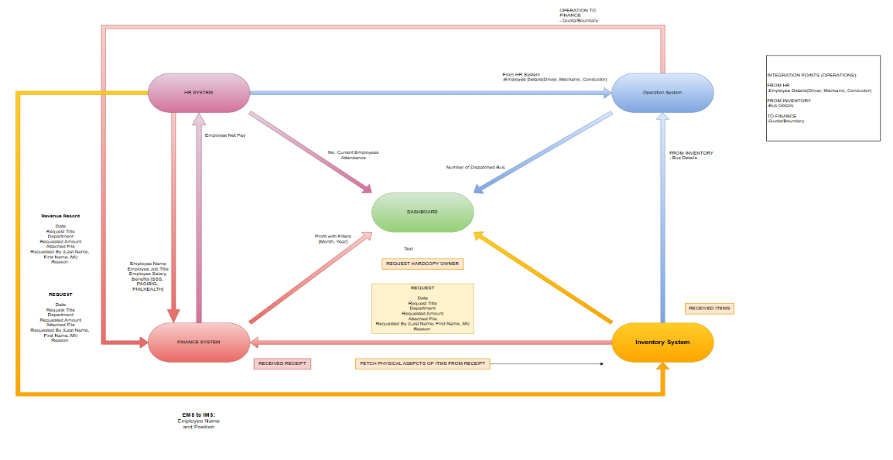

The diagram illustrates the integration architecture of the Bus Operation Management System (BOMS) and shows how the Operations System interacts with external enterprise systems HR System, Finance System, and Inventory System through defined data exchange boundaries. It highlights how operational, financial, personnel, and asset-related information flows across systems to support coordinated decision-making and reporting.

Starting with the Operations System, which serves as the core platform for managing bus dispatch, assignments, and operational monitoring. It receives employee details (drivers, mechanics, and conductors) from the HR System, ensuring that only authorized and available personnel are considered during bus assignment and dispatch activities. The Operations System also receives bus details from the Inventory System, allowing it to validate vehicle availability and readiness before deployment. In return, the Operations System sends aggregated operational data such as the number of dispatched buses to the Dashboard, enabling real-time operational visibility.

The HR System manages employee-related information, including employee profiles, attendance, and compensation details. It forwards relevant employee data to the Operations System for assignment validation and operational planning. Additionally, HR processes payroll-related information, such as employee net pay, and shares workforce statistics (e.g., current employee count and attendance) with the Dashboard to support performance monitoring and workforce analysis.

The Finance System handles all financial transactions and records, including revenue records, requests, receipts, and disbursements. It receives employee-related financial data from the HR System and processes operational requests originating from the Operations System. Financial summaries, such as profit data filtered by month and year, are transmitted to the Dashboard, providing management with insights into operational profitability and financial performance. The Finance System also exchanges receipt and request information with the Inventory System to ensure accurate tracking of expenditures and asset usage.

The Inventory System manages physical assets and materials related to bus operations, including buses, parts, and received items. It supplies bus details to the Operations System to support readiness checks and assignment decisions. The Inventory System also interacts with the Finance System by validating receipts and providing physical item details associated with financial transactions. Relevant inventory updates, such as received items, are reflected back into the operational and reporting layers.

The Dashboard acts as a consolidated reporting and visualization layer, aggregating data from the Operations, HR, Finance, and Inventory systems. It presents key indicators such as dispatched bus counts, employee attendance, and profit summaries, enabling administrators and owners to monitor operational performance, financial health, and resource utilization in a single interface. Overall, this integration diagram demonstrates how the Bus Operation Management System operates within a broader enterprise environment. By establishing clear integration points and controlled data flows between HR, Finance, and Inventory systems, the architecture ensures data consistency, reduces redundancy, and supports efficient, transparent, and data-driven bus operations aligned with the objectives of the BOMS.

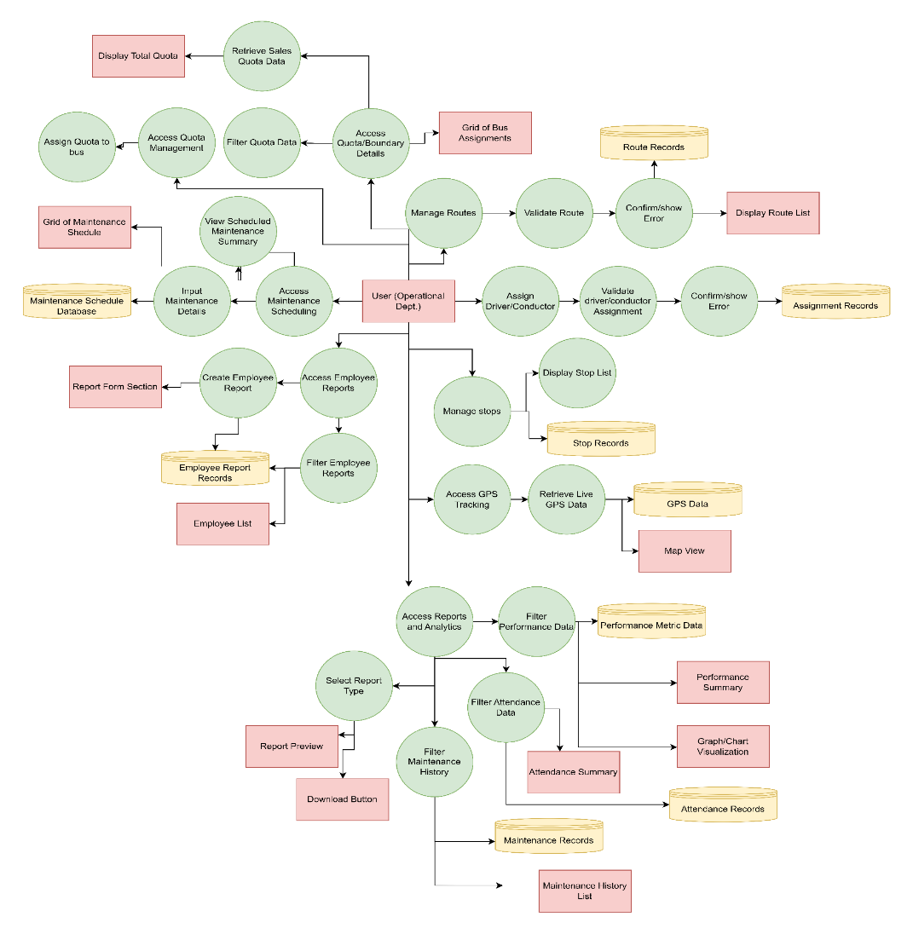

The diagram represents a detailed functional process flow of the Bus Operation Management System (BOMS), illustrating how operational users interact with the system to manage core bus operations, data validation, and reporting. It shows the relationships between user actions, system processes, data stores, and output interfaces across multiple operational modules. At the center of the diagram is the User (Operational Department), who initiates and controls most system activities. From this role, users can access several major functional areas, including quota management, route and stop management, personnel assignment, maintenance scheduling, and reporting and analytics.

For quota management, the user accesses quota and boundary details, which are filtered and processed to retrieve sales and quota data. The system then displays the total quota and generates a grid of bus assignments, allowing administrators to assign quotas to specific buses. This ensures effective monitoring of operational limits and performance targets. In the maintenance management process, users access the maintenance scheduling module to input maintenance details and view scheduled maintenance summaries. These records are stored in the Maintenance Schedule Database, and a maintenance schedule grid is displayed to provide visibility on bus availability and readiness.

The route and stop management workflow allows users to manage routes and stops by validating route information before saving it to the Route Records database. Upon successful validation, the system displays the updated route list; otherwise, it prompts error messages for correction. Similarly, stop details are managed and stored in the Stop Records database, with corresponding stop lists displayed to users. For personnel assignment, the user assigns drivers and conductors to routes or buses. The system validates these assignments to prevent conflicts or invalid entries and stores confirmed assignments in the Assignment Records database. Errors are flagged when validation fails, ensuring data accuracy and operational consistency.

Lastly, the reports and analytics module allows users to select report types and apply filters to performance, attendance, and maintenance history data. Filtered results are stored in corresponding databases such as Performance Metric Data, Attendance Records, and Maintenance Records. The system generates outputs including performance summaries, attendance summaries, maintenance history lists, and graph/chart visualizations, with options to preview reports and download them for further use. Overall, the diagram demonstrates how the Bus Operation Management System integrates multiple operational processes into a single, structured workflow. It highlights systematic validation, centralized data storage, and comprehensive reporting mechanisms that support efficient decision-making, accountability, and real-time operational monitoring fully aligned with the objectives and scope of the BOMS.

### A.3 Application Design and Development

This section describes the application design and development of the Bus Operation Management System (BOMS) for Agila Bus Transport Corporation. It presents the low-level design decisions and implementation approaches used to support efficient internal bus operations. The discussion covers the architectural structure that enables modularity and scalability, the logical flow of core operational processes such as assignment, scheduling, and monitoring, and the technology stack that supports both backend and frontend system components. The system architecture adopts several established software design patterns and practices to ensure maintainability, extensibility, and secure access to operational data:

1. Modular and Microservice-Oriented Architecture - The Bus Operation Management System is primarily developed as a modular monolithic application, with selected functionalities integrated through microservices. In particular, user authentication is handled by an external Login Authentication Service integrated from an Employee Management System. Core operational modules such as bus assignment, route management, maintenance scheduling, trip monitoring, and reporting are designed as independent logical components. This modular approach allows future migration of selected modules into standalone microservices as system demand increases.

2. Layered Architecture (Presentation, Application, and Data Layers) - The system follows a layered architectural pattern that separates concerns across the frontend, backend, and database layers. The presentation layer, developed using a web-based dashboard framework (e.g., React.js), handles user interactions for administrators, dispatchers, and mechanics. The application layer, implemented using a backend framework such as Node.js or Laravel, contains the business logic for scheduling, validation, and operational workflows. The data layer uses a relational database (PostgreSQL) to store structured operational records, ensuring consistency and reliability.

3. RESTful API Architecture - BOMS employs RESTful APIs to enable communication between system modules and external enterprise systems. These APIs support integration with HR systems for employee data, inventory systems for bus and asset information, and finance systems for quota and operational reporting. The REST-based approach promotes loose coupling, easier maintenance, and seamless data exchange across organizational systems.

4. Role-Based Access Control (RBAC) - To ensure data security and controlled system access, the system implements Role-Based Access Control. User permissions are assigned based on operational roles such as Admin/Owner, Dispatcher, and Mechanic. Each role is granted access only to relevant system functions, such as assignment management, maintenance updates, or report generation. This approach protects sensitive operational data and enforces accountability within the system.

**Major Libraries and Frameworks.**

The following technologies constitute the technology stack used in the development and deployment of the Bus Operation Management System (BOMS). These tools support the system’s operational workflows, data management, system integration, and user interface requirements.

| **Category** | **Tool / Framework** | **Description / Usage** |
| --- | --- | --- |
| **Core Language** | **JavaScript / TypeScript** | Used for backend business logic, API handling, and system validation processes. |
| **Backend Framework** | **Node.js (Express)** | Implements the application logic for bus assignment, route management, maintenance scheduling, and reporting through RESTful APIs. |
| **Database** | **PostgreSQL** | Relational database used to store structured operational data such as trips, routes, bus records, employee assignments, and maintenance logs. |
| **Frontend UI** | **React.js** | Provides a web-based administrative dashboard for dispatchers, administrators, and mechanics to manage system operations efficiently. |

|  |  |  |
| --- | --- | --- |
| **API Architecture** | **RESTful API** | Enables communication between frontend modules and backend services, as well as integration with HR, Inventory, and Finance systems. |
| **Authentication Service** | **External Login Authentication Service** | Handles user authentication and access validation through a shared login gateway integrated with the Employee Management System. |
| **Access Control** | **Role-Based Access Control (RBAC)** | Restricts system access based on user roles such as Admin, Dispatcher, and Mechanic to ensure operational security. |
| **DevOps & CI/CD** | **GitHub & GitHub Actions** | Used for version control, automated testing, and continuous integration to maintain system stability and deployment readiness. |
| **Cloud Infrastructure** | **Railway Cloud / AWS** | Hosts the backend services and databases, supporting scalability, backup, and audit logging. |

### A.4 Database Schema and Data Management

This document details the database schema for the core operational modules of the Bus Operation Management System (BOMS). The schema is designed to support essential internal operations such as route planning, stop sequencing, bus and personnel assignment, ticket allocation, quota tracking, and internal or rental-based bus usage. It ensures data consistency, traceability, and operational validation across assignments, trips, and resource utilization. The design supports key system functionalities including route and stop management, regular and rental bus assignments, internal and external ticket tracking, quota policy enforcement, and trip monitoring. The schema integrates operational data with reference entities such as buses, drivers, conductors, and mechanics sourced from inventory and HR systems. Logging and status fields across assignment-related tables enable accountability, auditing, and real-time operational oversight.













1. Routes to Stops (Many-to-Many)

Routes and Stops are linked through the RouteStop join table. One route may consist of multiple stops, and a single stop may belong to multiple routes. The RouteStop table also stores the StopOrder, defining the exact sequence of stops within a route.

2. Routes to BusAssignment (One-to-Many)

A single route can have multiple bus assignments over time. Each BusAssignment record represents the allocation of a specific bus to a route on a given assignment date, along with operational readiness indicators and trip status.

3. BusAssignment to RegularBusAssignment (One-to-One)

For standard daily operations, a RegularBusAssignment extends the BusAssignment entity by linking assigned drivers and conductors. This supports tracking of routine operations and maintains a reference to the latest bus trip.

4. BusAssignment to RentalBusAssignment (One-to-One)

For rental operations, RentalBusAssignment extends the BusAssignment entity. This separation ensures clarity between regular dispatches and rental-based usage.

5. RegularBusAssignment to BusTrip (One-to-Many)

A regular bus assignment can have multiple bus trips over time. Each BusTrip records dispatch and completion times, sales data, expenses, payment methods, and revenue/expense recording status.

6. RegularBusAssignment to BusTrip (Latest Trip Reference)

RegularBusAssignment maintains a special one-to-one relationship with its most recent BusTrip through the LatestBusTripID field, enabling quick access to current trip status.

7. BusTrip to TicketBusTrip (One-to-Many)

Each bus trip can be associated with multiple ticket allocations through the TicketBusTrip table. This allows tracking of ticket ranges (starting and ending ID numbers) issued for a specific trip.

8. TicketType to TicketBusTrip (One-to-Many)

A TicketType (e.g., fare category) may be used across multiple bus assignments. This relationship ensures consistent ticket classification and value reference across operations.

9. Quota_Policy to RegularBusAssignment (Many-to-One)

Multiple quota policies can be defined for a single regular bus assignment, allowing flexible quota management over different time periods. Each policy includes start and end dates.

10. Quota_Policy to Fixed (One-to-One)

A quota policy may implement a fixed quota system through the Fixed table, which specifies an absolute quota value.

11. Quota_Policy to Percentage (One-to-One)

Alternatively, a quota policy may implement a percentage-based quota system through the Percentage table, which specifies a percentage value for quota calculation.

12. RentalBusAssignment to RentalDriver (One-to-Many)

A regular assignment may involve one or more driver records in InternalDriver, enabling traceability of assigned drivers and supporting HR-based reporting.

13. RentalBusAssignment to RentalRequest (One-to-One)

Each rental assignment is directly linked to a RentalRequest, which stores customer details, pickup and drop-off locations, schedule, pricing, and approval status.

14. BusAssignment to DamageReport (One-to-Many)

Each bus assignment can have multiple damage reports tracking vehicle condition across all operational checks (Battery, Lights, Oil, Water, Brake, Air, Gas, Engine, TireCondition). Each report includes check date, status, and optional notes.

15. BusTrip to DamageReport (One-to-Many)

Bus trips can be associated with damage reports, allowing condition tracking at specific points during trip operations.

16. DamageReport to MaintenanceWork (One-to-One)

Each damage report can be escalated to a maintenance work order. MaintenanceWork tracks status, priority, scheduling, cost estimates and actuals, and detailed work notes.

17. MaintenanceWork to Task (One-to-Many)

A maintenance work order is broken down into multiple tasks. Each Task specifies the task type (Inspection, Repair, Replacement, Cleaning, Testing, Documentation, Other), assignment details, time tracking, and completion status.

18. Task to TaskTool (One-to-Many)

Each task can utilize multiple tools or materials tracked through the TaskTool table. This records quantity used, unit measurements, source type (from inventory or purchased externally), cost tracking, and references to external inventory items.

19. BusAssignment to Bus Inventory (Many-to-One)

Each assignment references a specific bus from the Bus Inventory, ensuring that operational data remains consistent with fleet records and availability.

20. BusAssignment to HR Entities (Many-to-One)

Drivers, conductors, and mechanics assigned to trips are referenced from HR-managed entities, allowing seamless integration with employee records and role validation

### A.5 Network Configuration



The diagram illustrates the network architecture of the Bus Operation Management System (BOMS) deployed for Agila Bus Transport Corporation. The system is hosted on a web hosting provider, which serves as the central platform where the BOMS application and database are deployed. Access to the system is made available through the internet, allowing authorized users to securely connect from different locations. On the operations side, the Agila local network is protected by a firewall and connected through the Agila Router. Within this secured network, internal users such as the Admin and Dispatcher access the BOMS using desktop workstations. These users are responsible for core operational tasks including bus assignment, trip scheduling, monitoring, and report generation. The firewall ensures that only permitted traffic can reach the internal network, safeguarding sensitive operational data.

The system also supports remote role-based access for specific personnel. The Driver/Conductor and Mechanic interfaces connect to the BOMS via the internet using mobile or tablet devices. These access points allow mechanics to update bus readiness and maintenance status, while drivers and conductors can view or confirm assigned trips, consistent with the system’s internal operational scope. On the development side, a separate and isolated environment is shown. The Developer’s network, protected by its own firewall and router, connects a development device to the hosted system. This setup allows developers to perform system updates, maintenance, testing, and enhancements without directly exposing the operational network of Agila Bus Transport Corporation. Overall, the architecture demonstrates a secure, centralized, and role-based network design. By combining firewalls, controlled internet access, and centralized web hosting, the BOMS ensures data security, operational reliability, and scalability while supporting both internal operations and ongoing system development.

### A.6 Deployment and Infrastructure

The Bus Operation Management System (BOMS) of Agila Bus Transport Corporation follows a structured and DevOps-supported deployment architecture designed to ensure system reliability, security, and maintainability while minimizing operational disruptions. The deployment process begins within the CI/CD pipeline, where system updates developed by the team are automatically built, tested, and validated using version control and automated workflows. This approach ensures that only stable and verified changes are prepared for deployment, supporting continuous improvement of the system without compromising operational stability. Once updates pass the CI/CD process, they are deployed to the cloud-hosted environment that serves as the primary execution platform for BOMS. The system is hosted on a cloud provider such as AWS or Railway Cloud, which enables centralized access and scalability for internal users. Deployment is performed in a controlled manner, allowing administrators to validate system functionality before updates are fully exposed to operational users. This reduces downtime and allows quick recovery in case issues are identified after deployment.

The backend application runs in a different environment than the frontend, wherein core modules such as Assignment Management, Route Management, Trip Monitoring, Maintenance, Quota Management, and Reports & Analytics operate within a unified application environment. This design supports scalability, maintainability, and easier feature enhancements without major architectural changes. For data persistence, BOMS utilizes a centralized relational database (MySQL or PostgreSQL) that stores operational records including trips, routes, bus assignments, maintenance logs, and quota data. The database is hosted within the cloud infrastructure and supported by automated backups, logging, and monitoring services, ensuring data integrity, auditability, and disaster recovery readiness.

Overall, this deployment architecture enables the Bus Operation Management System to operate as a secure, reliable, and future-ready internal platform. By combining CI/CD practices, controlled cloud deployment, modular application design, secure networking, and centralized data management, BOMS effectively supports the day-to-day operational needs of Agila Bus Transport Corporation while providing a strong foundation for future system expansion.

### A.7 Security Measures

The Bus Operation Management System (BOMS) implements a layered security framework designed to protect operational data, system integrity, and authorized user access. As the system is intended exclusively for internal use by Agila Bus Transport Corporation, security controls focus on ensuring that only verified and authorized personnel can access sensitive operational functions. User authentication is handled through a centralized authentication service, which validates user credentials and issues secure session tokens to authenticated users. Access to system features is governed by role-based access control (RBAC), ensuring that users such as administrators, dispatchers, and mechanics can only perform actions aligned with their assigned roles. This prevents unauthorized access to critical functions such as bus assignment, trip activation, and report generation. The overall security design of BOMS aligns with recognized web application security best practices, drawing principles from established frameworks such as OWASP, which emphasize vulnerability prevention and secure input handling. Additionally, broader security concepts inspired by standards such as NIST and ISO are reflected in the system’s approach to access control, data protection, and risk mitigation.

### A.8 Testing and Quality Assurance

| **TEST CASE ID** | **TITLE** | **PRE CONDITIONS** | | **STEPS TO EXECUTE** | **INPUT DATA** | **EXPECTED RESULTS** | **STATUS** |
| --- | --- | --- | --- | --- | --- | --- | --- |
| Bus Assignment Module Components | | | | | | | | |
| BAM-001 | Verify Assignment Page Label | User is on the Assignment Page | 1. Go to 'https://auth.agilabuscorp.me/authentication/login' 2. Insert credentials 3. Click on the login button 4. Asert <div> element with class name "logo-img" equals "false" 5. Click on the link "Assignment" to https://boms.agilabuscorp.me/bus-assignment 6. Assert "innerText" of the <h2> element with text "Bus Assignments" equals "Bus Assignments" | | Link: https://auth.agilabuscorp.me/authentication/login  Credentials: EMP-2025-1G46NX P@ssw0rd00119 | "Assignment Page" label is visible | Passed |
| BAM-002 | Search Functionality | User is on the Assignment Page | 1. Go to 'https://auth.agilabuscorp.me/authentication/login' 2. Insert credentials 3. Click on the login button 4. Asert <div> element with class name "logo-img" equals "false" 5. Click on the link "Assignment" to https://boms.agilabuscorp.me/bus-assignment 6. Click on the "Search..." text field 7. Enter "PITX" in the "Search..." text field 8. Assert "innerText" of the first <td> element that meets the selected criteria equals "Sapang Palay - PITX" | | Link: https://auth.agilabuscorp.me/authentication/login  Credentials: EMP-2025-1G46NX P@ssw0rd00120 | Table displays only rows matching the search keyword | Passed |
| BAM-003 | Filter Functionality | User is on the Assignment Page | 1. Go to 'https://auth.agilabuscorp.me/authentication/login' 2. Insert credentials 3. Click on the login button 4. Asert <div> element with class name "logo-img" equals "false" 5. Click on the link "Assignment" to https://boms.agilabuscorp.me/bus-assignment 6. Click on the Filter button 7. Click all the available options | | Link: https://auth.agilabuscorp.me/authentication/login  Credentials: EMP-2025-1G46NX P@ssw0rd00121 | Table displays rows matching selected filter criteria | Passed |
| BAM-004 | Add Button Functionality | User is on the Assignment Page | 1. Go to 'https://auth.agilabuscorp.me/authentication/login' 2. Insert credentials 3. Click on the login button 4. Asert <div> element with class name "logo-img" equals "false" 5. Click on the link "Assignment" to https://boms.agilabuscorp.me/bus-assignment 6. Click on the Add Button 7. Check if the modal exists | | Link: https://auth.agilabuscorp.me/authentication/login  Credentials: EMP-2025-1G46NX P@ssw0rd00122 | "Add Assignment" modal appears | Passed |
| BAM-005 | Edit Button Functionality | Assignment exists in table | 1. Go to 'https://auth.agilabuscorp.me/authentication/login' 2. Insert credentials 3. Click on the login button 4. Asert <div> element with class name "logo-img" equals "false" 5. Click on the link "Assignment" to https://boms.agilabuscorp.me/bus-assignment 6. Click on the Edit Button 7. Check if the modal exists | | Link: https://auth.agilabuscorp.me/authentication/login  Credentials: EMP-2025-1G46NX P@ssw0rd00123 | "Edit Assignment" modal appears with assignment data pre-filled | Passed |
| BAM-006 | Delete Button Confirmation | Assignment exists in table | 1. Go to 'https://auth.agilabuscorp.me/authentication/login' 2. Insert credentials 3. Click on the login button 4. Asert <div> element with class name "logo-img" equals "false" 5. Click on the link "Assignment" to https://boms.agilabuscorp.me/bus-assignment 6. Click on the Delete Button of a certain row 7. Check if the confirmation exists | | Link: https://auth.agilabuscorp.me/authentication/login  Credentials: EMP-2025-1G46NX P@ssw0rd00124 | Confirmation dialog appears | Passed |
| BAM-007 | Soft Delete Assignment | User confirms deletion | 1. Go to 'https://auth.agilabuscorp.me/authentication/login' 2. Insert credentials 3. Click on the login button 4. Asert <div> element with class name "logo-img" equals "false" 5. Click on the link "Assignment" to https://boms.agilabuscorp.me/bus-assignment 6. Click on the Delete Button of a certain row 7. Click "Yes Delete It" button | | Link: https://auth.agilabuscorp.me/authentication/login  Credentials: EMP-2025-1G46NX P@ssw0rd00125 | Assignment is soft-deleted (e.g., disappears from list but not permanently) | Passed |
| BAM-008 | Pagination Navigation | More than one page of data | 1. Go to 'https://auth.agilabuscorp.me/authentication/login' 2. Insert credentials 3. Click on the login button 4. Asert <div> element with class name "logo-img" equals "false" 5. Click on the link "Assignment" to https://boms.agilabuscorp.me/bus-assignment 6. Click on the Delete Button of a certain row 7. Click "Yes Delete It" button | | Link: https://auth.agilabuscorp.me/authentication/login  Credentials: EMP-2025-1G46NX P@ssw0rd00126 | Table updates to show correct page data | Passed |
| Add Assignment Modal | | | | | | | | |
| BAM-009 | Display Add Assignment Modal | User is on Assignment Page | 1. Go to 'https://auth.agilabuscorp.me/authentication/login' 2. Insert credentials 3. Click on the login button 4. Asert <div> element with class name "logo-img" equals "false" 5. Click on the link "Assignment" to https://boms.agilabuscorp.me/bus-assignment 6. Click on the 'Add Assignment' button 7. Assert 'Add Regular Bus Assignment' label | | Link: https://auth.agilabuscorp.me/authentication/login  Credentials: EMP-2025-1G46NX P@ssw0rd00120 | "Add Assignment" modal appears with proper label | Passed |
| BAM-010 | Show Assign Bus Modal | Add Assignment Modal is open | 1. Go to 'https://auth.agilabuscorp.me/authentication/login' 2. Insert credentials 3. Click on the login button 4. Asert <div> element with class name "logo-img" equals "false" 5. Click on the link "Assignment" to https://boms.agilabuscorp.me/bus-assignment 6. Click on the 'Add Assignment' button 7. Assert 'Add Regular Bus Assignment' label 8. Click on 'Click to select Bus' input field 9. Assign Bus Modal will open | | Link: https://auth.agilabuscorp.me/authentication/login  Credentials: EMP-2025-1G46NX P@ssw0rd00121 | "Assign Bus" modal appears | Passed |
| BAM-011 | Display Selected Bus | Assign Bus Modal is open, a bus is selected | 1. Go to 'https://auth.agilabuscorp.me/authentication/login' 2. Insert credentials 3. Click on the login button 4. Asert <div> element with class name "logo-img" equals "false" 5. Click on the link "Assignment" to https://boms.agilabuscorp.me/bus-assignment 6. Click on the 'Add Assignment' button 7. Assert 'Add Regular Bus Assignment' label 8. Click on 'Click to select Bus' input field 9. Assign Bus Modal will open 11. Assign a single bus 12. The bus is assigned to the input field | | Link: https://auth.agilabuscorp.me/authentication/login  Credentials: EMP-2025-1G46NX P@ssw0rd00122 | Bus input field in Add Assignment Modal displays selected bus license plate | Passed |
| BAM-012 | Show Assign Driver Modal | Add Assignment Modal is open | 1. Go to 'https://auth.agilabuscorp.me/authentication/login' 2. Insert credentials 3. Click on the login button 4. Asert <div> element with class name "logo-img" equals "false" 5. Click on the link "Assignment" to https://boms.agilabuscorp.me/bus-assignment 6. Click on the 'Add Assignment' button 7. Assert 'Add Regular Bus Assignment' label 8. Click on 'Click to select Driver' input field 9. Assign Driver Modal will open | | Link: https://auth.agilabuscorp.me/authentication/login  Credentials: EMP-2025-1G46NX P@ssw0rd00123 | "Assign Driver" modal appears | Passed |
| BAM-013 | Display Selected Driver | Assign Driver Modal is open, a driver is selected | 1. Go to 'https://auth.agilabuscorp.me/authentication/login' 2. Insert credentials 3. Click on the login button 4. Asert <div> element with class name "logo-img" equals "false" 5. Click on the link "Assignment" to https://boms.agilabuscorp.me/bus-assignment 6. Click on the 'Add Assignment' button 7. Assert 'Add Regular Bus Assignment' label 8. Click on 'Click to select Driver' input field 9. Assign Driver Modal will open 10. Click on Assign button on the first driver 11. The driver is visible in the input field | | Link: https://auth.agilabuscorp.me/authentication/login  Credentials: EMP-2025-1G46NX P@ssw0rd00124 | Driver input field displays selected driver name | Passed |
| BAM-014 | Show Assign Conductor Modal | Add Assignment Modal is open | 1. Go to 'https://auth.agilabuscorp.me/authentication/login' 2. Insert credentials 3. Click on the login button 4. Asert <div> element with class name "logo-img" equals "false" 5. Click on the link "Assignment" to https://boms.agilabuscorp.me/bus-assignment 6. Click on the 'Add Assignment' button 7. Assert 'Add Regular Bus Assignment' label 8. Click on 'Click to select Conductor' input field 9. Assign Conductor Modal will open | | Link: https://auth.agilabuscorp.me/authentication/login  Credentials: EMP-2025-1G46NX P@ssw0rd00125 | "Assign Conductor" modal appears | Passed |
| BAM-015 | Display Selected Conductor | Assign Conductor Modal is open, a conductor is selected | 1. Go to 'https://auth.agilabuscorp.me/authentication/login' 2. Insert credentials 3. Click on the login button 4. Asert <div> element with class name "logo-img" equals "false" 5. Click on the link "Assignment" to https://boms.agilabuscorp.me/bus-assignment 6. Click on the 'Add Assignment' button 7. Assert 'Add Regular Bus Assignment' label 8. Click on 'Click to select Conductor' input field 9. Assign Conductor Modal will open 10. Click on the assign button of the first conductor 11. The driver will is visible in the input field | | Link: https://auth.agilabuscorp.me/authentication/login  Credentials: EMP-2025-1G46NX P@ssw0rd00126 | Conductor input field displays selected conductor name | Blocked |
| BAM-016 | Add Quota Policy Inputs | Add Assignment Modal is open | 1. Go to 'https://auth.agilabuscorp.me/authentication/login' 2. Insert credentials 3. Click on the login button 4. Asert <div> element with class name "logo-img" equals "false" 5. Click on the link "Assignment" to https://boms.agilabuscorp.me/bus-assignment 6. Click on the 'Add Assignment' button 7. Click on Add Quota Policy Button 8. A new row will be created | | Link: https://auth.agilabuscorp.me/authentication/login  Credentials: EMP-2025-1G46NX P@ssw0rd00127 | A new set of Quota Policy input fields (Start Date, End Date, Quota Type, Quota Value) is added | Passed |
| BAM-017 | Remove Quota Policy Inputs | At least one Quota Policy input set is visible | 1. Go to 'https://auth.agilabuscorp.me/authentication/login' 2. Insert credentials 3. Click on the login button 4. Asert <div> element with class name "logo-img" equals "false" 5. Click on the link "Assignment" to https://boms.agilabuscorp.me/bus-assignment 6. Click on the 'Add Assignment' button 7. Click on Add Quota Policy Button 8. Delete the second row 9. There should only one row | | Link: https://auth.agilabuscorp.me/authentication/login  Credentials: EMP-2025-1G46NX P@ssw0rd00128 | That Quota Policy input set is removed | Passed |
| BAM-018 | Prevent Submission with Empty Fields | Add Assignment Modal is open | 1. Go to 'https://auth.agilabuscorp.me/authentication/login' 2. Insert credentials 3. Click on the login button 4. Asert <div> element with class name "logo-img" equals "false" 5. Click on the link "Assignment" to https://boms.agilabuscorp.me/bus-assignment 6. Click on the 'Add Assignment' button 7. Click on Create Assignment button having empty values with the row | | Link: https://auth.agilabuscorp.me/authentication/login  Credentials: EMP-2025-1G46NX P@ssw0rd00129 | Error is shown, modal does not allow submission | Passed |
| BAM-019 | Allow Submission with All Fields Filled | Add Assignment Modal is open, all inputs are properly filled | 1. Go to 'https://auth.agilabuscorp.me/authentication/login' 2. Insert credentials 3. Click on the login button 4. Asert <div> element with class name "logo-img" equals "false" 5. Click on the link "Assignment" to https://boms.agilabuscorp.me/bus-assignment 6. Click on the 'Add Assignment' button 7. Add all values to the row 8. Click on "Create Assignment" button | | Link: https://auth.agilabuscorp.me/authentication/login  Credentials: EMP-2025-1G46NX P@ssw0rd00130 | Assignment is successfully added, modal closes | Passed |
| Edit Assignment Modal | | | | | | | | |
| BAM-020 | Display Edit Assignment Modal | User is on Assignment Page with existing assignments | 1. Go to 'https://auth.agilabuscorp.me/authentication/login' 2. Insert credentials 3. Click on the login button 4. Asert <div> element with class name "logo-img" equals "false" 5. Click on the link "Assignment" to https://boms.agilabuscorp.me/bus-assignment 6. Click on edit button on the first row | | Link: https://auth.agilabuscorp.me/authentication/login  Credentials: EMP-2025-1G46NX P@ssw0rd00120 | "Edit Assignment" modal appears with proper label | Passed |
| BAM-021 | Populate Fields with Existing Data | Edit Assignment Modal is open | 1. Go to 'https://auth.agilabuscorp.me/authentication/login' 2. Insert credentials 3. Click on the login button 4. Asert <div> element with class name "logo-img" equals "false" 5. Click on the link "Assignment" to https://boms.agilabuscorp.me/bus-assignment 6. Click on edit button on the first row | | Link: https://auth.agilabuscorp.me/authentication/login  Credentials: EMP-2025-1G46NX P@ssw0rd00121 | All fields are pre-filled with data from the selected assignment | Passed |
| BAM-022 | Show Assign Bus Modal from Edit | Edit Assignment Modal is open | 1. Go to 'https://auth.agilabuscorp.me/authentication/login' 2. Insert credentials 3. Click on the login button 4. Asert <div> element with class name "logo-img" equals "false" 5. Click on the link "Assignment" to https://boms.agilabuscorp.me/bus-assignment 6. Click on edit button on the first row 7. Click on Bus input | | Link: https://auth.agilabuscorp.me/authentication/login  Credentials: EMP-2025-1G46NX P@ssw0rd00122 | "Assign Bus" modal appears | Passed |
| BAM-023 | Display Updated Bus in Input | Assign Bus Modal is open, a bus is selected | 1. Go to 'https://auth.agilabuscorp.me/authentication/login' 2. Insert credentials 3. Click on the login button 4. Asert <div> element with class name "logo-img" equals "false" 5. Click on the link "Assignment" to https://boms.agilabuscorp.me/bus-assignment 6. Click on edit button on the first row 7. Click on Bus input 8. Click on any row 9. The bus selected is reflected | | Link: https://auth.agilabuscorp.me/authentication/login  Credentials: EMP-2025-1G46NX P@ssw0rd00123 | Bus input field shows updated bus license plate | Passed |
| BAM-024 | Show Assign Driver Modal from Edit | Edit Assignment Modal is open | 1. Go to 'https://auth.agilabuscorp.me/authentication/login' 2. Insert credentials 3. Click on the login button 4. Asert <div> element with class name "logo-img" equals "false" 5. Click on the link "Assignment" to https://boms.agilabuscorp.me/bus-assignment 6. Click on edit button on the first row 7. Click on driver input | | Link: https://auth.agilabuscorp.me/authentication/login  Credentials: EMP-2025-1G46NX P@ssw0rd00124 | "Assign Driver" modal appears | Passed |
| BAM-025 | Display Updated Driver in Input | Assign Driver Modal is open, a driver is selected | 1. Go to 'https://auth.agilabuscorp.me/authentication/login' 2. Insert credentials 3. Click on the login button 4. Asert <div> element with class name "logo-img" equals "false" 5. Click on the link "Assignment" to https://boms.agilabuscorp.me/bus-assignment 6. Click on edit button on the first row 7. Click on driver input 8. Click on 'Assign' button on any row | | Link: https://auth.agilabuscorp.me/authentication/login  Credentials: EMP-2025-1G46NX P@ssw0rd00125 | Driver input field shows updated driver name | Passed |
| BAM-026 | Show Assign Conductor Modal from Edit | Edit Assignment Modal is open | 1. Go to 'https://auth.agilabuscorp.me/authentication/login' 2. Insert credentials 3. Click on the login button 4. Asert <div> element with class name "logo-img" equals "false" 5. Click on the link "Assignment" to https://boms.agilabuscorp.me/bus-assignment 6. Click on edit button on the first row 7. Click on conductor input field | | Link: https://auth.agilabuscorp.me/authentication/login  Credentials: EMP-2025-1G46NX P@ssw0rd00126 | "Assign Conductor" modal appears | Passed |
| BAM-027 | Display Updated Conductor in Input | Assign Conductor Modal is open, a conductor is selected | 1. Go to 'https://auth.agilabuscorp.me/authentication/login' 2. Insert credentials 3. Click on the login button 4. Asert <div> element with class name "logo-img" equals "false" 5. Click on the link "Assignment" to https://boms.agilabuscorp.me/bus-assignment 6. Click on edit button on the first row 7. Click on conductor input field 8. Click on the assign button of any row 9. The new assigned conductor must appear | | Link: https://auth.agilabuscorp.me/authentication/login  Credentials: EMP-2025-1G46NX P@ssw0rd00127 | Conductor input field shows updated conductor name | Passed |
| BAM-028 | Add Quota Policy Inputs in Edit Modal | Edit Assignment Modal is open | 1. Go to 'https://auth.agilabuscorp.me/authentication/login' 2. Insert credentials 3. Click on the login button 4. Asert <div> element with class name "logo-img" equals "false" 5. Click on the link "Assignment" to https://boms.agilabuscorp.me/bus-assignment 6. Click on edit button on the first row 7. Click on Add Quota Policy button | | Link: https://auth.agilabuscorp.me/authentication/login  Credentials: EMP-2025-1G46NX P@ssw0rd00128 | A new set of Quota Policy input fields is added | Passed |
| BAM-029 | Remove Quota Policy Inputs in Edit Modal | There are atleast two Quota Policy input set | 1. Go to 'https://auth.agilabuscorp.me/authentication/login' 2. Insert credentials 3. Click on the login button 4. Asert <div> element with class name "logo-img" equals "false" 5. Click on the link "Assignment" to https://boms.agilabuscorp.me/bus-assignment 6. Click on edit button on the first row 7. Add one more row is there are only one Quota Policy 8. Click on 'x' button on any row of the Quota Configuration | | Link: https://auth.agilabuscorp.me/authentication/login  Credentials: EMP-2025-1G46NX P@ssw0rd00129 | That Quota Policy input set is removed | Passed |
| BAM-030 | Prevent Update with Empty Fields | Edit Assignment Modal is open | 1. Go to 'https://auth.agilabuscorp.me/authentication/login' 2. Insert credentials 3. Click on the login button 4. Asert <div> element with class name "logo-img" equals "false" 5. Click on the link "Assignment" to https://boms.agilabuscorp.me/bus-assignment 6. Click on edit button on the first row 7. Empty any value in a certain Quota Policy 8. Click on 'Save Assignment" button | | Link: https://auth.agilabuscorp.me/authentication/login  Credentials: EMP-2025-1G46NX P@ssw0rd00130 | Error is shown, modal prevents submission | Passed |
| BAM-031 | Allow Update with All Fields Filled | Edit Assignment Modal is open, all fields are valid | 1. Go to 'https://auth.agilabuscorp.me/authentication/login' 2. Insert credentials 3. Click on the login button 4. Asert <div> element with class name "logo-img" equals "false" 5. Click on the link "Assignment" to https://boms.agilabuscorp.me/bus-assignment 6. Click on edit button on the first row 7. Edit one column on any Quota Policy 8. Click on Save Assignemnt | | Link: https://auth.agilabuscorp.me/authentication/login  Credentials: EMP-2025-1G46NX P@ssw0rd00131 | Assignment is successfully updated, modal closes | Passed |
| Assign Bus Modal | | | | | | | | |
| BAM-032 | Display All Buses in Assign Bus Modal | Assign Bus Modal is open | 1. Go to 'https://auth.agilabuscorp.me/authentication/login' 2. Insert credentials 3. Click on the login button 4. Asert <div> element with class name "logo-img" equals "false" 5. Click on the link "Assignment" to https://boms.agilabuscorp.me/bus-assignment 6. Click on edit button on the first row 7. Click on bus input field 8. Check the list of bus displayed | | Link: https://auth.agilabuscorp.me/authentication/login  Credentials: EMP-2025-1G46NX P@ssw0rd00120 | All available buses are listed in the modal | Passed |
| BAM-033 | Search Buses in Assign Bus Modal | Assign Bus Modal is open | 1. Go to 'https://auth.agilabuscorp.me/authentication/login' 2. Insert credentials 3. Click on the login button 4. Asert <div> element with class name "logo-img" equals "false" 5. Click on the link "Assignment" to https://boms.agilabuscorp.me/bus-assignment 6. Click on edit button on the first row 7. Click on bus input field 8. Click on Search input field on the assign bus modal 9 . Enter 'BUS-00013' | | Link: https://auth.agilabuscorp.me/authentication/login  Credentials: EMP-2025-1G46NX P@ssw0rd00120  Search Value Term: 'BUS-00013' | List updates to show only buses matching the filter criteria  List only shows 'BUS-00013' | Passed |
| BAM-034 | Filter Buses in Assign Bus Modal | Assign Bus Modal is open | 1. Go to 'https://auth.agilabuscorp.me/authentication/login' 2. Insert credentials 3. Click on the login button 4. Asert <div> element with class name "logo-img" equals "false" 5. Click on the link "Assignment" to https://boms.agilabuscorp.me/bus-assignment 6. Click on edit button on the first row 7. Click on bus input field 8 . Check Filter criteria 'All, Alphabetical, Aircon, Non-aircon' | | Link: https://auth.agilabuscorp.me/authentication/login  Credentials: EMP-2025-1G46NX P@ssw0rd00120 | List updates to show only buses matching the filter criteria | Passed |
| BAM-035 | Assign Bus Modal | Assign Bus Modal is open and a bus is selected | 1. Go to 'https://auth.agilabuscorp.me/authentication/login' 2. Insert credentials 3. Click on the login button 4. Asert <div> element with class name "logo-img" equals "false" 5. Click on the link "Assignment" to https://boms.agilabuscorp.me/bus-assignment 6. Click on edit button on the first row 7. Click on bus input field 8. Click on assign button on any bus | | Link: https://auth.agilabuscorp.me/authentication/login  Credentials: EMP-2025-1G46NX P@ssw0rd00120 | Modal closes and selected bus information is returned to the previous modal | Passed |
| BAM-036 | Cancel Assign Bus Modal | Assign Bus Modal is open | 1. Go to 'https://auth.agilabuscorp.me/authentication/login' 2. Insert credentials 3. Click on the login button 4. Asert <div> element with class name "logo-img" equals "false" 5. Click on the link "Assignment" to https://boms.agilabuscorp.me/bus-assignment 6. Click on edit button on the first row 7. Click on bus input field 8. Click on Cancel Button | | Link: https://auth.agilabuscorp.me/authentication/login  Credentials: EMP-2025-1G46NX P@ssw0rd00120 | Modal closes without assigning any bus | Failed |
| Assign Driver Modal | | | | | | | | |
| BAM-037 | Display All Drivers in Assign Driver Modal | Assign Driver Modal is open | 1. Go to 'https://auth.agilabuscorp.me/authentication/login' 2. Insert credentials 3. Click on the login button 4. Asert <div> element with class name "logo-img" equals "false" 5. Click on the link "Assignment" to https://boms.agilabuscorp.me/bus-assignment 6. Click on edit button on the first row 7. Click on driver input field 8. Verify the list of drivers rendered | | Link: https://auth.agilabuscorp.me/authentication/login  Credentials: EMP-2025-1G46NX P@ssw0rd00120 | All available drivers are listed in the modal | Passed |
| BAM-038 | Search Drivers in Assign Driver Modal | Assign Driver Modal is open | 1. Go to 'https://auth.agilabuscorp.me/authentication/login' 2. Insert credentials 3. Click on the login button 4. Asert <div> element with class name "logo-img" equals "false" 5. Click on the link "Assignment" to https://boms.agilabuscorp.me/bus-assignment 6. Click on edit button on the first row 7. Click on driver input field 8. Click on the search button 9. Enter any driver name | | Link: https://auth.agilabuscorp.me/authentication/login  Credentials: EMP-2025-1G46NX P@ssw0rd00120 | List updates to show only drivers matching the keyword  Search Term:  - Any driver available | Passed |
| BAM-039 | Filter Drivers in Assign Driver Modal | Assign Driver Modal is open | 1. Go to 'https://auth.agilabuscorp.me/authentication/login' 2. Insert credentials 3. Click on the login button 4. Asert <div> element with class name "logo-img" equals "false" 5. Click on the link "Assignment" to https://boms.agilabuscorp.me/bus-assignment 6. Click on edit button on the first row 7. Click on driver input field 8 . Check Filter criteria 'All, Alphabetical' | | Link: https://auth.agilabuscorp.me/authentication/login  Credentials: EMP-2025-1G46NX P@ssw0rd00120 | List updates to show only drivers matching the filter criteria | Passed |
| BAM-040 | Assign Driver from Modal | Assign Driver Modal is open and a driver is selected | 1. Go to 'https://auth.agilabuscorp.me/authentication/login' 2. Insert credentials 3. Click on the login button 4. Asert <div> element with class name "logo-img" equals "false" 5. Click on the link "Assignment" to https://boms.agilabuscorp.me/bus-assignment 6. Click on edit button on the first row 7. Click on driver input field 8. Click on assign button on any bus | | Link: https://auth.agilabuscorp.me/authentication/login  Credentials: EMP-2025-1G46NX P@ssw0rd00120 | Modal closes and selected driver information is returned to the previous modal | Passed |
| BAM-041 | Cancel Assign Driver Modal | Assign Driver Modal is open | 1. Go to 'https://auth.agilabuscorp.me/authentication/login' 2. Insert credentials 3. Click on the login button 4. Asert <div> element with class name "logo-img" equals "false" 5. Click on the link "Assignment" to https://boms.agilabuscorp.me/bus-assignment 6. Click on edit button on the first row 7. Click on driver input field 8. Click on cancel button | | Link: https://auth.agilabuscorp.me/authentication/login  Credentials: EMP-2025-1G46NX P@ssw0rd00120 | Modal closes without assigning any driver | Failed |
| Assign Conductor Modal | | | | | | | | |
| BAM-042 | Display All Conductors in Assign Conductor Modal | Assign Conductor Modal is open | 1. Go to 'https://auth.agilabuscorp.me/authentication/login' 2. Insert credentials 3. Click on the login button 4. Asert <div> element with class name "logo-img" equals "false" 5. Click on the link "Assignment" to https://boms.agilabuscorp.me/bus-assignment 6. Click on edit button on the first row 7. Click on conductor input field 8. Verify the list of drivers rendered | | Link: https://auth.agilabuscorp.me/authentication/login  Credentials: EMP-2025-1G46NX P@ssw0rd00120 | All available conductors are listed in the modal | Passed |
| BAM-043 | Search Conductors in Assign Conductor Modal | Assign Conductor Modal is open | 1. Go to 'https://auth.agilabuscorp.me/authentication/login' 2. Insert credentials 3. Click on the login button 4. Asert <div> element with class name "logo-img" equals "false" 5. Click on the link "Assignment" to https://boms.agilabuscorp.me/bus-assignment 6. Click on edit button on the first row 7. Click on conductor input field 8. Click on the search button 9. Enter any conductor name available | | Link: https://auth.agilabuscorp.me/authentication/login  Credentials: EMP-2025-1G46NX P@ssw0rd00120  Search Value Term: - Any conductor available | List updates to show only conductors matching the keyword | Passed |
| BAM-044 | Filter Conductors in Assign Conductor Modal | Assign Conductor Modal is open | 1. Go to 'https://auth.agilabuscorp.me/authentication/login' 2. Insert credentials 3. Click on the login button 4. Asert <div> element with class name "logo-img" equals "false" 5. Click on the link "Assignment" to https://boms.agilabuscorp.me/bus-assignment 6. Click on edit button on the first row 7. Click on conductor input field 8 . Check Filter criteria 'All, Alphabetical' | | Link: https://auth.agilabuscorp.me/authentication/login  Credentials: EMP-2025-1G46NX P@ssw0rd00120  Search Value Term: - Any route available | List updates to show only conductors matching the filter criteria | Passed |
| BAM-045 | Assign Conductor from Modal | Assign Conductor Modal is open and a conductor is selected | 1. Go to 'https://auth.agilabuscorp.me/authentication/login' 2. Insert credentials 3. Click on the login button 4. Asert <div> element with class name "logo-img" equals "false" 5. Click on the link "Assignment" to https://boms.agilabuscorp.me/bus-assignment 6. Click on edit button on the first row 7. Click on conductor input field 8. Click on assign button on any conductor | | Link: https://auth.agilabuscorp.me/authentication/login  Credentials: EMP-2025-1G46NX P@ssw0rd00120 | Modal closes and selected conductor information is returned to the previous modal | Passed |
| BAM-046 | Cancel Assign Conductor Modal | Assign Conductor Modal is open | 1. Go to 'https://auth.agilabuscorp.me/authentication/login' 2. Insert credentials 3. Click on the login button 4. Asert <div> element with class name "logo-img" equals "false" 5. Click on the link "Assignment" to https://boms.agilabuscorp.me/bus-assignment 6. Click on edit button on the first row 7. Click on conductor input field 8. Click on cancel button | | Link: https://auth.agilabuscorp.me/authentication/login  Credentials: EMP-2025-1G46NX P@ssw0rd00120 | Modal closes without assigning any conductor | Failed |
| Assign Route Modal | | | | | | | | |
| BAM-047 | Display All Routes in Assign Route Modal | Assign Route Modal is open | 1. Go to 'https://auth.agilabuscorp.me/authentication/login' 2. Insert credentials 3. Click on the login button 4. Asert <div> element with class name "logo-img" equals "false" 5. Click on the link "Assignment" to https://boms.agilabuscorp.me/bus-assignment 6. Click on edit button on the first row 7. Click on route input field 8. Verify the list of drivers rendered | | Link: https://auth.agilabuscorp.me/authentication/login  Credentials: EMP-2025-1G46NX P@ssw0rd00120 | All available routes are listed in the modal | Passed |
| BAM-048 | Search Routes in Assign Route Modal | Assign Route Modal is open | 1. Go to 'https://auth.agilabuscorp.me/authentication/login' 2. Insert credentials 3. Click on the login button 4. Asert <div> element with class name "logo-img" equals "false" 5. Click on the link "Assignment" to https://boms.agilabuscorp.me/bus-assignment 6. Click on edit button on the first row 7. Click on route input field 8. Click on the search button 9. Enter any route name available | | Link: https://auth.agilabuscorp.me/authentication/login  Credentials: EMP-2025-1G46NX P@ssw0rd00120  Search Value Term: - Any route available | List updates to show only routes matching the keyword | Passed |
| BAM-049 | Filter Routes in Assign Route Modal | Assign Route Modal is open | 1. Go to 'https://auth.agilabuscorp.me/authentication/login' 2. Insert credentials 3. Click on the login button 4. Asert <div> element with class name "logo-img" equals "false" 5. Click on the link "Assignment" to https://boms.agilabuscorp.me/bus-assignment 6. Click on edit button on the first row 7. Click on route input field 8 . Check Filter criteria 'All, Alphabetical' | | Link: https://auth.agilabuscorp.me/authentication/login  Credentials: EMP-2025-1G46NX P@ssw0rd00120 | List updates to show only routes matching the filter criteria | Passed |
| BAM-050 | Assign Route from Modal | Assign Route Modal is open and a route is selected | 1. Go to 'https://auth.agilabuscorp.me/authentication/login' 2. Insert credentials 3. Click on the login button 4. Asert <div> element with class name "logo-img" equals "false" 5. Click on the link "Assignment" to https://boms.agilabuscorp.me/bus-assignment 6. Click on edit button on the first row 7. Click on route input field 8. Click on assign button on any conductor | | Link: https://auth.agilabuscorp.me/authentication/login  Credentials: EMP-2025-1G46NX P@ssw0rd00120 | Modal closes and selected route information is returned to the previous modal | Passed |
| BAM-051 | Cancel Assign Route Modal | Assign Route Modal is open | 1. Go to 'https://auth.agilabuscorp.me/authentication/login' 2. Insert credentials 3. Click on the login button 4. Asert <div> element with class name "logo-img" equals "false" 5. Click on the link "Assignment" to https://boms.agilabuscorp.me/bus-assignment 6. Click on edit button on the first row 7. Click on route input field 8. Click on cancel button | | Link: https://auth.agilabuscorp.me/authentication/login  Credentials: EMP-2025-1G46NX P@ssw0rd00120 | Modal closes without assigning any route | Passed |
| Set Up API Endpoints (CRUD) for Assignment Page | | | | | | | | |
| BAM-052 | GET /api/routes returns all routes | API server is running; database contains routes | 1. Go to 'https://auth.agilabuscorp.me/authentication/login' 2. Insert credentials 3. Click on the login button 4. Send GET request to /api/routes | | Link: https://auth.agilabuscorp.me/authentication/login  Credentials: EMP-2025-1G46NX P@ssw0rd00120 | Response status 200; returns list of all routes for table display | Passed |
| BAM-053 | POST /api/routes adds new route | API server is running | 1. Go to 'https://auth.agilabuscorp.me/authentication/login' 2. Insert credentials 3. Click on the login button 4. Send POST request to /api/routes with valid route data | | Link: https://auth.agilabuscorp.me/authentication/login  Credentials: EMP-2025-1G46NX P@ssw0rd00120 | Response status 201; new route is created in database | Passed |
| BAM-054 | POST /api/routes validation error | API server is running | 1. Go to 'https://auth.agilabuscorp.me/authentication/login' 2. Insert credentials 3. Click on the login button 4. Send POST request with missing or invalid route data | | Link: https://auth.agilabuscorp.me/authentication/login  Credentials: EMP-2025-1G46NX P@ssw0rd00120 | Response status 400; error message indicating validation failure | Passed |
| BAM-055 | PUT /api/routes updates a route | API server is running; route exists | 1. Go to 'https://auth.agilabuscorp.me/authentication/login' 2. Insert credentials 3. Click on the login button 4. Send PUT request to /api/routes/{id} with updated data | | Link: https://auth.agilabuscorp.me/authentication/login  Credentials: EMP-2025-1G46NX P@ssw0rd00120 | Response status 200; route data is updated in database | Passed |
| BAM-056 | PUT /api/routes with invalid ID | API server is running | 1. Go to 'https://auth.agilabuscorp.me/authentication/login' 2. Insert credentials 3. Click on the login button 4. Send PUT request to /api/routes/{invalid_id} | | Link: https://auth.agilabuscorp.me/authentication/login  Credentials: EMP-2025-1G46NX P@ssw0rd00120 | Response status 404; error message "Route not found" | Passed |
| BAM-057 | PATCH /api/routes soft deletes a route | API server is running; route exists | 1. Go to 'https://auth.agilabuscorp.me/authentication/login' 2. Insert credentials 3. Click on the login button 4. Send PATCH request to /api/routes/{id} to mark route deleted | | Link: https://auth.agilabuscorp.me/authentication/login  Credentials: EMP-2025-1G46NX P@ssw0rd00120 | Response status 200; route is soft deleted (e.g., isDeleted = true) | Passed |
| BAM-058 | DELETE /api/routes permanently deletes a route | API server is running; route exists | 1. Go to 'https://auth.agilabuscorp.me/authentication/login' 2. Insert credentials 3. Click on the login button 4. Send DELETE request to /api/routes/{id} | | Link: https://auth.agilabuscorp.me/authentication/login  Credentials: EMP-2025-1G46NX P@ssw0rd00120 | Response status 200; route is removed from database | Passed |
| BAM-059 | Error handling for database failure | Database connection interrupted | 1. Go to 'https://auth.agilabuscorp.me/authentication/login' 2. Insert credentials 3. Click on the login button 4. Send any CRUD request | | Link: https://auth.agilabuscorp.me/authentication/login  Credentials: EMP-2025-1G46NX P@ssw0rd00120 | Response status 500; appropriate error message returned | Passed |

**Executive Summary**

The testing phase for the defined system scope has been successfully completed. A total of 264 test cases were executed, representing 100% test execution coverage. Of these, 260 test cases passed, resulting in an overall execution pass rate of 98.48%, which indicates a high level of system stability and functional correctness across the tested modules. Only three test cases (0.0113%) failed, while one test case (0.0037%) was blocked, suggesting that the remaining issues are minimal and isolated. These results demonstrate that the majority of system functionalities perform as expected and meet the defined requirements. The small number of failed and blocked cases require targeted corrective action but do not significantly affect the overall readiness of the system for deployment. Overall, the testing outcomes confirm that the system is stable, reliable, and largely compliant with the functional and non-functional requirements within the tested scope.

**Execution Status**

|  |  |  |
| --- | --- | --- |
| **Status** | **Count** | **Percentage of Total** |
| **Passed** | **260** | **98.48%** |
| **Failed** | **3** | **0.0113%** |
| **Blocked** | **1** | **0.0037%** |
| **Total Executed** | **264** | **100%** |
| **Total Test Cases** | **264** | **100%** |

**Success Rate Analysis**

To assess system quality and reliability, execution-based metrics were used, as they provide the most accurate representation of system stability by focusing on test cases that were actually run. Since all 264 test cases were executed, the success rate is calculated directly from execution results:

Execution-Based Success Rate (Passed vs. Executed Tests):

Success Rate = 260 / 264 = 98.48%

This metric is recommended as the primary indicator of system readiness, as it reflects real test outcomes rather than planned or unexecuted cases. The high success rate indicates that the system’s core functionalities are stable and functioning correctly under test conditions. The presence of a very small number of failed and blocked test cases highlights specific areas for refinement but does not undermine the overall quality of the system. Addressing these remaining issues is expected to further improve system robustness and ensure full operational readiness.

**Bug Summary**

| **#** | **Defect Name** | **Steps to Replicate** | **Input** | **Status** |
| --- | --- | --- | --- | --- |
| 1 | Assign Bus Modal -Cancel button does not exist, only exit button at the top of the moda | 1. Go to 'https://auth.agilabuscorp.me/authentication/login' 2. Insert credentials 3. Click on the login button 4. Asert <div> element with class name "logo-img" equals "false" 5. Click on the link "Assignment" to https://boms.agilabuscorp.me/bus-assignment 6. Click on the 'Add Assignment' button 7. Assert 'Add Regular Bus Assignment' label 8. Click on 'Click to select Conductor' input field | Link: https://auth.agilabuscorp.me/authentication/login   Password: P@ssw0rd | Closed |
| 2 | Assign Conductor Modal There are no conductors yet | 1. Go to 'https://auth.agilabuscorp.me/authentication/login' 2. Insert credentials 3. Click on the login button 4. Asert <div> element with class name "logo-img" equals "false" 5. Click on the link "Assignment" to https://boms.agilabuscorp.me/bus-assignment 6. Click on the 'Add Assignment' button 7. Assert 'Add Regular Bus Assignment' label 8. Click on 'Click to select Conductor' input field | Link: https://auth.agilabuscorp.me/authentication/login   Password: P@ssw0rd | Closed |
| 3 | Assign Driver Modal Cancel button does not exist, only exit button at the top of the assign bus modal | 1. Go to 'https://auth.agilabuscorp.me/authentication/login' 2. Insert credentials 3. Click on the login button 4. Asert <div> element with class name "logo-img" equals "false" 5. Click on the link "Assignment" to https://boms.agilabuscorp.me/bus-assignment 6. Click on the 'Add Assignment' button 7. Assert 'Add Regular Bus Assignment' label 8. Click on 'Click to select Driver input field | Link: https://auth.agilabuscorp.me/authentication/login   Password: P@ssw0rd | Closed |
| 4 | Assign Route Modal Cancel button does not exist, only exit button at the top of the assign bus modal | 1. Go to 'https://auth.agilabuscorp.me/authentication/login' 2. Insert credentials 3. Click on the login button 4. Asert <div> element with class name "logo-img" equals "false" 5. Click on the link "Assignment" to https://boms.agilabuscorp.me/bus-assignment 6. Click on the 'Add Assignment' button 7. Assert 'Add Regular Bus Assignment' label 8. Click on 'Click to select Route input field | Link: https://auth.agilabuscorp.me/authentication/login   Password: P@ssw0rd | Closed |
| 5 | Readiness Checklist Modal Instead of Update/Action button, the button contains pencil icon | 1. Go to 'https://auth.agilabuscorp.me/authentication/login' 2. Insert credentials 3. Click on the login button 4. Click on Bus Operation dropdown 5. Click on Create Stop Page 6. Click on Pre Dispatch Option 7. Click “Update/Action” button in a row | Link: https://auth.agilabuscorp.me/authentication/login   Password: P@ssw0rd | Closed |
| 6 | Pres Dispatch Page No Readiness indicator yet | 1. Go to 'https://auth.agilabuscorp.me/authentication/login' 2. Insert credentials 3. Click on the login button 4. Click on Bus Operation dropdown 5. Click on Create Stop Page 6. Click on Pre Dispatch Option 7. Click “Update/Action” button in a row | Link: https://auth.agilabuscorp.me/authentication/login   Password: P@ssw0rd | Closed |
| 7 | Dispatch page Edit button is encountered instead of 'Dispatch Button" | 1. Go to 'https://auth.agilabuscorp.me/authentication/login' 2. Insert credentials 3. Click on the login button 4. Click on Bus Operation dropdown 5. Click on Create Stop Page 6. Click on Dispatch Option 7. Click the “Dispatch” button on any row | Link: https://auth.agilabuscorp.me/authentication/login   Password: P@ssw0rd | Closed |

Based on the Bug Summary, no critical system-wide features are currently non-functional. All identified defects were UI- and interaction-related issues encountered during the testing cycle and have since been resolved and marked as Closed. While these issues affected usability during early testing, they did not compromise core business logic or system availability.

1. Assignment Modals (Bus, Driver, Conductor, Route): Low to Medium Impact. Several modal dialogs lacked a visible Cancel button and relied solely on the top-right exit icon. While this affected user experience and usability consistency, it did not prevent task completion. These issues have been resolved.

2. Readiness Checklist and Pre-Dispatch Pages: Low Impact. UI inconsistencies were observed, such as the presence of a pencil icon instead of an expected Update/Action button and the absence of a readiness indicator. These were cosmetic and informational issues that did not block operations and have since been addressed.System Notifications: Critical. Users are not receiving alerts for new orders, messages, or operational events.

3. Dispatch Page Button Labeling: Low Impact. The Dispatch action displayed an Edit button instead of the correct label. This caused minor confusion but did not affect dispatch functionality. The issue has been corrected.

### A.9 System Monitoring and Maintenance

The Bus Operations Management System (BOMS) is continuously monitored and maintained to ensure high availability, performance stability, and secure operation. Monitoring and maintenance activities are carried out regularly to detect and resolve issues proactively, ensuring smooth bus operations and minimizing system downtime.

**Monitoring Activities**

1. **Performance Monitoring**
   * System performance is monitored through metrics such as response time, server CPU usage, memory utilization, and database query performance.
   * Alerts are configured to notify the team if performance thresholds are exceeded, ensuring prompt corrective actions.
2. **Error and Log Monitoring**
   * Application logs and error reports are continuously tracked to identify and diagnose system issues.
   * Critical errors trigger immediate notifications to the development and operations team for rapid resolution.
3. **Availability and Uptime Monitoring**
   * The system’s uptime is tracked to ensure continuous access for users.
   * Downtime incidents are logged and analyzed to prevent future occurrences.
4. **Security Monitoring**
   * Monitoring of suspicious activities, unauthorized access attempts, and security vulnerabilities is performed regularly.
   * Security patches and updates are applied promptly to maintain system integrity.

**Maintenance Activities**

1. **Routine Updates and Patches**
   * The system is updated periodically with security patches, dependency upgrades, and performance improvements.
   * Updates are tested in a staging environment before deployment to production.
2. **Database Maintenance**
   * Regular database backups are scheduled to prevent data loss.
   * Database optimization tasks such as indexing and query optimization are performed to maintain system efficiency.
3. **Bug Fixes and Enhancements**
   * Reported bugs are documented, prioritized, and resolved based on severity and impact.
   * System enhancements and new feature updates are planned and implemented according to operational needs.
4. **Infrastructure Maintenance**
   * Cloud infrastructure components are reviewed and maintained to ensure reliability and scalability.
   * Monitoring of hosting services and resource usage helps prevent service interruptions.

**Reporting and Review**

* Monthly monitoring reports are generated to review system health, incident history, and maintenance activities.
* A review meeting is conducted to evaluate system performance, discuss improvements, and plan future maintenance.

### A.10 APIs and Integration Points

This section presents the official API Documentation for the Bus Operation Management System (BOMS). It serves as the formal contract that defines how internal modules and external systems interact with the platform’s services. The documentation specifies all integration points, communication standards, authentication mechanisms, and technical requirements necessary to ensure secure, reliable, and seamless interoperability across the system.

**Purpose of the API Documentation.**

The primary purpose of this documentation is to describe the structure, behavior, and access requirements of all exposed API endpoints within the BOMS platform. It ensures that internal modules such as Bus Assignment, Route Management, Dispatch Operations, Reporting, and Employee Management as well as authorized external systems, can communicate with the backend consistently and securely. In addition, this documentation defines how backend services built using the Node.js Framework interact with supporting tools and services used for authentication, reporting, geographic data handling, and operational updates.

Technologies Utilized in API Development.

Backend Frameworks & Authentication

Next.js API Routes serve as the core backend framework for building RESTful and server-side APIs within the Bus Operations Management System (BOMS). These API routes manage essential system functionalities such as bus assignments, route management, dispatch status updates, report generation, and operational data processing. They enable seamless communication between the frontend interface and the database, ensuring that real-time updates and transactions are handled efficiently. By leveraging Next.js, the system benefits from a unified frontend and backend architecture, simplified deployment, and optimized server-side rendering performance. This integrated approach enhances maintainability while reducing development complexity.

JWT-Based Authentication implements token-based security mechanisms to ensure controlled and secure system access for administrators, dispatchers, and other authorized personnel. JSON Web Tokens (JWTs) are used to verify user identity, maintain session validity, and enforce role-based access control across protected API endpoints. This ensures that sensitive operational data and administrative functions remain accessible only to permitted users, strengthening overall system security.

Node.js Runtime Environment provides the server-side execution environment that powers API handling and backend logic within the Next.js framework. It enables asynchronous request processing, allowing the system to efficiently handle multiple simultaneous operations such as dispatch updates and report queries. The scalability and event-driven architecture of Node.js ensure that BOMS can maintain consistent performance even as user demand and operational data volume increase.

### A.11 User Documentation

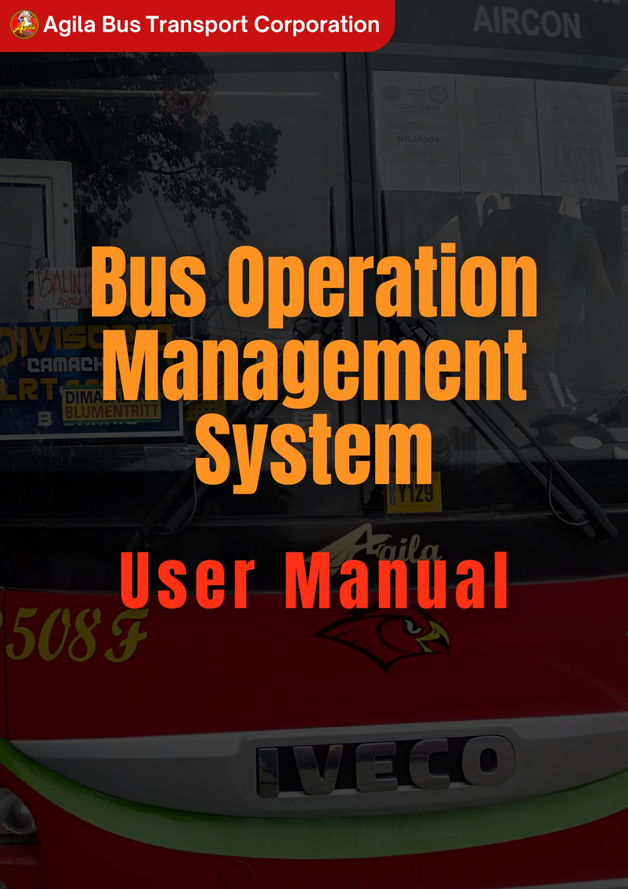

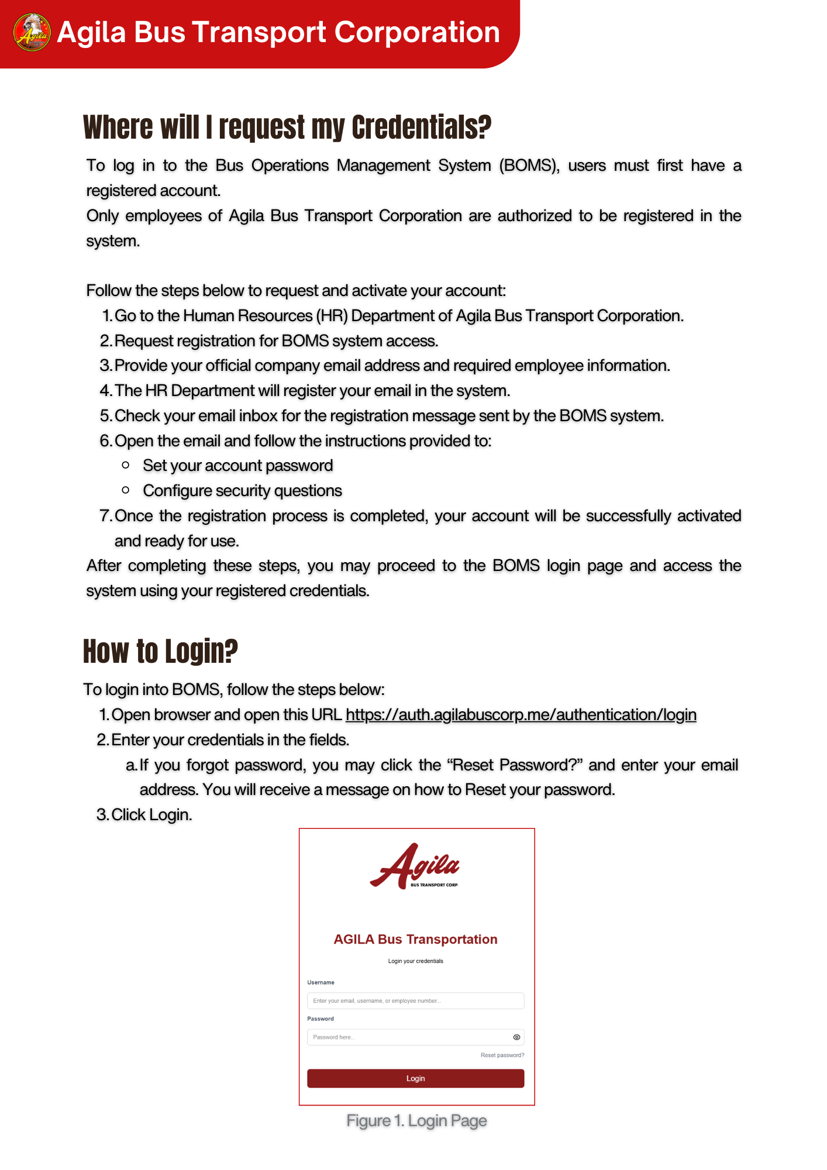

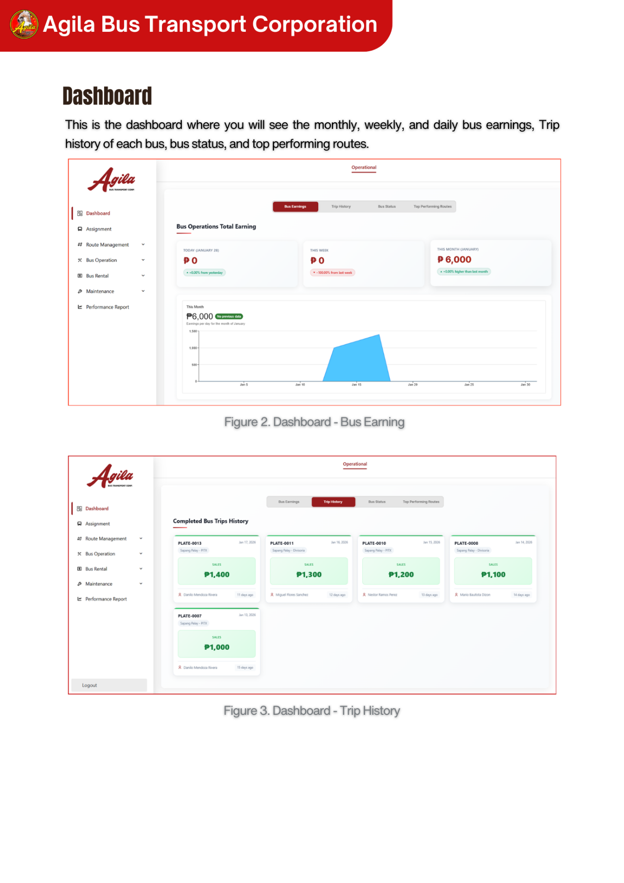

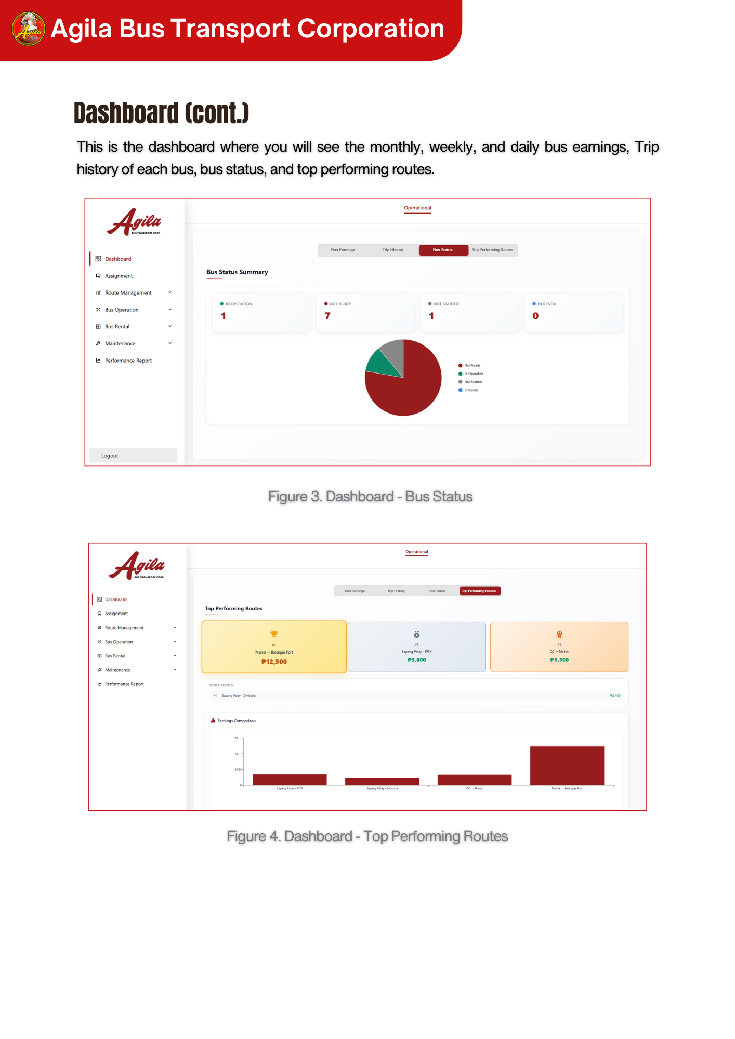

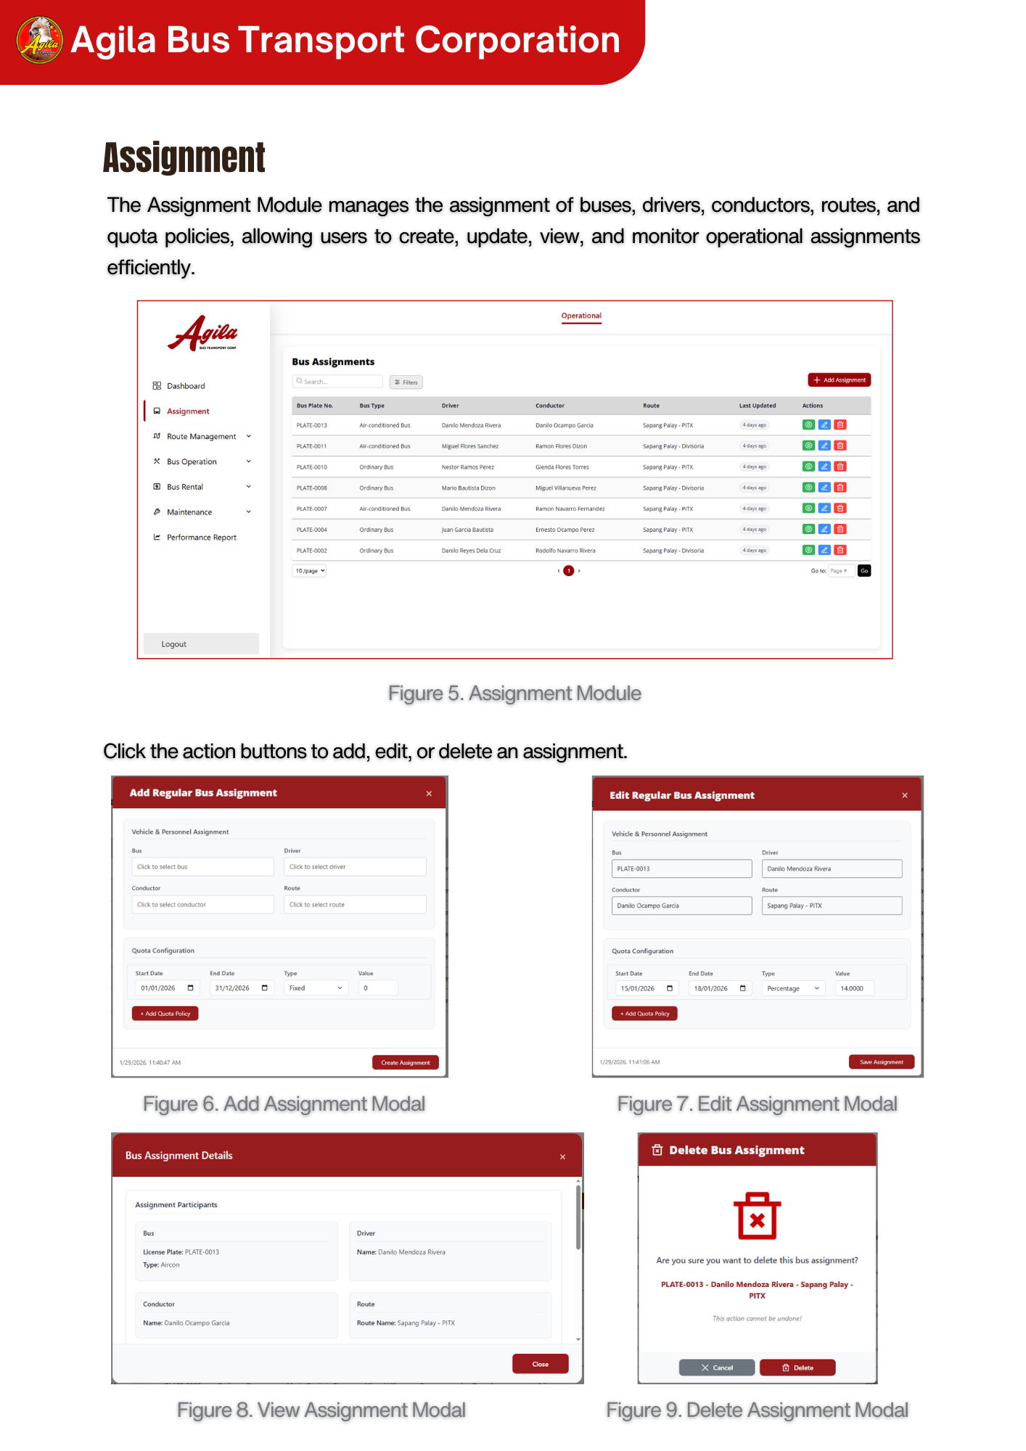

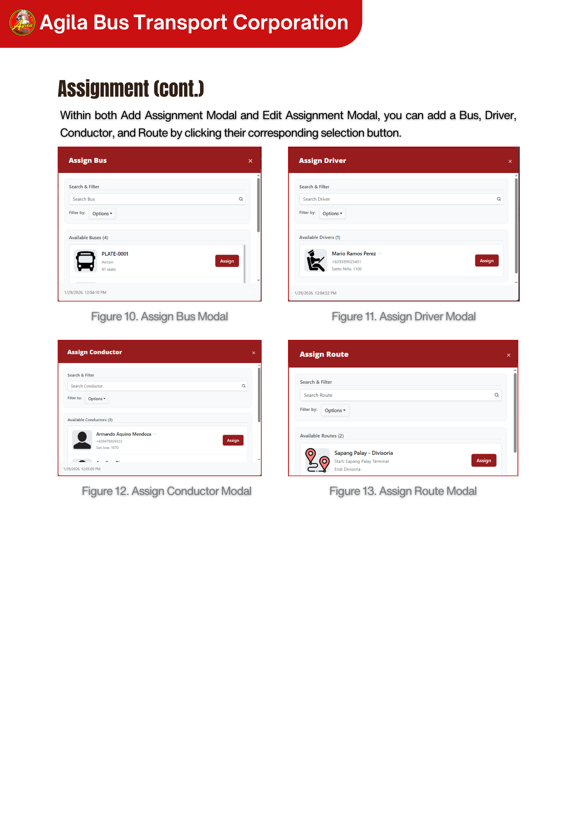

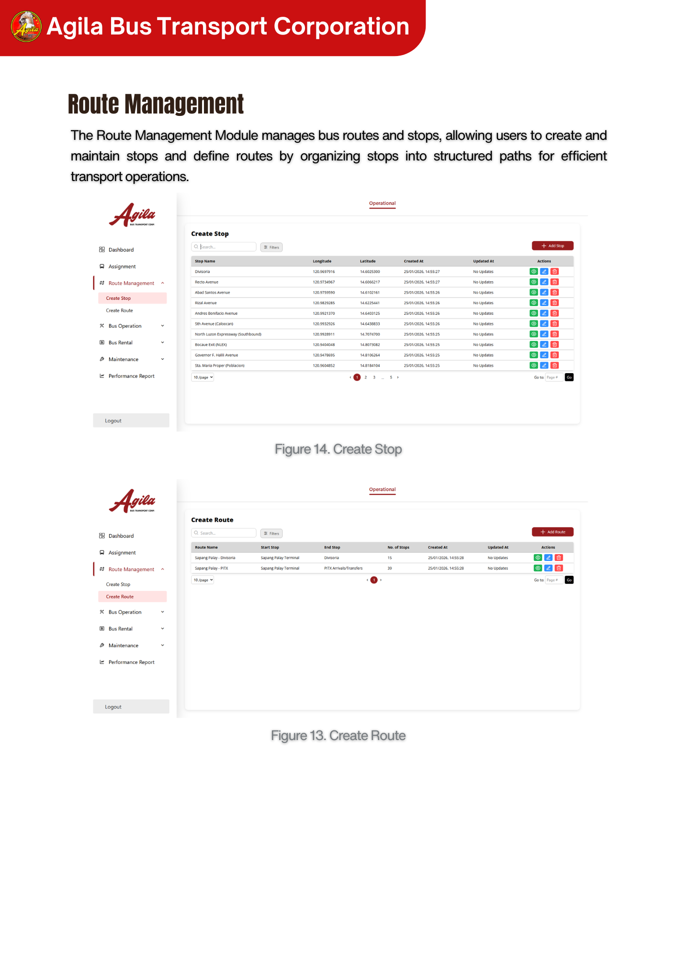

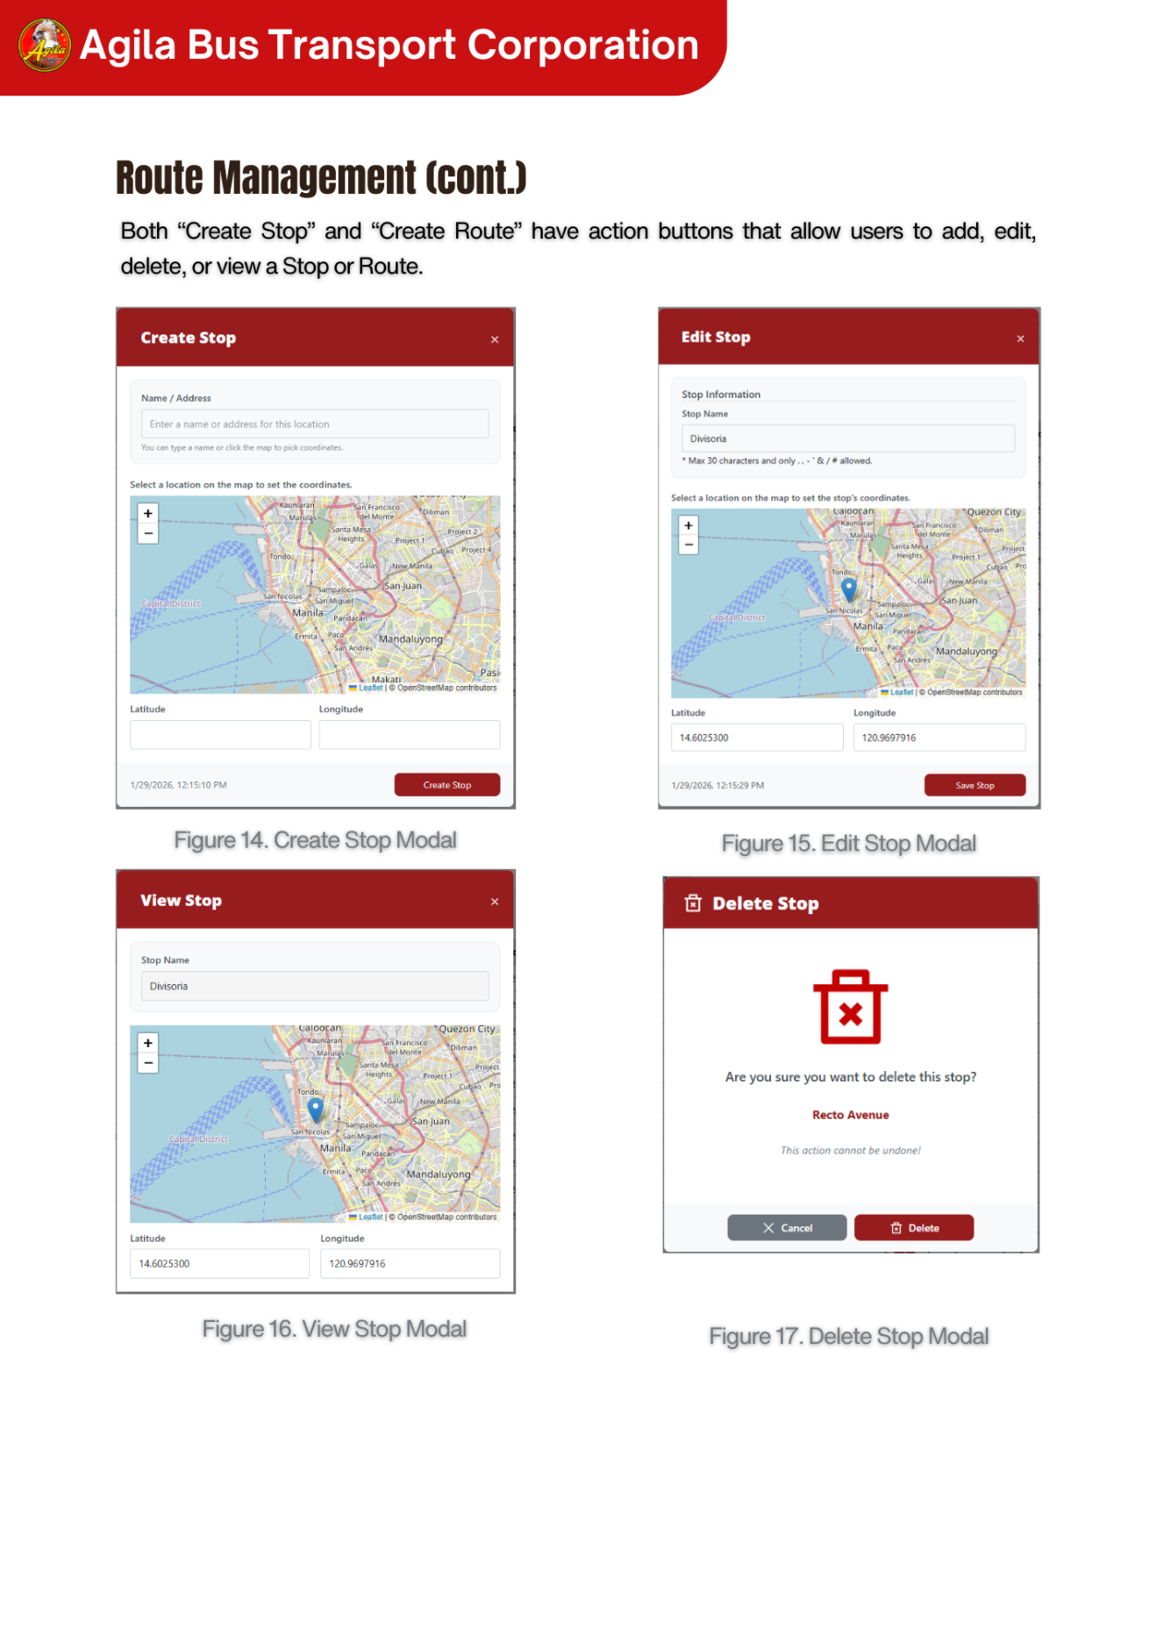

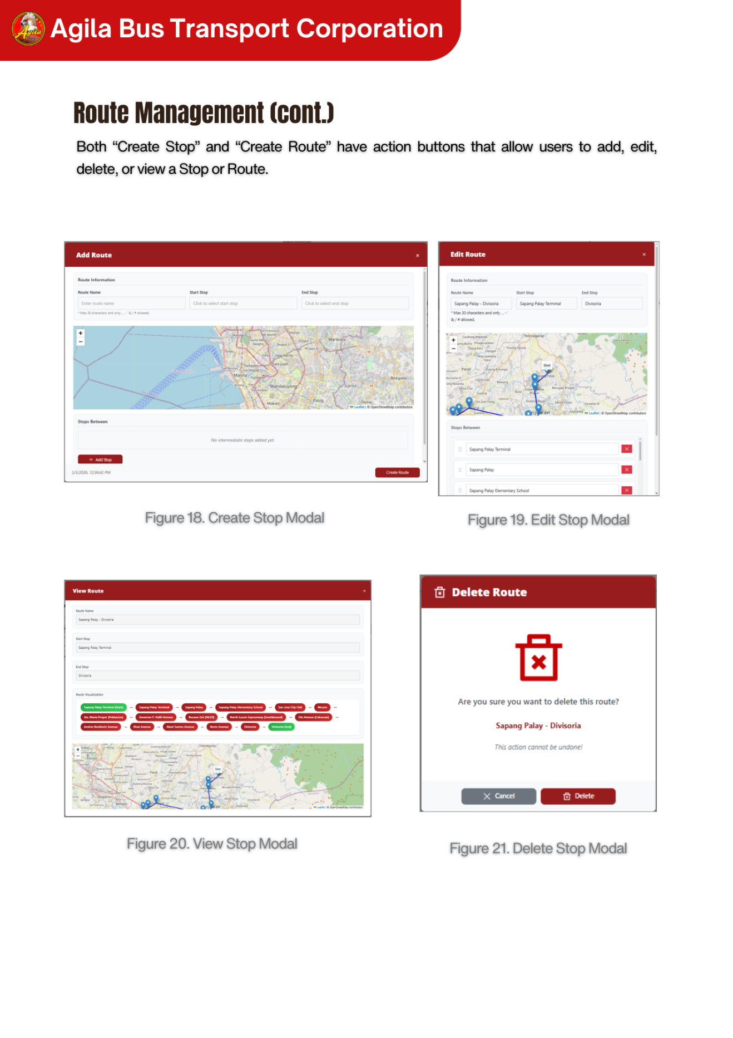

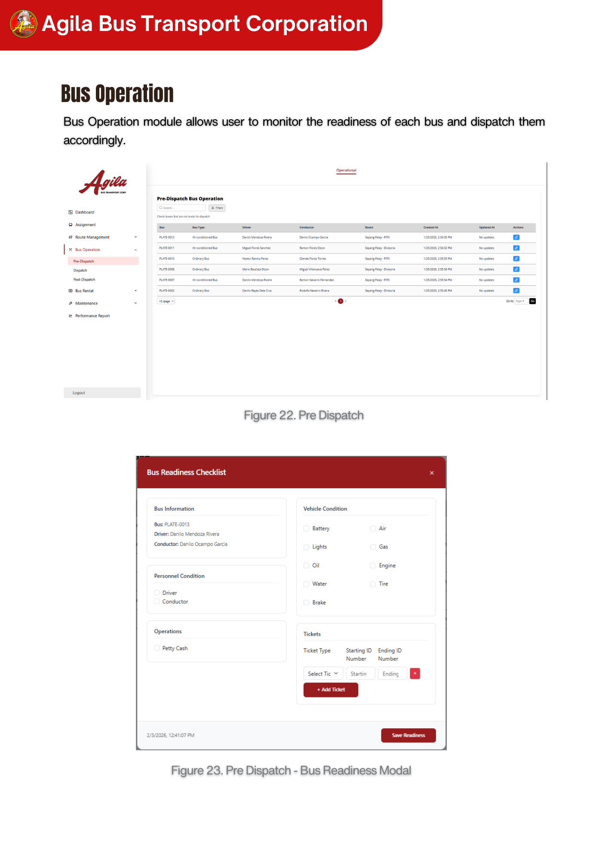

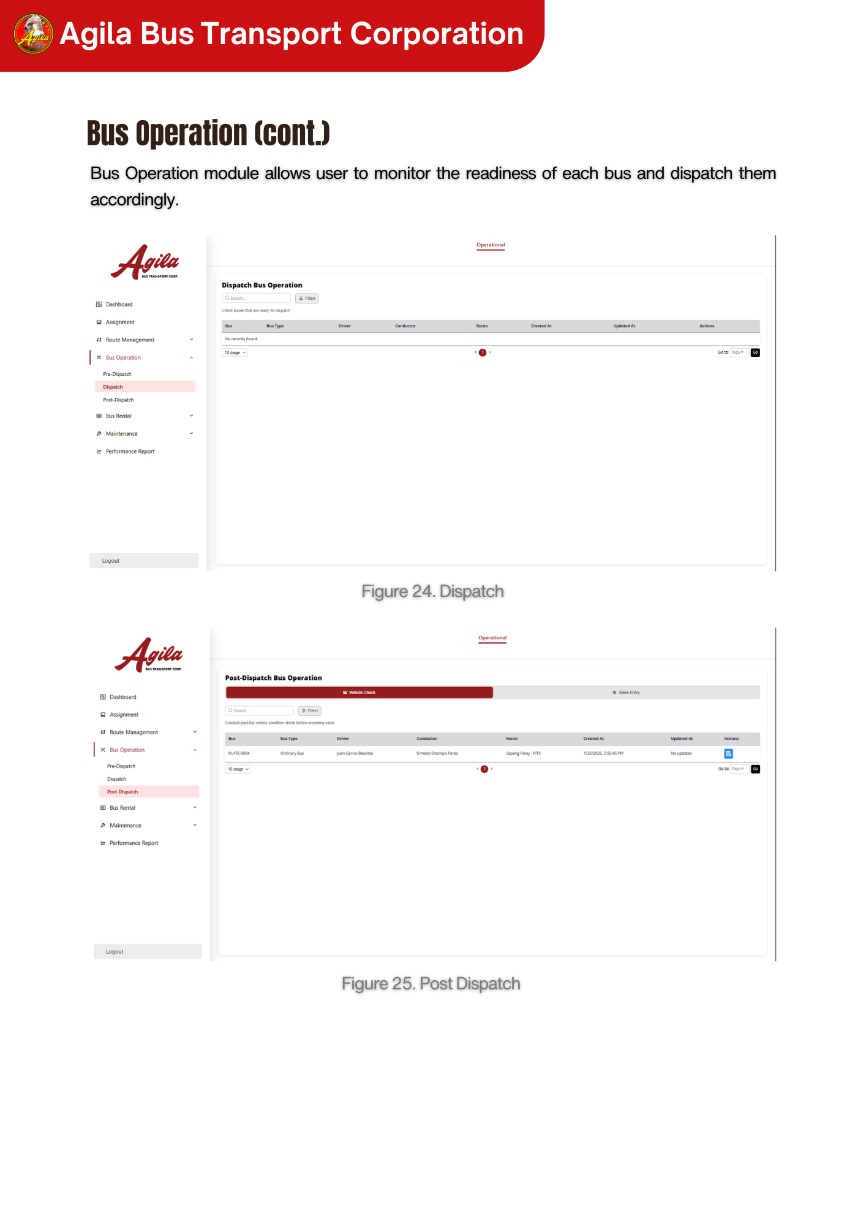

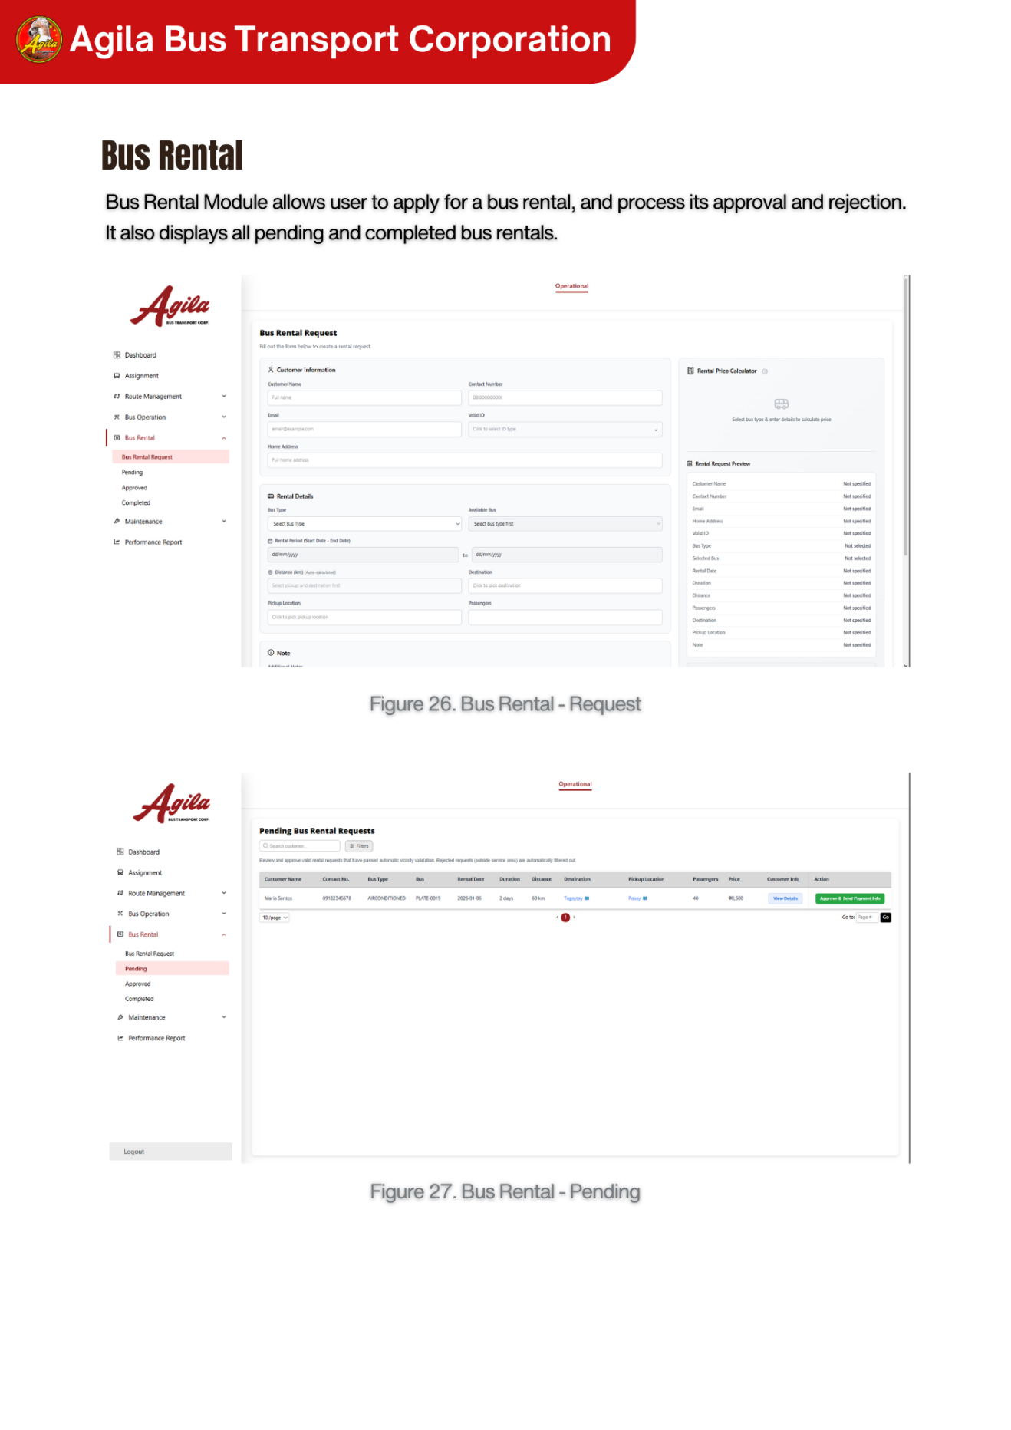

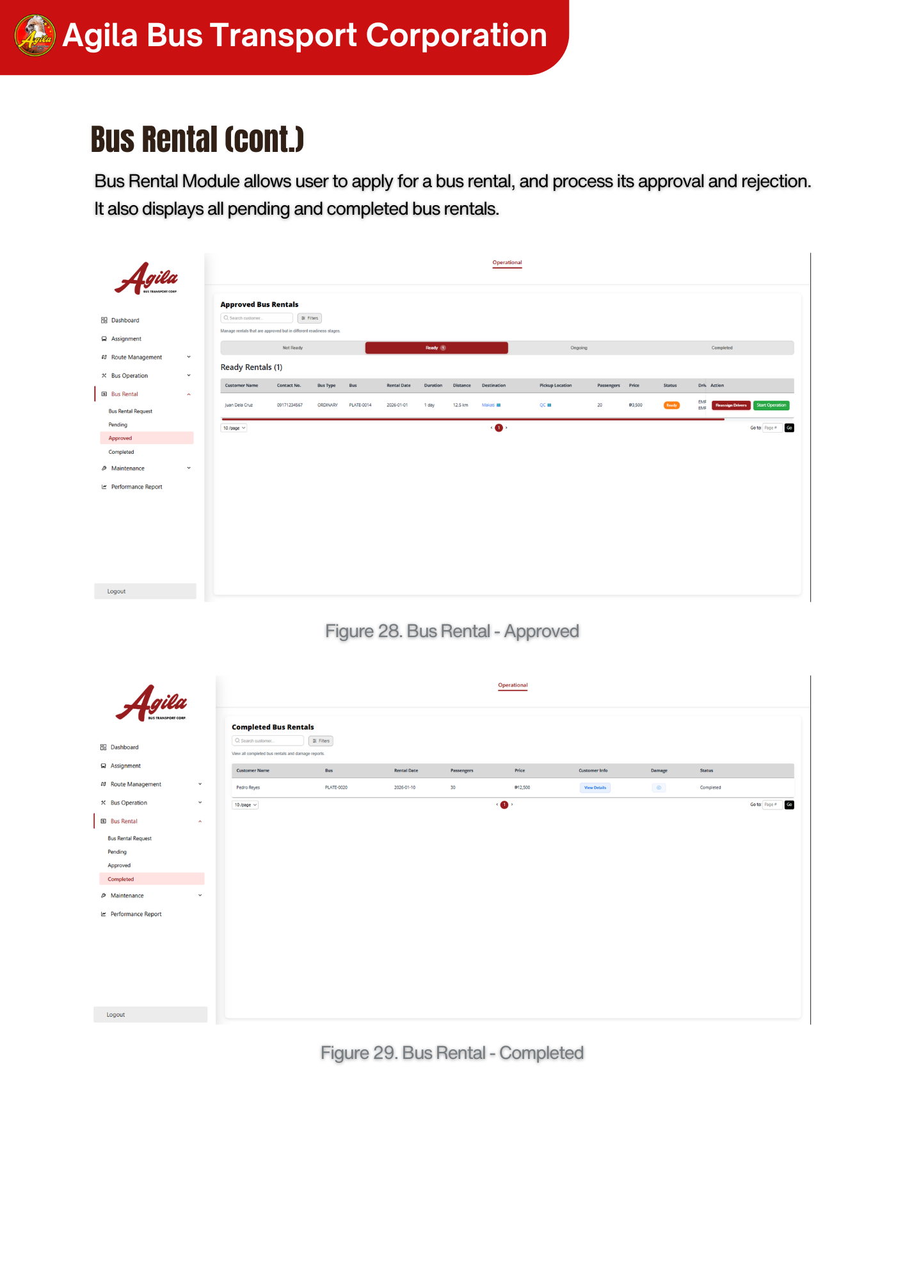

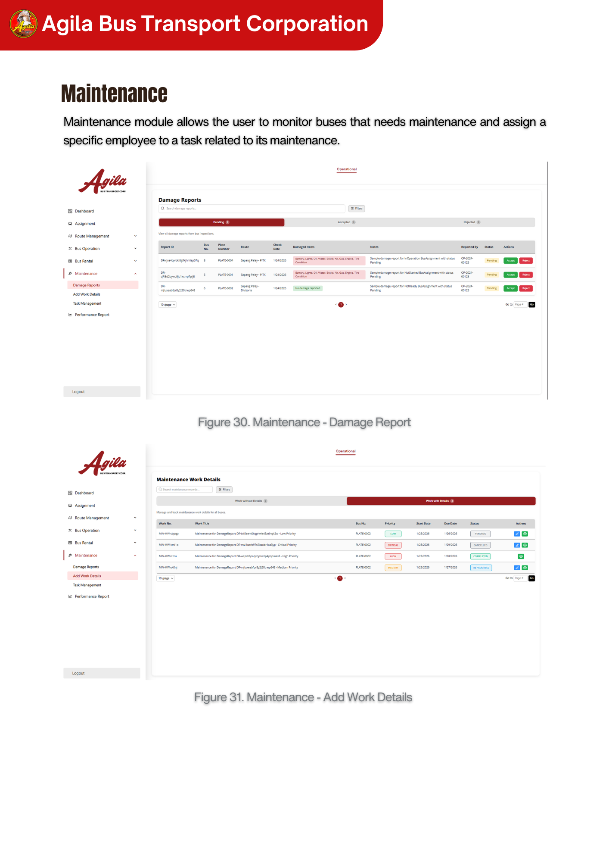

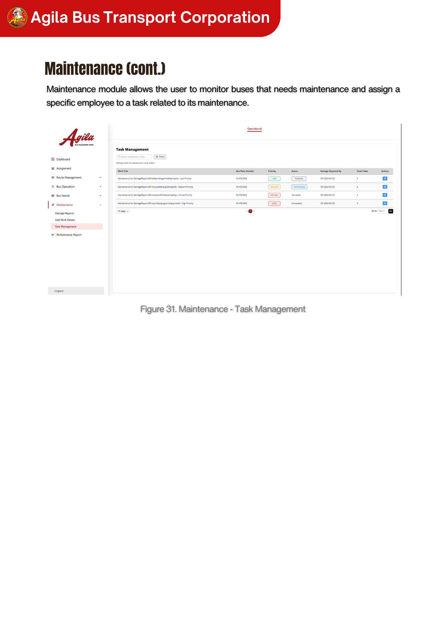

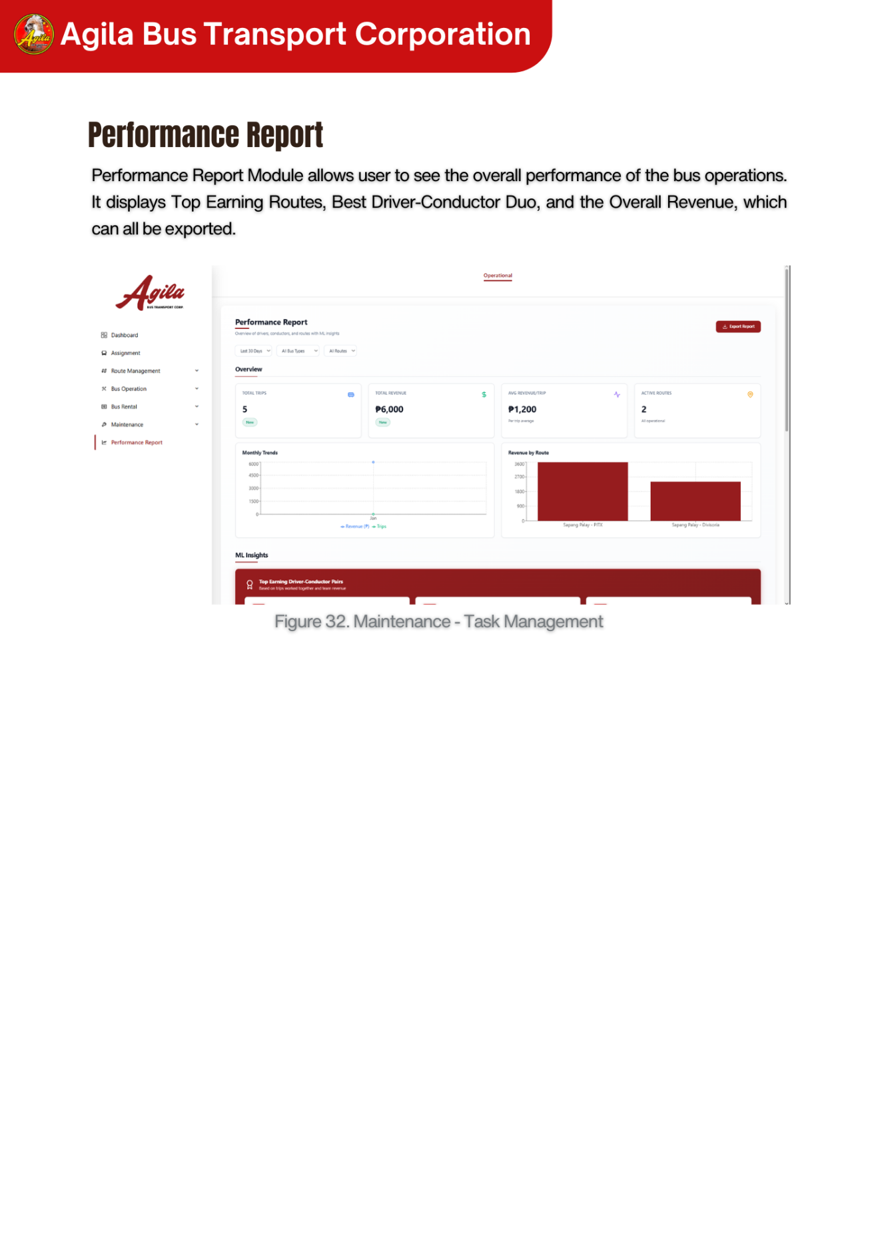

### A.12 Known Issues and Troubleshooting

This section provides a transparent record of system limitations and defects identified during the latest testing and validation phase of the Bus Operation Management System (BOMS). It also documents their resolution status and offers guidance for users and administrators. Based on the most recent Bug Summary, no critical or high-severity issues remain unresolved in the current build.

Known Issues Log.

All defects identified during the testing cycle were related to user interface behavior and interaction consistency. These issues have been resolved and officially closed prior to deployment.

| **Issue ID** | **Component** | **Description** | **Severity** | **Status** |
| --- | --- | --- | --- | --- |
| KI-001 | Assignment Modals (Bus, Driver, Conductor, Route) | Missing visible Cancel button; modal relied only on top-right exit icon | Low–Medium | Closed |
| KI-002 | Assign Conductor Modal | No conductors available for selection during early test data setup | Low | Closed |
| KI-003 | Readiness Checklist Modal | Update/Action button displayed as pencil icon | Low | Closed |
| KI-004 | Pre-Dispatch Page | Readiness indicator not yet displayed | Low | Closed |
| KI-005 | Dispatch Page | Edit button displayed instead of Dispatch button label | Low | Closed |

**User Workarounds**

As all identified issues have been resolved, no active user workarounds are required at this time. Users are advised to operate the system as intended using the standard interface components.

**Technical Troubleshooting Procedures**

Although no open defects exist, administrators may follow the procedures below should similar UI-related issues reoccur in future updates.

**UI Rendering and Interaction Issues**

Symptom: Buttons, labels, or modal controls do not display as expected.

**Diagnostic Steps:**

1.Clear browser cache and reload the application.

2.Verify that the latest frontend build has been deployed.

3.Inspect browser console (F12) for JavaScript or rendering errors.

Confirm consistency between frontend component labels and backend action mappings.

**Reporting New Issues**

If users encounter an issue not listed above, it should be reported following the standard defect reporting procedure:

1. Navigate to: Help & Support > Report a Bug.

2. Required Details: Include "Steps to Reproduce," "Expected Result vs.

Actual Result," and any relevant screenshots or screen recordings.

3. Priority Level: Please indicate if this blocks your core workflow (High) or is cosmetic (Low).

### A.13 Version Control and Source Code Repository

#### A.13.1 Repository URL

| **Name** | **Repository Name** | **URL** | **Description** | **Branching Strategy** |
| --- | --- | --- | --- | --- |
| Bus Operations Management Frontend | Bus-Operations-System | <https://github.com/RHILIUS/Bus-Operations-System> | Frontend web application | Git Flow |
| Bus Operations Management Backend | Bus-Operations-System-Backend | <https://github.com/Rj-Aquino/Bus-Operations-System-Backend> | Backend web application | Git Flow |
| Analytics Microservice | Microservice-ML-Capstone | <https://github.com/Rj-Aquino/Microservice-ML-Capstone> | Handles Analytics and Forecasting | Git Flow |

#### A.13.2 Branching Strategy

|  |  |
| --- | --- |
| **Branch Name** | **Purpose** |
| main | Contains production-ready code; always stable and deployable |
| developer_name | Individual developer branches for isolated development |
| feature_name | Dedicated branches used as checkpoints before implementing new features or fixes |

#### A.13.3 Commit Messages

Format:

● Title: A concise summary of the feature, fix, or enhancement introduced.

● Message/Body: A detailed explanation of the changes, including:

○ Affected modules or components

○ Setup or configuration steps (if applicable)

#### A.13.4 Tagging Strategy

Purpose: Tags are used to mark specific points in the repository for feature updates or fixes, making it easy to identify and deploy changes. This enables easy identification of stable builds and supports rollback if necessary.

Usage:

● Tagged versions serve as references for deployment, validation, or rollback operations.

#### A.13.5 Code Reviews

Code reviews are conducted to maintain quality, consistency, and maintainability.

1. Pre-Merge Check

○ The qa or developer double-checks the code before merging into main.

○ Ensures compliance with project standards and helps prevent merge conflicts in GitHub.

### A.14 DevOps and CI/CD

The development workflow leverages a CI/CD pipeline primarily managed through GitHub, automating code integration, testing, and deployment to ensure frequent and reliable releases. Developers work on dedicated feature branches and submit pull requests to merge their changes into the main branch. While testers verify features in the staging environment. Once approved, Vercel handles deployment to the production environment, which is continuously monitored for errors, performance issues, and system health. This workflow ensures stable releases while enabling continuous improvement through feedback from each cycle.

### A.15 Licensing and Open Source Libraries

| **Library / Tool** | **Purpose** | **License** |
| --- | --- | --- |
| Next.js | Frontend framework | MIT |
| React | UI library | MIT |
| Node.js | Backend runtime | MIT |
| Express.js | Web server framework | MIT |
| PostgreSQL | Database | PostgreSQL License |
| Redis (Upstash) | Caching | BSD-3-Clause |
| Sequelize / Prisma | ORM | MIT |
| Axios | API requests | MIT |
| Tailwind CSS | UI styling | MIT |
| JWT | Authentication | MIT |
| Bcrypt | Password hashing | MIT |
| Docker (optional) | Containerization | Apache 2.0 |
| Vercel | Hosting | Proprietary |
| Railway / Render | Hosting | Proprietary |

All open-source libraries used in this project are compliant with their respective licenses. The project uses these libraries under the terms specified by each license. Any redistribution or modification of the project must adhere to the license terms of the corresponding libraries.

All third-party libraries and frameworks used in this system are properly attributed. The developers acknowledge the contributions of the open-source community and adhere to the license requirements of each library.

### A.16 Performance Metrics and Monitoring

Performance metrics and monitoring are implemented to ensure that the Bus Operations Management System (BOMS) operates efficiently, reliably, and continuously meets the needs of its users. The system tracks key performance indicators (KPIs) and generates regular reports to identify potential bottlenecks, maintain system stability, and support continuous improvement.

**Performance Metrics**

| **Metric** | **Description** | **Target** |
| --- | --- | --- |
| Response Time | Time taken for the system to respond to user requests | ≤ 3 seconds |
| System Uptime | Percentage of time the system is available and operational | ≥ 99.5% |
| Error Rate | Percentage of failed transactions or errors | ≤ 1% |
| CPU Usage | Average CPU utilization of the server | ≤ 70% |
| Memory Usage | Average memory consumption of the system | ≤ 75% |
| Database Query Time | Average time taken to execute database queries | ≤ 2 seconds |
| API Latency | Time delay in API responses | ≤ 2 seconds |
| Cache Hit Rate | Percentage of requests served from cache | ≥ 80% |
| User Activity Load | Number of concurrent users supported | ≥ 50 users |

Performance monitoring is carried out using a combination of tools and regular procedures:

1. **Real-Time Monitoring**
   * The system continuously tracks performance metrics and resource usage.
   * Alerts are triggered when thresholds are exceeded (e.g., high response time, high CPU usage).
2. **Log Monitoring**
   * System logs are analyzed for errors, warnings, and unusual activities.
   * Error logs are reviewed daily to prevent recurring issues.
3. **Weekly Performance Review**
   * The development team reviews performance reports weekly.
   * Performance issues are documented, prioritized, and resolved.
4. **Load Testing (Optional)**
   * Load tests are conducted to measure system performance under peak conditions.
   * Results are used to optimize server resources and database queries.

To maintain optimal performance, the following actions are performed:

* **Database Optimization:** Indexing and query optimization to reduce query time.
* **Cache Implementation:** Caching frequently used data using Redis (Upstash) to improve response time.
* **Code Optimization:** Refactoring and optimizing code for faster execution.
* **Infrastructure Scaling:** Increasing server capacity or upgrading hosting plans when needed.

Performance monitoring reports are generated monthly and stored for review. The reports include performance trends, incidents, and improvement actions. These documents help support continuous system improvement and provide a historical record of system performance.

## APPENDIX B: Project Management Artifacts

### B.1 Project Charter / Proposal

**1. Project Title**

**Agila Bus Transport Corporation – Bus Operation Management System**

**1.1 Project Background and Motivation**

The increasing demand for efficient and reliable transportation services has highlighted the limitations of traditional, manual operational processes within bus transport companies. As operations grow in scale and complexity, organizations are expected to maintain accuracy, transparency, and timely coordination across scheduling, dispatching, and resource management. However, many transport operators continue to rely on paper-based records and fragmented workflows, which hinder operational efficiency and decision-making.

Two persistent challenges are evident in manual bus operations:

1. **Operational Visibility and Data Reliability Issues**  
   These arise from handwritten logs and disconnected records, making it difficult to track bus availability, personnel assignments, and trip statuses accurately. These issues often result in scheduling conflicts, delays, and accountability gaps.
2. **Workflow Inefficiencies and Coordination Gaps**  
   These affect dispatchers and administrative staff, as critical operational decisions depend heavily on manual verification and verbal communication, increasing the likelihood of human error.

In response to these challenges, the adoption of digital management systems has become essential rather than optional. Centralized, web-based platforms enable transport organizations to automate assignments, monitor operational readiness, and maintain accurate records in real time. Such systems not only improve internal efficiency but also support informed decision-making and long-term operational planning.

The motivation for this project stems from the need to modernize the internal operations of Agila Bus Transport Corporation by transitioning from a manual, paper-based process to a centralized digital platform. The development of the Bus Operation Management System (BOMS) aims to strengthen operational control, improve coordination among administrative staff, and establish a scalable foundation for future enhancements such as real-time tracking and advanced analytics.

**1.2 Problem Statement**

Bus transport companies that rely on manual and paper-based systems face significant challenges in managing daily operations effectively. The absence of a centralized digital platform results in inconsistent records, delayed updates, and limited visibility into bus readiness, personnel assignments, and trip progress. These issues increase the risk of scheduling conflicts, operational delays, and data inaccuracies.

Additionally, the lack of automated workflows places a heavy administrative burden on dispatchers and managers, reducing efficiency and making it difficult to maintain transparency and accountability across operations. Without a structured system to validate resource availability and track operational data, decision-making becomes reactive rather than proactive. As a result, transport organizations struggle to optimize resource utilization, ensure timely dispatch, and maintain reliable operational records.

Addressing these challenges requires a centralized, secure, and scalable Bus Operation Management System that digitizes internal processes, improves coordination, and supports efficient, data-driven transport operations.

**2. Project Overview**

The Bus Operation Management System (BOMS) is a web-based platform developed to modernize and streamline the internal operations of Agila Bus Transport Corporation. The system replaces manual, paper-based workflows with a centralized digital solution that improves efficiency, accuracy, and coordination across daily bus operations.

In the context of modern transport operations, there is a growing need for systems that go beyond basic record-keeping and provide real-time insights, operational validation, and integrated workflows. Traditional manual processes are no longer sufficient to support the increasing complexity of scheduling, dispatching, and resource allocation. As such, BOMS is designed to support smarter, more reliable operational management through digital transformation.

The system concentrates on core operational areas essential to bus transport management, including:

1. **Assignment Management** – Automating the assignment of buses, drivers, and conductors while validating availability and readiness.
2. **Route Management** – Digitally managing routes, stops, and schedules to ensure consistency and operational clarity.
3. **Trip Monitoring and Status Tracking** – Providing administrators and dispatchers with up-to-date information on trip readiness and progress.
4. **Reporting and Operational Analytics** – Generating summaries and reports that support management oversight and data-driven decision-making.

Through these capabilities, BOMS aims to improve operational efficiency, reduce scheduling conflicts, and strengthen accountability within the organization. The system serves as a scalable foundation for future enhancements such as real-time GPS tracking, maintenance analytics, and mobile access, positioning Agila Bus Transport Corporation for long-term operational growth.

**3. Scope of Work**

The scope of this project defines the functional and technical boundaries of the Bus Operation Management System, clearly outlining the features included in the current development phase and those intentionally excluded.

**Inclusions**

The project will cover the following activities and deliverables:

1. **Development of the Assignment Management Module**  
   Designing and implementing a system for assigning buses, drivers, and conductors based on availability and readiness, with complete documentation and traceability.
2. **Implementation of Route Management Features**  
   Enabling the creation, modification, and management of bus routes and stops through a centralized digital interface.
3. **Trip Status and Readiness Monitoring**  
   Providing tools for administrators and dispatchers to track trip readiness and operational status, ensuring only qualified resources are deployed.
4. **Reports and Summary Views**  
   Developing basic reporting and dashboard features that present operational data such as assignments, trip statuses, and bus utilization.
5. **User Authentication and Role-Based Access Control**  
   Ensuring system security by restricting access to sensitive operations based on defined user roles.
6. **System Testing and Validation**  
   Conducting unit testing, integration testing, and user acceptance testing to verify system reliability, usability, and alignment with operational requirements.

**Exclusions**

The following items are outside the scope of this project and will not be delivered as part of the initiative:

* **Passenger-Facing Features** – Modules such as online booking, fare payment, passenger notifications, and estimated arrival times are not included.
* **Mobile Applications for Drivers or Conductors** – The system is intended for internal administrative use only and does not include mobile interfaces for drivers or conductors.
* **Advanced Features** – Real-time GPS tracking, predictive analytics, and automated maintenance forecasting are excluded from the current version but may be considered for future development phases.

**1.4 Objectives and Goals**

**1.4.1 General Objective**

The primary objective of this project is to develop and implement a web-based Bus Operation Management System (BOMS) for Agila Bus Transport Corporation that digitizes and streamlines internal operational processes. The system aims to improve efficiency, accuracy, transparency, and coordination in managing bus assignments, personnel deployment, trip monitoring, and operational reporting by replacing the existing paper-based workflows.

**1.4.2 Specific Objectives**

1. To design and develop a centralized Bus Operation Management System that automates the assignment of buses, drivers, and conductors, ensuring clear documentation, traceability, and reduced scheduling conflicts.
2. To implement real-time monitoring of bus and trip statuses (e.g., available, not ready, ongoing, completed) to support dispatchers and administrators in making informed operational decisions.
3. To establish a Trip Readiness Indicator that validates bus availability, personnel assignment, and maintenance clearance before a trip can be activated, preventing operational delays and safety risks.
4. To provide summary dashboards and basic reporting tools that allow management to monitor bus utilization, trip performance, and operational efficiency.
5. To ensure data security, system reliability, and controlled access through user authentication and role-based permissions, restricting sensitive operations to authorized personnel only.

**1.5 Significance and Relevance**

**Theoretical Significance**

The Bus Operation Management System contributes to existing studies on transportation operations management and information systems by demonstrating how digital platforms can replace manual, paper-based workflows in small- to medium-sized transport companies. The system serves as a practical reference for applying concepts such as centralized data management, role-based access control, and modular system architecture within a real-world transport operations context.

By incorporating operational performance indicators—such as bus readiness, trip status monitoring, and resource utilization—the system provides a foundation for examining how structured digital processes can improve accountability, accuracy, and decision-making in transportation management. This contributes to broader research on the role of enterprise information systems in enhancing operational efficiency and organizational control.

**Practical Significance**

From a practical standpoint, the Bus Operation Management System delivers substantial benefits to administrative staff, dispatchers, and management at Agila Bus Transport Corporation. The system addresses common operational challenges such as misplaced records, scheduling conflicts, and delayed coordination by centralizing all operational data into a single, accessible platform. This reduces reliance on manual documentation and minimizes human error.

For dispatchers and administrators, the system simplifies daily operations by automating assignments, providing real-time visibility into trip readiness, and enabling faster responses to operational issues. Clear status indicators and digital logs improve coordination among departments and ensure that only ready and properly assigned resources are deployed.

Although drivers and conductors are not direct users of the system in its current version, they benefit indirectly from clearer and more consistent assignments managed through the platform. Improved documentation and tracking also enhance accountability and reduce miscommunication. For Agila Bus Transport Corporation as a whole, the BOMS supports long-term operational improvement by generating reliable data for performance analysis, planning, and optimization.

The system establishes a scalable digital foundation that can support future enhancements such as GPS tracking integration or maintenance analytics while ensuring smoother daily operations, improved safety, and better overall service reliability.

**1.6 Definition of Terms**

To ensure clarity and accessibility for all readers, this section defines key terms and technical acronyms used throughout this document. These definitions aim to simplify technical language and support understanding among both technical and non-technical stakeholders involved in bus operations and system administration.

* **BOMS (Bus Operation Management System)**  
  A web-based information system developed for Agila Bus Transport Corporation to digitize and manage internal bus operations, including assignment of buses and personnel, trip monitoring, maintenance coordination, and operational reporting.
* **CI/CD (Continuous Integration / Continuous Deployment)**  
  A software development practice in which code changes are regularly integrated into a shared repository and automatically tested and deployed. In this project, CI/CD supports reliable system updates, reduces deployment errors, and ensures the system remains in a deployable state.
* **UAT (User Acceptance Testing)**  
  The testing phase in which actual end-users such as administrators and dispatchers evaluate the system to confirm that it meets operational requirements and supports daily tasks before full deployment.
* **API (Application Programming Interface)**  
  A set of protocols that enables different software systems or modules to communicate and exchange data. Within BOMS, APIs are used to integrate with external systems such as Human Resource, Finance, and Inventory systems.
* **Trip Readiness Indicator**  
  A system feature that determines whether a bus trip can be activated by validating bus condition, personnel availability, and maintenance clearance. This indicator helps prevent operational delays and unsafe dispatching.
* **Assignment Management**  
  The process of allocating buses, drivers, and conductors to scheduled routes or trips. The Assignment Management Module automates this process based on availability and readiness rules.
* **Trip Monitoring**  
  The function of tracking the status and progress of active bus trips. This may include trip status updates (e.g., not started, ongoing, completed) and, in future versions, real-time GPS location tracking.
* **Maintenance Scheduling**  
  The process of planning, recording, and monitoring bus maintenance activities to ensure fleet safety and readiness. Maintenance data directly influences bus availability for assignment.
* **Dashboard**  
  A visual interface that displays key operational data and summaries, such as bus status, trip readiness, assignments, and reports. Dashboards are primarily used by administrators and dispatchers for operational oversight.
* **Role-Based Access Control (RBAC)**  
  A security mechanism that restricts system access based on user roles. In BOMS, sensitive functions are accessible only to authorized personnel such as administrators and dispatchers.

**1.7 Structure of the Document**

This document is structured to guide the reader through the comprehensive analysis, design, development, implementation, and evaluation of the Bus Operation Management System (BOMS) for Agila Bus Transport Corporation. Each chapter focuses on a specific aspect of the project, providing a systematic discussion of the system’s objectives, architecture, processes, and operational impact.

1. **Chapter 1: Introduction**  
   This chapter presents an overview of the Bus Operation Management System, including the background of the project, the existing operational challenges faced by the transport company, and the motivation for transitioning from manual, paper-based processes to a digital platform. It also outlines the system’s objectives, scope, and significance, emphasizing its relevance to transportation operations management.
2. **Chapter 2: Related Studies and Literature Review**  
   This chapter reviews relevant studies, methodologies, and existing systems related to transportation management, enterprise information systems, and operational optimization. It discusses how previous research and industry practices informed the design and development of the Bus Operation Management System.
3. **Chapter 3: Methodology**  
   Chapter 3 describes the development methodology adopted for the project, including the use of the Agile Scrum framework. It outlines team roles, sprint cycles, development tools, and quality practices that guided the iterative design, implementation, and testing of the system.
4. **Chapter 4: System Analysis and Design**  
   This chapter provides a detailed discussion of the system’s requirements and architecture. It covers stakeholder analysis, user stories, use cases, business process modeling (As-Is and To-Be), and the application, data, and technology architectures. The chapter explains how the system modules such as assignment management, route management, trip monitoring, and maintenance scheduling support internal bus operations.
5. **Chapter 5: Implementation Strategy and Development Journey**  
   Chapter 5 outlines the implementation strategy of the Bus Operation Management System, including deployment phases, data migration, user training, and support plans. It also presents the development journey across sprint cycles, highlighting completed features, challenges encountered, and key achievements during system development.
6. **Chapter 6: Testing, Quality Assurance, and Evaluation**  
   This chapter discusses the testing and validation processes applied to ensure system reliability and performance. It includes unit testing, integration testing, system testing, and User Acceptance Testing (UAT), as well as an evaluation of testing results and system readiness for deployment.
7. **Chapter 7: Conclusion**  
   The final chapter summarizes the outcomes of the project and evaluates how the Bus Operation Management System meets its stated objectives. It reflects on the system’s impact on operational efficiency and data accuracy and discusses potential enhancements and future development opportunities.

### B.2 Sprint Backlogs and Burndown Charts

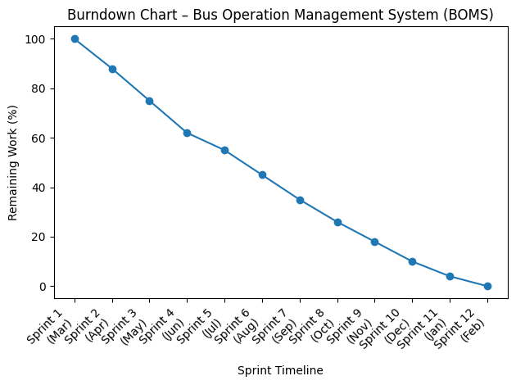

The burndown chart illustrates the progress of the Bus Operation Management System (BOMS) development across twelve sprint cycles, spanning March 2025 to February 2026. It represents the gradual reduction of remaining project workload as development activities progressed from system setup to final deployment. At the start of Sprint 1 (March), the project began with the full scope of work, including repository setup, environment configuration, and initial planning. Early sprints show a steady decline in remaining work, reflecting the successful completion of foundational modules such as Assignment Management, Route Management, and initial UI development. This period aligns with meetings focused on system setup, Figma design, and early module implementation.

From May to July, the chart shows a consistent burn rate as core functionalities including bus operations, dashboards, and reporting features were developed and refined. This steady progress corresponds with multiple coordination meetings on UI refinement, integration planning, and module expansion. Between August and October, a sharper decrease in remaining work is observed, indicating major milestones such as GPS tracking preparation, maintenance scheduling, quota counting, and full reporting features. This phase also included extensive testing, sprint reviews, and pre-deployment preparations, as documented in the meeting minutes. In the final sprints (November to February), the burndown curve approaches zero, reflecting activities focused on security checks, bug fixes, system stabilization, and code freeze enforcement. The final reduction to zero remaining work represents successful deployment readiness and completion of all planned features in time for the final presentation and system rollout.

Overall, the burndown chart demonstrates a controlled and consistent development pace, effective sprint planning, and successful scope management. Minor slowdowns during integration and testing phases were addressed through scope adjustments and prioritization, ensuring that the project remained on track and achieved full completion within the defined timeline.

### B.3 Meeting Minutes

**Phase 1: Project Setup and Initial Development**

**Meeting Record: April 14, 2025**

**Focus:** System Setup and Repository Initialization  
The team conducted an initial setup meeting to establish the development environment for the Bus Operation Management System. Activities included setting up the GitHub repository, installing required dependencies using npm install, and ensuring that all members could successfully run the system locally. This session marked the formal start of the development phase.

**Meeting Record: April 15, 2025**

**Focus:** Assignment Module Planning and Design  
The team discussed and finalized the first core module of the system, the Assignment Management Module. Initial wireframes and interface designs were created using Figma. Following design approval, development of the module commenced, focusing on assigning buses, drivers, and conductors based on availability and readiness.

**Meeting Record: April 25, 2025**

**Focus:** Integration Planning with Other Capstone Groups  
A coordination meeting was held to discuss potential system integration with other capstone groups. The discussion focused on identifying shared data requirements and defining possible API interactions, particularly for authentication and operational data exchange.

**Phase 2: Core Feature Development & Integration**

**Meeting Record: May 10, 2025**

**Focus:** New Module Planning and UI Refinement  
The team met to plan the development of additional system modules, including Route Management, Bus Operations, and the Operations Dashboard. UI refinements were discussed to improve usability and consistency across modules. The team agreed on a standardized layout and navigation structure to support dispatcher and administrator workflows.

**Meeting Record: June 16, 2025**

**Focus:** Integration Readiness and Endpoint Preparation  
A follow-up integration meeting was conducted to prepare system endpoints for inter-group connectivity. The team focused on finalizing API structures and ensuring compatibility with external systems, particularly for authentication and operational data sharing.

**Meeting Record: June 20, 2025**

**Focus:** UI and Module Finalization  
The team finalized the user interface designs and completed the development of core modules. Integration points with the partner group were connected and tested. This meeting marked the completion of the primary development phase prior to formal testing and documentation.

**Phase 3: Sprint Initialization and Dashboard**

**Meeting Record: July 14, 2025**

**Focus:** Sprint Initialization and Repository Cleanup  
The team convened to formally initiate the sprint cycle under the Agile Scrum methodology. The Scrum Master facilitated the session. Repository cleanup activities were reported, including the removal of unused services and the standardization of branch naming conventions. Initial UI placement confirmations were conducted, and plans for defect review and test case creation were outlined.

**Meeting Record: July 15, 2025**

**Focus:** Operations Dashboard Conceptualization  
The team discussed the design and content of the Operations Dashboard. It was agreed that the dashboard would include metrics such as Total Trips Scheduled, Active and Upcoming Trips, Bus Utilization Rate, and a summary of Top Routes by Frequency. Additional views for recent trips and performance trends were proposed.

**Meeting Record: July 16, 2025**

**Focus:** Dashboard Refinement and Module Progress  
Discussions continued regarding dashboard consistency and layout. Card-based components were recommended for presenting summary metrics, and color schemes were aligned with system branding. Progress updates included successful implementation of multi-assignment logic and the initiation of reporting-related features.

**Phase 4: Testing, Integration, and Finalization**

**Meeting Record: August 27, 2025**

**Focus:** Pre-Deployment and Smoke Testing  
The team reviewed the completion of sprint testing activities and confirmed submission of pre-deployment test reports. A temporary leadership assignment was made to oversee process continuity. Development updates included the completion of cancellation and report export functionalities relevant to operational tracking.

**Meeting Record: November 3, 2025**

**Focus:** Security Review and Code Freeze Planning  
Security-related issues were discussed, including authentication validation and access control. The team agreed to implement fixes prior to enforcing a formal Code Freeze to prepare for final submission and presentation. Minor UI elements were removed to reduce interface clutter.

**Meeting Record: November 10, 2025**

**Focus:** Scope Finalization and Documentation Submission  
The team reviewed remaining features and agreed to limit system scope to ensure stability and feasibility. Security enhancements were implemented to protect against unauthorized access. Documentation covering Chapters 1.0 to 4.10 was prepared for plagiarism checking and final submission.

**Meeting Record: November 14, 2025**

**Focus:** Deployment Authorization  
The team authorized a test deployment of the current system build, including assignment management, route management, dashboards, and security controls. Deadlines were set for final validations and issue resolution prior to the final presentation.

**Meeting Record: November 17, 2025**

**Focus:** Final System Polish and Freeze Strategy  
With the final presentation approaching, the team confirmed the completion of remaining features and dashboard components. A strict Final Code Freeze date was reaffirmed to ensure system stability. Final action items included completing validations, conducting last-round testing, and finalizing system diagrams.

### B.4 Gantt Chart or Project Timeline

**Capstone 1 Gantt Chart**

|  |  |  |  |  |  |  |  |  |  |  |  |  |  |  |  |  |  |  |  |  |
| --- | --- | --- | --- | --- | --- | --- | --- | --- | --- | --- | --- | --- | --- | --- | --- | --- | --- | --- | --- | --- |
| Gantt Chart for Capstone 1 (March-July) | | | | | | | | | | | | | | | | | | | | |
|  | March | | | | April | | | | May | | | | June | | | | July | | | |
| **Task/Module** | **W1** | **W2** | **W3** | **W4** | **W1** | **W2** | **W3** | **W4** | **W1** | **W2** | **W3** | **W4** | **W1** | **W2** | **W3** | **W4** | **W1** | **W2** | **W3** | **W4** |
| Project Planning & Setup |  |  |  |  |  |  |  |  |  |  |  |  |  |  |  |  |  |  |  |  |
| Module 2: Assignment Management |  |  |  |  |  |  |  |  |  |  |  |  |  |  |  |  |  |  |  |  |
| - Assign Bus Driver/Conductor |  |  |  |  |  |  |  |  |  |  |  |  |  |  |  |  |  |  |  |  |
| - Assign Bus to a Route |  |  |  |  |  |  |  |  |  |  |  |  |  |  |  |  |  |  |  |  |
| Module 3: Route Management |  |  |  |  |  |  |  |  |  |  |  |  |  |  |  |  |  |  |  |  |
| - Manage Bus Routes |  |  |  |  |  |  |  |  |  |  |  |  |  |  |  |  |  |  |  |  |
| - Manage Stops |  |  |  |  |  |  |  |  |  |  |  |  |  |  |  |  |  |  |  |  |
| Module 5: Reports & Analytics |  |  |  |  |  |  |  |  |  |  |  |  |  |  |  |  |  |  |  |  |
| - View Performance Reports |  |  |  |  |  |  |  |  |  |  |  |  |  |  |  |  |  |  |  |  |
| - Generate Attendance Reports |  |  |  |  |  |  |  |  |  |  |  |  |  |  |  |  |  |  |  |  |
| Module 6: Employee Reports |  |  |  |  |  |  |  |  |  |  |  |  |  |  |  |  |  |  |  |  |
| Final Testing & Debugging |  |  |  |  |  |  |  |  |  |  |  |  |  |  |  |  |  |  |  |  |

**Capstone 2 Gantt Chart**

|  |  |  |  |  |  |  |  |  |  |  |  |  |  |  |  |  |  |  |  |  |  |  |  |  |  |  |  |  |
| --- | --- | --- | --- | --- | --- | --- | --- | --- | --- | --- | --- | --- | --- | --- | --- | --- | --- | --- | --- | --- | --- | --- | --- | --- | --- | --- | --- | --- |
| Gantt Chart for Capstone 2 (August 2025-March 2026) | | | | | | | | | | | | | | | | | | | | | | | | | | | | |
|  | August | | | | September | | | | October | | | | November | | | | December | | | | January | | | | February | | | |
| **Task/Module** | **W1** | **W2** | **W3** | **W4** | **W1** | **W2** | **W3** | **W4** | **W1** | **W2** | **W3** | **W4** | **W1** | **W2** | **W3** | **W4** | **W1** | **W2** | **W3** | **W4** | **W1** | **W2** | **W3** | **W4** | **W1** | **W2** | **W3** | **W4** |
| Enhance Prototype Features |  |  |  |  |  |  |  |  |  |  |  |  |  |  |  |  |  |  |  |  |  |  |  |  |  |  |  |  |
| Module 4: Bus Rental |  |  |  |  |  |  |  |  |  |  |  |  |  |  |  |  |  |  |  |  |  |  |  |  |  |  |  |  |
| Module 5: Maintenance |  |  |  |  |  |  |  |  |  |  |  |  |  |  |  |  |  |  |  |  |  |  |  |  |  |  |  |  |
| Module 7: Performance monitoring |  |  |  |  |  |  |  |  |  |  |  |  |  |  |  |  |  |  |  |  |  |  |  |  |  |  |  |  |
| QA |  |  |  |  |  |  |  |  |  |  |  |  |  |  |  |  |  |  |  |  |  |  |  |  |  |  |  |  |
| Final Testing & Security Checks |  |  |  |  |  |  |  |  |  |  |  |  |  |  |  |  |  |  |  |  |  |  |  |  |  |  |  |  |
| Deployment |  |  |  |  |  |  |  |  |  |  |  |  |  |  |  |  |  |  |  |  |  |  |  |  |  |  |  |  |

Operation Management System (BOMS) across two capstone periods, spanning from March to July for Capstone 1 and August to February for Capstone 2. The schedule reflects a structured, iterative approach aligned with the Agile Scrum methodology, ensuring progressive delivery of system modules and continuous improvement. Capstone 1 (March–July) focuses on system foundation and core operational modules. The project begins with Project Planning and Setup, establishing system requirements, architecture, and development environment. This is followed by the implementation of Assignment Management, including assigning drivers and conductors and linking buses to routes. Next, the Route Management Module is developed, covering route creation and stop management. The latter part of Capstone 1 emphasizes Reports and Analytics and Employee Reports, enabling performance monitoring and attendance tracking. The phase concludes with Final Testing and Debugging, ensuring system stability and readiness for the next development stage.

Capstone 2 (August–February) builds upon the initial prototype by enhancing features and introducing advanced operational modules. This is followed by the expansion of Reports and Analytics to full functionality, providing deeper operational insights. Additional modules such as Maintenance Scheduling and Quota Counting are then implemented to improve fleet readiness and resource utilization. The final months are dedicated to Comprehensive Testing and Security Checks, ensuring system reliability, followed by Deployment, marking the transition of BOMS to an operational environment. Overall, the Gantt chart demonstrates a logical progression from planning and core feature development to system enhancement, validation, and deployment. It reflects a realistic development timeline that supports iterative refinement, risk mitigation, and successful delivery of a scalable and future-ready Bus Operation Management System.

## APPENDIX C: Research and Requirements Artefacts

### C.1 Approved Adviser Acceptance Form

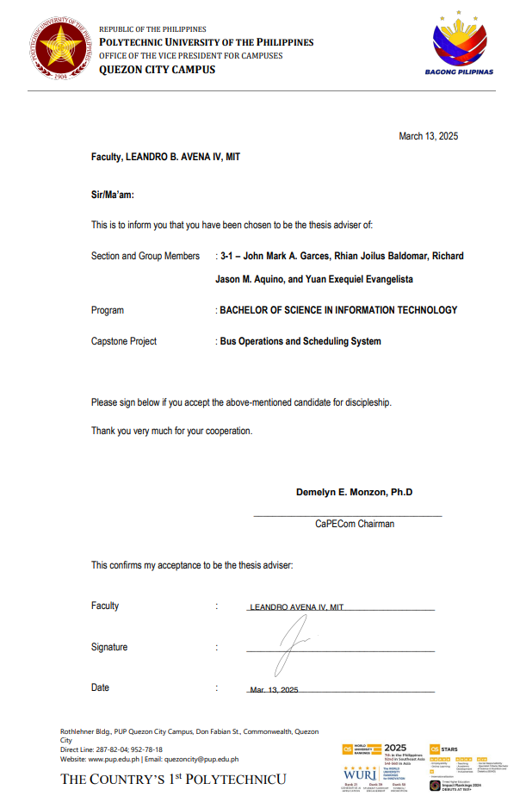

### C.2 Company Endorsement / Memorandum of Agreement

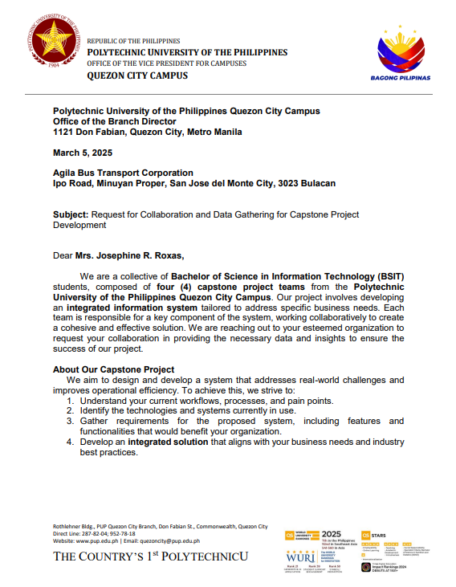

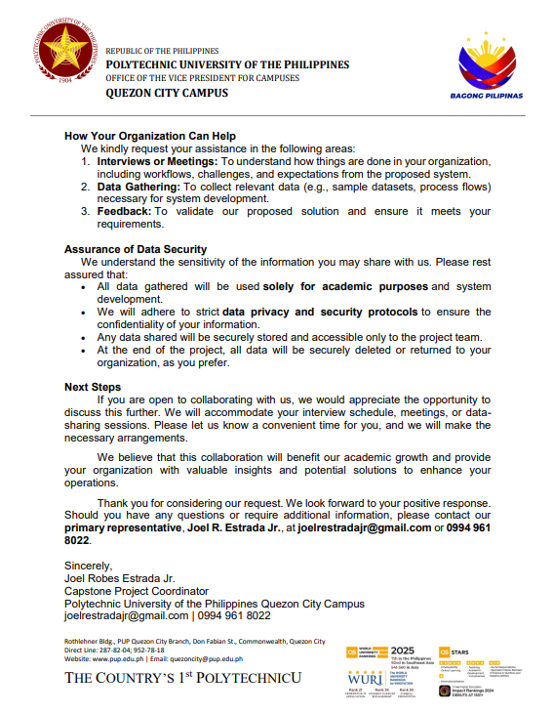

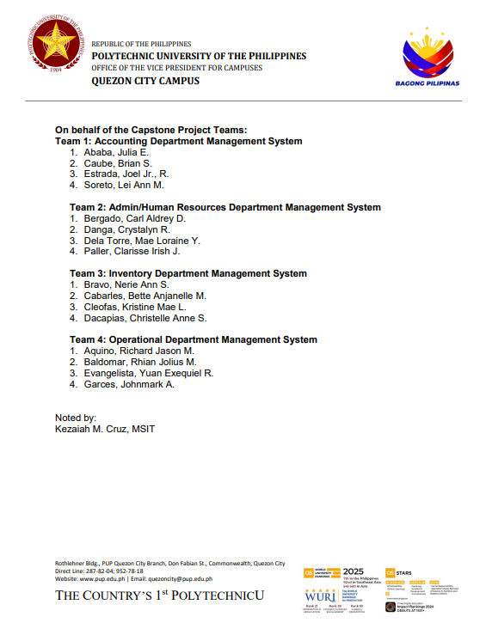

### C.3 Survey Questionnaires and Raw Data

This section presents the survey questionnaires developed and administered by the project team to gather requirements and insights directly from the product owner and key operational stakeholders of the Bus Operations Management System (BOMS). The questionnaires were carefully designed to identify the client’s expectations, operational challenges, and priority features needed in the system.

The survey focused on core areas such as bus assignment workflows, route and schedule management, dispatch procedures, reporting needs, and system usability. Responses collected from the product owner and relevant personnel served as a primary source of raw data, which was analyzed and translated into functional and non-functional requirements of the system.

The inclusion of the raw survey data ensures transparency in the requirements engineering process and demonstrates that the design and development of BOMS are aligned with actual operational needs and stakeholder expectations.

**March 2 Interview Questions**

| **Department** | **Question** |
| --- | --- |
| **GENERAL** | Anong panagalan ng kumpaniya niinyo? |
| Ilan ang empleyado ninyo? |
| Ano-anong klaseng (role) ng empleyado ang meron kayo? |
| Ilan po ang bus (units) na meron kayo? |
| Ano-anong proseso ang gusto niyong ma-computerize o ma-digitalize? |
| Ano-anong reports ang gusto niyong makita sa system? |
| Anong preference niyo sa kulay (UI)? |
| Ano-anong device ang meron kayo? |
| **ACCOUNTING DEPARTMENT** | Ano po ang Accounting Department? |
| May accountant po ba kayo? |
| Ano-ano ang ni-re-record ninyo sa manual accounting/finance (notebook) niyo? |
| Ano-anong document ang gusto niyong automatically na-pi-print ng system? |
| Ano pong inaasahan ninyo sa magiging Accounting System? |
| Proseso at presyo ng pagbili ng bus? |
| Sino pong nag-ha-handle ng payroll ng mga empleyado? |
| **ADMIN / HUMAN RESOURCE DEPARTMENT** | Ano po ang Secretary (HR/Admin) Department? |
| Gusto niyo ba ng digitalized, computerized (forms) para sa application ng mga empleyado? |
| Ano pong expectations ninyo sa isang HR System? |
| Ano-ano po 'yung data na kinukuha niyo sa mga empleyado ninyo? |
| Paano niyo po ni-re-record ang mga impormasyon ng empleyado niyo? |
| Anong process ng employee hiring? |
| Paano niyo po tina-track ang attendance at leave ng mga empleyado? |
| Challenges in payroll? |
| Paano niyo kino-compute ang suweldo ng mga empleyado (payroll)? |
| Paano po kayo mag-performance evaluation ng mga empleyado? |
| May training phase po ba kayo? |
| Main issues/challenges ng HR? |
| Paano po ang proseso ng resignation? |
| May mga data access restriction po ba per employee? |
| Ano pong mino-monitor sa mga emppleyado kapag hired na? |
| Nanghihingi ba kayo ng email? |
| **INVENTORY DEPARTMENT** | Ano po ang Inventory Department? |
| Okay lang bang i-require ang empleyado na ilista kung ano, ilan, sino, at kailan kinuha/kumuha ng piyesa? |
| May room (bodega) po ba kayo para sa mga piyesa? |
| Sino pong tao para sa inventory? |
| If ginagamit ang stock, paano po siya nai-re-record? (stock & maintenance) |
| Paano po ang process niyo sa inventory (kailan kayo bumibili at kailan hindi)? |
| Paano niyo siya gustong i-record? |
| May supplier ba kayo? |
| Paano po kayo umu-order ng mga piyesa't materyales? |
| Chalenges ng inventory bukod sa expense and counting? |
| Paano kapag delayed ang oreder, anong nangyayari? |
| Gusto niyo ba ng barcode? |
| Ang Inventory Department ba ay connected sa ibang department? |
| **OPERATIONAL DEPARTMENT** | Ano ang Operational Department? |
| Sino ang humahawak ng scheduling/pag-assign ng mga empleyado sa bus? |
| Paano niyo kino-communicte ang schedule nila (employees)? |
| Ano pong penalty sa mga late? |
| Ano pong penalty sa mga absent? |
| Ang driver at kundoktor ba ay puwedeng i-assign sa kahit anong bus? |
| Fixed ba ang ruta (route) ng bus? |
| Puwede bang madagdagan o mabago ang route niyo? |
| May GPS ba ang mga bus? |
| Gusto niyo ba na nag-se-send ng SMS automaticaly sa mga employees na late na? |
| Puwede ba na ang mga empleyado ang namimilli ng schedule? |
| Gusto niyo po ba ng feedbacks? |

**July 5 Interview Questions**

| **Department** | **No.** | **Question** |
| --- | --- | --- |
| **GENERAL (G)** | G1 | May gusto po ba kayong ipabago sa itsura ng system? |
| **FINANCE (F) DEPARTMENT** | F1 | Paano po ang presyuhan niyo sa pagbebenta ng bus at piyesa? |
| F2 | Paano ang proses niyo (with the supplier) sa mga gamit na deffective o sira? |
| F3 | Paano ang proseso ninyo sa pag-abono ng mga empleyado at ano ang katunayan na kailangan nilang ibigay sa inyo? |
| F4 | Ni-re-record niyo po ba ang mga gastusin ng mga driver at kundoktor sa biyahe tulad ng basahan, pagkain, ...? |
| F5 || I2 | Pagkabili ba ay may resibo na o nagkakaroon lang kapag na-deliver na, or both (may resibo pagkabili at pagka-deliver)? |
| **HUMAN RESOURCES (H) DEPARTMENT** | H1 | Lahat ba ng driver at kundoktor ay mayroong PhilHealth at PAGIBIG na deductions? |
| H2 | Magkano at paano ang deduction ng PhilHealth, PAGIBIG, ... sa sahod ng mga empleyado (including weekly-based-salary employees)? |
| H3 | Paano kayo magbayad ng mga PhilHealth, PAGIBIG, ... ng mga empleyado, fixed ba o by percent? |
| H4 | Paano po ang cash advance, leave request ng mga empleyado? Si HR ba ang mag-approve no'n o ipapasa pa sa inyo? |
| H5 | May leave ba ang konduktor at driver? |
| H6 | Ni-re-record niyo pa ba kung hindi sila pumasok? |
| H7 | Okay po ba kung mag-implement ng facial recognition (sa attendance)? |
| H8 | Ano-anong employee-document-related concerns ang gusto niyong matulugnan namin kayong i-address? |
| H9 | Ano-ano po ang mga company documents na mayroon kayo? |
| **INVENTORY (I) DEPARTMENT** | I1 | Okay lang ba kung galing sa Finance (resibo) 'yung mga stock (items)? |
| F5 || I2 | Pagkabili ba ay may resibo na o nagkakaroon lang kapag na-deliver na, or both (may resibo pagkabili at pagka-deliver)? |
| I3 | About sa frequency ng pagpri-print ng stock report... |
| I4 | Kapag nanghihiram ba ng gamit sa inventory, mayroon bang "time limit" na kailangang masunod sa pagbabalik ng gamit? |
| I4.1 | Not asked but is informative. |
| I4.2 | Not asked but is informative. |
| I5 | Paano ang process niyo sa pag-o-order? |
| I6 | Lahat ba ng bus ay sabay-sabay niyong binili? |
| I7 | May available files (copy) pa ba kayo ng mga official attachments (documents) ng mga bus i.e. official receipts? |
| I8 | May iba pa bang documents (requirements) ang kailangang i-comply kapag bumili ng bus (unit)? |
| I9 | Anong chini-check sa status ng bus bago bumiyahe? |
| I10 | May routine inspection ba kayo ng mga bus i.e. monthly, weekly? |
| I11 | Paano ang process ng maintenance ng machine, equipments? |
| I12 | Ano-anong bus-related documents ang ina-update? |
| I13 | Napapalitan po ba ang engine number at chassis number ng mga bus? |
| I14 | Paano ang proseso ng pag-dispose ng sirang gamit at bus? |
| I15 | Paano niyo po pinagdedesisyunan kung ang isang unit ay hindi na talaga kayang ayusin at kailangan nang bitawan? |
| I16 | Sa pag-o-order, may siniset ba kayong budget limit? |
| I17 | Alam niyo po ba ang pricelist ng mga item kapag bumibili kayo? |
| **OPERATIONS (O) DEPARTMENT** | O1 | Paano ang proseso/aksyon sa mga logged reports (issues ng bus) ng mga driver/conductor sa bus na na-assign sa kanila after ng biyahe? |
| O2 | Paano kayo nag-de-deploy ng mga mekaniko? |
| O3 | Ano-anong requirements ang kailangan ko kung gusto kong magrenta ng bus? |
| O4 | Sino-sino ang nag-re-rent sa inyo? Private company ba, school, ...? |
| O5 | Ilan ang minimum (days/weeks) advanced ang kailangan sa pag-inform sa inyo kung gusto naming magrenta ng bus? |
| O6 | Paano niyo prinepresyuhan ang pagrenta? |
| O7 | Paano ang bayad sa driver sa pagrenta ng bus? Kasama na ba iyon sa binayaran? |
| O8 | May document at kung anong requirements po bang kailangan/hinihingi sa mga gustong magrenta? |
| O9 | Paano tsini-check ang isang unit na iparerenta? |
| O10 | Anong empleyado (job title) ang nag-tsi-check ng bus (condition) bago iparenta? |
| O11 | Paano niyo ni-re-record ang mga nirerentahan? |
| O12 | May limit ba kung ilang bus lang ang pwede niyo iparenta? |
| O13 | Paano ang proseso kung may nasira sa bus habang nirerentahan? |
| O14 | Paano namin mako-contact ang GPS provider ninyo? |

### C.4 Interview Transcripts and Guides

This section contains the complete interview guides and corresponding transcripts, including both the questions prepared by the project team and the actual responses provided by the product owner and key stakeholders involved in bus operations. The interviews were conducted to gain an in-depth understanding of current operational practices, existing challenges, and specific expectations for the Bus Operation Management System (BOMS).

The interview guides were structured to cover critical operational areas such as assignment management, route planning, trip readiness validation, reporting requirements, and system access control. The recorded responses offer qualitative insights into stakeholder workflows, pain points, and decision-making processes that are not easily captured through surveys alone.

The documented transcripts serve as a primary qualitative data source for the project and directly informed the system’s functional requirements, non-functional requirements, and overall design decisions. Including both the guides and transcripts ensures traceability between stakeholder input and implemented system features, while also supporting transparency and validity in the system analysis process.

**March 2 Interview with answers**

| **Department** | **Question** | **Client's Response** | **Rating (Question:Answer)** | **Follow-Up Question** | **IT-Related Information Concluded** |
| --- | --- | --- | --- | --- | --- |
| **GENERAL** | Anong panagalan ng kumpaniya niinyo? | Marami: **Agila Bus Transport Corporation**, Hilltop Tours Corporation, Pinagrealan Tours Inc., DARJ Transport Corporation. | **Satisfied** | **N/A** | **Uncertain** |
| Ilan ang empleyado ninyo? | Pre-pandemic: >= 100; Post-pandemic >= 50. | **Needs Elaboration** | What is the exact number of current employees? | **Uncertain** |
| Ano-anong klaseng (role) ng empleyado ang meron kayo? | Manager, Asst. Manager, Secretary, Asst. Secretary, Treasurer, Chief Mechanic, Mekaniko, Helper (3), Taga-washing, Driver, Kundoktor, Latero, Dispatcher, Tugis (Extra or backup employee) = **13 IN TOTAL**.  **Saturday and Sunday** lang pumapasok si **Secretary**. Siya ang nag-re-record ng mga emplloyee details (e.g. SSS, PhilHealth, Pag-ibig, etc.) sa computer. | **Satisfied** | **N/A** | **ATTRIBUTE:  employee_role** (including non-users) {Manager, Assistant Manager, Secretary, Assistant Secretary, Treasurer, Chief Mechanic, Mechanic, Helper, Bus Cleaner, Bus Driver, Bus Conductor, *Latero*, Dispatcher, Tugis} |
| Ilan po ang bus (units) na meron kayo? | <= 100 in total, <= 30 ang tumatakbo. | **Needs Elaboration** | What is the exact number of current units (buses)? | **Uncertain** |
| Ano-anong proseso ang gusto niyong ma-computerize o ma-digitalize? | **Scheduling**, ma-handle 'yung pasok ng mga empleyado kahit irregular ang schedule sa mga transportation company (may umaga, tanghali, hapon, o gabi pumapasok/umuuwi);  **Accounting**, dapat nakabukod ang suweldo ko (may-ari). Hiwalay ang gastusing personal sa kumpanya;  **Inventory**, dapat nakikita ko kung ilan ang stock ng mga piyesa (e.g gulong, lining, langis, etc.). | **Unsure** | **N/A** | **EXPECTATIONS:**   **+ Operational Department (Scheduling):** The system should be able to manage employee work schedules, even if they are irregular (morning, noon, afternoon, or night shifts).  **+ Accounting Department:** The system should separate the owner's salary from personal and company expenses to maintain clear financial records.  **+ Inventory Department:** The system should provide "real-time" visibility into the stock levels (amounts) of spare parts (e.g., tires, brake linings, oil, etc.). |
| Ano-anong reports ang gusto niyong makita sa system? | Gusto kong makita kung kailan sila nag-start at umalis sa kumpaniya (**HR**);  Makita nang tama at maayos ang kita at gastos ng kumpanya especially 'yung daily amount ng kita, weekly amount ng gastusin (**ACCOUNTING**);  Kung ilang bus ang bumiyahe ngayon---daily (**OPERATIONAL**); | **Unsure** | **N/A** | **EXPECTATIONS:**   **+ Operational Department:** The system should provide a daily count of buses in operation, showing how many buses are running on a given day.  **+ Accounting Department:** The system should display company income and expenses clearly, focusing on Daily revenue tracking and Weekly expense monitoring.  **+ Admin/Human Resource Department:** The system should track employee hire dates and resignation/termination dates to monitor employment history. |
| Anong preference niyo sa kulay (UI)? | Hindi dapat siya masakit sa mata tapos dapat 'yung "happy". | **Unsure** | **N/A** | **EXPECTATION:  Broad:** UI's colors must be pleasant. |
| Ano-anong device ang meron kayo? | Si Secretary lang ang may computer. | **Satisfied** | **N/A** | **Uncertain** |
| **ACCOUNTING DEPARTMENT** | Ano po ang Accounting Department? | Dito makikita kung magkano ang kinikita ng mga bus daily, magkano ang expenses namin, kung okay ang performance (revenue: positive or negative) namin. | **Satisfied** | **N/A** | **EXPECTATIONS:  + Accounting Department:** The system is expected to provide financial monitoring by tracking daily bus revenue, company expenses, and overall performance. It should clearly show whether the company is operating at a profit or loss. The accounting module must generate reports for daily income, and weekly expenses. |
| May accountant po ba kayo? | May personal accountant for BIR purposes pero hindi niya handle ang kumpanya. | **Satisfied** | **N/A** | **Uncertain** |
| Ano-ano ang ni-re-record ninyo sa manual accounting/finance (notebook) niyo? | Ang ni-re-record lang ay ang mga empleyado, kinita nila, at litro ng diesel nila. | **Satisfied** | **N/A** | **ATTRIBUTES (TENTATIVE):  net_revenue** =  gross_income − (liters_used * cost_per_liter) |
| Ano-anong document ang gusto niyong automatically na-pi-print ng system? | Yung resibo ng mga binibili, 'yung mga binibiling materyales dahil hinihingi ito ng Accountant sa BIR. | **Unsure** | **N/A** | **EXPECTATIONS:  + Accounting Department: The system should store records of purchased materials along with their corresponding receipts. Each record should include item details, quantity, price, supplier, and receipt number for auditing and tax purposes.** |
| Ano pong inaasahan ninyo sa magiging Accounting System? | Na magiging maayos at malinaw ang halaga ng gastos at kita ng kumpanya (might add personal expenses e.g food, electricity, water, etc.). | **Unsure** | **N/A** | **EXPECTATIONS:  + Accounting Department: The system should provide a transparent breakdown of company income and expenses for accurate financial monitoring. It should also allow personal expenses (e.g., food, electricity, water, etc.) to be optionally recorded, ensuring they are separated from company expenses to maintain financial clarity.** |
| Proseso at presyo ng pagbili ng bus? | Puwedeng loan. 10M to 12M ang isang bus na bago. | **Needs Elaboration** | What are the exact costs of ordinary and air-conditioned units? | **Uncertain** |
| Sino pong nag-ha-handle ng payroll ng mga empleyado? | Ako, 'yung may-ari at 'yung isa kong assistant (Jenny), minsan si Lenlen---isa pang assistant. | **Satisfied** | **N/A** | **Uncertain** |
| **ADMIN / HUMAN RESOURCE DEPARTMENT** | Ano po ang Secretary (HR/Admin) Department? | Sila ang nagtatabi ng mga files/documents ng mga empleyado (e.g biodata/resume, 2x2 picture, SSS, PhilHealth, Pagibig), ng kumpaniya (e.g mga requirements namin sa DOLE, BIR), Ticket (ng bus?), at marami pang iba. | **Unsure** | **N/A** | **Uncertain** |
| Gusto niyo ba ng digitalized, computerized (forms) para sa application ng mga empleyado? | Yes. | **Unsure** | **N/A** | **Uncertain** |
| Ano pong expectations ninyo sa isang HR System? | Less paper, mas madaling maghanap (mag-search) ng mga empleyado (kung may kaso/kasalanan e.g AWOL kapag absent), mas matipid, less stress para sa amin (employees). | **Unsure** | **N/A** | **Uncertain** |
| Ano-ano po 'yung data na kinukuha niyo sa mga empleyado ninyo? | Biodata/resume (pangalan, kung saang kumpanya nanggaling, year/s [DATE RANGE] ng pagtatrabaho nila doon) w/ signature nila, 2x2 picture, lisensya, barangay clearance na same year dapat kung kailan sila nag-apply, NBI/police clearance, sketch ng bahay nila, xerox ng mga valid IDs (voter's ID, license, etc.). | **Unsure** | **N/A** | **Uncertain** |
| Paano niyo po ni-re-record ang mga impormasyon ng empleyado niyo? | Naka-computerized (ni Scretary) and may cabinet na pinaglalagyan ng mga folders (hiwalay ang driver and kundoktor).  **Expectation**: to store employees' submitted documents in the system (e.g PhilHeallth, SSS, etc.). | **Unsure** | **N/A** | **Uncertain** |
| Anong process ng employee hiring? | For **drivers**, ini-interview ni Boss. Itatanong kung saan ka nakatira, sinong kaptian niyo, I-road test ka, etc.  For **kundoktors**, interview lang. | **Unsure** | **N/A** | **Uncertain** |
| Paano niyo po tina-track ang attendance at leave ng mga empleyado? | **Attendance**: sa notebook sinusulat and date, bus' body number, driver/kundoktor's name, signature. **Leave:** unanswered. | **Unsure** | **N/A** | **Uncertain** |
| Challenges in payroll? | Unanswered. | **Unsure** | **N/A** | **Uncertain** |
| Paano niyo kino-compute ang suweldo ng mga empleyado (payroll)? | Sa notebook lang based sa ruta (route). Daily tapos may boundary at may percentage.  Example per unit (bus) may 8k na kailangang maibalik + diesel sa admin, the rest suweldo nila. | **Unsure** | **N/A** | **Uncertain** |
| Paano po kayo mag-performance evaluation ng mga empleyado? | Walang gano'ng sistema. Basta on time kang pumapasok, everyday kang bumibiyahe, hindi ka na-sho-short, wala kang kasalanan... isa kang mabuting empleyado. | **Unsure** | **N/A** | **Uncertain** |
| May training phase po ba kayo? | Wala. Bast dapat ang mag-a-apply ay kakilala ko or kakilala ng ibang empleyado + requirements na hinihingi. Dapat may experience na kapag nag-apply, dahil umaalis 'yung iba kahit may contract pa. | **Unsure** | **N/A** | **Uncertain** |
| Main issues/challenges ng HR? | **Non-IT reated:** Hindi lahat ng lisensya ay puwede nang maging driver. | **Unsure** | **N/A** | **Uncertain** |
| Paano po ang proseso ng resignation? | Walang gano'n. Biglaan nalang silang umaalis lalo na kapag may kasalanan. | **Unsure** | **N/A** | **Uncertain** |
| May mga data access restriction po ba per employee? | Wala naman dahil nakikita na nila ang ruta, kita nila daily kapag nag-co-compute sila. | **Unsure** | **N/A** | **Uncertain** |
| Ano pong mino-monitor sa mga emppleyado kapag hired na? | For **drivers**, maayos mag-drive, hindi nadidisgrasya. For **kundoktors**, kung nan-ti-ticket nang maaayos at walang shortage.  If may na-short, **kapag maliit** hindi na bibiyahe; **kapag malaki**, ipapupullis dahil nagnakaw ng pera ng kumpaniya. | **Unsure** | **N/A** | **Uncertain** |
| Nanghihingi ba kayo ng email? | Hindi. Contact number lang. | **Unsure** | **N/A** | **Uncertain** |
| **INVENTORY DEPARTMENT** | Ano po ang Inventory Department? | Sila ay para sa pagtitingin ng mga materyales kagaya ng sa stock namin sa molye, sa stock namin sa lining. Kung mayro'n bang kulang o kung mayro'n bang kailangang bilhin. May mga piyesa kasi sa mga auto supply (tindahan ng piyesa) na madaling bilhin at mayro'n namang mga kailangan pang order-in sa malalaki/malalayong auto-suppy na nagiging cause ng delay sa pagbiyahe ng isang unit o bus. | **Unsure** | **N/A** | **Uncertain** |
| Okay lang bang i-require ang empleyado na ilista kung ano, ilan, sino, at kailan kinuha/kumuha ng piyesa? | Yes. **Non-IT-Related:** Mas okay kung i-lock (bodega) ng mga piyesa. | **Unsure** | **N/A** | **Uncertain** |
| May room (bodega) po ba kayo para sa mga piyesa? | Iba-iba ang puwesto ng mga piyesa, hindi pa iisa ang bodega. | **Unsure** | **N/A** | **Uncertain** |
| Sino pong tao para sa inventory? | Wala pa akong tao para ro'n. | **Unsure** | **N/A** | **Uncertain** |
| If ginagamit ang stock, paano po siya nai-re-record? (stock & maintenance) | Si **Chief mechanic** at **boss** ang nag-re-record ng mga ginagamit na stock, materyales at piyesa. | **Unsure** | **N/A** | **Uncertain** |
| Paano po ang process niyo sa inventory (kailan kayo bumibili at kailan hindi)? | If may stock, go lang. Kung nauubos na, tsaka palang o-order. | **Unsure** | **N/A** | **Uncertain** |
| Paano niyo siya gustong i-record? | Gusto kong makita kung kailan ako um-order, kailan mauubos, at kung magkano ang nagagastos per piyesa monthly. | **Unsure** | **N/A** | **Uncertain** |
| May supplier ba kayo? | Iba-iba. Iba sa diesel, sa langis, sa lining, etc. | **Unsure** | **N/A** | **Uncertain** |
| Paano po kayo umu-order ng mga piyesa't materyales? | Pinapaalam kay boss kung anong materyales ang bibillhin. Kapag approved, edi go. | **Unsure** | **N/A** | **Uncertain** |
| Chalenges ng inventory bukod sa expense and counting? | Hindi nalalaman kung may mekanikong nagnanakaw. Hindi alam kung saang bus (Hilllltop or Agila) ginamit ang mga stock/piyesa. | **Unsure** | **N/A** | **Uncertain** |
| Paano kapag delayed ang oreder, anong nangyayari? | Wala pa namang case na ganiyan dahil sinasabi naman kaagad kung wala silang ganoong piyesa kaya maghahanap nalang kami sa iba (supplier). | **Unsure** | **N/A** | **Uncertain** |
| Gusto niyo ba ng barcode? | Puwede. Para malaman kung anong mga materyales ang nilalabas. | **Unsure** | **N/A** | **Uncertain** |
| Ang Inventory Department ba ay connected sa ibang department? | Inventory ay dapat laging dumadaan sa Finance/Accounting Deapartment. | **Unsure** | **N/A** | **Uncertain** |
| **OPERATIONAL DEPARTMENT** | Ano ang Operational Department? | Hawak niya lahat ng departments, mga **dispatcher**---nag-aasign ng driver at kundoktor sa isang biyahe ng bus while considering kung magkasundo (okay) ba sila o hindi---, at ang buong operasyon ng kumpanya.  Dapat i-consider ang mga late/absent na empleyado at ang mga "tugis" or back-up employees. | **Unsure** | **N/A** | **Uncertain** |
| Sino ang humahawak ng scheduling/pag-assign ng mga empleyado sa bus? | Noon ay may empleyado (nag-co-compute/humahawak ng pera) para rito ang kaso, natutukso sila sa pera kaya nangungupit. Ang **pag-dispatch** naman noon ay hindi alam kung sinong magkasundo sa mga empleyado kaya hindi nakakapag-adjust kapag may hindi sumipot.  **Pero sa ngayon, ako lahat.** | **Unsure** | **N/A** | **Uncertain** |
| Paano niyo kino-communicte ang schedule nila (employees)? | Alam naman nila na may biyahe sila araw-araw, Tinatawagan ko lamang sila kung may late. | **Unsure** | **N/A** | **Uncertain** |
| Ano pong penalty sa mga late? | 1st offence, warning. 2nd offence, pinagliilnis ng paligid nagdidillig ng halaman at hindi pinapabiyahe for today. 3rd, gagawa ng letter. 4th, suspension. 5th, possible termination. | **Unsure** | **N/A** | **Uncertain** |
| Ano pong penalty sa mga absent? | 1st offence, gagawa siya ng letter. 2nd offence, letter with medical certifiacte (if sakit ulilt ang dahilan). | **Unsure** | **N/A** | **Uncertain** |
| Ang driver at kundoktor ba ay puwedeng i-assign sa kahit anong bus? | Ang **driver** ay may naka-assign na bus hence, iisang bus lang ang dina-drive nila dahil ayun ang kabisado nila.  Pero ang **kundoktor** ay puwedeng pagpallit-palitin. | **Unsure** | **N/A** | **Uncertain** |
| Fixed ba ang ruta (route) ng bus? | Ang prangkisa ko ay S.Palay to PITX & S. Palay to Sta. Cruz kaya bawal kang mag-iba ng ruta (out of line) dahil may 1M penalty fine 'yon sa LTO. | **Unsure** | **N/A** | **Uncertain** |
| Puwede bang madagdagan o mabago ang route niyo? | Puwede naman. Pero doon tayo sa ruta na maganda ang kita.  **Suggested:** Puwedeng gumawa ng performance summary ng mga ruta, like alin ang mataas ang kita by season (month). | **Unsure** | **N/A** | **Uncertain** |
| May GPS ba ang mga bus? | May GPS at CCTV ang ilang units. At dapat sana, nakikita ko 'yun sa system. | **Unsure** | **N/A** | **Uncertain** |
| Gusto niyo ba na nag-se-send ng SMS automaticaly sa mga employees na late na? | Puwede naman. Kayo ang nakakaalam kung anong mas magandang gawin. | **Unsure** | **N/A** | **Uncertain** |
| Puwede ba na ang mga empleyado ang namimilli ng schedule? | Hindi, bawal 'yon dahil hindi maganda kung ikaw ang kinikontrol ng mga empleyado. | **Unsure** | **N/A** | **Uncertain** |
| Gusto niyo po ba ng feedbacks? | Dapat nakikita sa system, 'yung mga comments, kung may gustong umarkila ng bus, at kung "puwede ba tayong mag-apply riyan?" (Marketing purposes, as stated.) | **Unsure** | **N/A** | **Uncertain** |

**July 5 Interview with Answers**

| **Department** | **No.** | **Question** | **Client's Response** | **Rating (Question:Answer)** | **Follow-Up Question Needed** | **IT-Related Information Concluded** |
| --- | --- | --- | --- | --- | --- | --- |
| **GENERAL (G)** | **G1** | May gusto po ba kayong ipabago sa itsura ng system? | Okay naman pero laikhan pa ('yung fonts) kasi matatanda na kami hindi katulad niyo, mahihirapan na kaming mabasa 'yung mga 'yan. Okay naman 'yung kulay na red dahil favourite color ko 'yan, at paboritong kulay ng mga business 'yan. | **Uncertain** | **N/A** | Allow adjustable font sizes for better readability in printed and on-screen documents. |
| **FINANCE (F) DEPARTMENT** | **F1** | Paano po ang presyuhan niyo sa pagbebenta ng bus at piyesa? | Hindi kami nagbebenta ng piyesa. Sa pagbenta naman ng bus, si Boss naman ang bahala kung ano ang iprepresyo niya sa pagbenta no'n, wala na akong pakialam doon. | **Needs Elaboration** | - Paano pinipresyuhan ni Boss ang mga pagbenta ng lumang units i.e. estimation, depreciation formula, etc.? | Allow manual input of depreciated selling prices for now, but design the system to support future integration of a flexible automated depreciation calculator. |
| **F2** | Paano ang proses niyo (with the supplier) sa mga gamit na deffective o sira? | Itatawag lang at gagawan naman nila ng paraan 'yun. Kung full refund naman ay syrempre i-re-refund nila iyon kung hindi naman talaga nagamit. Inaalagaan din naman ng supplier ang relasyon nila sa customer kaya hindi nila kami pababayan. | **Satisfied** | **N/A** | Consider implementing a purchase refund processing module. |
| **F3** | Paano ang proseso ninyo sa pag-abono ng mga empleyado at ano ang katunayan na kailangan nilang ibigay sa inyo? | Kailangan lang nilang magbigay ng resibo. | **Satisfied** | **N/A** | Add a feature for uploading and managing reimbursement support documents. |
| **F4** | Ni-re-record niyo po ba ang mga gastusin ng mga driver at kundoktor sa biyahe tulad ng basahan, pagkain, ...? | Hindi dahil personal na pera nila ang ginagamit nila sa mga personal nilang kagamitan. | **Satisfied** | **N/A** | **Uncertain** |
| **F5 || I2** | Pagkabili ba ay may resibo na o nagkakaroon lang kapag na-deliver na, or both (may resibo pagkabili at pagka-deliver)? | Hindi. May resibo pang-maramihang order, at 'yung isa kapag naubusan at bumili ka sa auto-supply. | **Needs Elaboration** | **I have no idea, send help.** | **Uncertain** |
| **HUMAN RESOURCES (H) DEPARTMENT** | **H1** | Lahat ba ng driver at kundoktor ay mayroong PhilHealth at PAGIBIG na deductions? | Hindi lahat, 'yung mga matatagal lang ang mayro'n. | **Needs Elaboration** | - How many years of employment ang "matagal"?  - Paano naman sa mga non-driver at non-conductor na employees i.e. secretary, mekaniko? | **Uncertain** |
| **H2** | Magkano at paano ang deduction ng PhilHealth, PAGIBIG, ... sa sahod ng mga empleyado (including weekly-based-salary employees)? | Hindi ako nagbabawas, libre (ko) lahat. Malinis ang mga sahod nila hindi ko sila kinukuhaan, may nakaw pa sila (kupit). | **Satisfied** | **N/A** | Exclude PhilHealth, PAGIBIG, and SSS deductions from the current payroll system, but (optionally) design the system to allow optional inclusion and flexible configuration in the future. |
| **H3** | Paano kayo magbayad ng mga PhilHealth, PAGIBIG, ... ng mga empleyado, fixed ba o by percent? | Iba-iba, by percentage. | **Needs Elaboration** | - Ilan ang rate (percentage) per employee? Paano dini-determine kung ano ang appropriate rate per employee? | Use percentage rate for employees' PhilHealth, PAGIBIG, and SSS payments. |
| **H4** | Paano po ang cash advance, leave request ng mga empleyado? Si HR ba ang mag-approve no'n o ipapasa pa sa inyo? | Applicable sa lahat ng empleyado:  Ang Cash Advanced (might need to change terminology) nila ay hindi "bale" kung hindi isang "utang". Nakakahiram lang sila (empleyado) ng pera kapag may emergency sila tulad ng namatayan ng kamag-anak o kung may bibilhin na pangangailangan.  Pwede nilang hulugan 'yon (weekly, monthly, daily) bahala sila. Wala iyong fixed installment amount, interes, at walang deadline.  Ako ang nag-a-approve dahil sa akin manggagaling 'yung pera, pero minsan kapag gusto ko, pwedeng 'yung secretary ko muna ang kausapin nila. | **Not Satisfied** | - Paano ang leave request? (Will be addressed on the following question) | Implement a flexible loan system with Admin approval flow, Secretary delegation, and no fixed repayment terms. |
| **H5** | May leave ba ang konduktor at driver? | Walang leave dahil sila na mismo ang hindi pumapasok kapag gusto nila. Minsan pinagagawan ko sila ng letter. | **Uncertain** | - Paano naman ang leave sa mga non-driver at non-conductor na employees i.e. secretary, mekaniko? | No formal leave module needed, but add optional absence logging with excuse letter uploads. |
| **H6** | Ni-re-record niyo pa ba kung hindi sila pumasok? | Oo, dahil may attendance sila lalo na ngayong may NCAP na.  Kailangan alam kung sinong bumiyahe sa araw na iyon (route, body number, date). | **Needs Elaboration** | ***Probably? It is likely that the statement pertains exclusively to drivers and conductors.***  - Paano naman sa mga non-driver at non-conductor na employees i.e. secretary, mekaniko? | Build a daily log module to capture date, driver and conductor names, route, and bus body number. |
| **H7** | Okay po ba kung mag-implement ng facial recognition (sa attendance)? | Okay lang pero gusto ko na-pri-print sila para madali nang ipakita sa mga pasaherong lumalapit tuwing may naiiwan silang gamit.  ***Note: might need a lost and found module.*** | **Satisfied** | **N/A** | Ensure printable format for attendance logs and consider adding a **Lost and Found tracking module**. |
| **H8** | Ano-anong employee-document-related concerns ang gusto niyong matulugnan namin kayong i-address? | Kagaya nung sinabi ko sa iyo kanina, gusto kong na-pri-print 'yung (listahan at attendance) ng mga empleyado ko at 'yung year ng expiration ng driver's license nila.  Lagyan mo ng alarma kapag expired na. | **Satisfied** | **N/A** | Implement printable employee attendance and license records, and add an alert system for expired driver's licenses. |
| **H9** | Ano-ano po ang mga company documents na mayroon kayo? | Mayor's permit, BIR, SSS, PAGIBIG, PhilHealh, 'yung mga resibo naman ay binibigay ko sa secretary ko na binibigay niya sa accountant ko. | **Satisfied** | **N/A** | Include a document tracking module for company registrations (e.g., Mayor’s Permit, BIR, SSS, PAGIBIG, PhilHealth). |
| **INVENTORY (I) DEPARTMENT** | **I1** | Okay lang ba kung galing sa Finance (resibo) 'yung mga stock (items)? | Hindi nasagot directly, hindi rin ata na-gets tapos sumingit agad ako ('ra ulo) | **Not Satisfied** | **N/A** | **N/A** |
| **F5 || I2** | Pagkabili ba ay may resibo na o nagkakaroon lang kapag na-deliver na, or both (may resibo pagkabili at pagka-deliver)? | Hindi. May resibo pang-maramihang order, at 'yung isa kapag naubusan at bumili ka sa auto-supply. | **Needs Elaboration** | **I have no idea, send help.** | **Uncertain** |
| **I3** | About sa frequency ng pagpri-print ng stock report... | Mas maganda kung weekly or twice a month lang (1 to 15 & 16 to last day of the month) | **Satisfied** | **N/A** | Enable configurable stock report generation with options for scheduled printing---weekly or bi-monthly (1–15 and 16–end of month). |
| **I4** | Kapag nanghihiram ba ng gamit sa inventory, mayroon bang "time limit" na kailangang masunod sa pagbabalik ng gamit? | Hindi nasagot 'yung about sa mga borrowed items.  About sa mga replaceable-consumables? na item, dapat ibigay sa inventory manager 'yung gamit na ni-replace at siya ang mag-dispose no'n for assurance na ginamit ang kinuhang gamit at hindi tinago't binenta lang ng empleyadong kumuha.  Example scenario: If kumuha ng gulong, dapat ibigay sa inventory manager 'yung lumang gulong na pinalitan as proof na ginamit 'yung kinuhang item (bagong gulong) para i-replace ito (lumang gulong). Si inventory manager din ang dapat na mag-dispose nung lumang gulong. | **Not Satisfied** | - Mayroon bang "time limit" na kailangang masunod sa pagbabalik ng gamit? | **Probably?** Implement a borrowing and return tracking system with optional time limits for borrowed items.   For **replaceable consumables**, require return of the replaced item to the inventory manager for verification and proper disposal. Include proof-of-replacement logging (e.g., old item tag and disposal confirmation). |
| **I4.1** | Not asked but is informative. | Although weekly/bi-weekly ang recommended na frequency ng stock report, dapat daw binabawas na agad ni inventory manager sa stocks 'yung mga items na kinukuha't nako-consume para updated 'yung bilang ng stock araw-araw. | **Uncertain** | **N/A** | While stock reports may be generated weekly or bi-weekly, the system must allow real-time or daily stock deduction by the inventory manager as items are withdrawn or consumed, ensuring up-to-date inventory counts. |
| **I4.2** | Not asked but is informative. | Ang isa sa titignan sa stock report ay 'yung balance ng biniling items at nagamit na items.If balanced, meaing walang nawawalang gamit (unauthorized usage/consume). | **Uncertain** | **N/A** | Include balance tracking in the stock report by comparing purchased items against consumed items to help identify discrepancies and detect unauthorized usage. |
| **I5** | Paano ang process niyo sa pag-o-order? | If sinabi ni inventory manager na olow stock na si ITEM A, madali lang 'yon dahil on the spot, tatawag lang ako (sa supplier) at i-di-deliver naman nila agad 'yon.  May contact na ako (mga supplier). Mahihirapan lang kung kailangang maghanap ng piyesa (meaning, walang ganoong item sa mga suppliers niya).  May mga price comparison din na ginagawa between suppliers. | **Satisfied** | **N/A** | Implement a low-stock alert system that notifies when items reach reorder level.   Optionally, include supplier contact management, manual ordering capability, and optional price comparison logging between suppliers.  Allow exception handling for hard-to-source items. |
| **I6** | Lahat ba ng bus ay sabay-sabay niyong binili? | Hindi. Mayroong mga 2010, 2014, 2015, 2018, 2019, iba-iba 'yan. | **Satisfied** | **N/A** | **Uncertain** |
| **I7** | May available files (copy) pa ba kayo ng mga official attachments (documents) ng mga bus i.e. official receipts? | Hindi ko na alam kung saan siya nakalagay. | **Uncertain** | **N/A** | **Uncertain** |
| **I8** | May iba pa bang documents (requirements) ang kailangang i-comply kapag bumili ng bus (unit)? | Process ng pagbili ng unit:  Pumunta sa manufacturer at i-check kung magkano ang isang unit, magkano ang huhulugan (installments), at kung gaano katagal mong huhulugan (installment term). May financing na nag-a-approve sa amin (if eligible na mag-installment/loan).  Noong pre-pandemic, 3 years ang hulugan ng isang unit. | **Satisfied** | **N/A** | **To/with Finance:** Include a bus acquisition module that records unit price, financing details (installment amount, term, and approval status), and purchase method (full or installment). Allow attachment of compliance documents required for unit acquisition and financing. |
| **I9** | Anong chini-check sa status ng bus bago bumiyahe? | Una dapat may driver at conductor (assigned by dispatcher), mag-check si driver ng BLOWBAG, mag-check si conductor ng opening niya (i-compare si starting ticket number sa ending ticket number ng last biyahe ng ticket na hawak niya). | **Satisfied** | **N/A** | **To/with Operations:** Implement a pre-trip checklist system requiring dispatcher assignment of driver and conductor, BLOWBAG inspection logging by the driver, and ticket sequence verification by the conductor (start vs. previous trip’s end). |
| **I10** | May routine inspection ba kayo ng mga bus i.e. monthly, weekly? | Hindi siya monthly o weekly. Kapag ang isang bus ay walang biyahe o hindi bumiyahe, tsini-check na siya agad. Or kapag ang bus ay umuwing sira, i-tse-check na agad 'yung bus (regardless kung hour, day ang interval).  Kapag may sira, i-check agad. | **Satisfied** | **N/A** | Implement an on-demand bus inspection system triggered by non-operation or reported issues, rather than fixed schedules. Allow immediate logging and tracking of inspections upon bus return or breakdown. |
| **I11** | Paano ang process ng maintenance ng machine, equipments? | Hindi nasagot. Hindi naintindihan at about sa purchasing pa rin ang naging response.  May mekaniko at assistant mechanic na tumitingin kung anong mga equipment at piyesa ang kailangang bilihin talaga, tapos si manager ang titingin (assuming it refers to "to shop") para bumili ng piyesa. | **Not Satisfied** | - Paano ang process ng maintenance ng machine, equipments? | Implement request and evaluation workflow where mechanics identify needed parts or equipment, and the manager reviews and approves items for purchase. Include roles for mechanic assessment and managerial approval before procurement. |
| **I12** | Ano-anong bus-related documents ang ina-update? | Every year pinaparehistro (ina-update) ang OR/CR. | **Satisfied** | **N/A** | **Uncertain** |
| **I13** | Napapalitan po ba ang engine number at chassis number ng mga bus? | Hindi. Habang-buhay na iyon. | **Satisfied** | **N/A** | Ensure engine and chassis numbers are fixed, non-editable fields in the system once registered, as these are permanent identifiers for each bus. |
| **I14** | Paano ang proseso ng pag-dispose ng sirang gamit at bus? | Binabasura o binibenta---ang mga pwedeng ibenta tapos kanila (employees, Boss, ...) na 'yon, wala na akong pakialam doon. | **Satisfied** | **N/A** | Implement a disposal tracking module that records whether damaged items or buses are discarded or sold. Include disposal method, recipient (e.g., employee, management), and mark items as non-trackable post-disposal. |
| **I15** | Paano niyo po pinagdedesisyunan kung ang isang unit ay hindi na talaga kayang ayusin at kailangan nang bitawan? | Kapag hindi na kayang ayusin, hindi na ipapagawa 'yun. I-ja-junk na 'yun, ibebenta nalang sa junkshop.  Hindi kami nagpapabulok ng unit. | **Satisfied** | **N/A** | **Uncertain** |
| **I16** | Sa pag-o-order, may siniset ba kayong budget limit? | Wala, hindi kayang gawin dahil magastos talaga ang mga maintenance ng bus. | **Satisfied** | **N/A** | **Uncertain** |
| **I17** | Alam niyo po ba ang pricelist ng mga item kapag bumibili kayo? | Oo kailangan 'yun para alam ko kung saan ako mas makakamura. | **Satisfied** | **N/A** | **To/with Finance:** Maintain an updatable price list per supplier to support cost comparison and informed purchasing decisions. |
| **OPERATIONS (O) DEPARTMENT** | **O1** | Paano ang proseso/aksyon sa mga logged reports (issues ng bus) ng mga driver/conductor sa bus na na-assign sa kanila after ng biyahe? | Isusulat ng mga driver/kundoktor 'yung sira tapos i-tsi-check ng mga mekaniko lahat ng logged reports. Sila-sila (mga mekaniko) lang ang nag-a-assign kung sinong gagawa/mag-aayos ng mga sinulat sa report. | **Satisfied** | **N/A** | **To/with Inentory:** Implement a post-trip issue logging system where drivers and conductors can report bus problems. Mechanics should be able to review all logged issues and internally assign tasks among themselves for resolution. |
| **O2** | Paano kayo nag-de-deploy ng mga mekaniko? | Mayroon silang Chief Mechanic at siya ang nagtuturo at nag-a-assign ng mga dapat gawin ng mga assistant mechanic.  Tsaka lang magsasabi (sa akin o kay Boss) si Chief Mechanic kung mayroon siyang hindi kayang solusyunan katulad ng piyesa (kakulangan).  After niyang ayusin 'yung bus, i-te-text niya sa akin na okay na (cleared) 'yung bus (through body number) para alam kong pwede kong i-dispatch 'yung bus na 'yon sa umaga. | **Satisfied** | **N/A** | **To/with Inventory:** Implement a task assignment system led by the Chief Mechanic, who delegates repair tasks to assistant mechanics. Include escalation for unresolved issues (e.g., missing parts), and a status update feature to mark buses as cleared and ready for dispatch. |
| **O3** | Ano-anong requirements ang kailangan ko kung gusto kong magrenta ng bus? | Kailangan mong pumunta nang personal o mag-text sa akin at sabihin kung saang lugar ang pupuntahan mo, ilang katao, saan pi-pick up-in (meeting place), saan pupunta (stops and destinations).  Then bibigyan kita ng presyo, if okay sa iyo ay kailangan mong mag-down ng at least 5,000 para makakuha tayo ng permit sa LTFRB. | **Satisfied** | **N/A** | **To/with Finance:** Implement a rental booking module that captures trip details (pickup point, destination, number of passengers, stops), allows manual price quotation, and records down payment for LTFRB permit processing. |
| **O4** | Sino-sino ang nag-re-rent sa inyo? Private company ba, school, ...? | Iba-iba, depende.Hindi naman namin tatanggihan dahil kita 'yan. | **Satisfied** | **N/A** | **Uncertain** |
| **O5** | Ilan ang minimum (days/weeks) advanced ang kailangan sa pag-inform sa inyo kung gusto naming magrenta ng bus? | At least one week before kailangan makapag-down payment ka or 10 days before dahil kailangan hingan ng permit iyon sa LTFRB.  One day before naman dapat fully paid ka na. | **Satisfied** | **N/A** | **With Finance: Set rental booking requirements to accept reservations at least 7–10 days in advance for LTFRB permit processing, with full payment required at least 1 day before the scheduled trip.** |
| **O6** | Paano niyo prinepresyuhan ang pagrenta? | Depende sa bilang ng tao, sa tagal, sa luigar, ... | **Needs Elaboration** | - Ano ang matrix or formula (talagang tantsahan lang)? | Enable manual input of rental pricing. |
| **O7** | Paano ang bayad sa driver sa pagrenta ng bus? Kasama na ba iyon sa binayaran? | Ako na ang bahalang magpasweldo sa driver. | **Satisfied** | **N/A** | **To Finance:** record/deduct drivers' share from rental revenue. |
| **O8** | May document at kung anong requirements po bang kailangan/hinihingi sa mga gustong magrenta? | Pera, contact number, at pangalan lang. | **Satisfied** | **N/A** | **With Finance:** For bus rental bookings, require collection of basic client information: name, contact number, and down payment. No formal documents are currently required, but the system should allow optional attachment of additional requirements if needed in the future. |
| **O9** | Paano tsini-check ang isang unit na iparerenta? | Nag-ge-general checkup 'yung mga mekaniko bago ipaarkela 'yung unit. | **Satisfied** | **N/A** | Include a mandatory general check-up process by mechanics before a unit is cleared for rental. Log inspection results to ensure unit readiness and safety compliance. |
| **O10** | Anong empleyado (job title) ang nag-tsi-check ng bus (condition) bago iparenta? | Mekaniko. | **Satisfied** | **N/A** | **Uncertain** |
| **O11** | Paano niyo ni-re-record ang mga nirerentahan? | Mayroon akong notebook na sarili para alam ko kung sino 'yung nag-rent, contact number, kung magkano ang price na binigay ko, date, at kung saang lugar (pangalan mismo ng beach, for example).  Para makita ko rin (reference) kung magkano ang bigayan ko last year (for example) sa lugar na ito. | **Satisfied** | **N/A** | Implement a rental record-keeping module to log renter name, contact number, quoted price, date, and destination. Include historical lookup to reference past pricing for specific locations. |
| **O12** | May limit ba kung ilang bus lang ang pwede niyo iparenta? | Hindi nasagot directly.  Depende kung ilan ang kaya naming ibigay. Kung limang bus ang okay (nasa condition) edi limang bus ang pwede. | **Not Satisfied** | **N/A** | Do not enforce a fixed rental bus limit. Instead, dynamically determine availability based on the number of buses in good condition and cleared for dispatch. |
| **O13** | Paano ang proseso kung may nasira sa bus habang nirerentahan? | Kung kasalanan ng nagrenta, babayaran nila 'yun. Kung aksidente naman, hindi nila (renters) babayaran 'yun. | **Satisfied** | **N/A** | **To/with Fiannce:** Include an incident reporting and liability tracking feature for rental units. Record whether damage was renter-caused or accidental, and flag renter liability only if at fault. |
| **O14** | Paano namin mako-contact ang GPS provider ninyo? | Nasa Secretary ko ang number ng GPS Provider. Kayo ang kokontak at magpapa-appoint ng meeting sa kanila DITO (sa Agila office). | **Satisfied** | - Ano ang contact number ng GPS provider? | **Uncertain** |

### C.5 UAT Forms and Signed Off Sheets

**USER ACCEPTANCE TEST (UAT)**

**Bus Operation Management System (BOMS)**

The purpose of this User Acceptance Testing (UAT) is to verify that the Bus Operation Management System meets business requirements and is ready for deployment. This document defines the test scenarios, test cases, and acceptance criteria to ensure the system functions as expected from an end-user perspective.

**Test Environment**

* Browser: Google Chrome / Microsoft Edge / Mozilla Firefox
* Operating System: Windows 10 / Windows 11

Module 1:

| **Test Case ID** | **Test Scenario** | **Coverage** | **Expected Result** | **Status** |
| --- | --- | --- | --- | --- |
| M1-01 | Access Dashboard | Login → Operations → Dashboard | Loads within 3 seconds | Pass |
| M1-02 | Tab Navigation | Bus Earnings / Bus Status / Top Routes | Tabs switch smoothly, auto-load data | Pass |
| M1-03 | KPI Validation | Today / Week / Month earnings | Correct calculations with % comparison | Pass |
| M1-04 | Trend Indicators | Previous day/week/month comparison | Accurate ↑ ↓ % trends | Pass |
| M1-05 | Earnings Chart | Current vs previous month | Accurate visual rendering | Pass |
| M1-06 | Bus Status Summary | In Operation, Not Ready, Not Started, Rental | Counts match BusAssignment data | Pass |
| M1-07 | Route Performance | Revenue by route | Accurate bar chart values | Pass |
| M1-08 | Loading/Error Handling | API delay/failure simulation | Loading indicator + graceful error | Pass |
| M1-09 | Responsive UI | Desktop / Tablet / Mobile | Layout adapts correctly | Pass |
| M1-10 | API Integration | /api/dashboard | Data pulled correctly from all modules | Pass |

Module 2:

| **Test Case ID** | **Test Scenario** | **Coverage** | **Expected Result** | **Status** |
| --- | --- | --- | --- | --- |
| M2-01 | Trip Creation | Create bus trip record | Trip saved successfully | Pass |
| M2-02 | Earnings Recording | Input quota/collection | Earnings recorded accurately | Pass |
| M2-03 | Status Update | Update operational status | Status reflected correctly | Pass |
| M2-04 | Validation | Required fields enforced | Errors shown if incomplete | Pass |
| M2-05 | Assignment Link | Linked to BusAssignment | Data synced correctly | Pass |
| M2-06 | Reporting Sync | Earnings reflected in Dashboard | Dashboard updated correctly | Pass |
| M2-07 | API Validation | POST/PATCH requests | Successful response codes | Pass |

Module 3:

| **Test Case ID** | **Test Scenario** | **Coverage** | **Expected Result** | **Status** |
| --- | --- | --- | --- | --- |
| M3-01 | Bus Assignment | Assign bus to route | Assignment saved | Pass |
| M3-02 | Driver Assignment | Assign drivers | Linked successfully | Pass |
| M3-03 | Status Reflection | In Operation / Not Ready / Not Started | Status accurate | Pass |
| M3-04 | Validation | Required assignment fields | Proper validation enforced | Pass |
| M3-05 | Dashboard Sync | Status appears in Dashboard | Counts match | Pass |
| M3-06 | Edit Assignment | Update assignment details | Changes saved | Pass |
| M3-07 | API Integration | CRUD operations | Successful execution | Pass |

Module 4:

| **Test Case ID** | **Test Scenario** | **Coverage** | **Expected Result** | **Status** |
| --- | --- | --- | --- | --- |
| M4-01 | Create Route | Add route details | Route saved | Pass |
| M4-02 | Edit Route | Modify route info | Updated successfully | Pass |
| M4-03 | Revenue Tracking | Revenue per route | Accurate aggregation | Pass |
| M4-04 | Validation | Required route fields | Enforced properly | Pass |
| M4-05 | Performance Sync | Data reflected in Dashboard & Reports | Accurate values | Pass |
| M4-06 | API Integration | Route CRUD endpoints | Functional | Pass |

Module 5:

| **Test Case ID** | **Test Scenario** | **Coverage** | **Expected Result** | **Status** |
| --- | --- | --- | --- | --- |
| M5-01 | Rental Request Creation | Customer + trip details | Request saved successfully | Pass |
| M5-02 | Field Validation | Date, duration, distance, passengers | Validation enforced | Pass |
| M5-03 | Bus Filtering | Filter by type | Only available buses shown | Pass |
| M5-04 | Price Calculation | ₱ formula validation | Correct computation | Pass |
| M5-05 | Server Validation | Tamper attempt | Prevented server-side | Pass |
| M5-06 | Approval Workflow | Pending → Approved/Rejected | Status updated via PATCH | Pass |
| M5-07 | Lifecycle Workflow | Not Ready → Ready → Not Started → Ongoing → Completed | Sequential workflow enforced | Pass |
| M5-08 | Driver Assignment | Requires 2 drivers | Enforced | Pass |
| M5-09 | Readiness Check | 9 vehicle conditions required | Enforced | Pass |
| M5-10 | Damage Reporting | Stored in DamageReports | Accurate record saved | Pass |
| M5-11 | Archive View | Completed rentals read-only | No modification allowed | Pass |
| M5-12 | Currency & Date Format | ₱ + YYYY-MM-DD | Proper formatting | Pass |
| M5-13 | API Integration | POST/PATCH operations | Successful | Pass |

Module 6:

| **Test Case ID** | **Test Scenario** | **Coverage** | **Expected Result** | **Status** |
| --- | --- | --- | --- | --- |
| M6-01 | Damage Report Review | Pending/Accepted/Rejected tabs | Filter works correctly | Pass |
| M6-02 | Damaged Detection | Unchecked conditions flagged | Accurate list | Pass |
| M6-03 | Accept Report | Creates MaintenanceWork (Medium priority) | Work auto-created | Pass |
| M6-04 | Reject Report | Status updated | Removed from Pending | Pass |
| M6-05 | Work Details | Add required title & due date | Saved successfully | Pass |
| M6-06 | Status Auto-Update | Changes to In Progress | Updated correctly | Pass |
| M6-07 | View Details | Shows damage + work info | Accurate display | Pass |
| M6-08 | Task Management | Add/Edit tasks | POST & PATCH successful | Pass |
| M6-09 | Task Validation | Name required | Enforced | Pass |
| M6-10 | Filters & Sorting | Search, sort, priority filter | Functional | Pass |
| M6-11 | Integration | Inventory trigger on acceptance | Successful | Pass |

Module 7:

| **Test Case ID** | **Test Scenario** | **Coverage** | **Expected Result** | **Status** |
| --- | --- | --- | --- | --- |
| M7-01 | Default Dashboard Load | 30 Days / All Types / All Routes | Loads with defaults | Pass |
| M7-02 | Filter Functionality | Date / Bus Type / Route | Data refresh triggered | Pass |
| M7-03 | KPI Accuracy | Trips, Revenue, Punctuality, Active Routes | Correct calculations | Pass |
| M7-04 | Trend Comparison | Previous period comparison | Accurate | Pass |
| M7-05 | Monthly Chart | 6-month trend display | Accurate | Pass |
| M7-06 | Revenue by Route | Top 5 routes | Correct ranking | Pass |
| M7-07 | ML Insights | Top 3 driver-conductor pairs | Accurate results | Pass |
| M7-08 | Tables | Top/Low Drivers, Conductors, Routes | Correct population | Pass |
| M7-09 | Badge Formatting | Punctuality color-coded | Accurate display | Pass |
| M7-10 | PDF Export | Multi-page export | Generated successfully | Pass |
| M7-11 | System Integration | Finance, HR, Inventory sync | Data integrated properly | Pass |

**UAT Sign-Off**

By signing below, stakeholders confirm that the Bus Operation Management System has met the required business expectations and is approved for deployment.

**Name:** _______________________

**Role:** _______________________

**Signature:** _______________________

**Date:** _______________________

## APPENDIX D: Defense and Validation

### D.1 Panel Evaluation Sheets

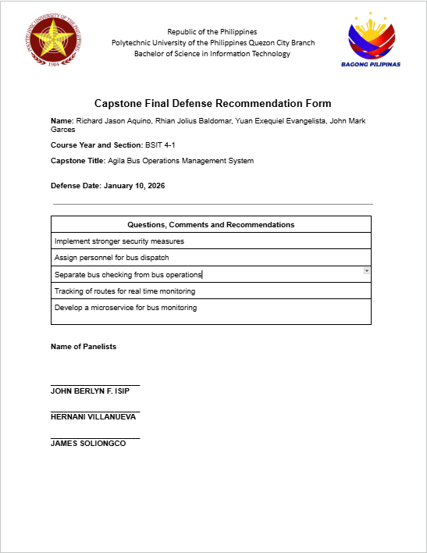

### D.2 Photos from Defense and Pilot Testing

Pilot Test



Capstone 1 Final Defense via Zoom

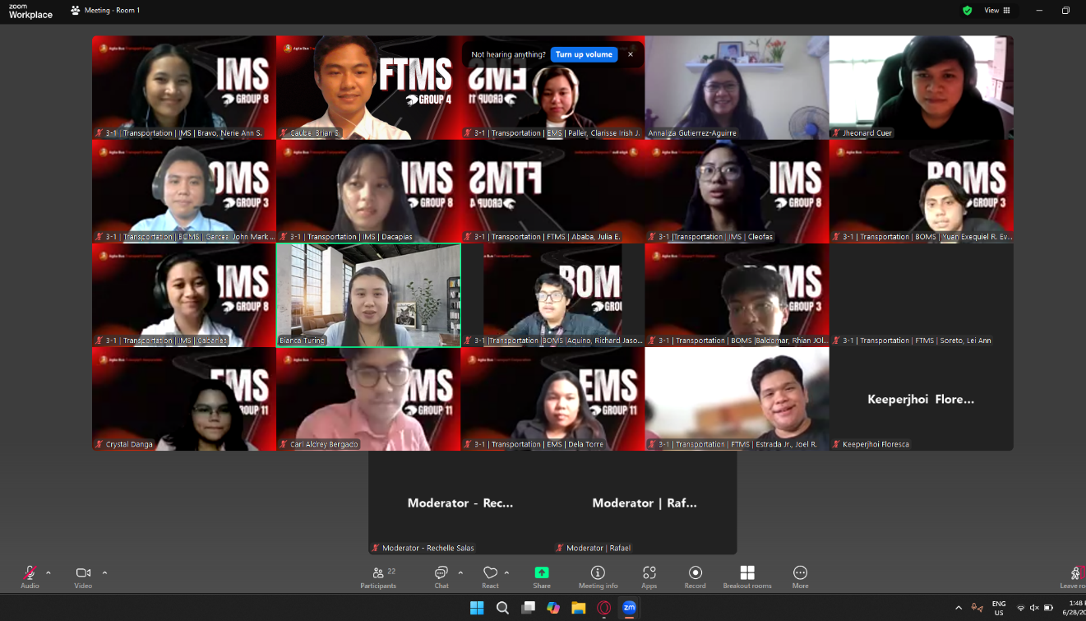

Capstone 2 Integration Defense

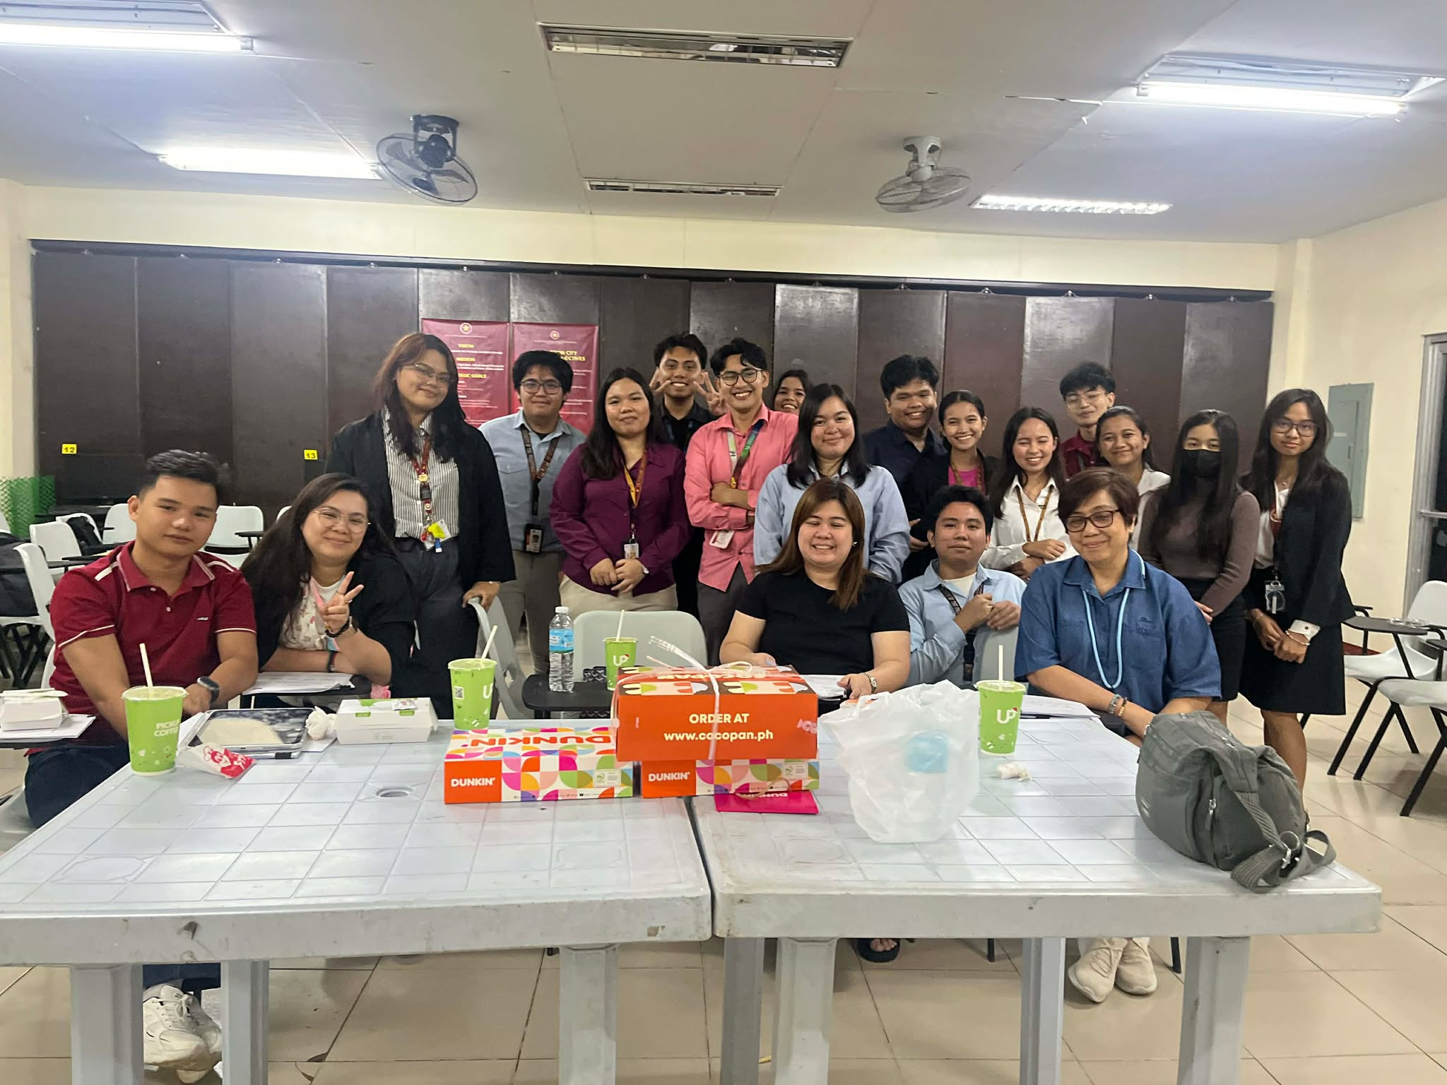

Capstone Overnight



Capstone 2 Integration Defense

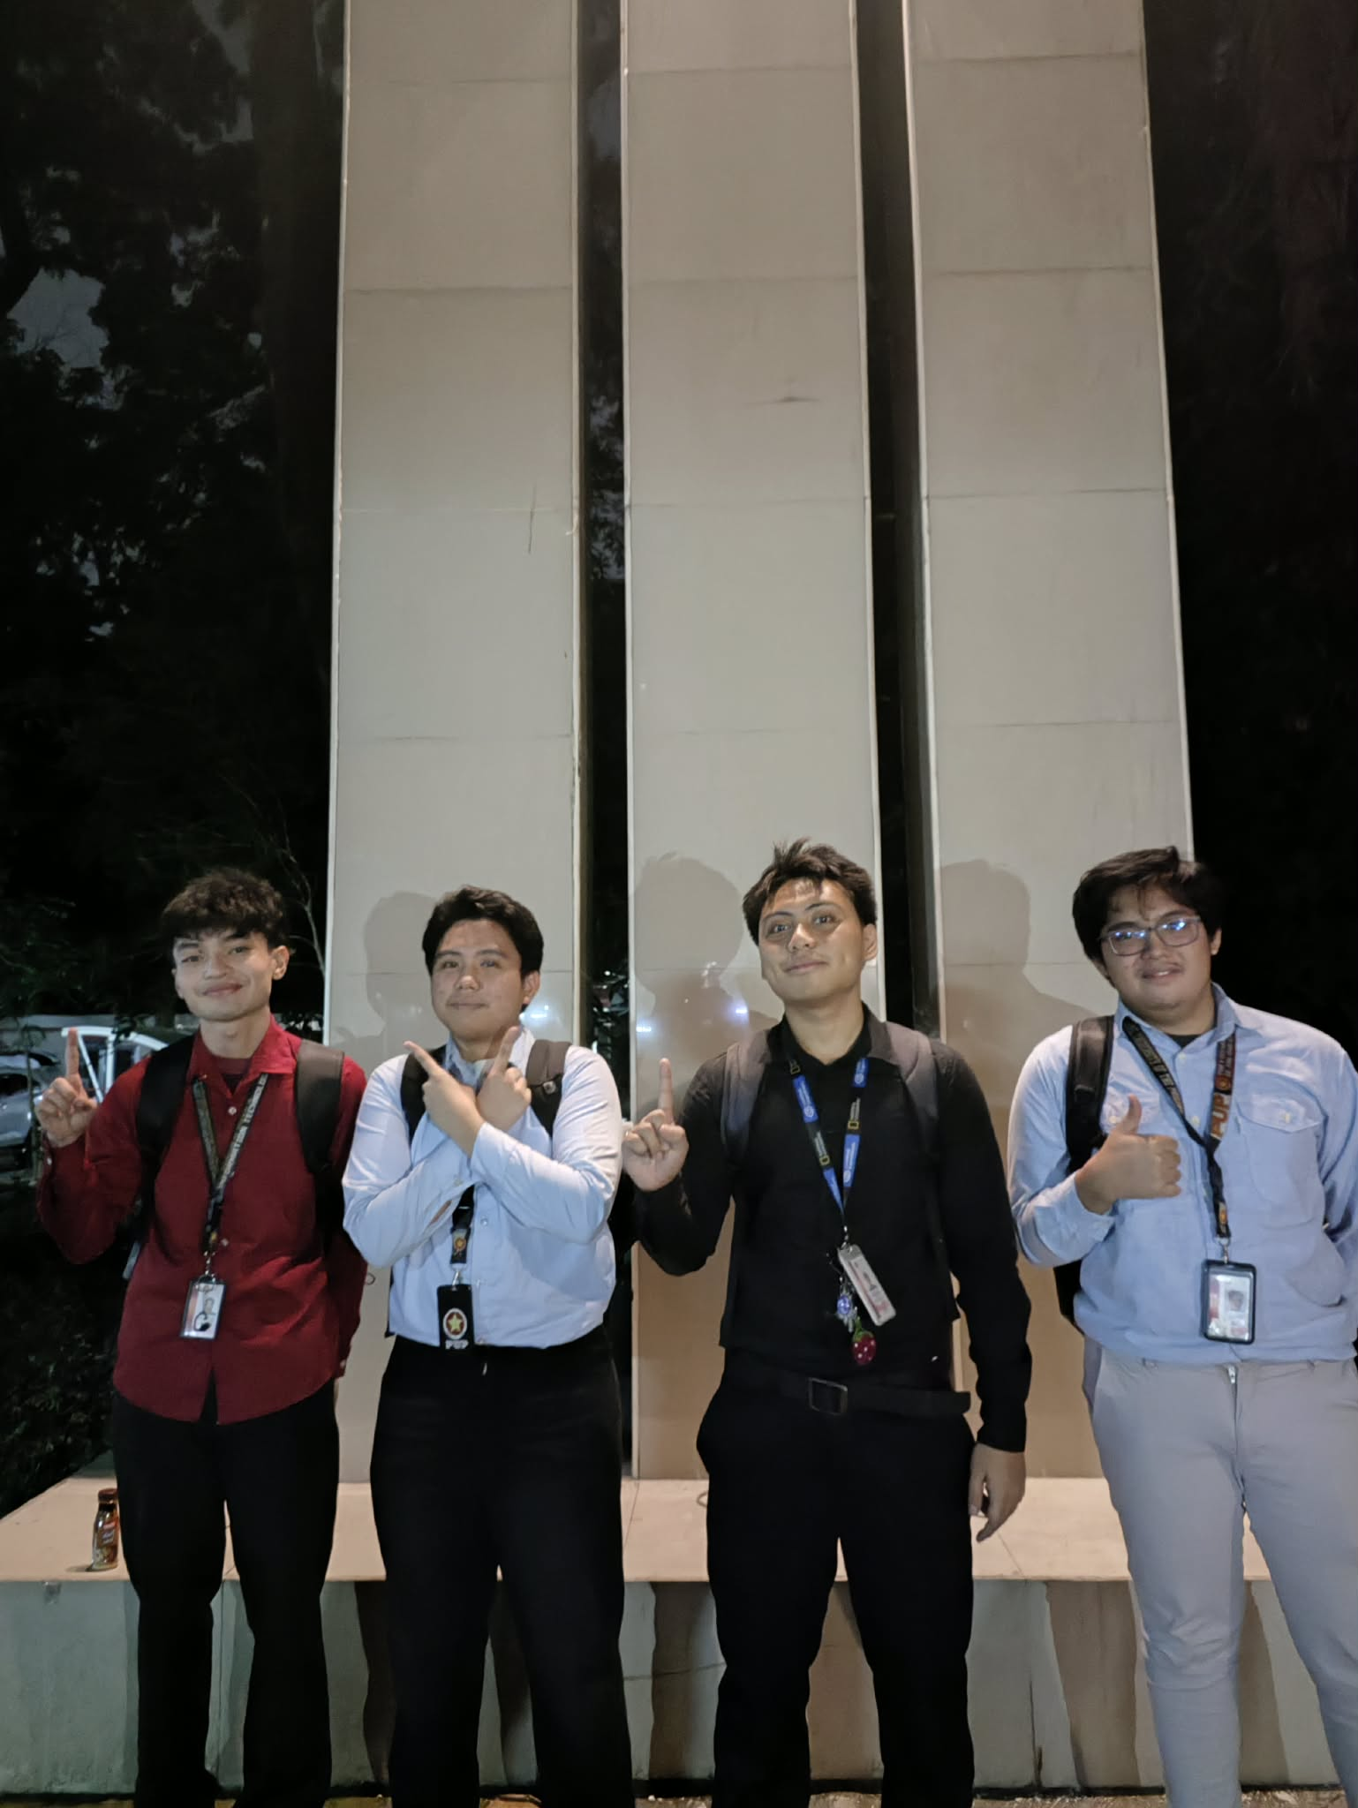

Capstone 2 Functionalities Defense

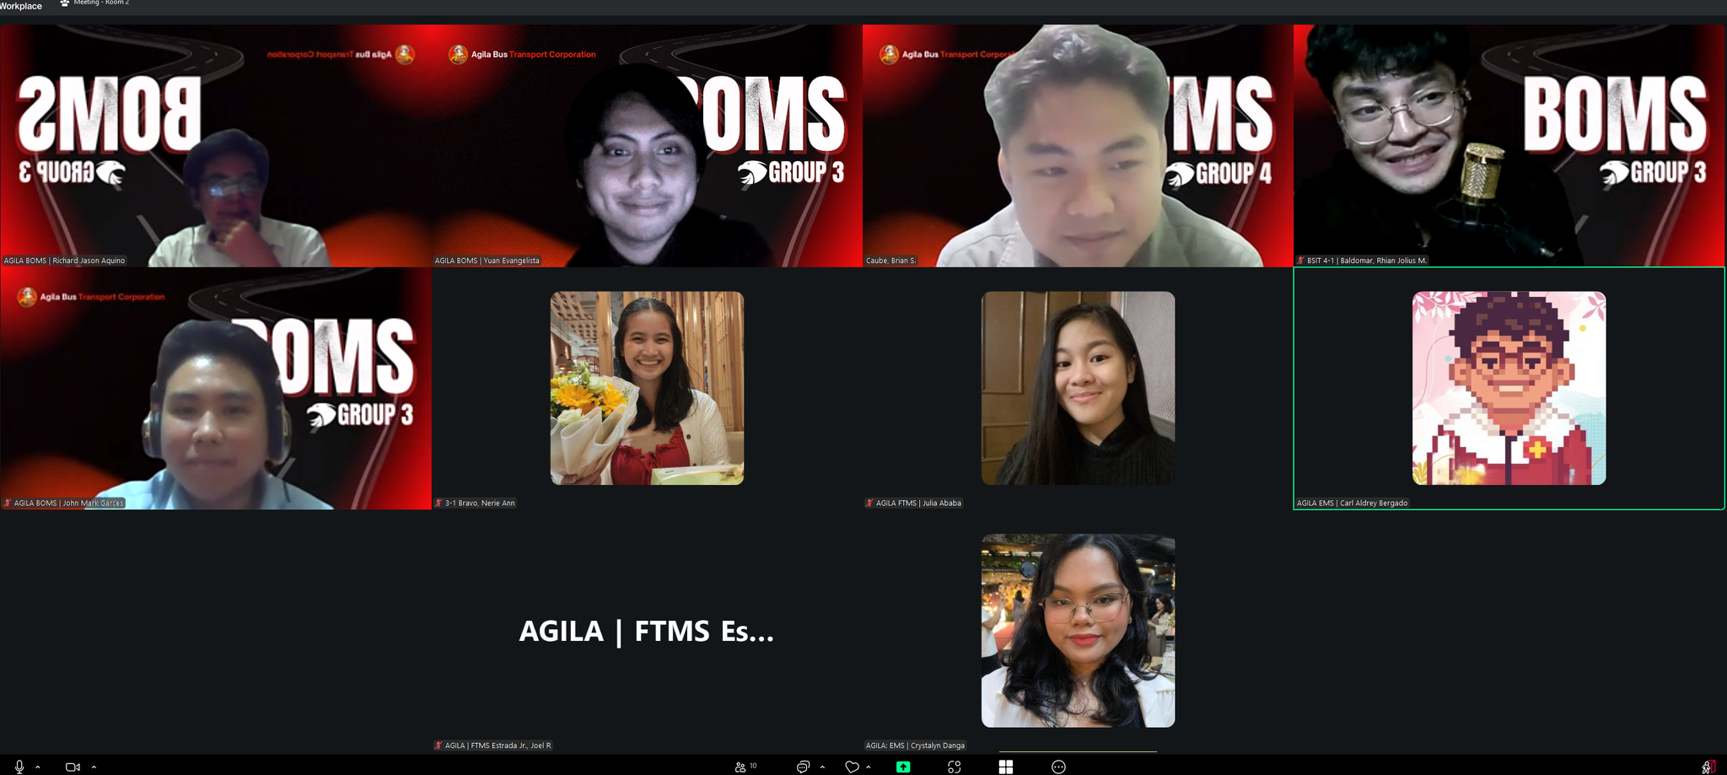

## APPENDIX E: Access Links

### E.1 Live System URL

https://auth.agilabuscorp.me/api/auth/login



### E.2 Source Code Repository

| **Name** | **Repository Name** | **URL** | **Description** | **Branching Strategy** |
| --- | --- | --- | --- | --- |
| Bus Operations Management Frontend | Bus-Operations-System | <https://github.com/RHILIUS/Bus-Operations-System> | Frontend web application | Git Flow |
| Bus Operations Management Backend | Bus-Operations-System-Backend | <https://github.com/Rj-Aquino/Bus-Operations-System-Backend> | Backend web application | Git Flow |
| Analytics Microservice | Microservice-ML-Capstone | <https://github.com/Rj-Aquino/Microservice-ML-Capstone> | Handles Analytics and Forecasting | Git Flow |

### E.3 Comprehensive Online Documentation

“Comprehensive Online Documentation” is not considered applicable to the Bus Operations Management System (BOMS) because the system is primarily designed to support internal operational processes rather than serve as a public-facing platform. BOMS focuses on managing routes, dispatching buses, tracking quotas, and generating reports for authorized personnel within the organization. Its users are typically trained staff members who operate within a controlled environment. As a result, extensive public documentation, user manuals published online, or open-access knowledge bases are not essential to the system’s core functionality.

Additionally, BOMS operates within a structured organizational setting where guidance and training are usually provided directly through internal briefings, onboarding sessions, or limited user guides. The system’s effectiveness depends more on accuracy, reliability, and operational efficiency than on publicly accessible documentation. Since it is not intended for widespread public use or third-party integration, maintaining comprehensive online documentation would not significantly enhance its performance or usability. Therefore, such documentation is considered outside the primary scope and objectives of the system.

### E.4 System Demo Video

https://www.youtube.com/watch?v=N9Pc6_ireN4



## APPENDIX F: Plagiarism Certificate

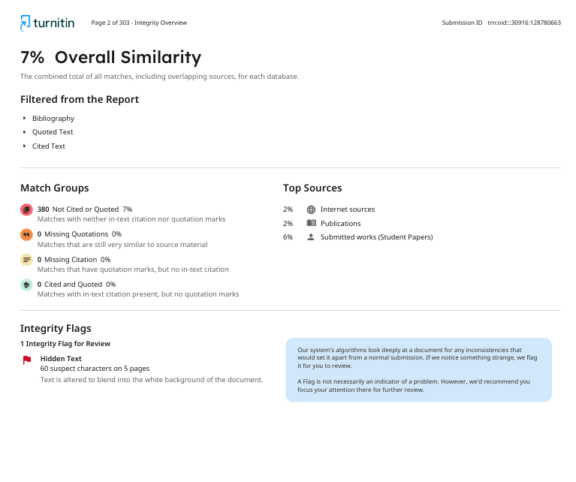

## APPENDIX G: Grammarly Certificate

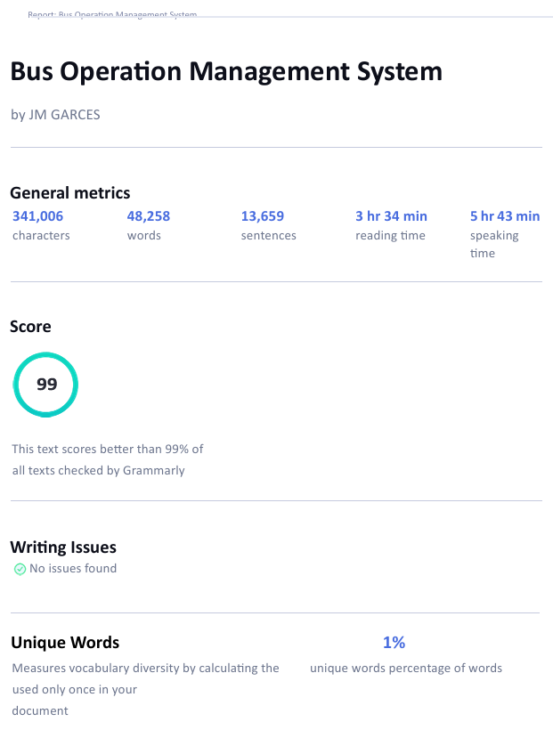

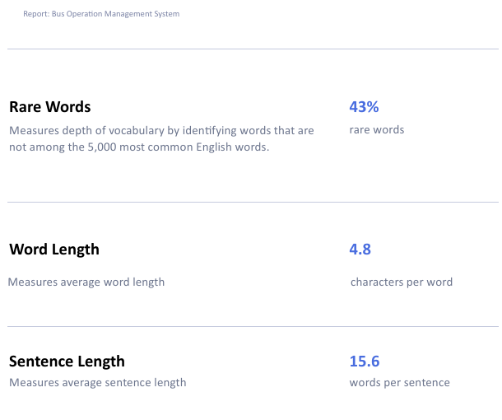

## APPENDIX H: Biographical Statements



**Richard Jason M. Aquino**

**Bachelor of Science in Information Technology**

Mr. Richard Jason M. Aquino. is a third-year Information Technology student at the Polytechnic University of the Philippines – Quezon City Campus. As a full- time student, he spends most of his time improving his skills in programming and learning about computer hardware. Motivated by his goal of being a skilled programmer and technician, he is dedicated to constantly learning and growing in the field and takes on new challenges to further develop his skills. His commitment to personal and professional growth makes him a promising future expert in the IT industry.



**Rhian Jolius M. Baldomar**

**Bachelor of Science in Information Technology**

Mr. Rhian Jolius M. Baldomar is a third-year student at the Polytechnic University of the Philippines – Quezon City Campus. He graduated senior high school under the strand Information and Communications Technology in Quezon City. He is proficient in full-stack web development and stays updated with the latest IT trends by continuously learning and exploring different fields of technology. This curiosity helps him discover the best path that aligns with his skills and interests. His love for learning, problem-solving, and adapting to the fast-paced world of IT reflects his commitment to growth and innovation. With his determination and openness to new challenges, he aims to make a meaningful impact in the field of Information Technology.



**Yuan Exequiel R. Evangelista**

**Bachelor of Science in Information Technology**

Mr. Yuan Exequiel R. Evangelista is a third-year Information Technology student at the Polytechnic University of the Philippines – Quezon City Branch. He has a strong passion for video editing, film direction, and web design, and is committed to refining his skills in these creative fields. With a focus on mastering the art of editing and directing films, as well as crafting visually engaging websites, Yuan strives to blend technical expertise with creativity. His goal is to become a versatile professional with a well-rounded skill set in both the tech and creative aspects of web development and filmmaking.



**John Mark A. Garces**

**Bachelor of Science in Information Technology**

Mr. Johnmark A. Garces is a third-year student in Information Technology at the Polytechnic University of the Philippines – Quezon City Campus. He has a strong passion for learning new technologies and exploring advancements in the IT industry. His interests extend beyond academic coursework, as he enjoys inventing unique features in his projects, particularly in mobile applications and websites. He possesses proficiency in multiple programming languages, including Python, C, C#, and COBOL, and is wellversed in modern development frameworks and technologies such as Flutter Flow and Laravel. With a keen interest in full-stack development, he actively works on integrating both front-end and back-end solutions to create innovative and efficient digital experiences. His commitment to continuous learning and experimentation allows him to stay at the forefront of software development and emerging technologies.